
SRI LANKAN INTERNATIONAL SCHOOL , RIYADH -KSA
NAME IN FULL: ________________________________________________
ADMISSION NUMBER: _____________ CLASS: ___________

Mathematics
Grade 1
1 hour 30 minutes

SECOND SEMESTER EXAMINATION 2022/2023
Sunday, 4th June 2023.

TOTAL MARKS

Question No: | Marks
01
02
03
04
05
06
07
08
09
10
Total
Information for Candidates
- The total mark for the paper is 100
- This paper contains 10 questions on 9 pages.
- The mark for each question is indicated next to the question.
- Plagiarism / Copying will result in zero marks.
Advice to Candidates
- Read all questions carefully before you start to answer it.
- Check page numbers if all pages are attached in order.
- Check your answers before submission.
- All answers should be written neatly.
- Do not use highlighter, glue, or correction fluid.
- Write your answer neatly and in good English.

For Examiner’s Use Only
Checked by: | Signature | Date

Page 01 of 09
01. Answer the below additions and subtractions.

- ____ + 15 = 20

- 10 + _____ = 20

- 38 + _____ = 48

- 50 - 10 = ______

- 13 + 7 = _____

- 39 + 1 = _______

- 49 – 10 = _______

- _____ + 3 = 20

- _____ - 10 = 93

- 22 + _____ = 32

- 10 + ____ = 40

- ____ + 10 = 55

(1 x 12 = 12 Marks )

02 of 09 page

02. Write each set of numbers in order, smallest to largest.

19
33
42
17
24
85

23
25

49
93
63
69

39
81
42
909

89
44
80

19

(4x5=20Marks)

03 of 09 page

03. Complete the number pattern 2, 5 and 10

 | 10 | 15 | 20

 | 70 | 80 |  |  | 110

 | 24 | 26 | 28

 | 55 | 65 |  |  | 95

 | 19 |  |  | 49

 |  | 55 | 60

(1 x20 = 20 Marks)

04 of 09 page

- 3. Colour ½ of each given picture

04.Colour each shape with given fraction .

- Colour ½ of each given picture
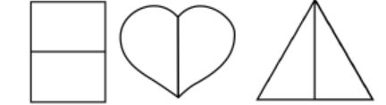

- Colour ¼ of each given picture

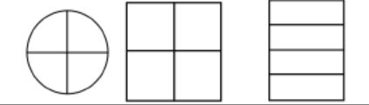

- Colour ½ of each given picture
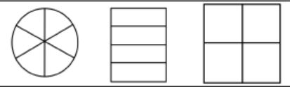

(1 x 9= 9 Marks)

05 of 09 page
05. Add up the numbers to find the answers.

- 5 + 6 + 4 = _______

- 6 + 6 + 5 = _______

- 8 + 4 + 2 = _______

- ___ + 8 + ___ = 15

- ___ + ____ + ____ = 21

(1 x 5 =5 Marks)
06. Adding and subtracting using bonds.

- 43 + 5 = _____

- 75 - 1 = _____

- 64 + 2 = ____

- 26 – 3 = ____

- 68 – 5 = _____

(1 x 5 =5 Marks)

06 of 09 page
06. Write down the time.

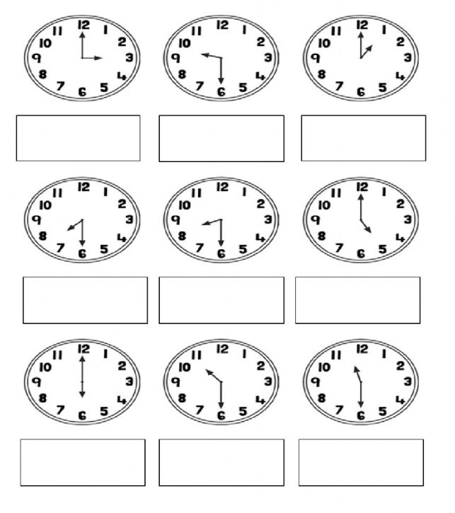

(1 x 9 = 9 Marks)

07 of 09 page

07. Partition these 2 digit numbers into their 10s and 1s.

87
99

63
38

55

(1 x 5 = 5 Marks)

08 of 09 page
08. Complete the pictogram.

Favourite Ice cream Flavour | Number of Children
Chocolate | 8
Vanilla | 7
Strawberry | 5
Mango | 4
Cookie | 4

Favourite Ice cream Flavour | Number of Children
Chocolate
Vanilla
Strawberry
Mango
Cookie


1 Child

(1 x 5 = 5 Marks)

09 of 09 page
09. Complete the below sentences.

- Double 7p = _____ p

- Double 10 = ______

- Half of 18p = ______ p

- ½ of 16 = _____

- Half of 20p = ____ p

(1 x 5 = 5 Marks)
10. Colour the Even numbers in Red.

11 | 21 |  | 57 |  | 88
 |  | 18 |  | 16
55

 | 22 |  | 99 |  | 10

(1 x 5 = 5 Marks)

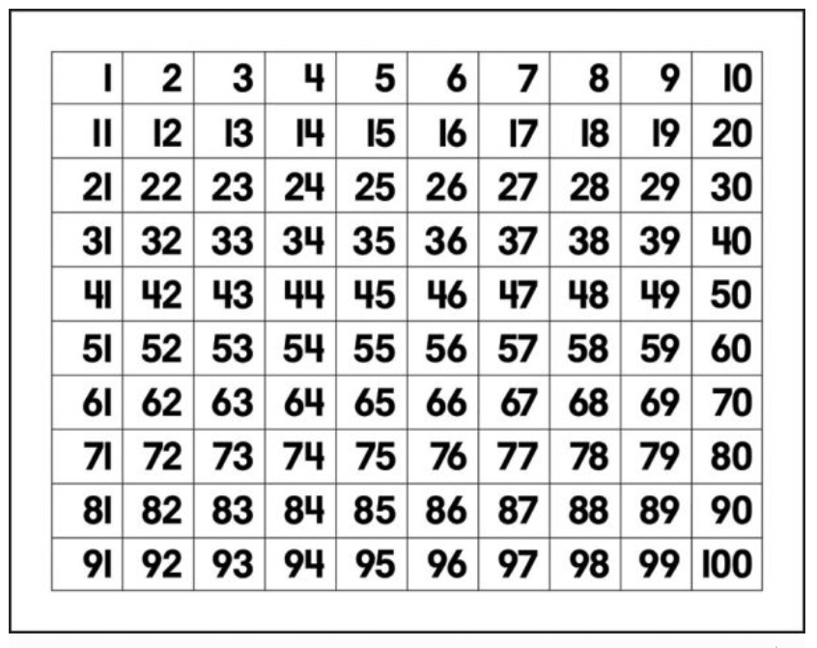
END

END
(1 x 10 = 10 Marks)

