User Registration Backend Documentation

Overview
This project sets up a user registration backend using Node.js, Express, and MySQL. Users can register with a username, email, and password. The passwords are securely hashed before storing in the database

Prerequisites
- Node.js and npm installed
- MySQL installed and running

API Endpoint
URL: api/register
Method: POST

Setup Instructions
- Install Dependencies:
- npm install
- npm install express mysql2 bcryptjs body-parser
- Start the Server: node index.js
- The server runs on http://localhost:3000.

Backend API Details
- Endpoint: /api/register
- Method: POST
- Purpose: Creates a username and password for registration

- Request Body (JSON format):
{
"username": "test_user",
"password": "securepassword123",
"email": "test@example.com"
}
Response (Success):
{
"message": "User registered successfully"
}

- User Registered Successfully
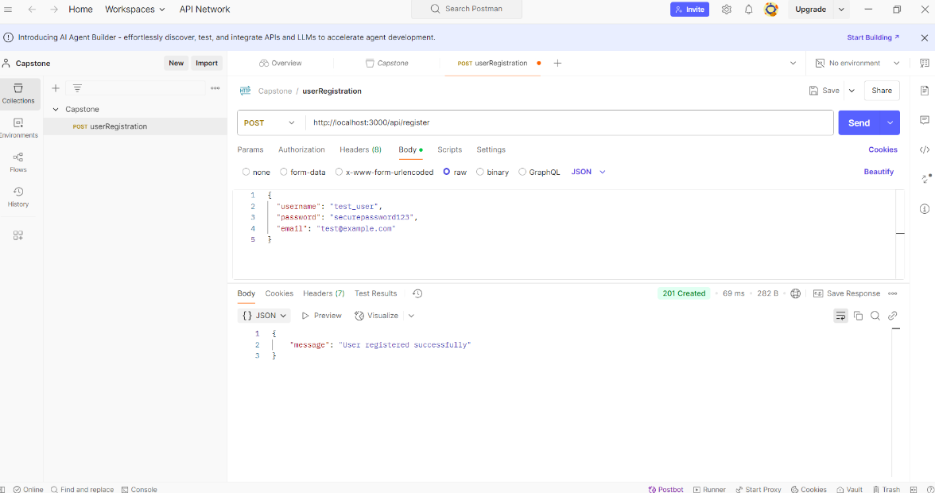

- User Already Exists
