**10. ReactJS-HOL**

App.js

// src/App.js

import React from 'react';

const App = () => {

const offices = [

{

id: 1,

name: 'Cozy Corner Workspace',

rent: 45000,

address: 'Chennai, Tamil Nadu',

image: 'https://via.placeholder.com/250?text=Office+1'

},

{

id: 2,

name: 'Premium Tech Hub',

rent: 85000,

address: 'Bangalore, Karnataka',

image: 'https://via.placeholder.com/250?text=Office+2'

},

{

id: 3,

name: 'Startup Garage',

rent: 30000,

address: 'Coimbatore, Tamil Nadu',

image: 'https://via.placeholder.com/250?text=Office+3'

}

];

const headingStyle = {

textAlign: 'center',

color: '#333',

marginTop: '20px'

};

const cardStyle = {

border: '1px solid #ccc',

padding: '15px',

borderRadius: '10px',

marginBottom: '20px',

width: '300px',

textAlign: 'left',

boxShadow: '0 2px 5px rgba(0,0,0,0.1)'

};

return (

<div style={{ padding: '30px', fontFamily: 'Arial' }}>

{/* JSX Heading */}

<h1 style={headingStyle}>🏢 Office Space Rental App</h1>

{/* Render List */}

{offices.map((office) => (

<div key={office.id} style={cardStyle}>

{/* Office Image */}

<img src={office.image} alt={office.name} style={{ width: '100%', borderRadius: '8px' }} />

{/* Office Details using JSX */}

<h2>{office.name}</h2>

<p>

<strong>Rent:</strong>{' '}

<span style={{ color: office.rent < 60000 ? 'red' : 'green' }}>

₹{office.rent}

</span>

</p>

<p>

<strong>Address:</strong> {office.address}

</p>

</div>

))}

</div>

);

};

export default App;

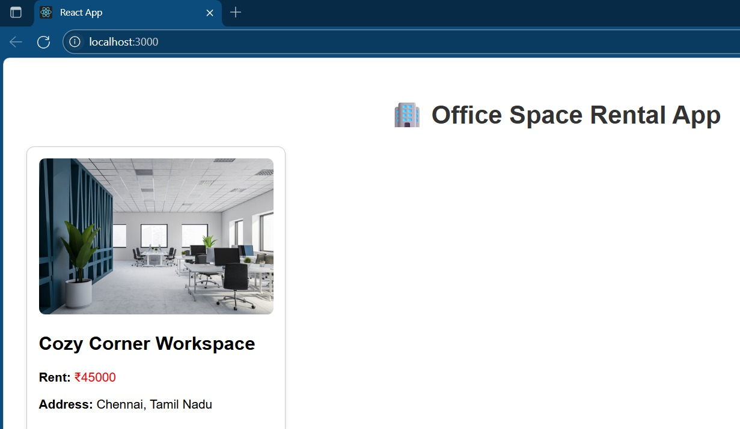OUTPUT:

