**Blogger App**

**App.js**

import React, { useState } from 'react';

import BookDetails from './BookDetails';

import BlogDetails from './BlogDetails';

import CourseDetails from './CourseDetails';

function App() {

const [activeTab, setActiveTab] = useState("book");

// Using element

variable

let selectedComponent;

if (activeTab === "book") {

selectedComponent = <BookDetails />;

} else if (activeTab === "blog") {

selectedComponent = <BlogDetails />;

} else {

selectedComponent = <CourseDetails />;

}

return (

<div style={{ padding: '20px' }}>

<h1>🧠 Blogger App</h1>

<div style={{ marginBottom: '10px' }}>

<button onClick={() => setActiveTab("book")}>Book</button>

<button onClick={() => setActiveTab("blog")}>Blog</button>

<button onClick={() => setActiveTab("course")}>Course</button>

</div>

{/* Render via variable */}

{selectedComponent}

{/* Using ternary operator */}

<div style={{ marginTop: '20px' }}>

<h4>Status:</h4>

{activeTab === "book" ? (

<p>Viewing book content</p>

) : activeTab === "blog" ? (

<p>Viewing blog content</p>

) : (

<p>Viewing course content</p>

)}

</div>

{/* Short-circuit rendering */}

{activeTab === "blog" && (

<p style={{ color: "blue" }}>(You might enjoy our latest tech blog!)</p>

)}

</div>

);

}

export default App;

**BlogDetails.js**

import React from 'react';

function BlogDetails() {

const blogs = [

{ id: 1, title: "Intro to React", writer: "Nina" },

{ id: 2, title: "React vs Vue", writer: "Arjun" }

];

return (

<div>

<h3>📝 Blog Details</h3>

<ul>

{blogs.map(blog => (

<li key={blog.id}>

<strong>{blog.title}</strong> — {blog.writer}

</li>

))}

</ul>

</div>

);

}

export default BlogDetails;

**BookDetails.js**

import React from 'react';

function BookDetails() {

const books = [

{ id: 1, title: "React Essentials", author: "Dan Abramov" },

{ id: 2, title: "Learning JavaScript", author: "Kyle Simpson" }

];

return (

<div>

<h3>📚 Book Details</h3>

<ul>

{books.map(book => (

<li key={book.id}>

<strong>{book.title}</strong> by {book.author}

</li>

))}

</ul>

</div>

);

}

export default BookDetails;

**CourseDetails.js**

import React from 'react';

function CourseDetails() {

const courses = [

{ id: 1, name: "React Basics", duration: "3 weeks" },

{ id: 2, name: "Advanced JS", duration: "2 weeks" }

];

return (

<div>

<h3>🎓 Course Details</h3>

<ul>

{courses.map(course => (

<li key={course.id}>

<strong>{course.name}</strong> - {course.duration}

</li>

))}

</ul>

</div>

);

}

export default CourseDetails;

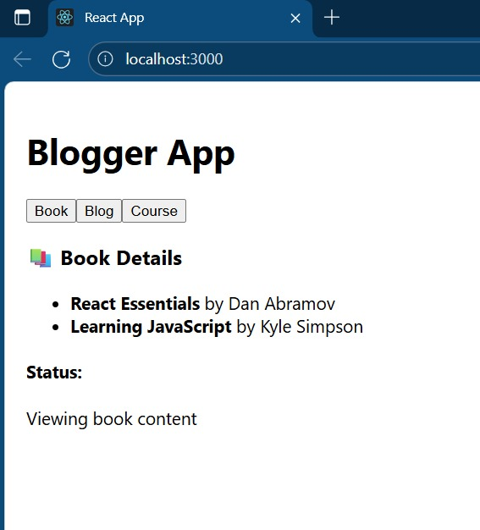**OUTPUT:**

