**9. ReactJS-HOL**

// src/component/IPlayer.js or IPlayer.jsx

import React from "react";

const IPlayers = () => {

  const players = [

    { name: "Virat", score: 85 },

    { name: "Rohit", score: 78 },

    { name: "Rahul", score: 69 },

    { name: "Dhoni", score: 55 },

    { name: "Ashwin", score: 90 },

    { name: "Pant", score: 40 },

  ];

  // Filter Odd Team and Even Team

  const oddTeam = players.filter(player => player.score % 2 !== 0);

  const evenTeam = players.filter(player => player.score % 2 === 0);

  return (

    <div>

      <h2>Odd Team Players (Score is Odd)</h2>

      <ul>

        {oddTeam.map((player, index) => (

          <li key={index}>

            {player.name} - Score: {player.score}

          </li>

        ))}

      </ul>

      <h2>Even Team Players (Score is Even)</h2>

      <ul>

        {evenTeam.map((player, index) => (

          <li key={index}>

            {player.name} - Score: {player.score}

          </li>

        ))}

      </ul>

    </div>

  );

};

export default IPlayers;

import React from 'react';

const LPlayer = () => {

  const players = [

    { name: 'Gill', score: 45 },

    { name: 'Hardik', score: 65 },

    { name: 'Rahul', score: 55 },

    { name: 'Jadeja', score: 66 },

    { name: 'Pant', score: 50 },

    { name: 'Shami', score: 60 },

    { name: 'Rohit', score: 78 },

    { name: 'Virat', score: 95 }

  ];

  const below70 = players.filter(player => player.score < 70);

  const oddTeam = below70.filter(player => player.score % 2 !== 0);

  const evenTeam = below70.filter(player => player.score % 2 === 0);

  return (

    <div style={{ padding: '20px', fontFamily: 'Arial' }}>

      <h2>🏏 Cricket App</h2>

      <h3>All Players</h3>

      <ul>

        {players.map((player, index) => (

          <li key={index}>{player.name} - {player.score}</li>

        ))}

      </ul>

      <h3>Players with Score below 70</h3>

      <ul>

        {below70.map((player, index) => (

          <li key={index}>{player.name} - {player.score}</li>

        ))}

      </ul>

      <h3>Odd Team Players (Score % 2 ≠ 0)</h3>

      <ul>

        {oddTeam.map((player, index) => (

          <li key={index}>{player.name} - {player.score}</li>

        ))}

      </ul>

      <h3>Even Team Players (Score % 2 = 0)</h3>

      <ul>

        {evenTeam.map((player, index) => (

          <li key={index}>{player.name} - {player.score}</li>

        ))}

      </ul>

    </div>

  );

};

export default LPlayer;

App.js

import React from 'react';

import LPlayer from './component/Lplayer';

import IPlayer from './component/Iplayer';

function App() {

  const flag = true; // Change this to false to test

  return (

    <div className="App">

      <h1>🏏 Cricket App</h1>

      {flag ? <LPlayer /> : <IPlayer />}

    </div>

  );

}

export default App;

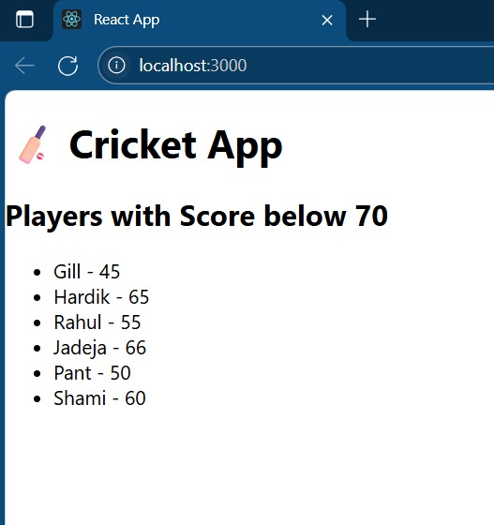OUTPUT:

