**Step 1: Setup your machine with Git Configuration**

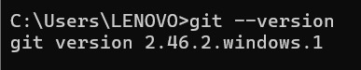

C:\Users\LENOVO\AppData\Local\Packages\5319275A.WhatsAppDesktop_cv1g1gvanyjgm\TempState\EA09078653F7F3AF86385B096A177D30\WhatsApp Image 2025-08-06 at 19.29.24_1d3c86fb.jpg

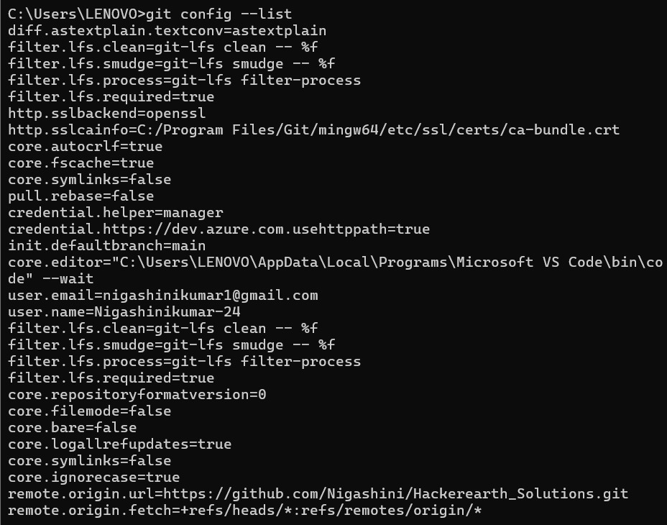

**Step 2: Integrate notepad++.exe to Git and make it a default editor**

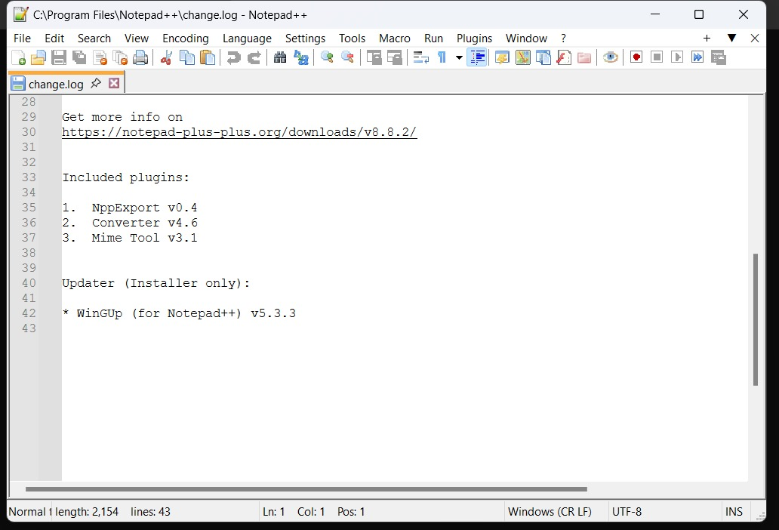

**Step 3: Add a file to source code repository**

