CI/CD Basics with GitHub Actions
Hands-On Lab Completion Report
Name: Nigatie Sahlie | Repository: CI-CD-Project-2 | Date: July 15, 2026

Project Overview
This report documents the completion of a four-part hands-on lab covering GitHub Actions fundamentals: creating a first workflow, automated testing with a build matrix, deploying a static site to AWS S3, and adding a manual approval gate for production deployments. All work was performed on the repository Nigatie-Sahlie/CI-CD-Project-2, driven from an Ubuntu terminal and verified through the GitHub Actions dashboard.
Lab | Objective | Status
Lab 1 | First GitHub Actions workflow (checkout, print commit info, create artifact) | Complete
Lab 2 | Automated Python testing across 3 Python versions + linter | Complete
Lab 3 | Deploy static website to AWS S3 via GitHub Actions | Complete
Lab 4 | Manual approval gate before production deployment | Complete

Lab 1: First GitHub Actions Workflow
A workflow file (first-workflow.yml) was created under .github/workflows to trigger on push, pull request, and manual dispatch. It checks out the code, prints commit and repository metadata, lists repository files, generates a timestamped text file, and uploads it as a build artifact.
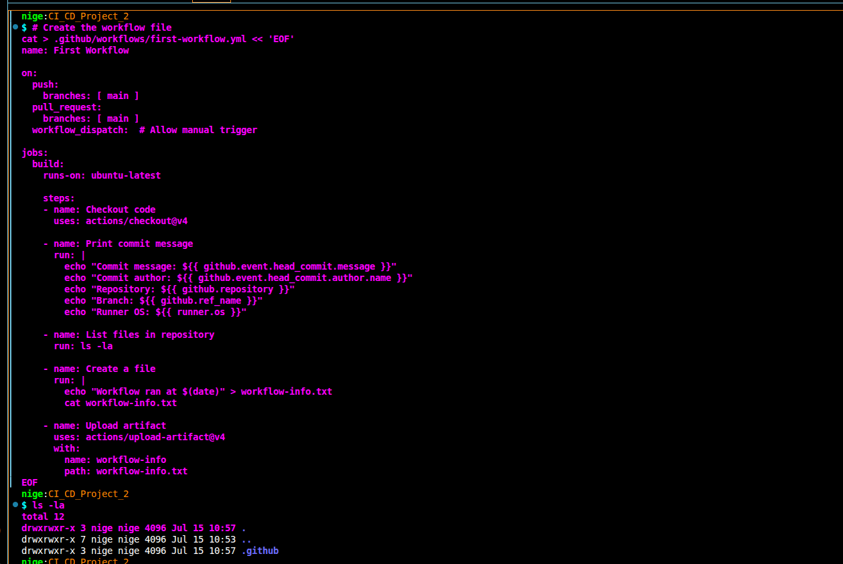
Figure 1 — first-workflow.yml created via terminal heredoc.
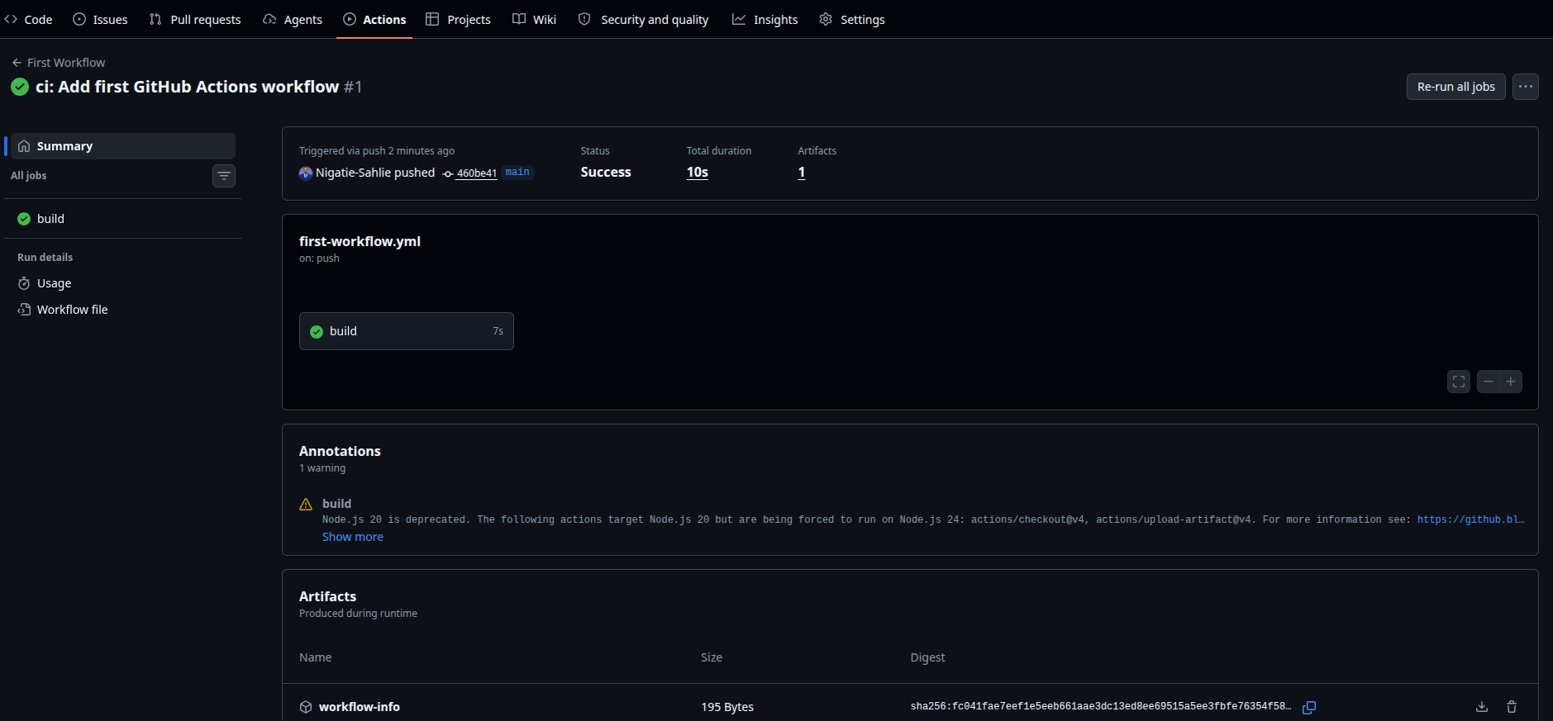
Figure 2 — Workflow run succeeded (10s); workflow-info artifact (195 Bytes) uploaded.

Lab 2: Automated Testing Workflow
A small Python application (app.py) with add, subtract, multiply, and divide functions was created alongside a pytest test suite (tests/test_app.py). The test.yml workflow runs the suite across Python 3.9, 3.10, and 3.11 using a build matrix, caches pip dependencies, and runs flake8 as a linting step. An initial run failed due to a missing conftest.py (pytest could not resolve the app module); adding an empty conftest.py at the repository root resolved it.
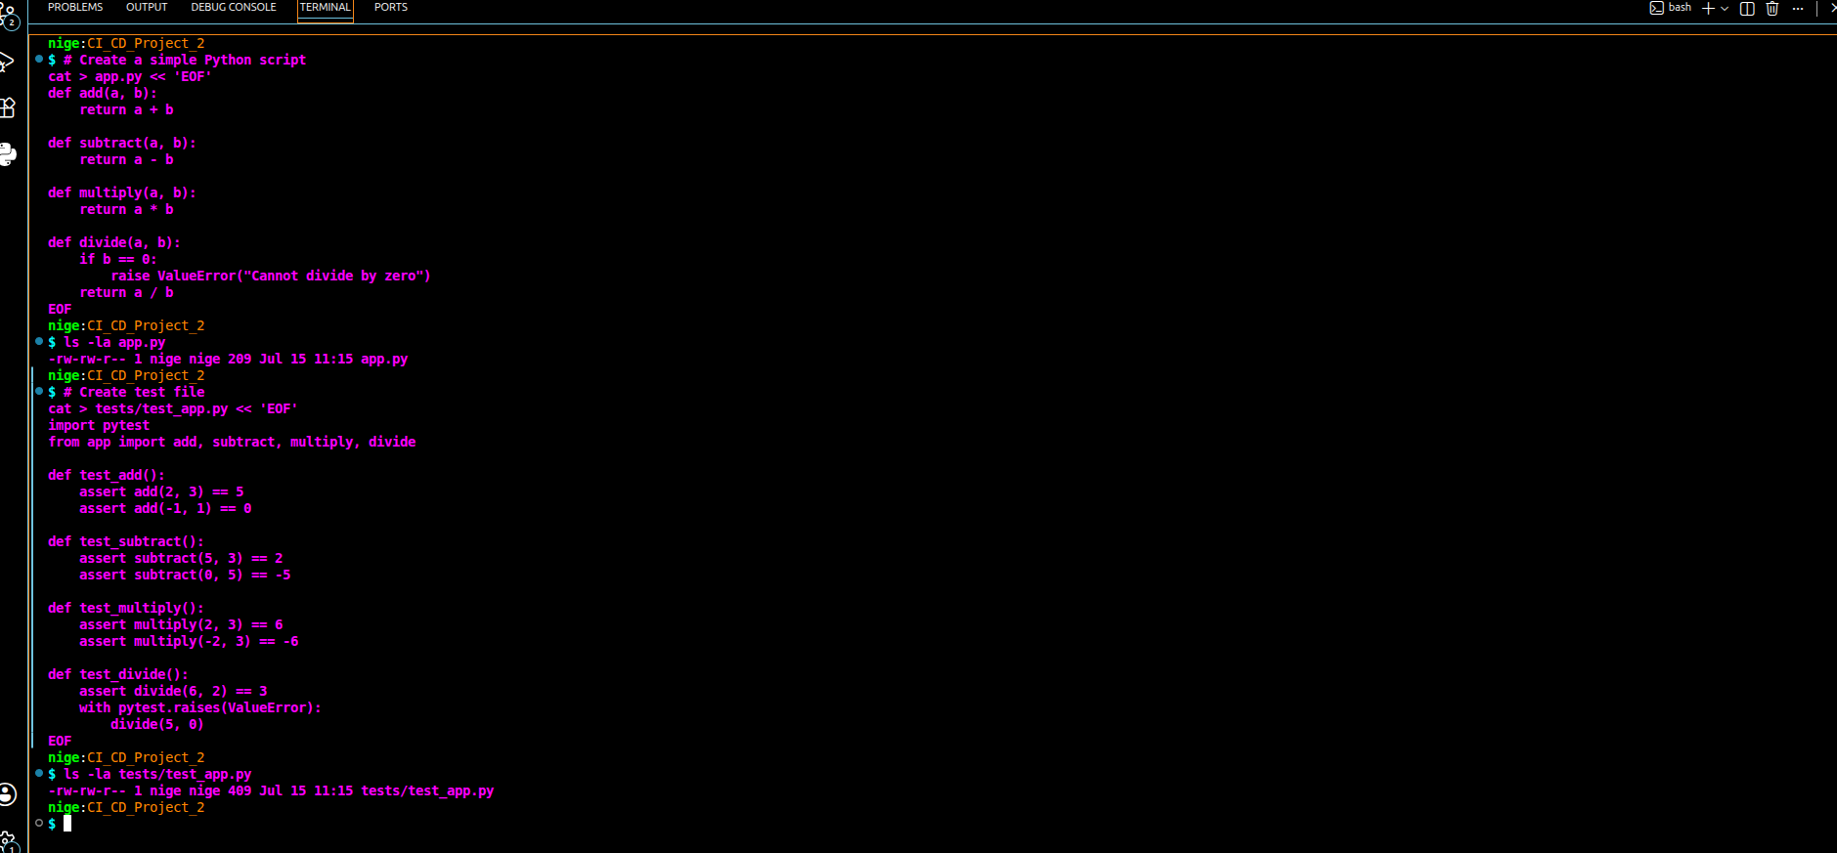
Figure 3 — app.py and tests/test_app.py created via terminal.
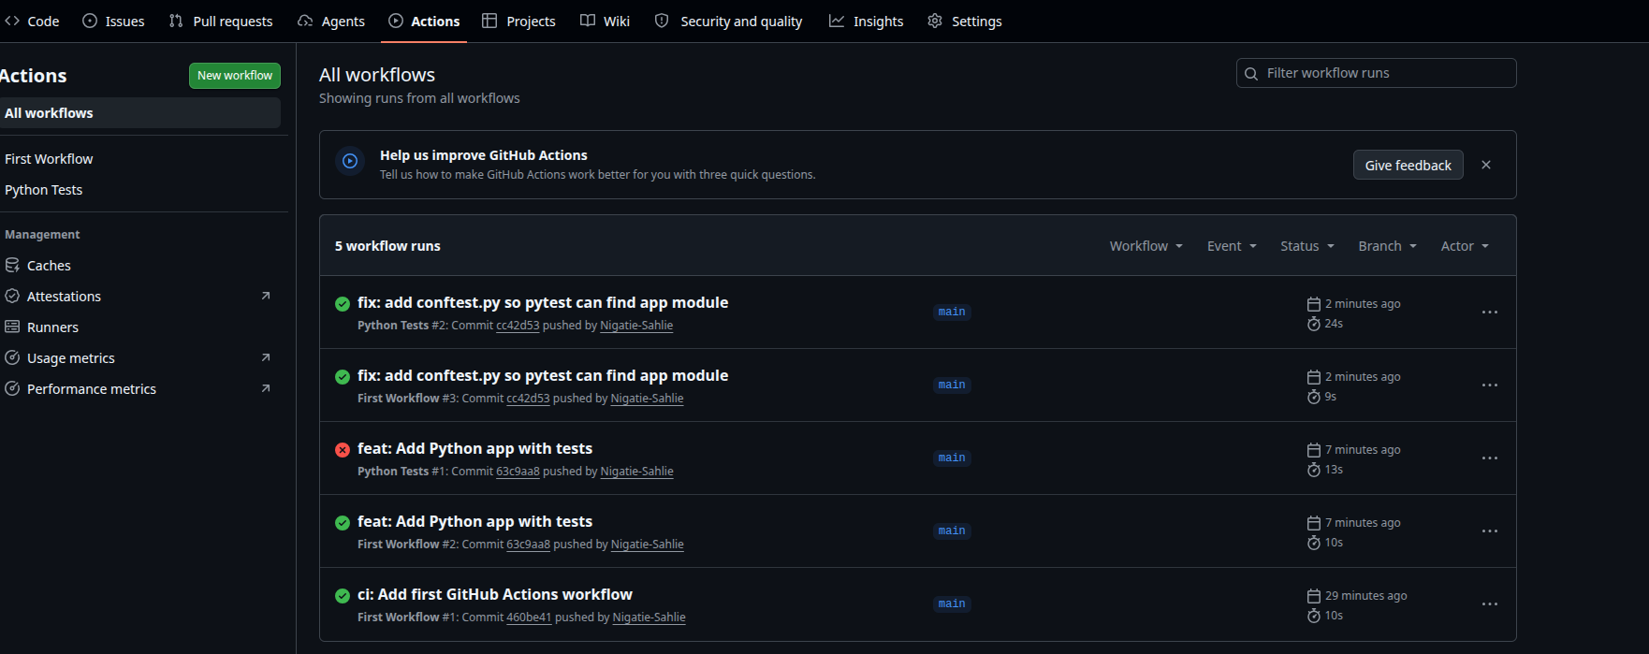
Figure 4 — Python Tests and First Workflow runs passing after the conftest.py fix.

Lab 3: Deploy to AWS S3 from GitHub Actions
An S3 bucket was created and configured for static website hosting, with Block Public Access disabled and a public-read bucket policy applied. A deploy.yml workflow was added that configures AWS credentials from repository secrets and syncs the repository's website files to the bucket on every push to index.html, *.html, *.css, or *.js. The AWS_ACCESS_KEY_ID and AWS_SECRET_ACCESS_KEY secrets were added under repository settings, and the access key was rotated after being briefly exposed during setup.
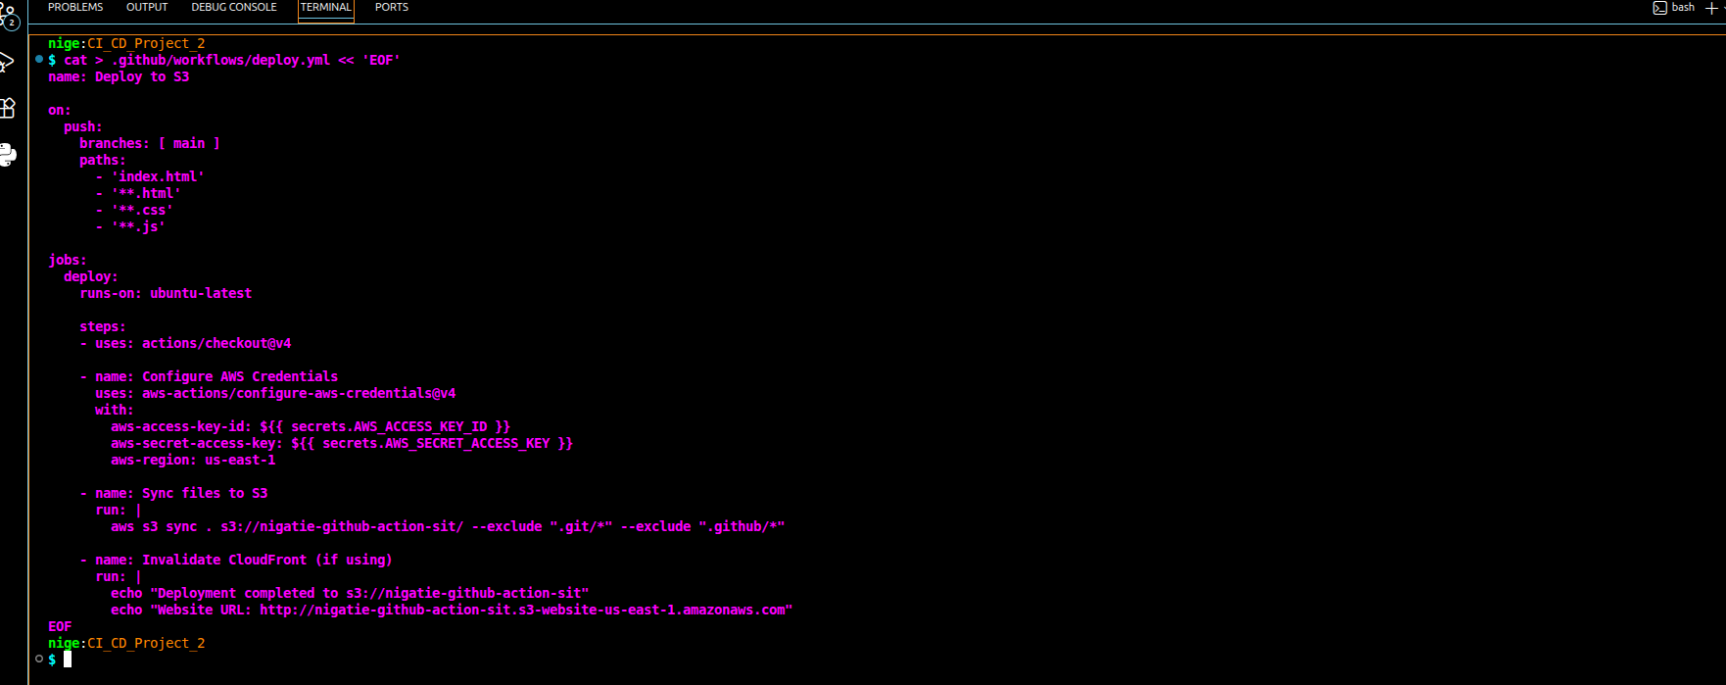
Figure 5 — deploy.yml workflow file created.
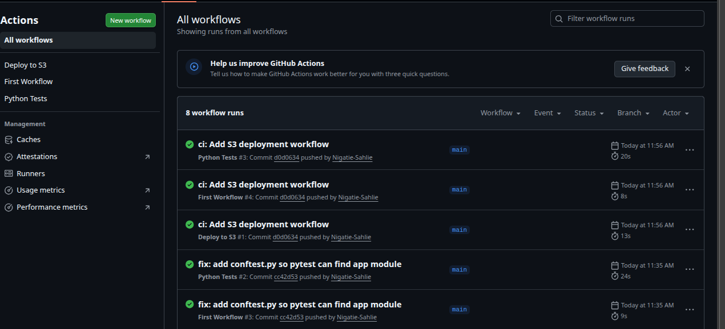
Figure 6 — Deploy to S3 job succeeded after correcting the repository secrets.
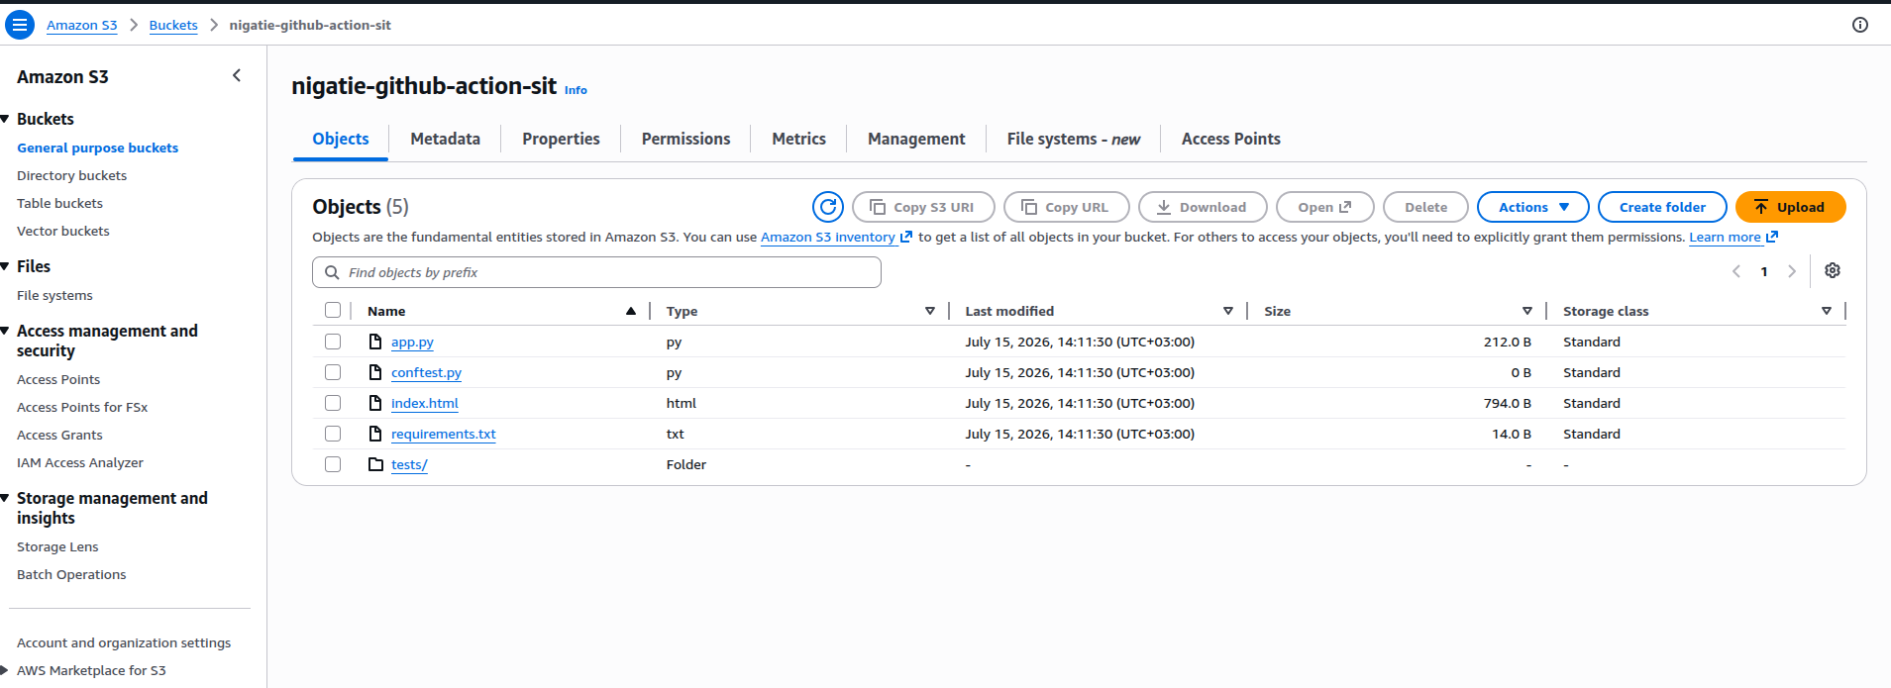
Figure 7 — Bucket contents in the AWS S3 console after sync.
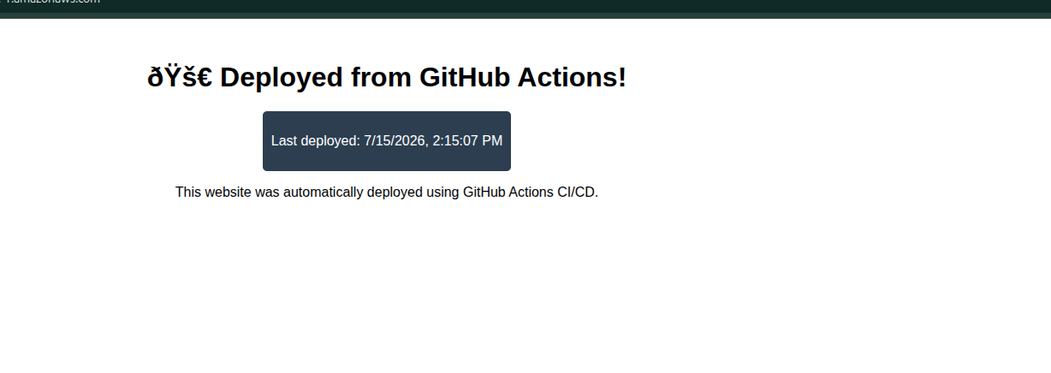
Figure 8 — Live site served from the S3 static website endpoint.

Lab 4: Manual Approval for Production
A production environment was configured under repository Settings > Environments with a required-reviewer protection rule. The deploy job in deploy.yml was updated to reference environment: production, so any push touching the website files now pauses for manual review before the deployment proceeds. A test commit was pushed to confirm the run paused correctly and completed only after approval.
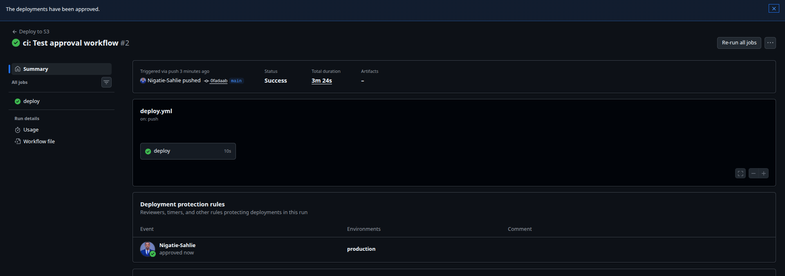
Figure 9 — Deployment approved by reviewer; job completed in 3m 24s including wait time.
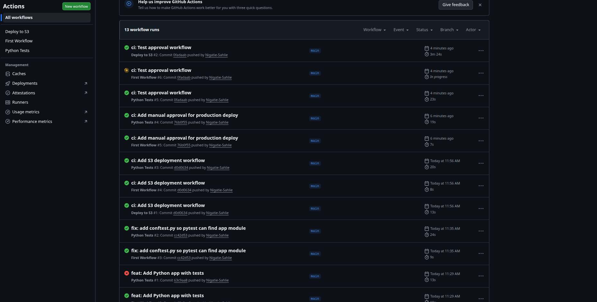
Figure 10 — Full workflow run history showing all four labs completed successfully.

Conclusion
All four labs were completed successfully. Two issues were encountered and resolved independently: a missing conftest.py causing pytest import failures in Lab 2, and a repeated misconfiguration of GitHub repository secrets (entering the key value as the secret name rather than the secret value) in Lab 3, corrected by re-adding the secrets with the correct name/value pairs. The exercise demonstrated a complete CI/CD pipeline: build and test automation, cloud deployment, and a governance control (manual approval) before production release.

