**Installation of FreeIPA VirtualBox VM**

1. **Description**

This document details the manual steps required to install FreeIPA software on a VirtualBox using the ‘ipa-server-install’ script.

Appendix A lists all user input as a separate script This may be easier to follow when familiar with the installation process.

Enter ‘ipa.cleosmith.com’

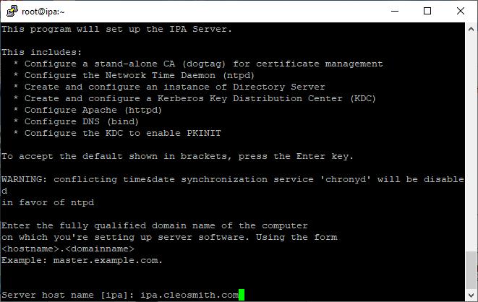

Press ‘[Enter]’

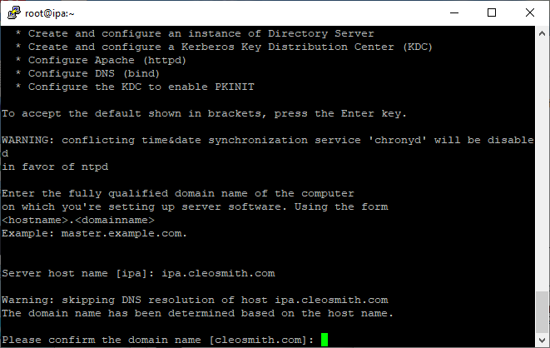

Press ‘[Enter]’

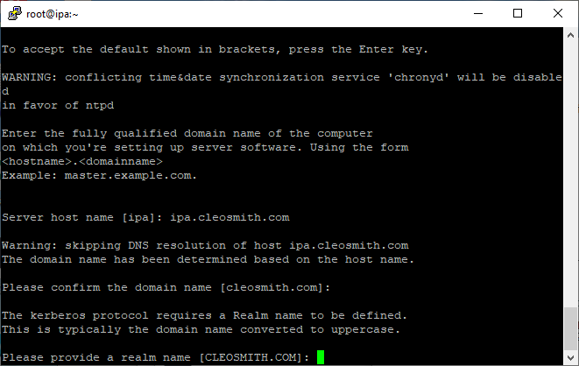

Enter ‘dmpassword’

Enter ‘dmpassword’

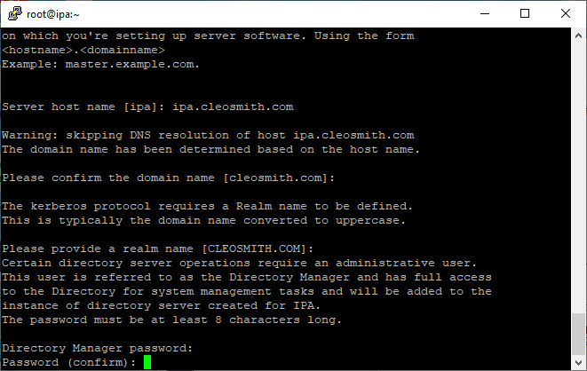

Enter ‘adpassword’

Enter ‘adpassword’

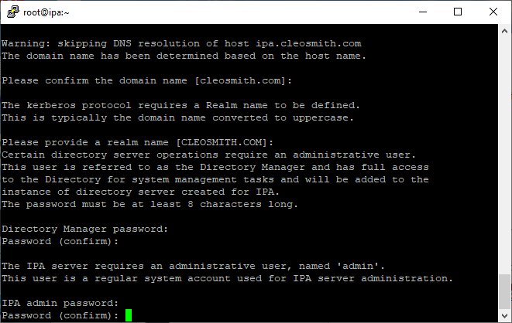

Press ‘[Enter]’

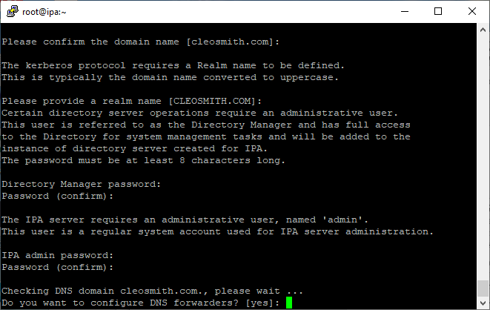

Enter ‘no’

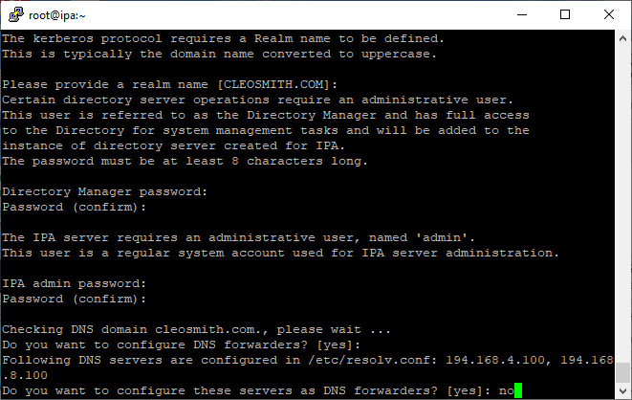

Enter ‘8.8.8.8’

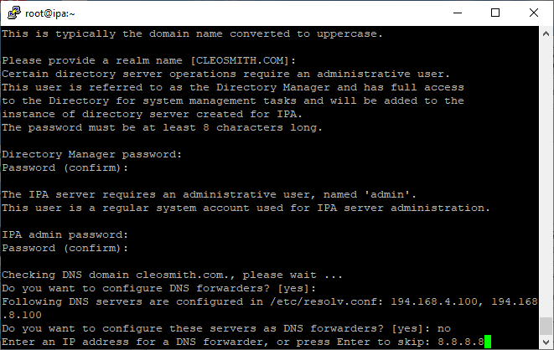

Press ‘[Enter]’

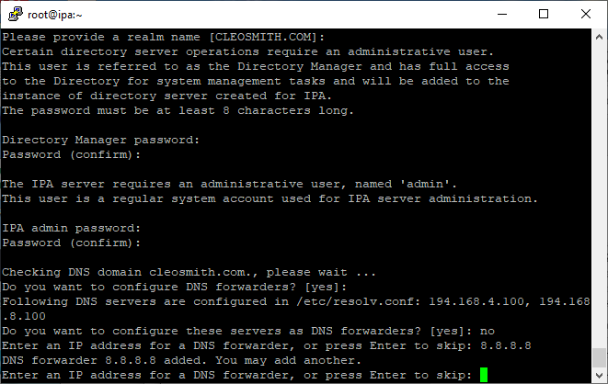

Press ‘[Enter]’

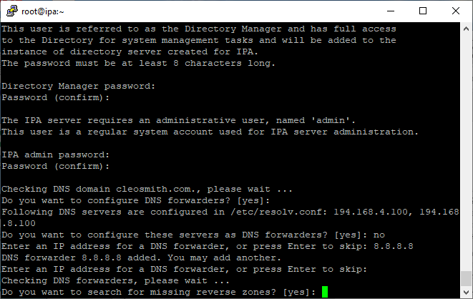

Press ‘[Enter]’

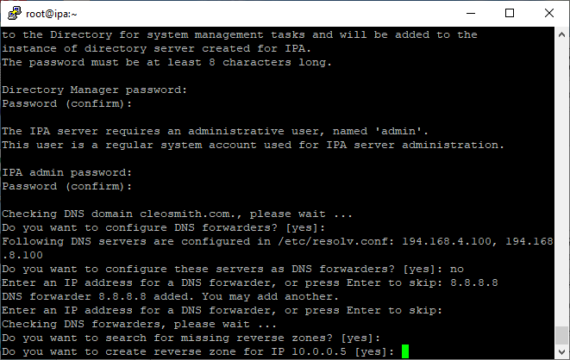

Press ‘[Enter]’

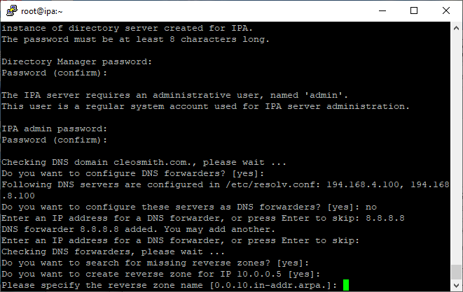

Enter ‘yes’

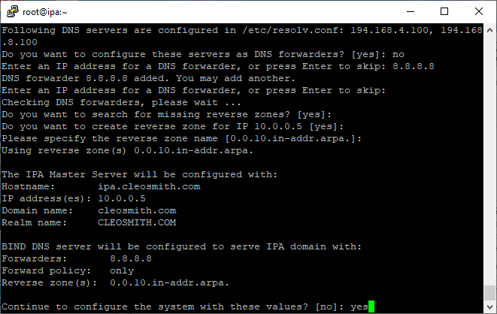

**APPENDIX A**

Enter ‘ipa.cleosmith.com’

Press ‘[Enter]’

Press ‘[Enter]’

Enter ‘dmpassword’

Enter ‘dmpassword’

Enter ‘adpassword’

Enter ‘adpassword’

Press ‘[Enter]’

Enter ‘no’

Enter ‘8.8.8.8’

Press ‘[Enter]’

Press ‘[Enter]’

Press ‘[Enter]’

Press ‘[Enter]’

Enter ‘yes’