## Nigel Guerin. Server-Side Development

This project is a car rental system. The user will add their details to the system. When booking they chose between two dates, from and to and the cars available on those dates are displayed, they then choose the car they want and make the booking. This is added to the database and that car is unavailable. The user can view and cancel bookings. They can also update their personal details.

Database name:

* Carsys

SQL file:

* Carsys.sql

INSERT:

* addCustomer.php
* On the homepage hover over customer and click add details.
* register.php -> addCustomer.php

DELETE:

* remove-booking.php
* removeBookingForm.php -> deletebooking.php -> remove-booking.php
* On the homepage hover over booking and click cancel booking, enter your booking number and click the confirmation to remove the booking.

SELECT:

* chosecar.php
* On the homepage when choosing the dates.
* getcarinfo.php - used to get car details in bookcar.php
* numofbook.php, numofcar.php, numofcustomer.php – are used to count, seen on the homepage
* selectviewbooking.php -> viewbookings.php – are used to view previous bookings
* viewindex.php – is used to see available cars on the homepage.

UPDATE:

* updatedCustomer.php
* whoupdateCust.php -> updateformCustomer.php -> updatedCustomer.php
* On the homepage hover over customer and click update details, enter your customer id number and edit the form. A confirmation is then displayed.

Process:

* The user must add details before making a booking. The user selects a pick-up date and return date, they then chose from the available cars. Then the booking is made, and an invoice is displayed. This invoice displays the user information, the cost of the rental per day, the start and end date and the total cost of the rental. The cars availability is updated, the booking is inserted into the table
* Index.php (form line 13) -> chosecar.php -> bookcar.php -> makebooking.php

Bookings Table:

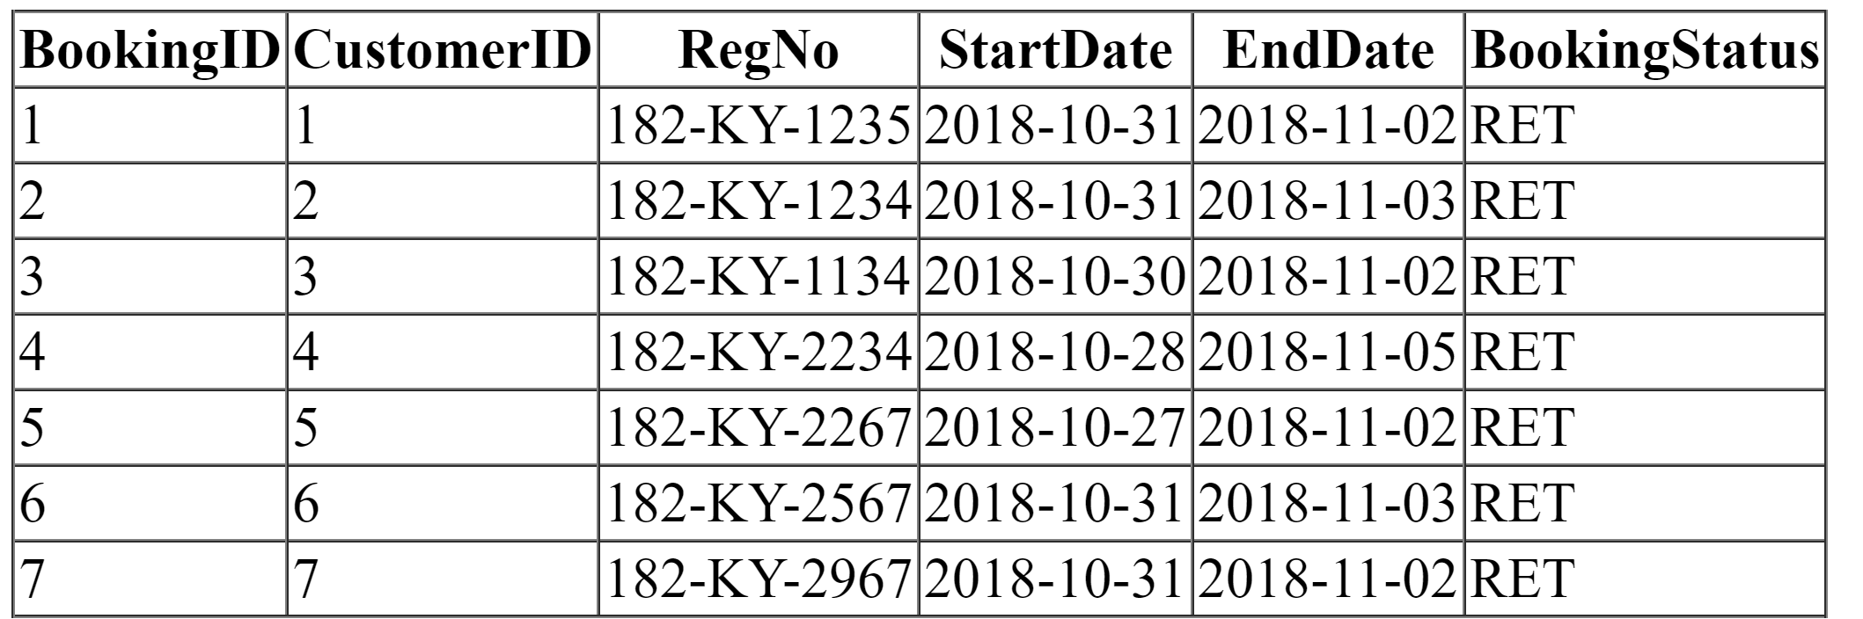

Cars Table:

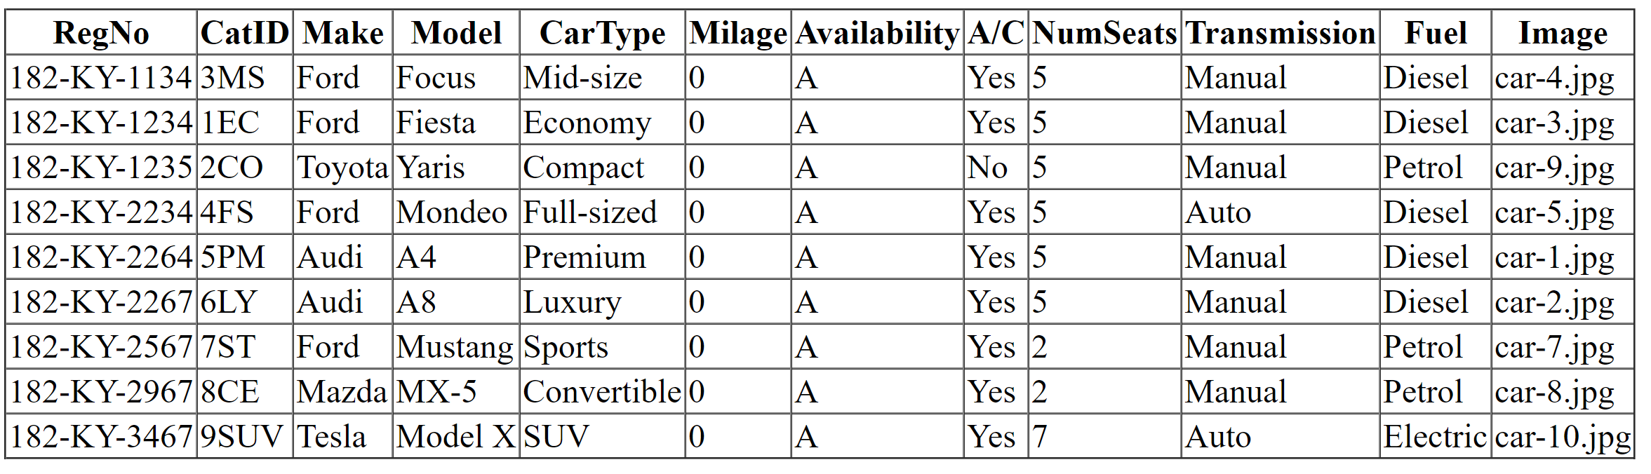

Categories Table:

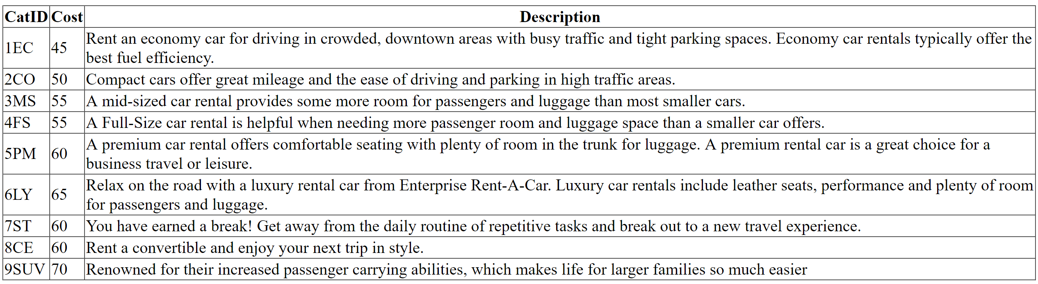

Customers Table:

