**Part 1: Creating Portfolio Database**

* Creating Portfolio table in the data_analytics_2020 database:

* Updating Portfolio’s primary key date attribute based on dates from GOOG table, then updating all stock close values based on aligning dates between the queried tables:

* Calculating cumulative return for each stock and updating the Portfolio table:

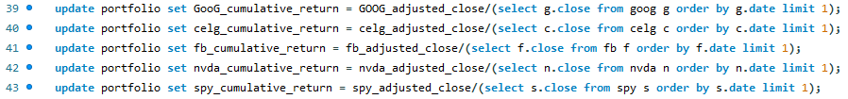

* Resulting Portfolio table in the data_analytics_2020 database:

**Part 2: Write Portfolio Simulation Function**

* Running the created simulation function on the input specified below:

* The result of the simulation on the Portfolio table:

Manually adjusting stock weights to improve Sharpe Ratio:

**Part 3: Write a portfolio optimization function:**

* Output of optimization function that takes into account all possible combinations of stock weights, and returns the combination of weights used to achieve the highest Sharpe Ratio:

* Resulting Portfolio table after running optimization function:

