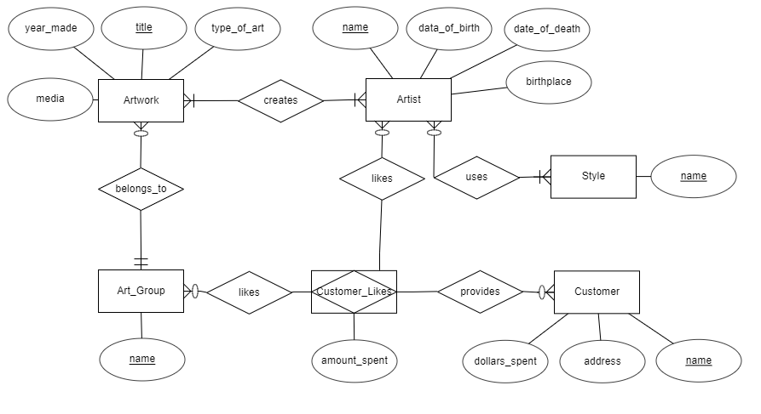

**Explanation:**

* A gallery keeps track of Artists, who have several described attributes, including a name that is unique, making it the primary key. In the prompt, it was described that Artists also have an age, however, the attribute date_of_birth is already included as an attribute, so it was determined age was redundant and could be removed. Besides these attributes, artists also have a date_of_death if applicable and a birthplace. Artists also have a style of art, of which they can have many. This is illustrated by a Style entity that is used by the Artist Entity. An assumption was made that each Style would have a unique name. Another assumption was made that Style is different from the type_of_art attribute, which is also different from Art_Group Entity. In addition, it was concluded an artist can have one or more styles, because they need to have one or more pieces of art to be an artist, and that piece, or pieces, of art would be example of some style. In addition, a Style can be used by many Artists, however, its not mandatory that they be used by any because a gallery may not currently have Artists in their database that use every Style. In addition to this, Artists create Artwork, which have a unique title, a year_made, a media, and a type_of_art attribute. This relationship is modeled by a mandatory many to a mandatory many. This is because to be considered an Artist, an Artist must create one of more pieces of Artwork. In addition, a piece of art must have at least one creator, but can also have many. Artwork also belongs to an Art_Group, which is identified by a unique name. It was concluded that each piece of art may belong to only one Art_Group, because even if a piece of art is a mix of art groups, then there should be a new unique Art_Group to describe that mixture. In addition, Each Art_Group can be used by many pieces of art, or none at all, because a gallery may not have a piece of art in their database for each Art_Group. Lastly, there are Customer entities, who have a unique name, an address, and a dollars_spent attribute for the amount of money that they have spent at the gallery. A Customer can like Art_Groups and Artists, this is shown by a ternary relationship using an associative entity which represents a table that would store this “like” information. This relationship table would include an attribute for the amount of money a Customer has spent on each Artist or Art_Group that they like. A Customer can like many Artists or none at all, and the same goes for Customers liking Art_Groups. Also, an Artist can have many Customers like them, or none at all, the same goes for Art_Groups being liked by Customers. For this ternary relationship, no quantity parameters were placed where “like” relationships connect to Customer_Likes. The reason for this is Customer_Likes merely represents a table for the relationship between the three linked entities, and is not an entity itself, so its relationship quantity info is not meaningful for this diagram’s purpose.