**Big Pharma Entity Relationship Diagram:**

­­ 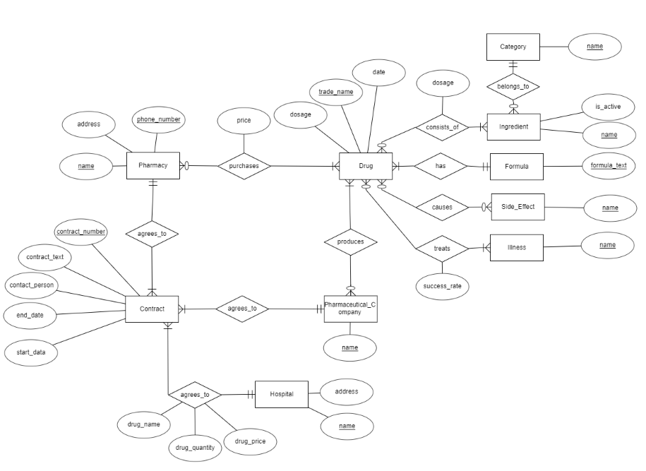

**ERD Explanation:**

**Drug Entity Explanation:**

* As a pharmaceutical company Big Pharma’s produces an array of drugs. To model this, there is a Drugentity. Each Drug has a unique *trade_name* attribute, a *dosage* attribute, and a *date* attribute. Drugs also have a Formula, which is shown by the *has* relationship a Drug has with a Formula. A Formula has a unique attribute *formula_text* which describes the Formula. Formal was decided to be its own entity as it was conveyed that different Drugs can have the same formula. So, to better show this possibility Formula was made as an Entity, where a Drug must have a single Formula, because that is what makes a given drug chemically unique, and where a Formula can belong to one or more Drugs, because if there is not a Drug associated with Formula, Big Pharma likely has no intentions of using that Formula so it serves little function to the database. Drugs also have Ingredients, this is shown by the *consists_of* relationship with the Ingredient entity. Where a Drug *consists_of*  one or more Ingredients, because otherwise there is no substance to the Drug, and an Ingredient can be used by zero or more Drugs, because Drugs can be a mixture of Ingredients but Big Pharma may also want to keep track of Ingredients that they aren’t currently using. This *consists_of* relationship has a dosage attribute because several Drugs may use the same Ingredient differently, and thus may have a different dosage of the same Ingredient. Ingredients also have a unique *name* attribute, and an *is_active* attribute. Furthermore, an Ingedient *belongs_to* a Category Entity. A Category has unique attribute, *name*, to identify the Category. An Ingredient must belong to a single Category, because an Ingredient is a single chemical that should be classifiable into a Category, and a Category can have zero or many Ingredients belong to it, because Big Pharma may keep track of many Categories where it may not have Ingredients in its database that belong to each Category at any given time. The Drug Entity also has a *causes* relationship with the Side_Effects Entity. The Side_Effect Entity has a unique *name* attribute to identify it. A Drug can cause zero or many Side_Effects, because while unlikely, a Drug can have no Side Effects, but could also have several. In addition, a Side_Effect entity could have a relationship with zero or many Drugs, because Big Pharma may keep track of Side_Effects that none of their current Drugs cause, but some of their Drugs could also produce the same Side_Effects. Lastly, a Drug is used to treat Illnesses. This is shown by a Drug’s *treats* relationship with the Illness entity. Where the *treats* relationship has an attribute *success_rate*  to measure the effectiveness of a Drug for a given Illness. This attribute was placed on the relationship because several drugs could potentially treat the same Illness, each with their own effectiveness in the treatment of that Illness. An Illness has a unique *name* attribute to identify it. A Drug can be used to treat one of more Illnesses, because if its not treating an Illness then it isn’t a Drug, and because Drugs can be used for several different Illnesses according to Big Pharma. Illnesses can be treated by zero or more Drugs, because Big Pharma may want to keep track of Illnesses even if it doesn’t offer a Drug that treats it at a given time, and because a single Illness can be treated by several different Drugs.

**Pharmacy Entity Explanation:**

* Big Pharma wants its database to keep track of Pharmacies that sells its products. This is shown by the Pharmacy entity, which has *name* attribute, an *address* attribute, and a *phone_number* attribute. The *name* combined with the *phone_number* uniquely identifies the Pharmacy, and this is shown by having both attributes underlined. A Pharmacy buys Drugs from Big Pharma. This is shown by the *purchases* relationship connecting Pharmacy and Drug. This relationship has a *price* attribute because the price can vary for the same Drug for Pharmacy to Pharmacy and even day to day. A Pharmacy *purchases* one or more Drugs, because if a Pharmacy is not buying a single Drug from Big Pharma, they should not be in the database. Also, A Drug can be purchased by zero or more Pharmacies, because a Drug may just be released and not have any Pharmacies buying it yet, but a single Drug can also be bought by many Pharmacies.

**Pharmaceutical_Company Entity Explanation:**

* Big Pharma produces its Drugs on its own, but also with the aid of other Pharmaceutical companies. To model this, there is the Pharmaceutical_Company entity, which has a unique *name* attribute to identify it. It has a *produces* relationship with Drug. A Pharmaceutical_Company can produce one or more Drugs, because if they didn’t *produce* any Drugs they wouldn’t be in the database, and because Pharmaceutical_Companies are capable of producing multiple Drugs. In addition, a Drug can be produced by zero or multiple Pharmaceutical_Companies, because Big Pharma may want to keep track of old Drugs that are no longer produced, and a Drug can be jointly produced by Big Pharma and another Pharmaceutical_Company. This last statement is an assumption made due to Big Pharma stating in their requirements that they want the ability to contract another Pharmaceutical company to produce a drug jointly, with this being interpreted as meaning that a single Drug could be produced by multiple Pharmaceutical_Companies, Big Pharma and another Pharmaceutical_Company. A final note about this entity is that Big Pharma itself would be an instance of a Pharmaceutical_Company so that they can keep track of what Drugs they produce.

**Hospital Entity Explanation:**

* Big Pharma also keeps track of Hospitals that it has a contract with. A Hospital has a unique *name*  attribute and an *address* attribute.

**Contract Entity Explanation:**

* Big Pharma needs to keep track of Contracts that it has with outside companies. This is conveyed by the Contract entity, which has unique *contract_number,* a *start_data*, an *end_date*, a *contact_person*, and the *contract_text*. Besides *contract_number*, Big Pharma’s requirements conveyed that those attributes were only required to be included for contracts with Pharmacies, however, when contracts with other Entities were described, minimal information was given so it was assumed that these attributes were a solid foundation for all of Big Pharma’s Contracts to use. Pharmacies have an *agrees_to* relationship with the Contract entity. Where each Pharmacy can have one or more Contracts, because a Pharmacy must have a Contract with Big Pharma to purchase Drugs, and a single Pharmacy can have multiple Contracts. In addition, a single Contract can only be used by one Pharmacy because each Contract is made unique for each Pharmacy and each Contract instance. Hospitals also have an *agrees_to* relationship with the Contract entity. This relationship has a *drug_name* attribute, a *drug_quantity* attribute, and a *drug_price* attribute. These attributes were defined at the relationship level because in Big Pharma’s requirements, these attributes were only described to be relevant to a Contract with Hospitals. In this relationship, a Hospital can have one or more Contracts, because if they don’t have a Contract they don’t contribute to the database, and also because Hospitals can have many Contracts per Big Pharma’s requirements. In addition, a Contract must have exactly one Hospital associated with it because each Contract is made unique for a given situation and a Hospital. Lastly, a Pharmaceutical_Company has an *agrees_to* relationship with a Contract. In Big Pharma’s requirements few details were given about the Contracts with Pharmaceutical_Companies, so it was assumed that the general Contract described for Pharmacies would store sufficient detail. A Pharmaceutical_Company can *agree_to* one or more contracts, because without a contract the Pharmaceutical_Company cannot produce Drugs, and because there is no limit to the number of Contracts a Pharmaceutical_Company can *agree_to*. The only issue with this constraint is that Big Pharma itself is an instance of the Pharmaceutical_Company entity, as such a default Contract will have to be used in this instance to meet the Contract quantity constraint. Also, a single Contract is associated with exactly one Pharmaceutical_Company because Contracts are made unique for each Contract instance and each Pharmaceutical_Company.