**Downloading Visual Studio Code**

**What is it and why are we using it?**

* **VSCode** is a powerful code editor that supports multiple programming languages and offers a wide range of extensions for customizable functionality.
* It is particularly useful for beginners due to its **user-friendly interface, built-in debugging tools, and integrated terminal**, which make it easy to learn and manage code. Additionally, it provides a consistent platform for users on **different operating systems,** such as macOS and Windows.

**Let’s Download it**

**Step 1:** Open web browser. Visit official Visual Studio Code website or click the link

<https://code.visualstudio.com/download>

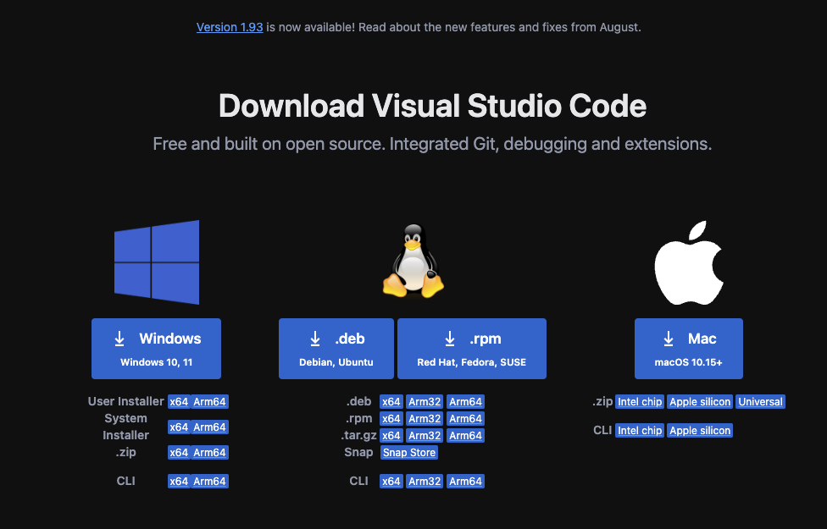**Step 2**: Select specific operating system downloader package (Windows, macOS, or Linux).

**Step 3**: Extract files. Double click on zipped files.

**MacOS Windows**

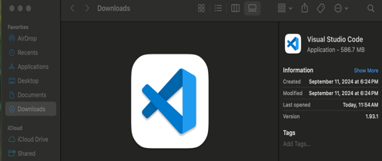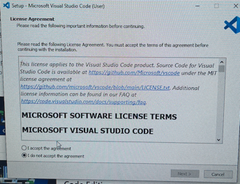

Step 4: Launch Application.

* Should appear as such. **WINDOWS USERS** notice you are capable of alternating between command line shells by clicking on the drop down next to the +. This will allow you to alternate from powershell to the gitbash shell.

