**Downloading GitBash for Windows Users**

**\*For this class all Window users must download gitbash to operate within a bash command line\***

1. **Bash Shell for Windows**

Git Bash provides the Bash shell (Bourne Again Shell), which is a popular Unix/Linux shell. For developers used to Linux or macOS, Git Bash offers an environment similar to what they're familiar with, bringing Unix-like command-line utilities (like ssh, scp, ls, grep, etc.) to Windows.

**How to Download:**

* **Search GitBash for windows in search browser or click this link.** <https://gitforwindows.org/>

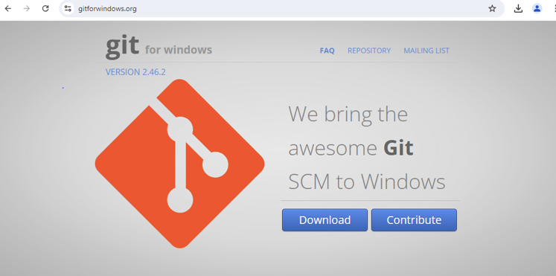

* **Install the git downloader package.**

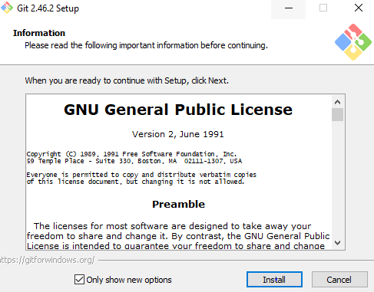

* **Launch Git Bash Application. Search for the GitBash application using the windows search bar. Double click on the Gitbash application.**

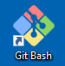

* **Terminal should appear as such. Double check everything works as expected.**

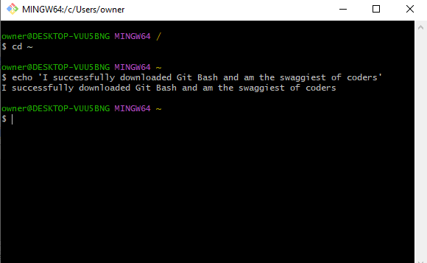

**Great! May the Bash terminal be with you, and may your code always avoid the dark side!**

