**NIGERIA IMMUNIZATION**

**DIGITAL ADAPTATION KIT**

**Draft Version 1.0**

**January 2025**

# Table of Contents

**Table of Contents 2**

**Acronyms and Abbreviations 4**

**Introduction to the Nigeria Immunization Digital Adaptation Kit 5**

**Notation Guidance 6**

Component 1: Health interventions and recommendations 6

Component 2: Generic personas 6

Component 3: User scenarios 6

Component 4: Business processes and workflows 6

Component 5: Core data elements (Data dictionary) 6

Component 6: Decision-support logic 7

Component 7: Indicators and performance metrics 7

Component 8: Functional and non-functional system requirements 7

1. Health Interventions and recommended interventions 8

1.1 List of interventions referenced in this DAK based on WHO Universal Health Coverage List of Interventions and Nigeria’s Immunization Schedule 8

1.2. Nigeria and global guidelines, recommendations, and guidance 10

1.3. Intended Audience and Reading Suggestions 10

**2. PERSONAS 11**

2.1. User Personas 11

**3. USER SCENARIOS 16**

3.1. User scenario for Routine Immunization 16

3.2. User scenario for Defaulter Tracking 18

3.3. Catch-up Vaccination 19

3.4. Report Generation 21

3.5 Contraindication 22

3.6 AEFI 23

3.7. HIV client Immunization 24

3.8 Stock Management 25

**4. BUSINESS PROCESSES & WORKFLOWS 28**

4.1. Business Processes 28

4.2. Workflows 38

A. Health Facility Registration 38

B. Plan Service delivery 39

C. Client registration 40

D. Vaccine administration 41

E. Manage and report AEFIs 42

F. Client reminder 43

G. Defaulter tracking 44

**5. CORE DATA ELEMENTS 48**

**6. DECISION SUPPORT LOGIC 49**

6.1. Decision Support Logic Overview 49

6.2. Decision-support Tables 53

**7. INDICATORS & PERFORMANCE METRICS 56**

**8. FUNCTIONAL & NON-FUNCTIONAL REQUIREMENTS 57**

8.1. Functional Requirements 57

8.2. Non-Functional Requirements 66

**APPENDIX: 75**

2.1. National, State, and LGA User Personas 75

# 

# 

# 

# Acronyms and Abbreviations

| **No** | **Acronym** | **Meaning** |
| --- | --- | --- |
| 1.. | AEFI | Adverse event following immunization |
| 2. | BCG | *Bacille Calmette-Guérin* |
| 3. | DAK | Digital Adaptation Kit |
| 4. | DPT | Diphtheria, Pertussis, Tetanus |
| 5. | EIR | Electronic Immunization Registry |
| 6. | EPI | Expanded Program on Immunization |
| 7. | FMoHSW | Federal Ministry of Health and Social Welfare |
| 8. | Hep B | Hepatitis B Vaccine |
| 9. | HPV | Human Papilloma Virus |
| 10. | IPV | Inactivated Polio Vaccine |
| 11. | NPHCDA | National Primary Healthcare Development Agency |
| 12. | OPV | Oral Polio Vaccine |
| 13. | SMART | Standards-based, Machine-readable, Adaptive, Requirements-based, Testable |
| 14. | SRS | Software Requirements Specification |
| 15. | WHO | World Health Organization |

# Introduction to the Nigeria Immunization Digital Adaptation Kit

This Digital Adaptation Kit is part of the WHO [SMART Guidelines](https://www.who.int/teams/digital-health-and-innovation/smart-guidelines) and includes data and health content and is generically applicable to digital systems. The contents are software-neutral, operational, and structured documentation intended to systematically and transparently inform the design of digital systems for immunization in Nigeria.

Components include:

1. Linked  health interventions and recommendations
2. Generic personas
3. User scenarios
4. Business processes and workflows
5. Core data elements mapped to standard terminology codes
6. Decision support
7. Programme indicators
8. Functional and non-functional requirements.

| Notation Guidance Throughout this DAK, there are identification (ID) numbers to simplify tracking and referencing  of each of the components. Note that the DAK represents an overview across the different  components, while the comprehensive and complete outputs of each component (e.g. data  dictionary) are included in appended spreadsheets. The notation guide is as follows; **Component 1: Health interventions and recommendations**  No notations used. **Component 2: Generic personas**  No notations used. **Component 3: User scenarios**  No notations used **Component 4: Business processes and workflows** Each workflow should have a “Process name” and a corresponding letter   * Each workflow should also have a “Process ID” that should be structured as an “Abbreviated health domain” (e.g. IMMZ). “Corresponding letter for the process” (e.g. A) * Each activity in the workflow should be numbered with an “Activity ID” that should be structured as “Process ID” from above “Activity Number” e.g.IMMZ.A1  **Component 5: Core data elements (Data dictionary)** Each data element should have a running number and a “Data Element (DE) ID” that should be structured “Abbreviated health domain” (e.g. IMMZ).“DE”. “Sequential number of the data element” (e.g. IMMZ.C.DE5, IMMZ.C.DE4) **Component 6: Decision-support logic** Each decision-support logic table should have a running number and a “Decision-support table  (DT) ID” that should be structured “Abbreviated health domain” (e.g. IMMZ).“DT”.  “Sequential number of the decision-support table” (e.g. IMMZ.DT.1, IMMZ.DT.2). **Component 7: Indicators and performance metrics** Each indicator should have an “Indicator ID” that should be structured “Abbreviated health domain”  (e.g. IMMZ).“IND”. “Sequential number of the indicator”(e.g. IMMZ.IND.1, IMMZ.IND.2) **Component 8: Functional and non-functional system requirements** Each functional requirement should have a “Functional requirement ID” that should be  structured “Abbreviated health domain” (e.g. IMMZ).“FXREQ”. “Sequential number of the  functional requirement”(e.g. IMMZFXREQ.1, IMMZ.FXREQ.1).  Each non-functional requirement should have a “Non-functional requirement ID” that should be structured “Abbreviated health domain” (e.g. IMMZ). “NFXNREQ”. “Sequential number of non-functional requirements” (e.g. IMMZ.NFXNREQ.1, IMMZ. NFXNREQ.2). |
| --- |

## 

## **Health Interventions and recommended interventions**

### **1.1 List of interventions referenced in this DAK based on WHO Universal Health Coverage List of Interventions and Nigeria’s Immunization Schedule**

Interventions referenced in this DAK are based on Nigeria’s Immunization Schedule and WHO’s Universal Health Coverage List of Essential Interventions.

* General vaccine administration practices for all age groups, including children, include:
  + Counseling on the vaccine(s) to be administered (Health Talk)
  + Documentation on vaccinations received as captured on the Child Health Card
  + Documentation and report on immunizations administered
  + Observe for any adverse event following immunization (AEFI)
  + Targeted history and physical examination for vaccination
  + Defaulter tracking
  + Follow-up visit(s)
* Vaccinations in the [Nigeria immunization schedule](https://www.unicef.org/nigeria/media/9911/file/Nigeria%20Immunization%20Schedule.pdf.pdf)  include:

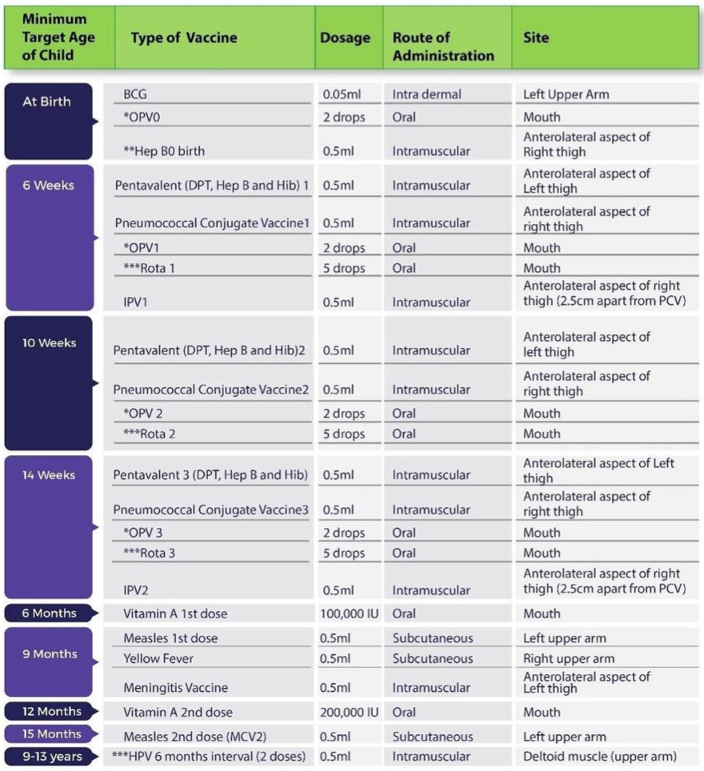

**Note:** The components of this DAK only includes content for childhood routine immunization in Nigeria. Non-routine adult vaccinations and campaigns are not included in this DAK.

## **1.2. Nigeria and global guidelines, recommendations, and guidance**

The interventions outlined in this DAK draw from Nigeria’s national immunization guidelines and recommendations where available, and default to WHO’s guidelines where not explicitly defined for Nigeria. The following guidance documents were referenced:

1. [WHO Recommendations For Routine Immunization](https://www.who.int/teams/immunization-vaccines-and-biologicals/policies/who-recommendations-for-routine-immunization---summary-tables)
2. [Nigeria Immunization Schedule](https://www.unicef.org/nigeria/media/9911/file/Nigeria%20Immunization%20Schedule.pdf.pdf)
3. [Basic Guide On Routine Immunization For Service Providers In Nigeria](https://drive.google.com/open?id=1vMEqb5A3YaSkn_Tl4tnzzqsRIMSvojsS)
4. Draft National Immunization Policy
5. Child health immunization card
6. Immunization registers in Nigeria
7. Immunization tally sheets in Nigeria
8. National Vaccine Policy
9. Nigeria Strategy for Immunization and PHC strengthening 2018- 2028
10. Nigeria National Digital Health Information (DHI) for Immunization and PHC Roadmap (2023-2027)
11. Surveillance of Adverse Events Following Immunization (AEFI), Field guide, 2011

## **1.3. Intended Audience and Reading Suggestions**

The intended audience for this document includes business analysts, routine immunization program managers, software developers, and other project members responsible for designing and adapting digital workflows for immunization in Nigeria. It is intended to clearly outline Nigeria's immunization business process for digital system development, upgrade, maintenance, and training. The document also outlines the functional and non-functional requirements that will be used to verify that the developed system functions as intended.

# 2. PERSONAS

A persona is a depiction of a relevant stakeholder or “end-user” of the system. In this section, the goal is to provide a clear depiction of the end-users, supervisors, and related stakeholders who would be interacting with the digital system or involved in the care pathway.

The personas were derived from the Basic Guide on Routine Immunization for Service Providers in Nigeria and the global [Digital Adaptation Kit for Immunization](https://iris.who.int/bitstream/handle/10665/380303/9789240099456-eng.pdf?sequence=1). It was further refined to reflect Nigeria by identifying the real user personas during the requirements gathering workshop.

## **2.1. User Personas**

| **Occupational Title** | **Description** | **Other Names** | **ISCO Code** |
| --- | --- | --- | --- |
| **NATIONAL** | | | |
| FMoHSW data users | Leads and coordinates insights-driven policy decision making with data from all the states in the country. National-level policy makers at FMoHSW (Please see appendix for full list and responsibilities) | Head of M&E, DHPRS program officers | 1112 |
| NPHCDA data users | Coordinates data-driven Routine Immunization activities. National-level policy and operational decision makers at NPHCDA (Please see appendix for full list specific roles and responsibilities at NPHCDA that will use this designation) | Head of RI, DCI program officers | 1342 |
| **STATE** | | | |
| SMoH health data users | Use insights to make public health decisions at the state level. State-level policy makers at SMoH (Please see appendix for full list roles and responsibilities) | State HMIS Officer |  |
| SPHCDA health data users | State Primary Healthcare Development Agency (SPHCDA) stakeholders. Use insights to make immunization decisions at the state primary healthcare level | State M&E officer |  |
| State Immunization Officer | Responsible for immunization communication and mobilization; management of logistics, the cold chain and vaccines; monitoring, supervision, and evaluation of immunization services; and coordination of EPI activities at the national and subnational levels. | Program Manager/Coordinator, EPI Managers |  |
| **LGA** | | | |
| LGA health data users | Responsible for generating and interpreting data insights from health facilities, ensuring summaries are of good quality in the national repository. Conduct targeted supportive supervision. (see appendix for list of all users) | HoD Health, LIO, LGA CCO, LGA M&E etc. |  |
| **HEALTH FACILITY** | | | |
| Routine Immunization Service Provider | The RI service providers plan sessions, register clients, provide health talks, counselling, vaccinate, record, and provide other services to clients. Conduct outreaches as appropriate. They identify, treat, and report AEFI. AEFI reporting and treatment. Vaccine management at the facility. Etc. | RI Focal Person, [Registered Nurse, Midwife Nurse, CHEW, JCHEW, Healthcare Worker] | 3221 |
| Officer In Charge (OIC) | Provide oversight and ensure resources are available, and oversee and supervise RI processes. Supervise data harmonization and validation. Facilitate higher level reporting. Attend Technical and harmonization meetings. Lead defaulter tracking and reporting. Responsible for surveillance at the facility. Vaccine management | Head of facility, |  |
| Health Information Officer | Reviews monthly aggregate data in summary sheets format and ensure submission to LGA M&E. and other data reports | Medical record officer, |  |
| Community Health Worker | Provide health education, referral and follow up, case management, and basic preventive health care and home visiting for defaulter tracking to specific communities. | CHEW, JCHEW, Volunteers | 3253 |
| System administrator | A System Administrator at the health facility level helps to assign roles as appropriate to resources in the EIR to team members.. | IT manager, Technical support staff, OIC | 2522 |
| Caregiver | This can be the mother, grandmother, father, guardian, carer of the child, infant, elderly, or disabled person. | Parent, Grand Parent, Guardian, Siblings | N/A |
| Client | The person who intends to receive vaccination services from the targeted health worker personas. A client who is 17 years of age or younger is considered a child | Infant, baby, child | N/A |

**Description of settings:**

| **Setting Title** | **Description** | **Different names** | **ISCO code** |
| --- | --- | --- | --- |
| Health Facility | Designated location where vaccinations are administered to individuals.  These sites are established and operated by healthcare organizations, government agencies, or other entities involved in public health efforts.  Health Facilities can vary in size and setup. A health facility can be public or private, and can be either a primary, Secondary, or Tertiary level health facility. A healthcare facility may have multiple vaccination locations under it. | Teaching Hospital, General Hospital, Comprehensive Health Center, Primary Health Clinic, Health post, | N/A |

# 

# 

# 3. USER SCENARIOS

User scenarios are narratives that describe how the different personas may interact with each other and are intended to give an illustrative idea of a typical workflow. This section is intended to provide an understanding of how the system would be used, and how it would fit into existing workflows.

## **3.1. User scenario for Routine Immunization**

| **Key Personas** | * Caregiver (mother): Juliet * Child: Ann * Health worker: Lucy |
| --- | --- |
| Juliet, a 21-year-old mother, lives in Ozuala, , a community in SouthEast Nigeria with her husband and their 6-weeks-old daughter, Ann. Despite having only completed primary school, Juliet is deeply committed to ensuring Ann’s health and well-being.  Ann was born at home, and her birth was not registered. Juliet took Ann to the local clinic shortly after birth for birth vaccines. At the Clinic, Juliet joins other waiting mothers at the waiting area, and briefly, Lucy, the RI service provider, walks in and delivers the Health Talk. After which, Juliet and other mothers queued for registration and child vital signs, recorded on the health card by Lucy.Ann was assessed and deemed eligible for vaccination. Lucy assigned Ann a unique identification number and issued Ann a child health card. She inputs Ann’s details including biodata, residential address, number of mother’s other children, vaccine schedule, weight and height. Lucy then administered the following vaccines: BCG 0.05ml intradermal, 2 drops of OPV1 orally, 0.05ml Penta 1, PCV1, IPV1, and Rota1 intramuscular and recorded on the child health card the date of administration, batch number and date for next visit. Lucy then observed Ann for adverse events following immunization for five-ten minutes and discharged Juliet afterwards with a reminder for the next visit date.  Four weeks later, Juliet reviews the child health card and sees that Ann is due for the 10-weeks vaccine. The clinic is over an hour’s walk from Juliet’s home. Despite the distance, Juliet appreciates the journey as it allows her to meet other new mothers and learn from the HealthTalk by the RI service provider.  The following morning, Juliet sets out with Ann to visit the clinic, arriving just after 9 a.m. The small waiting area is filled with other mothers and their children. Juliet takes her seat, holding Ann close as she waits for her turn. After the HealthTalk, it was her turn for vital signs and vaccination, Juliet then hands over Ann’s child health card to Lucy. Lucy takes the card and logs into the clinic’s Electronic Immunization Registry (EIR) on her tablet.  Using the unique ID from the card, Lucy retrieves Ann’s digital immunization record from last visit. She then reviews it alongside the child health card and confirms that Ann is due for Penta 2, PCV 2, OPV2, and Rota 2 , vaccines that day. Before proceeding, Lucy weighs Ann on the clinic’s scale, carefully noting her weight. She records this information in both the vaccine card and the EIR, remarking that Ann’s weight gain is on track. She also takes time to address Juliet’s questions about breastfeeding and reassures her about Ann’s growth.  Lucy then prepares the vaccines. She opens the giostyle, vaccine carrier, which she had stocked earlier that morning, and carefully checks the expiration dates, VVMs, and labels on each vial. Confident in their safety, she begins administering the vaccines. Ann receives oral doses first, followed by injections. Juliet comforts Ann as Lucy completes the process.  After the vaccinations, Lucy updates Ann’s digital record in the EIR and documents the details in the child health card. She explains to Juliet the importance of tracking both records to ensure continuity of care. Lucy then discusses the next steps, noting the date of Ann’s next immunization. She writes this information on the child health card and advises Juliet to aim for the suggested date, reassuring her that arriving within a day or two is still acceptable. Lucy also explains how to manage mild side effects, like fever, that Ann might experience after the vaccines. As a final step, Lucy tells Juliet that she will get a reminder notification a day before the due date for the upcoming vaccinations.  Feeling reassured by Lucy’s guidance and support, Juliet leaves the clinic with Ann. She is confident in her ability to care for her daughter and is grateful for the well-organized services that help her keep Ann healthy. The clinic’s integrated system ensures that Ann’s immunization schedule is well-documented, and the SMS reminders will help Juliet stay on track for future visits. | |
| **Business Processes** | * Registration * Administer vaccine * AEFI monitoring * Client reminder |

## **3.2. User scenario for Defaulter Tracking**

| **Key Personas** | Health worker: Lucy  Community health worker: Susan  Client: Ann  Caregiver: Juliet |
| --- | --- |
| Lucy, the OIC responsible for the under-5 clinic , is also tasked with ensuring that all children in her clinic’s catchment area are vaccinated. The estimated number of children is derived from the population served by her clinic, the only healthcare facility in the ward. To achieve her goal, Lucy collaborates closely with Susan, a respected community health worker.  The introduction of the EIR has significantly reduced Lucy’s administrative burden. Previously, she spent hours each week manually reviewing the paper immunization register and tally sheets to identify children who were overdue for vaccinations, calculating their status based on recorded dates.  Every end of the month, Lucy generates a list of defaulters from the system. She sends this list to Susan via SMS. Susan does defaulter tracking in her catchment area. In her list, Ann who was due for her 14 weeks vaccine, is first on the list.  She finds the location and phone number of Juliet, Ann’s mother from the list. She knows the location well and finds her way to Juliet’s house. She finds Juliet bathing Ann and confirms Juliet’s identification. Susan introduces herself and the reason for her visit.  Juliet warmly welcomes her and offers her a seat. She explains to Susan that she had travelled and did not remember to take Ann to the facility for her routine immunization. Susan emphasizes the importance of immunization on the child’s health and encourages Juliet to visit the health facility the next morning. Juliet agrees to take Ann to the facility as she bids Susan goodbye.  The next morning, Juliet takes Ann to the facility where Ann receives her immunization. Lucy updates her records and Ann’s name is taken off the defaulter list. | |
| **Business Processes** | * Defaulter tracking * Report generation |

## 

## **3.3. Catch-up Vaccination**

| **Key Personas** | LIO: Mrs Sade  RI Service Provider: Ms. Lydia  Community health worker: Mr. Abubakar Caregiver: Ms. Martha  Client: Happiness |
| --- | --- |
| Mrs. Sade has been serving as the Local Immunization Officer (LIO) in Lagos state for the last decade. In her role, she is responsible for planning and overseeing the immunization programs at all the facilities within Alimosho LGA . She supports these facilities, reviews data, and ensures that the programs are running efficiently. Mrs. Sade regularly monitors the monthly immunization reports submitted by each facility, looking for potential issues such as inaccurate data, low vaccine coverage, or vaccine stockouts that may disrupt the clinics' operations. She also keeps track of the target population of children in the LGA and maps where these children are located. Recently, Mrs. Sade noticed that the polio vaccination coverage was significantly lower than expected across several facilities.  During a workshop last month, Mrs. Sade and other LIOs were informed about a national initiative to conduct RI intensification activities to address this issue. These immunization activities were planned to be larger in scope due to the significant number of overdue vaccinations. While the LGA had previously carried out smaller RI intensification activities, such as during Child Health Week or Immunization Days, these activities were expected to be more extensive. Mrs. Sade’s task was to adapt the national plan for her LGA, manage the budget, and supervise the implementation of the RI intensification activities. She worked closely with various stakeholders to coordinate activities, while also ensuring that the community was engaged and well-informed about these activities.  Ms. Lydia and her team designed a vaccination strategy that included both fixed posts and outreach vaccination teams to reach urban and rural areas across Alimosho LGA of Lagos state. The goal was to vaccinate all children under five years old in the affected areas within three weeks. To ensure that the community was fully aware and engaged, community health workers and healthcare providers held town hall meetings, distributed flyers, and conducted radio broadcasts. These efforts helped explain the importance of the polio vaccination and address concerns and misconceptions, using endorsements from trusted local leaders and healthcare professionals to build confidence in the vaccine.  In preparation for the campaign, the National Primary Health Care Development Agency (NPHCDA) provided healthcare workers with training on vaccine administration, cold chain management, and accurate data recording. Vaccines were distributed to health centers and outreach teams, ensuring that the cold chain was maintained from the national storage facility to local sites.  The campaign kicked off with a highly publicized launch event, after which both fixed and outreach vaccination posts began administering the oral polio vaccine (OPV). Healthcare workers visited households, schools, marketplaces, bus stations, and remote villages to ensure that no child was left unvaccinated. Vaccination teams used the Electronic Immunization Registry (EIR) to record data in real time, allowing for immediate monitoring and adjustments as needed.  Mr Abubakar, a community registered worker, was one of the healthcare providers involved in the immunization campaign. During a visit to Igboland village, he met Martha, the mother of a 2-year-old girl named Happiness. Mr Abubakar explained the ongoing polio vaccination campaign to Martha, who was already aware and gave her consent to vaccinate Happiness. When Mr Abubakar searched for Happiness’s record in the EIR using her details, he could not find it. Martha, however, showed Mr Abubakar the child’s vaccination history in the child health card, confirming that Happiness had already been vaccinated. Mr Abubakar then registered Happiness in the EIR, updated her immunization record, administered the oral polio vaccine, and saved the data.  The healthcare providers continued with the immunization efforts over the course of the next three weeks. At the end of the campaign, they returned all data tools and equipment to the health centers. LGA healthcare authorities conducted post-vaccination surveillance to monitor for any adverse events and verify that the RI intensification activity coverage targets had been met.  Ms. Lydia and her team conducted an evaluation of the campaign's success based on the vaccination coverage data and the containment of the polio outbreak. A detailed report was compiled, highlighting the outcomes and lessons learned from the campaign. | |
| **Business Processes** | * Catch-up campaign * Report generation |

## 

## **3.4. Report Generation**

| **Key Personas** | State Immunization Officer- John |
| --- | --- |
| John is the FCT Immunization Officer. He is 35 years old and has a university degree in management. He has been the state Immunization officer for the last 6 years. John is responsible for planning, supervising, supporting and conducting data reviews of all the LGAs in his state He closely monitors the monthly reports that each LGA sends and looks for potential issues that may require his attention, such as inaccurate data on the reports or situations where the overall immunization coverage in a LGA may be lower than their targets, or if they have had times where they do have vaccine stockouts. John is also responsible for keeping track of the target population of children in his state and a sketch map of where that population is found. FCT, like the rest of the country, has had significant challenges due to the COVID-19 pandemic. Many parents/caregivers did not bring their children for their routine vaccinations for fear of contracting COVID-19. As a result, John has noticed their coverage rates for most vaccines are much lower.  John logs in to EIR with his credentials to generate monthly vaccination reports for his state. He generates the reports and during the analysis, he realizes there are still many children who are overdue for their vaccines.  John shares the report with his and colleagues at the LGAs and plans for targeted local outreach activities(state outreach days, RI intensification, etc) as part of a coordinated national plan to address this issue. John and his team have conducted these outreach sessions previously, typically one or 2 times a month during Maternal and Child Health Week events or Routine Immunization Intensification Days. Since this campaign will be larger due to the number of overdue vaccines, the National Primary Health Care Development Agency (NPHCDA) is working with other partners to offer additional support. John has the responsibility to review the plan made by the NPHCDA for the campaign in his state, monitor and supervise the implementation of the targeted activity. John works closely with stakeholders (coordination) and the community (communication) to implement the state immunization plans. | |
| **Business Processes** | * Report generation |

## **3.5 Contraindication**

| **Key Personas** | * Caregiver (mother): Chioma * Child: Favour * Health worker: Obi |
| --- | --- |
| Chioma is a hardworking 30-year-old businesswoman. Her child, Favour, is due for the 14-week vaccination. She wakes up early to prepare Favour for her clinic then rush back to her business. If she is late for the clinic, there will be a long queue, and Chioma does not wish to spend her day at the clinic.  At the health facility, she finds 2 mothers in the queue. She finds a seat and waits for her turn. Before long, it is Favour’s turn. Favour’s vaccination card was screened to determine what vaccines she is eligible for. As she prepares Favour for her vaccination, Obi asks her if Favour had any reaction after the last vaccination. Chioma casually mentions to Obi that after the last two vaccinations, Favour had a severe rash on her leg and Chioma had to rush her to the nearest private clinic.  Obi reassured her and documented it in the AEFI form, he also counselled Chioma that in the event of subsequent reactions, she should bring the child immediately back to the health facility for proper management and documentation. Obi administered the Penta 3, IPV2, Rota 3, PCV 3, OPV 3 antigens, updated Favour’s child health card, documents in the relevant data tools and reminds Chioma of the next visit.  Chioma is done with the clinic visit and leaves satisfied to attend to her business. | |
| **Business Processes** | * Register * Contraindicate |

## **3.6 AEFI**

| **Key Personas** | * Caregiver (Mother); Hauwa * Child: Aisha * Immunization Officer: Zainab * Community health worker: Blessing |
| --- | --- |
| It's a humid Wednesday afternoon, and Zainab has just finished vaccinating a group of infants when a distressed mother, Hauwa, rushes in carrying her 9-month-old daughter, Aisha. The baby received the Measles 1, MenA and Yellow fever vaccines a few hours before and now has a high fever and won't stop crying. Hauwa explains that Aisha has been unusually irritable and developed some swelling at the injection site.  Zainab quickly noticed that the baby's right arm where she received the Yellow Fever vaccine injection was swollen and red, and felt very hot to the touch. The facility's only working thermometer showed 39.5°C. This is clearly an adverse event following immunization (AEFI) case  Drawing from her experience, Zainab first tries to calm Hauwa while conducting a quick assessment. She notices that despite the fever and swelling, Aisha is still alert and taking breast milk.  She gives Aisha paracetamol. This is the only medication available and she knows Hauwa does not have money to go to the nearest referral health facility which is 30 kilometers away. She gets information of where she lives to give to the community health worker to visit her at home the next day. She provides counseling to Hauwa on the management of the symptoms and reassures her that she did the right thing in coming to the health facility to report.  Zainab asks for the child's immunization card only to discover that Hauwa, in her panic, left it at home. Zainab used the Immunization register to confirm Hauwa’s last clinic visit and the batch number of the vaccine administered - crucial information for AEFI reporting.  In the facility's AEFI forms (reporting and line listing), Zainab documents everything she observes: Onset of symptoms, current temperature, size of injection site swelling, baby's alertness level.  Hauwa goes home and the next day the community health worker does a home visit. She finds Aisha’s fever has subsided and the swelling has also decreased. | |
| **Business Processes** | * Registration * AEFI reporting and Line listing |

## **3.7. HIV client Immunization**

| **Key Personas** | * Caregiver (Mother); Mrs. Adekunle * Child: Tunde * Routine Immunization Officer: Bola |
| --- | --- |
| It's Monday morning when Mrs. Adekunle quietly approaches Bola's immunization desk after most other mothers have left. She whispers Tunde is 9months, HIV positive and is due for the yellow fever vaccine.  Bola pulls her aside and asks for Tunde’s child immunization card. She reviews Tunde's growth chart and notices he's been growing well. She looks for any signs of illness or severe thrush. Her assessment of Tunde shows that he is asymptomatic hence she can safely administer the vaccines. If Tunde had shown any HIV symptoms, then the yellow fever vaccine would not have been administered. Bola administered Yellow fever, and other co-administered vaccines at 9 months (Measles, and MenA).  She records in the immunization register, tally sheet and the child health card as she reminded Mrs Adekunle of the importance of keeping to the immunization schedule and advises her to always mention Tunde's HIV exposure status to healthcare workers.  Mrs.Adekunle is happy with the advice and promises to do her best. | |
| **Business Processes** | * Registration * Administer vaccine |

## 

## **3.8 Stock Management**

**NOTE:** This scenario is not scheduled for implementation at this stage. It has been included for reference to help stakeholders familiarize themselves with the workflow, and may be considered for future development.

| **Key Personas** | Healthcare Worker- Mrs Mariam  LGA Cold Chain Officer - Mr Kunle |
| --- | --- |
| Mrs Mariam is a healthcare worker in the Bungudu health facility in Zamfara State.  During her weekly stock inventory, she notices that the pentavalent vaccine is below the minimum stock level.  She needs to order the vaccines from the LGA cold store. She fills in the vaccine requisition voucher, capturing the vaccine, the devices and the quantity needed. She sends the voucher to the LGA cold store and monitors the vaccine status in her health facility.  At the LGA cold store, Mr Kunle is the LGA Cold Chain Officer in Bungudu LGA. He received the vaccine requisition voucher from Gidan Goro health facility. After confirming that the vaccines and devices are available, he approves the order. He fills in the vaccine ledger indicating the vaccines, devices, and quantities released.  Mrs Mariam, on the other hand, receives the vaccines and devices at the LGA Cold store. She fills in the remaining columns of the vaccine requisition voucher indicating the vaccine name, batch number, expiry date and the manufacturing company. | |
| **Business Processes** | * **Stock Management** |

**Table 1: *Interpretation of the routine vaccination***

| **Data Elements to be collected** | **Decision Logic to be embedded** | **Functional and non-functional requirements** |
| --- | --- | --- |
| * Unique ID * Name * Date of birth * Vaccine given * Date vaccine given * Weight | * Determine what vaccines are due at this time (taking into account, the last vaccine date, client’s age, and national vaccine schedule) * Determine if weight is appropriate for age based on standardized growth charts (age calculated by date of birth) * Determine when the next vaccines are due (taking into account, the last vaccine date, and the national vaccine schedule) * Determine if the due date of the vaccine is within a few days | * Ability to automatically generate SMS messages based on trigger events * Indicate consent to receive reminders * Indicate dissent to receive reminders if the default is to receive reminders and there is an opt-out option * Send reminders only to those who have given consent |

**Table 2: *Interpretation of the defaulter tracing***

| **Data Elements to be collected** | **Decision Logic to be embedded** | **Functional and non-functional requirements** |
| --- | --- | --- |
| * Catchment area population (entered by system admin) * Name * Date of Birth * Sex * Parent/contact name * Parent/contact phone number * Address/Location * Vaccine given * Vaccine given date | * Determine which vaccines are due at this time (taking into account, the last vaccine date, client’s age and national vaccine schedule) * Determine any vaccine past due (by more than a set number of days) | * Generate a list of children due (or overdue) for a specific vaccine within a specific time frame * Generate a list of children due (or overdue) for a specific vaccine within a specific catchment area * Send list of defaulters to the specific phone number associated with the catchment area * Ability to automatically generate SMS messages based on trigger events |

**Table 3: *Interpretation of catch-up campaign***

| **Data Elements to be collected** | **Decision Logic to be embedded** | **Functional and non-functional requirements** |
| --- | --- | --- |
| * Target population (estimated from census projections) * Coverage rates (the vaccines given divided by the target population) * Address of client | * Determine what vaccines are past due at this time (taking into account, date of birth, last vaccine date, and national vaccine schedule) * Determine if overall coverage is below the target * Calculate the stock needed to provide for those who are imminently due and overdue for vaccination * Determine where the target population is located (based on the clinic they are associated with as well as their address) | * Ability to generate monthly reports of vaccine coverage rates * Ability to generate ad hoc report * Ability to sort and filter reports by vaccination location, address, and other attributes as needed |

# 4. BUSINESS PROCESSES & WORKFLOWS

## **4.1. Business Processes**

A business process, or process, is a set of related activities or tasks performed together to achieve the objectives of the health programme area, such as registration, counseling, and referrals.

Workflows are a visual representation of the progression of activities (tasks, events, and interactions) that are performed within the business process. The workflow provides a story for the business process being diagrammed and is used to enhance communication and collaboration among users, stakeholders, and engineers.

The business processes here have been informed by [WHO Digital adaptation kit for immunizations](https://www.who.int/publications/i/item/9789240099456) as well as observations from facility visits and stakeholder engagements.

**Table 2: Overview of Business Processes**

| **#** | **Process Name** | **Process ID** | **Personas** | **Objectives** | **Task Set** |
| --- | --- | --- | --- | --- | --- |
|  | **Title** | **ID used to reference this process throughout the DAK** | **Individuals interacting to complete the process** | **A concrete statement describing what the process seeks to achieve** | **The general set of activities performed within the process** |
| A. | Health Facility Registration | IMMZ.A | System administrator | All vaccinator locations (public and private facilities) able to administer vaccines should be registered and uniquely identified to allow appropriate tracking of vaccine coverage and stock. | Starting point: The system administrator registers a new vaccination location.   1. Validate against the National Master Facility List/Health Facility Registry (MFL/HFR). 2. Notify MFL/HFR of changes/updates. 3. Request and submit additional information. 4. Create and update vaccination location record. 5. Generate EIR Unique identifier for vaccination location. 6. Send vaccination location registration notification. |
| B. | Plan immunization session | IMMZ.B | Health worker | In preparation for a vaccination session, ensure sufficient supply and plan their workload. | Starting point: The health worker reviews vaccination records to determine vaccine needs estimates.   1. Record details on the planning sheet. 2. Order additional stock. 3. Record stock received. 4. Assemble all needed materials for vaccination. |
| C. | Client Registration | IMMZ.C | Health worker | To create, retrieve and/or update a client's lifelong vaccine record in the EIR to support future vaccine administration. | Starting point: The client arrives at the vaccination point and the health worker locates the client’s immunization history.   1. Search for the client’s record via the EIR. 2. Review and update the client’s record. 3. Create new client records as required. 4. Save the record. |
| D. | Administer Vaccine | IMMZ.D | Health worker | To determine what vaccines a client needs, administer those and record the data both in the system and the client’s home-based vaccination record. | Starting point: The client has been registered in the system.   1. Query client’s record. 2. Verify the required vaccines. 3. Prepare and administer vaccines. 4. Monitor the client for any adverse event of vaccination. 5. Inform the client when to return for vaccination/   set client reminder. |
| E. | Manage and report AEFI | IMMZ.E | Health worker | To monitor and record AEFI | Starting point: The client reports AEFI or present with AEFI complaint at health facility   1. The health worker searches the record and records the AEFI against the vaccine administered. 2. Counsels the client and treats them appropriately. 3. Advise client on when to come for the next vaccine. |
| F. | Client reminder | IMMZ.F | Health worker | This is to remind clients that it is time to return for their vaccination. | Starting point: The client’s records are evaluated to determine if they meet the defined criteria.   1. Select notification method. 2. Generate a list of clients. 3. Send reminder notifications. |
| G. | Defaulter tracking | IMMZ.G | Community health worker | To identify clients that are overdue for a vaccine and reach out to them to schedule their vaccination. | Starting point: Clients are overdue for vaccination.   1. Determine if and which vaccines were missed. 2. Generate a list of clients and their contact information. 3. Send the client’s information to the respective CHWs 4. Plan for follow-up |
| H. | Report generation | IMMZ.H | Health worker | To provide data access and analysis for decision-making | Starting point: Define the reporting parameters   1. Generate report 2. High-level review and analysis. |
| I. | Resolve duplicate client records | IMMZ.I | Health facility system administrator | To ensure accurate and unified client data by identifying and merging duplicate records. | Starting point: Flag duplicate client records for evaluation   1. Review duplicate records 2. Determine if the duplicate records can be merged 3. Merge records |
| J. | Resolve duplicate vaccination events | IMMZ.J | Routine immunization service provider | To maintain reliable immunization records by detecting and resolving duplicate vaccination entries. | Starting point: Identify groups of vaccination events for evaluation   1. Review duplicate events 2. Select the most accurate/suitable event record 3. Update vaccination event |

**Table 3: Business process symbols used in workflows**

| **Symbol** | **Symbol name** | **Description** |
| --- | --- | --- |
|  | **Swim lane** | Each individual or type of user is assigned to a swim lane, a designated area for noting the activities performed or expected of that specific actor. For example, a family planning health worker may have one swim lane; the supervisor would be in another swim lane; the clients/patients would be classified in another swim lane. If the activities can be performed by either actor, then those activities can be depicted overlapping the two relevant swim lanes. |
|  | **Start event or Trigger event** | The workflow diagram should contain both a start and an end event, defining the beginning and completion of the task, respectively. |
|  | **End event** | There can be multipleend events depicted across multiple swimlanes in a business process diagram. However, for diagram clarity, there should only be one end event per swim lane. |
|  | **Activity, Process, Step or Task** | Each activity should start with a verb, e.g. for example, “Register client”, “Calculate risk”. Between the start and end of a task, there should be a series of activities noted - in the successive actions performed by the actor for that swim lane. There can also be sub-processes within each activity (see next row). |
|  | **Activity with sub-process** | This symbol denotes an activity that has a much longer sub-process, to be detailed in another diagram. If the diagram starts to become too complex and unhelpful, the sub-process symbol should be used to reference this sub-another process depicted on another diagram page. (Activity with sub-process in grey box is not covered in this DAK). |
|  | **Sequence flow** | This symbol denotes the flow direction from one process to the next. The end event should not have any output arrows. All symbols (except the Start event) may have an unlimited number of input arrows. All symbols (except the end event and the Gateway) should have one and only one output arrow, leading to a new symbol, looping back to a previously used symbol, or pointing to the end event symbol. Connecting arrows should not intersect (cross) each other. |
|  | **Gateway** | This symbol is used to depict a fork, or decision point, in the workflow, which may be a simple binary (for example,e.g. yes/no) filter with two corresponding output arrows or a different set of outputs.  In this document, There should typically be only two different outputs that originate from the decision- point. If you find yourself needing more than two “output” or sequence flow direction arrows, this is you most likely trying to depict “decision-support logic” or a “business rule”. This should be depicted as an “Activity with business rule” (above)instead. |
|  | **Throw – Link** | The “Throw–Link”serves as the start of an off-page connector. It is the end of the process when there is no more room on your page for that workflow. It is the end of a process on your current page or the end of a sub-process that is part of a larger process. When used, there will need to be a corresponding “Catch–Link” on the other page that shows the continuation of the workflow. that follows the “Throw–Link”. |
|  | **Catch – Link** | The “Catch–Link” serves as an off-page connector. It is the start of a new process that follows a previous process, a continuation of a process from a previous page, on a different page from the “Throw – Link” or the start of a sub-process that is part of a larger process. Every “CatchLink” needs to align with at least one corresponding There needs to be a “Throw–Link” that is aligned to the prior process diagram “Catch–Link”. |
|  | **Loop Activity** | This “Loop Activity” or loop task symbolizes an activity or task that is repeated until it no longer needs to be repeated. For example, vaccine administration can happen as many times as the number of vaccines that need to be given. |

The overview of the business processes in this DAK captures all business processes at a high level.

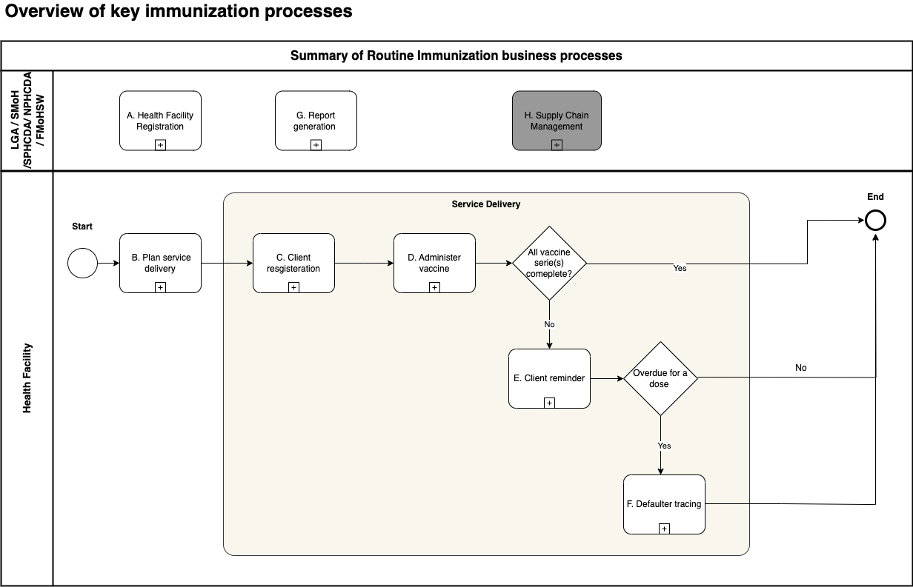

## **4.2. Workflows**

### **Health Facility Registration**

Objective: To register and uniquely identify vaccination locations in order to administer vaccines and enable appropriate tracking of vaccine coverage and stock.

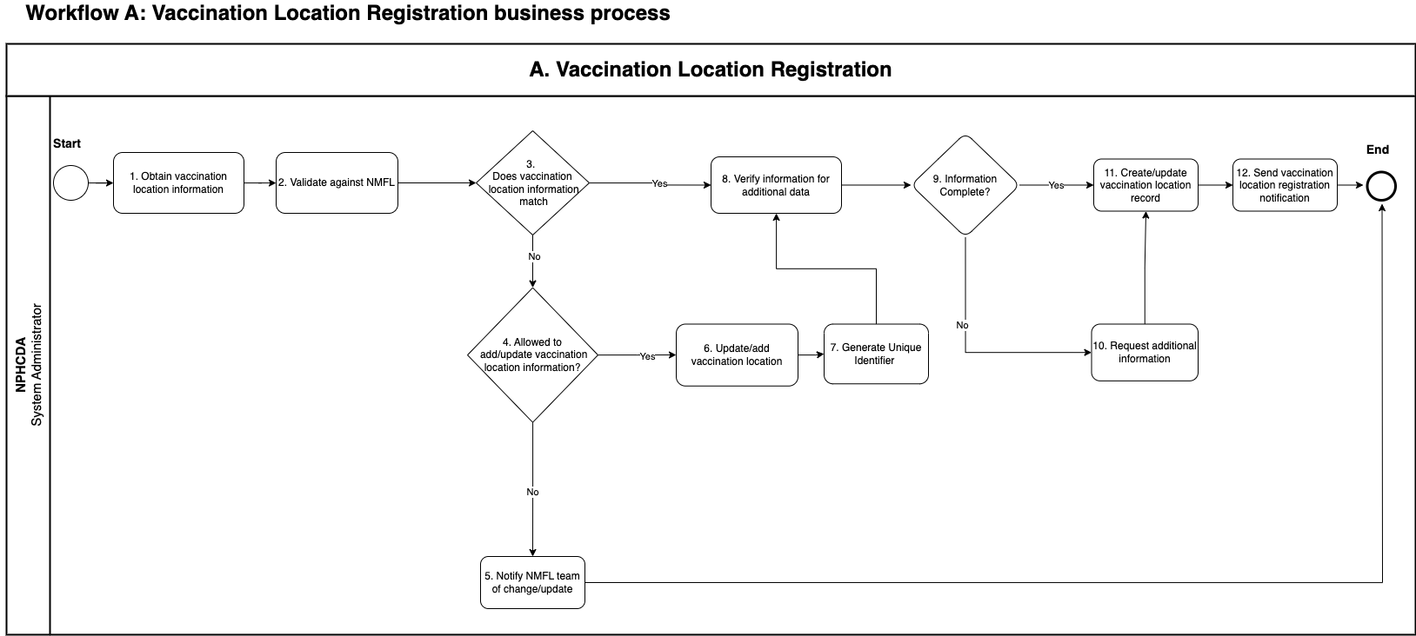

### 

### **Plan for Immunization Session**

Objective: To prepare for an immunization session, either at the vaccination location or done at an outreach site.

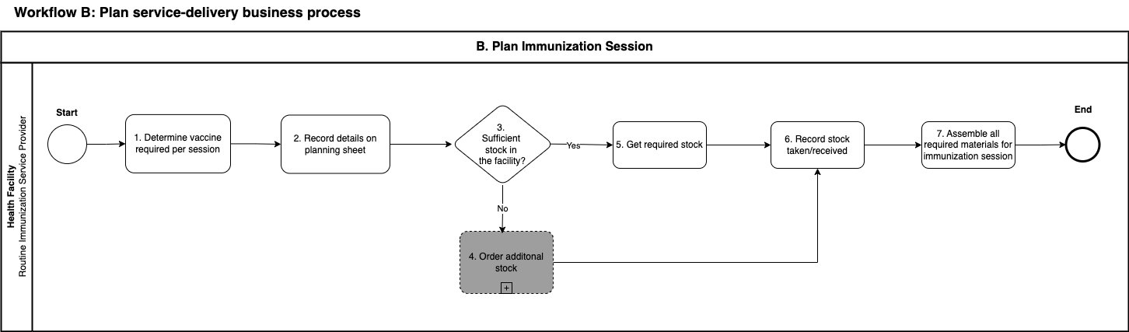

### 

### **C. Client Registration**

**Objective:** To start the client’s lifelong immunization record.

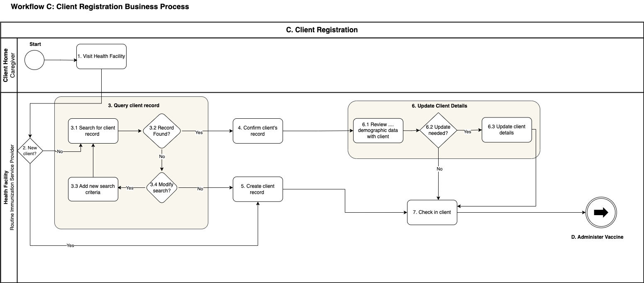

### 

### **D. Vaccine Administration**

**Objective:**  To determine what vaccines a client needs, administer those, and record the data both in the system and on the client’s vaccination card.

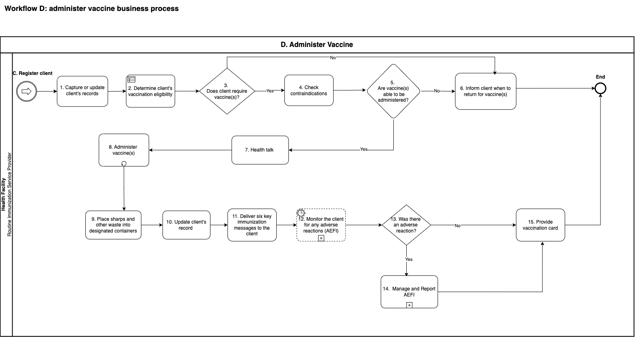

### **E. Manage and Report AEFIs**

**Objective:** To manage caregiver reports or client presenting at health facilities with cases of AEFI based on set triggers.

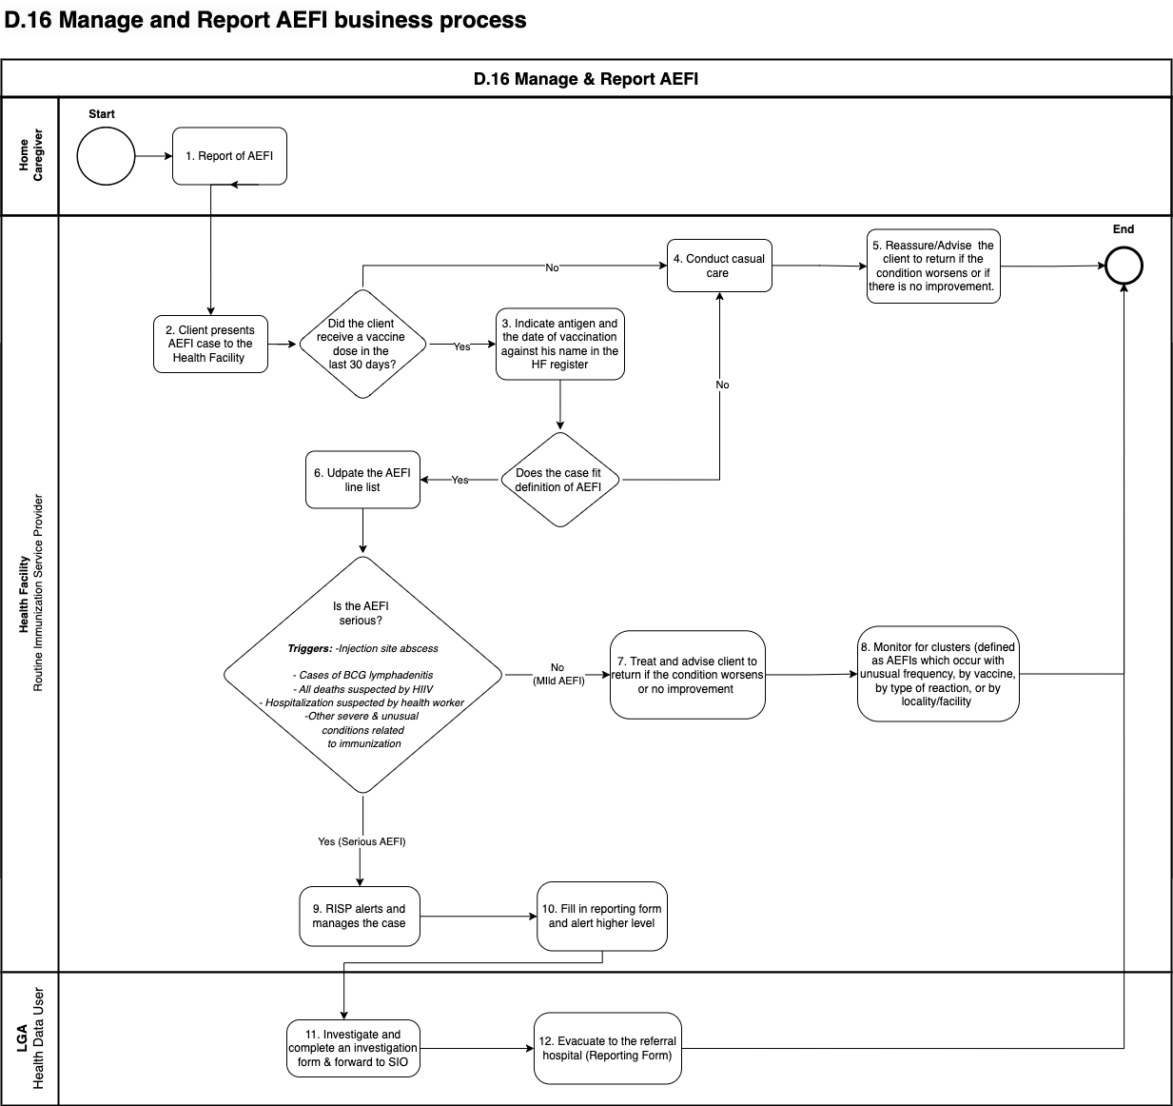

### **F. Client Reminder**

**Objective:** To send vaccination reminders to community health workers that certain clients are due for vaccination.

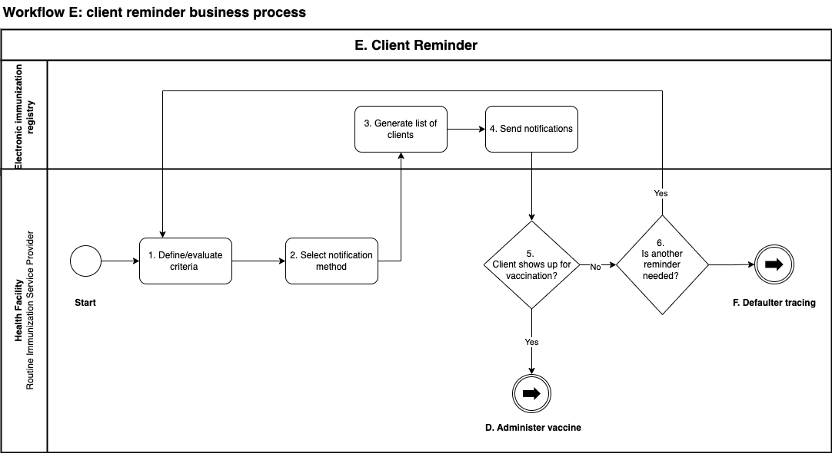

### 

### **G. Defaulter Tracking**

**Objective:**  To identify clients that are overdue for follow-up.

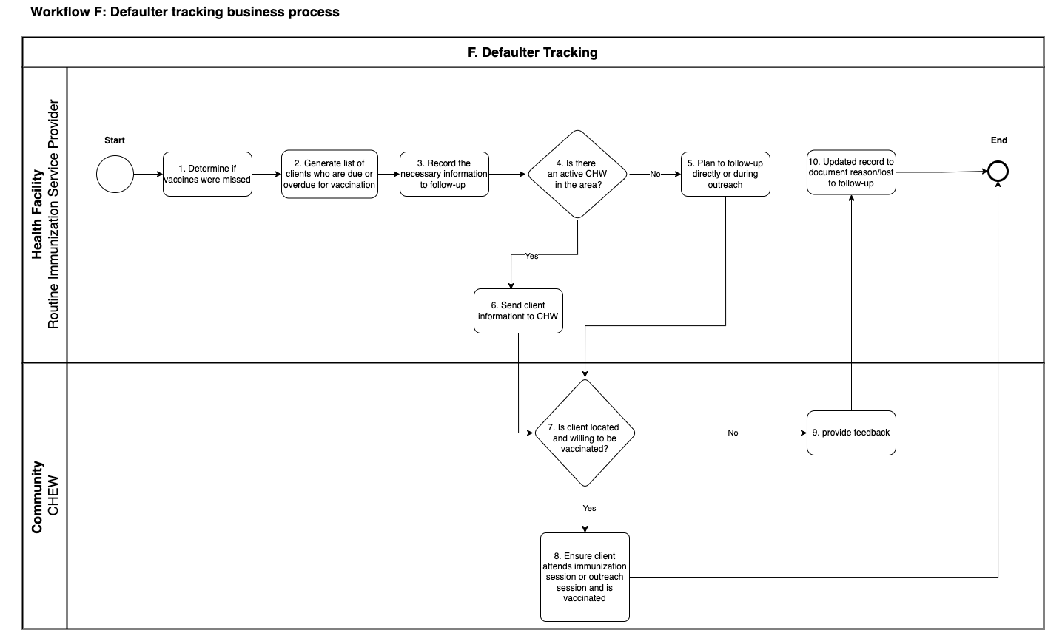

**H. Report Generation**

**Objective:** To provide data access and analysis for decision-making.

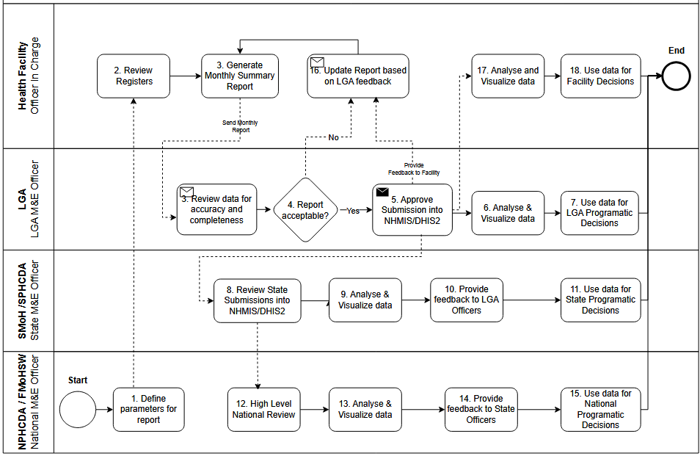

1. **Resolve Duplicate Client Record**

**Objective:** To ensure accurate and unified client data by identifying and merging duplicate records.

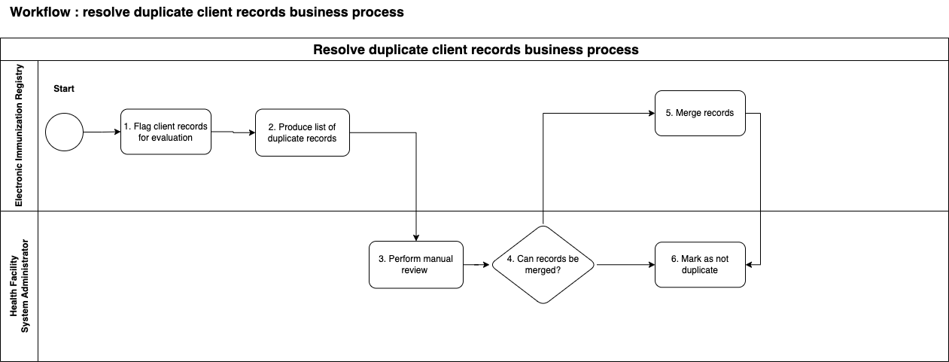

**J. Resolve Duplicate Vaccination Events**

**Objective:** To maintain reliable immunization records by detecting and resolving duplicate vaccination entries.

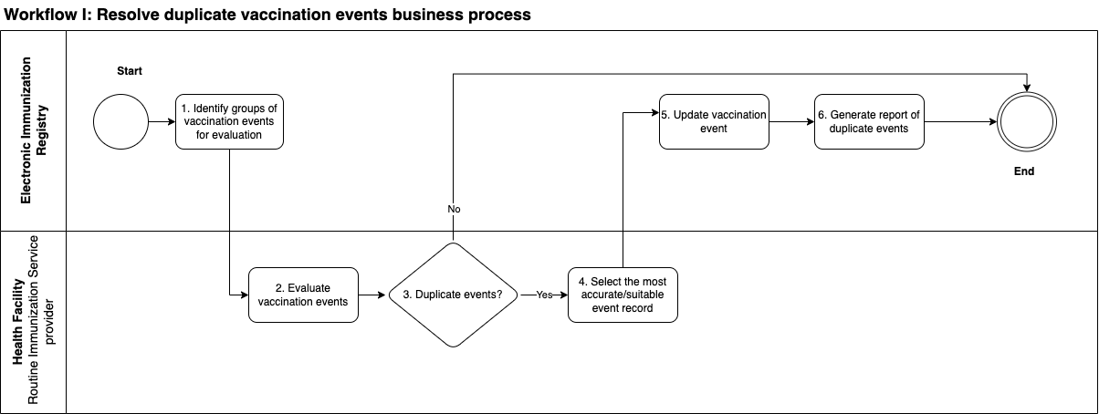

# 5. CORE DATA ELEMENTS

This section outlines the core set of data elements corresponding to different points of the workflow within the identified business processes. These data elements provide the foundation for executing the decision-support logic, as well as populating indicators and performance metrics.

Here is the [**Data Dictionary**](https://docs.google.com/spreadsheets/d/1WELFOeQ4-46AX6FSr9Zw7n7dl4xKC_mc/edit?usp=sharing&ouid=110264583837925077635&rtpof=true&sd=true)**.**

The data elements in the data dictionary have been extracted from different registers and forms shared as indicated [here](https://docs.google.com/spreadsheets/d/1IhvvOWeabgAIOILFrYChdddyDGvLNAKd20TdjEobO9Q/edit?usp=sharing).

# 

# 

# 6. DECISION SUPPORT LOGIC

The decision-support logic component of the adaptation kit provides the decision-support logic and algorithms, as well as the scheduling of services, in accordance with WHO guidelines. In this DAK, the decision logic and algorithms deconstruct the recommendations within the immunization guidelines and guidance into a format that clearly labels the inputs and outputs that would be operationalized in a digital decision-support system.

Here is the [**Decision support logic**](https://docs.google.com/spreadsheets/d/1NlEfryGIuZR3UYY8cAkEXY1e5oINKbwP/edit?usp=sharing&ouid=110264583837925077635&rtpof=true&sd=true)spreadsheet.

## **6.1. Decision Support Logic Overview**

The table below provides an overview of the decision-support tables and algorithms for the different business processes in an Immunization system. The structure of the decision-support tables is based on an adaptation of the Decision Model and Notation (DMN), an industry standard for modeling and executing decision logic. These decision-support tables detail the business rules, data inputs, and outputs to support IIS business processes.

**Table 7: Decision Support Logic Overview**

| **Activity ID & Activity Name** | **Tab** | **Decision Table ID** | **Decision Table Description** | **Reference/Source** |
| --- | --- | --- | --- | --- |
| IMMZ.D2  Determine required vaccinations | BCG Vaccine | IMMZ.DT.01 | Recommended vaccinations for Bacille Calmette-Guerin (BCG) as per recommendations by WHO and Nigeria | Nigeria National Immunization policy draft  [WHO Recommendations on Routine Immunization](https://www.who.int/teams/immunization-vaccines-and-biologicals/policies/who-recommendations-for-routine-immunization---summary-tables) |
| Hepatitis B Vaccine | IMMZ.DT.02 | Recommended vaccinations for Hepatitis B as per Nigeria recommendations |
| Polio Vaccine | IMMZ.DT.03 | Recommended vaccinations for Polio as per Nigeria recommendations |
| DTP+HepB+Hib(Pentavalent) Vaccine | IMMZ.DT.04 | Recommended vaccinations for Diphtheria, Pertussis and Tetanus (DPT)-containing vaccines+HepB+Hib (Penta)as per Nigeria recommendations |
| Pneumococcal Vaccine | IMMZ.DT.06 | Recommended vaccinations for pneumococcal as per Nigeria recommendations |
| Rota virus Vaccine | IMMZ.DT.07 | Recommended vaccinations for Rota virus as per Nigeria recommendations |
| Measles Vaccine | IMMZ.DT.08 | Recommended vaccinations for measles as per Nigeria recommendations |
| Malaria Vaccine | IMMZ.DT.09 | Recommended vaccinations for Malaria as per Nigeria recommendations |
| Human Papilloma Vaccine | IMMZ.DT.10 | Recommended vaccinations for HPV as per Nigeria recommendations |
| Yellow fever Vaccine | IMMZ.DT.11 | Recommended vaccinations for Yellow fever as per Nigeria recommendations |
|  | Meningococcal Vaccine | IMMZ.DT.13 | Recommended Vaccinations for Meningococcal as per Nigeria recommendations |  |
| Vitamin A supplementation | IMMZ.DT.14 | Recommended Vitamin A supplementation as per Nigeria recommendations |

## 

## 

## **6.2. Decision-support Tables**

Each of the decision logic above have been elaborated on in decision support tables. Below we have highlighted an example of what each component of the decision support table means and highlighted an example of the Yellow fever vaccine decision support table.

| **Decision ID** | The name of the “decision” describing what algorithm or logic is represented (e.g. pre-eclampsia risk counselling). The Decision ID should correspond to the number in the overview table on "overview" tab | | | |
| --- | --- | --- | --- | --- |
| **Business rule** | The description of the decision that needs to be made based on IF/THEN statements with the appropriate data element name for the variables. The rule should demonstrate the relationship between the input variables and the expected outputs and actions within the decision-support logic – e.g. if blood pressure is higher than 140 SBP/90 DBP, then the client should be flagged as a high-risk pregnancy. | | | |
| **Trigger** | The event that would indicate when this decision-support logic should appear within the workflow, such as the activity that would trigger this decision to be made. | | | |
| **Inputs** | | **Output** | **Action** | **Annotations** |
| These are the variables or conditions that need to be considered to determine the consequent actions or outputs | If there are multiple input entries on the same row (such as here), these different inputs are considered as “**AND**” – conditions that need to be in place at the same time. | The resulting action or decision based on the combination of input entries. This is the statement that immediately follows the “THEN”. Examples of outputs may include a diagnosis, alerts/prompts for referral, or a recommendation to vaccinate. | Concrete measures to be taken based on the output (refer, provide treatment and/or counselling, conduct test, etc.). In some cases, output and action may be the same. | Additional explanations or descriptions, including possible pop-up alert messages and relevant background information. This section can also include the written content which would appear in the pop-up messages notifying the health worker on the appropriate next steps, which can include counselling, case management approach, or referral. |
| Inputs placed on different rows are considered as “**OR**” conditions that can be considered independently of the inputs on other rows. |  |  |  |  |

***Table 9 . Example decision logic table for Yellow Fever vaccination***

| **Decision ID** | IMMZ.DT.06.Yellow Fever | | | | |
| --- | --- | --- | --- | --- | --- |
| **Business rule** | If child or person has not been vaccinated, give Yellow Fever vaccine between age 9-12 months | | | | |
| **Trigger** | IMMZ.D2 Determine Required Vaccinations if any | | | | |
| **Inputs** | | **Output** | **Action** | **Annotations** | **Reference(s)** |
| "Number of doses administered" = 0 | "Age in Months" >= 9 | Client vaccinated for Yellow Fever - No Doses | Should vaccinate Client for Yellow Fever because Client received no doses on a 1 dose scheme | Provide Yellow Fever immunizations – using the "Yellow Fever vaccine immunization – NO PREVIOUS" schedule (1 dose scheme)  Note:  This dose is applicable if the following scenarios are met:  - The country has a Yellow Fever endemic  - The individual is travelling to a Yellow Fever endemic area  -The child is 9 months old. | [WHO recommendations for routine immunization](https://www.who.int/teams/immunization-vaccines-and-biologicals/policies/who-recommendations-for-routine-immunization---summary-tables)  Nigeria National immunization policy Draft |

# 

# 7. INDICATORS & PERFORMANCE METRICS

This section details indicators and performance metrics that would be aggregated from core data elements identified in Component 5. The list in the spreadsheet is a minimum set of indicators that can be aggregated for decision-making, performance metrics, and subnational and national reporting based on data collected from individual-level, routine health systems.

Here is the [Indicators Spreadsheet](https://docs.google.com/spreadsheets/d/1pKL8Km9yvrKLOx75ueE2zAKCtawN9d9x/edit?usp=sharing&ouid=106234410585480643858&rtpof=true&sd=true)

# 

# 

# 

# 

# 

# 8. FUNCTIONAL & NON-FUNCTIONAL REQUIREMENTS

This section provides an overview of illustrative functional and non-functional requirements that may be considered to kick-start the process of designing or adapting the digital tracking and

decision-support system*. Functional requirements* describe the capabilities the system must have in order to meet the end-users’ needs and achieve tasks within the business process*. Non-functional requirements* provide the general attributes and features of the digital system to ensure usability and overcome technical and physical constraints.

## **8.1. Functional Requirements**

|  | **Activity ID and name** | **As a…** | **I want…** | **So that…** |
| --- | --- | --- | --- | --- |
| **Business process A: vaccination location registration** | | | |  |
| **IMMZ.FXNREQ.001** | IMMZ.A1.Obtain vaccination location information | State Immunization Officer | The EIR system to be integrated with other existing health registries | I know about new vaccination locations and be informed about any updated information |
| **IMMZ.FXNREQ.002** | IMMZ.A2.Update/anew vaccination location | Routine Immunization Service Provider/Medical Records Officer | The system to allow manual insertion of a new vaccination location | I can add and use vaccination locations not in the system |
| **IMMZ.FXNREQ.003** | IMMZ.A3.Digitize REW microplans | State Immunization officer | The system to have a have digitized REW microplans, | Plans can be automatically generated for each outreach session |
| **IMMZ.FXNREQ.004** | IMMZ.A4.Verify information for additional data | Routine Immunization Service Provider/Medical Records Officer | The system to verify all required vaccination location information is complete | Any missed fields can be identified |
| **IMMZ.FXNREQ.005** | IMMZ.A5.Generate unique location identifier | State Immunization Officer | The system to generate a unique code for each vaccination location | The vaccination location will have an unique identifier in the EIR system |
| **IMMZ.FXREQ.006** | IMMZ.A6. Generate Geo co-ordinates | State Immunization Officer | The system to have geo mapping capabilities | The vaccination locations can be easily identified. |
| **IMMZ.FXREQ.007** | IMMZ.A7.Obtain Contact information of focal persons | State Immunization Officer | The system to include the phone number and email address of the focal person | I can easily contact the focal person |
| **IMMZ.FXREQ.008** | IMMZ.A8Record vaccination location details | State Immunization Officer | The system to record vaccination dates, type of facility(public,private,secondary,tertiary) and type of site(fixed, outreach) | The exact vaccination location details are captured |
| **Business process B: Plan service delivery** | | | |  |
| **IMMZ.FXNREQ.009** | IMMZ.B1.Review past vaccination records to estimate vaccines needed | Routine Immunization Service Provider/Medical Records Officer | To identify, by checking the information in the system, all clients that are due (or overdue) for vaccination by the next immunization session date | I can plan my immunization session |
| **IMMZ.FXNREQ.010** | IMMZ.B2.Review past vaccination records to estimate vaccines needed | State Immunization Officer | To sort the list of needed vaccines by antigen | I know how much of each vaccine is needed |
| **IMMZ.FXNREQ.011** | IMMZ.B3.Record details on planning sheet | State Immunization Officer | To be able to check in the system the available stock at my vaccination location or at the local storage area/warehouse | I can determine the stock available for use |
| **Business process C: Client registration** | | | |  |
| **IMMZ.FXNREQ.012** | IMMZ.C1.Query client record | Routine Immunization Service Provider/Medical Records Officer | To search for a client using at least two identifying information | I improve my chances of finding a match and distinguishing between similar records |
| **IMMZ.FXNREQ.013** | IMMZ.C1.Query client record | Routine Immunization Service Provider/Medical Records Officer | To search for the client record given some demographic information | I can find the client record if I do not have the unique ID |
| **IMMZ.FXNREQ.014** | IMMZ.C1.Query client record | Routine Immunization Service Provider/Medical Records Officer | The system to return all potential matches based upon search criteria | I can find the best match |
| **IMMZ.FXNREQ.015** | IMMZ.C1.Query client record | Routine Immunization Service Provider/Medical Records Officer | The ability for searches to include results that look or sound similar to the search term (phonetic search) | I can find something that may be spelt incorrectly |
| **IMMZ.FXNREQ.016** | IMMZ.C1.Query client record | Routine Immunization Service Provider/Medical Records Officer | The system to prompt a search for the client (check if it is already in the system) prior to starting a new record | Duplicates are prevented |
| **IMMZ.FXNREQ.017** | IMMZ.C1.Query client record | Routine Immunization Service Provider/Medical Records Officer | The system to retrieve and display, as a search result, a specific set of data (demographic information/photo/unique ID, etc. ) | I can select the correct record |
| **IMMZ.FXNREQ.018** | IMMZ.C1.Query client record | Routine Immunization Service Provider/Medical Records Officer | The system to display the most probable matches at the top of the list | I can review them first |
| **IMMZ.FXNREQ.019** | IMMZ.C2.Create client record | Routine Immunization Service Provider/Medical Records Officer | The system to enforce a minimal required data set for new registrations | Sufficient data is entered to be able to identify the client |
| **IMMZ.FXNREQ.020** | IMMZ.C2.Create client record | Routine Immunization Service Provider/Medical Records Officer | To select the vaccination location of the client from a list of locations | Entry errors are prevented |
| **IMMZ.FXNREQ.021** | IMMZ.C2.Create client record | Routine Immunization Service Provider/Medical Records Officer | The system to uniquely identify every client using a system generated unique identifier or an existing identifier (e.g. national ID, client ID) | The client can be definitively identified using that number |
| **IMMZ.FXNREQ.022** | IMMZ.C3.Validate client details | Routine Immunization Service Provider/Medical Records Officer | To be able to modify appropriate client data as needed | the record contains up to date information |
| **IMMZ.FXNREQ.023** | IMMZ.C3.Validate client details | Routine Immunization Service Provider/Medical Records Officer | The system to track that I have changed an existing record | accountability for data modification is ensured |
| **IMMZ.FXNREQ.024** | IMMZ.C3.Validate client details | Routine Immunization Service Provider/Medical Records Officer | The system to identify changes made to the record for my confirmation before saving | I can have the opportunity to double check the data to prevent entry errors |
| **Business process D: Administer vaccine** | | | |  |
| **IMMZ.FXNREQ.025** | IMMZ.D1.Capture or update client history | Routine Immunization Service Provider/Medical Records Officer | The system to provide a history of previous care (including previous vaccination records) | I have access and review client's history |
| **IMMZ.FXNREQ.026** | IMMZ.D1.Capture or update client history | Routine Immunization Service Provider/Medical Records Officer | To add client's health history (including previous vaccination records) | I can appropriately determine which vaccinations are required |
| **IMMZ.FXNREQ.027** | IMMZ.D2.Determine required vaccination(s) | Routine Immunization Service Provider/Medical Records Officer | The system to display vaccines due according to predefined vaccine protocol | I can assess which vaccines need to be administered |
| **IMMZ.FXNREQ.028** | IMMZ.D2.Determine required vaccination(s) | Routine Immunization Service Provider/Medical Records Officer | The system to determine vaccines due for a given client by considering relevant information, such as the age of the client, vaccine products, vaccines already given and predefined vaccine protocol | it helps me with selecting the appropriate vaccines for the client |
| **IMMZ.FXNREQ.029** | IMMZ.D3.Determine vaccine(s) to be administered based on contraindications | Routine Immunization Service Provider/Medical Records Officer | To be alerted of any relevant potential contraindications for the vaccine (e.g. based on age, previous allergic reactions, etc.) | I can withhold the vaccine, if contraindicated |
| **IMMZ.FXNREQ.030** | IMMZ.D3.Determine vaccine(s) to be administered based on contraindications | Routine Immunization Service Provider/Medical Records Officer | To be able to quickly access information regarding any contraindications by antigen | I can access all information on contraindications in one place |
| **IMMZ.FXNREQ.031** | IMMZ.D4.Update client record | Routine Immunization Service Provider/Medical Records Officer | To document why a vaccine was not given | The client has a complete record |
| **IMMZ.FXNREQ.032** | IMMZ.D4.Update client record | Routine Immunization Service Provider/Medical Records Officer | To update clients’ vaccination record with all relevant information (i.e. date, dose, batch number, lot number, vaccine type, vaccine vial monitor status) | The client has a complete record, and doses can be traced |
| **IMMZ.FXNREQ.033** | IMMZ.D4.Update client record | Routine Immunization Service Provider/Medical Records Officer | The system to associate the context data for each entry (e.g. the vaccination location where the dose was given, the health worker administering it) | The client has a complete record and I can investigate if any issues arise |
| **IMMZ.FXNREQ.034** | IMMZ.D4.Update client record | Routine Immunization Service Provider/Medical Records Officer | To record vaccines in the EPI schedule, any vaccines introduced, COVID-19,TD vaccine for pregnant women, campaign vaccines | The client has a complete record |
| **IMMZ.FXNREQ.035** | IMMZ.D5.Determine time for next visit (as needed) | Routine Immunization Service Provider/Medical Records Officer | The system to display due date of the next vaccine | I can inform the client when to return for their next vaccination |
| **IMMZ.FXREQ.Q036** | IMMZ. D6.Generate digital certificate | Routine Immunization Service Provider/Medical Records Officer | The system to generate a digital certificate with name, age, contact number, QR code and other items as found in the WHO sample certificate | The client can verify they have been vaccinated |
| **Business process E; AEFI Monitoring** | | | | |
| **IMMZ.FXNREQ.037** | IMMZ.E1.Monitor adverse reactions in clients | Routine Immunization Service Provider/Medical Records Officer | The AEFI module to be separate | I can record any significant observations that may be specific to the client and treat as appropriate |
| **IMMZ.FXREQ.038** | IMMZ.E2.Follow-up clients | Routine Immunization Service Provider/Medical Records Officer | The system to be interoperable with the MedSafety App | I can follow-up vaccine related complications |
| **Business process F: Client reminder** | | | |  |
| **IMMZ.FXNREQ.039** | IMMZ.F1.Define/evaluate criteria | Routine Immunization Service Provider/Medical Records Officer | To associate a client with a vaccination location to generate a provider-based reminder/recall | Vaccination location specific lists of clients can be generated |
| **IMMZ.FXNREQ.040** | IMMZ.F2.Select notification method | Routine immunization Service Provider/Medical Records Officer | The system to Call/ SMS/WhatsApp a client | Notifications will go through the client’s preferred method |
| **IMMZ.FXNREQ.041** | IMMZ.F3.Send notifications | Routine Immunization Service Provider/Medical Records Officer | The system to automatically send reminder notification to caregiver a day before appointment or a day after a missed appointment | they will be alerted of an upcoming or overdue appointment |
| **IMMZ.FXNREQ.042** | IMMZ.F3.Send notifications | Routine Immunization Service Provider/Medical Records Officer | The notification to include specific details about upcoming immunization session dates and times or outreach dates and times as appropriate | The client will know specifically when and where to go to receive a vaccination |
| **Business process G: Defaulter tracing** | | | |  |
| **IMMZ.FXNREQ.043** | IMMZ.G1.Determine if vaccines were missed | Routine Immunization Service Provider/ Medical Records Officer | The system to flag a client as a defaulter after a configured number of reminders are sent | We can identify those who have not come and are overdue, requiring additional intervention |
| **IMMZ.FXNREQ.044** | IMMZ.G1.Determine if vaccines were missed | Routine Immunization service Provider/Medical Records Officer | The system to be linked to eCHIS | CHEWS can do follow-ups in the catchment area of the facility. |
| **IMMZ.FXNREQ.045** | IMMZ.G2.Generate list of clients who are due or overdue for vaccination | Routine Immunization Service Provider/Medical Records Officer | To produce a list of clients who missed their vaccine for each antigen, along with their location and personal information | I can plan follow up activities and contact the clients |
| **IMMZ.FXNREQ.046** | IMMZ.G3.Plan for follow-up directly or during outreach | Routine Immunization Service Provider/Medical Records Officer | To display a list of clients due for specific planned outreach and immunization sessions, based on area | The immunization session or outreach will have a targeted list of clients, allowing for prioritization of tasks and workload |
| **IMMZ.FXNREQ.047** | IMMZ.G4.Update record to document reason/lost follow-up | Routine Immunization Service Provider/Medical Records Officer | To record reason vaccine was missed | This information can be used for planning and reporting purposes |
| **IMMZ.FXNREQ.048** | IMMZ.G4.Update record to document reason/lost follow-up | Routine Immunization Officer/ Medical Officer | To update client information such as including change of address (moved permanently or temporarily) | To facilitate the client being contacted or being removed from an immunization session’s list |
| **IMMZ.FXREQ.049** | IMMZ.G5.Track zero dose children | State Immunization Officer | The system to automate follow up on zero-dose children from linkage to the birth register or from coverage calculations | I can follow up and have an idea of the # of zero dose children and communities where zero dose children are located. |
| **Business process H: Report generation** | | | |  |
| **IMMZ.FXNREQ.050** | IMMZ.H1.Define parameters for report | Routine Immunization Service Provider/Medical Records Officer/OIC | To be able to access the health facility’s dashboard | I can access and analyze health facility data |
| **IMMZ.FXNREQ.051** | IMMZ.H1.Define parameters for report | LGA M&E | To be able to access LGA and health facility dashboards in my area | I can generate reports specific to my LGA |
| **IMMZ.FXNREQ.052** | IMMZ.H1.Define parameters for report | State M&E | To be able to access State, LGA and Health facility data | I can generate reports specific to my State |
| **IMMZ.FXNREQ.053** | IMMZ.H2.View and download | Honourable Minister FMoHSW, DHPRS FMoH ED, DG NCDC, DDCI, DL&HC, H/RI, RIWG data team, DDPRS, DHIS2 national FP, Head NSCS, EPI Partners | To be able to view and download reports | I can view the immunization status at national level |
| **Business process I; Stock Management** | | | | |
| **IMMZ.FXNREQ.054** | IMMZ.I1. Record stock taken | Cold Chain Officer | To record stock removed from cold storage and taken to immunization session | The count for the cold storage will be accurate, and the immunization session stock will be accounted for |
| **IMMZ.FXNREQ.055** | IMMZ.11 Record stock taken | Cold Chain Officer | The system to maintain a tally of stock available at each location (e.g. stock available in the cold fridge at vaccination location, stock that is out for immunization session) | I can see where all stock is physically located in real time |
| **Administrative Data Access Rights and Controls** | | | | |
| **IMMZ.FXREQ.056** | Assign roles | Officer In Charge(OIC) | The system to assign roles | I can assign roles to team members in the facility |
| **IMMZ.FXREQ.057** | Support back-end | IT administrator | Access to back-end | I can offer backend support, troubleshooting and system maintenance |
| **IMMZ.FXREQ.058** | Create Profiles | State M&E | The system to create profiles | I can create user profiles for LGA and health facility |
|  |  |  |  |  |

## **8.2. Non-Functional Requirements**

| **Requirement ID** | **Category** | **Non-functional requirement** |
| --- | --- | --- |
| **IMMZ.NFXNREQ.001** | Performance | Make efficient use of data communication time |
| **IMMZ.NFXNREQ.002** | Performance | Make efficient use of capabilities of lower-cost mobile devices |
| **IMMZ.NFXNREQ.003** | Performance | Support data capacity considerations (including those for data transmission, storage and processing) for all users over the expected lifetime of the system |
| **IMMZ.NFXNREQ.004** | Performance | Use a database that can scale to support projected transaction volume |
| **IMMZ.NFXNREQ.005** | Performance | Provide real-time response to transactions submitted by connected devices up to the configured national volume level |
| **IMMZ.NFXNREQ.006** | Performance | Provide real-time messages such as "report processing" or "in progress" for transactions that affect the system performance |
| **IMMZ.NFXNREQ.007** | Compatibility | Use open standards to promote interoperability |
| **IMMZ.NFXNREQ.008** | Compatibility | Exchange actionable data between systems (need to enforce semantic interoperability) |
| **IMMZ.NFXNREQ.009** | Compatibility | Provide access from internet-enabled devices |
| **IMMZ.NFXNREQ.010** | Compatibility | Support flexible models for data collection (e.g. including paper forms, web forms, SMS, barcode, etc.) |
| **IMMZ.NFXNREQ.011** | Compatibility | Comply with industry standards for data exchange |
| **IMMZ.NFXNREQ.012** | Compatibility | Operate with open-source or third-party reporting tools |
| **IMMZ.NFXNREQ.013** | Compatibility | Comply with industry standards for tracking and tracing of supplies |
| **IMMZ.NFXNREQ.014** | Compatibility | Enable streamlined data collection, organization and dissemination |
| **IMMZ.NFXNREQ.015** | Interoperability | Provide access to data through application programming interfaces |
| **IMMZ.NFXNREQ.017** | Interoperability | Allow for data exchange and efficient synchronization across multiple facilities and points of service when the internet is available, even when it is intermittent and slow |
| **IMMZ.NFXNREQ.018** | Configuration | Configure the system centrally |
| **IMMZ.NFXNREQ.019** | Configuration | Configure business rules in line with guidelines and standard operating procedures |
| **IMMZ.NFXNREQ.020** | Configuration | Configure error messages |
| **IMMZ.NFXNREQ.021** | Configuration | Enable configuration to any national or subnational administrative structure or number of levels |
| **IMMZ.NFXNREQ.022** | Usability | Allow for flexible configurations based on the context of use, including the physical, regulatory and social environment |
| **IMMZ.NFXNREQ.023** | Usability | Transmit information in a language (script or voice) that is understood by the user population |
| **IMMZ.NFXNREQ.024** | Usability | Emphasize ease of use and learnability to reduce training costs |
| **IMMZ.NFXNREQ.025** | Usability | Be able to be learned easily by end users and supervisors to meet specified goals of system effectiveness and efficiency |
| **IMMZ.NFXNREQ.026** | Usability | Enable easy data collection, organization (predefined drop-down menus or searchable lists, radio buttons, check boxes), and dissemination |
| **IMMZ.NFXNREQ.028** | Usability | Allow users to find features in two clicks or fewer |
| **IMMZ.NFXNREQ.029** | Usability | Provide a search interface to reduce data-entry burden and improve accuracy on mobile devices |
| **IMMZ.NFXNREQ.030** | Usability | Support real-time data-entry validation and feedback to prevent data-entry errors from being recorded |
| **IMMZ.NFXNREQ.031** | Usability | Support ability to calculate values on behalf of user (eliminating need to add, subtract, multiply or divide) |
| **IMMZ.NFXNREQ.033** | Usability | Support ability to recalculate the immunization scheduled or provide clinical decision support in the event that the client does not receive vaccines on time or has contraindications to their administration |
| **IMMZ.NFXNREQ.034** | Usability | Be user-friendly for people with low computer literacy |
| **IMMZ.NFXNREQ.035** | Usability | Provide informative error messages and tooltips |
| **IMMZ.NFXNREQ.036** | Usability | Alert the user when navigating away from a form without saving |
| **IMMZ.NFXNREQ.037** | Usability | Use industry-standard user interface practices and apply them consistently throughout the system |
| **IMMZ.NFXNREQ.038** | Usability | Provide guidance to users to better support clinical guidelines and best clinical practices |
| **IMMZ.NFXNREQ.039** | Usability | Be reliable and robust (minimize the number of system crashes) |
| **IMMZ.NFXNREQ.040** | Usability | Adjust display to fit small screens (e.g. mobile phones) |
| **IMMZ.NFXNREQ.041** | Reliability | Enable a task to be cancelled and rolled back to previous state |
| **IMMZ.NFXNREQ.042** | Reliability | Enable users to work offline and then synchronize data when data connection is available |
| **IMMZ.NFXNREQ.043** | Reliability | Allow a task to be interrupted and resumed |
| **IMMZ.NFXNREQ.044** | Reliability | Enable earlier versions of a record to be recoverable |
| **IMMZ.NFXNREQ.045** | Reliability | Enable backup of data so that information is recoverable in the event of a system or hardware failure |
| **IMMZ.NFXNREQ.046** | Reliability | Accommodate loss of connectivity to hosted application (network may become unavailable while a user is in the process of submitting a form) |
| **IMMZ.NFXNREQ.047** | Reliability | Be able to reliably perform tasks within appropriate time with resistance to failures or deadlocks |
| **IMMZ.NFXNREQ.048** | Reliability | Be deployed in an environment subject to power loss |
| **IMMZ.NFXNREQ.049** | Reliability | Allow for client devices with low bandwidth or irregular connectivity |
| **IMMZ.NFXNREQ.050** | Confidentiality, privacy and security | Prevent unauthorized access to clients' protected health information |
| **IMMZ.NFXNREQ.051** | Confidentiality, privacy and security | Prevent updates to the database occurring only partially (atomicity), which can cause greater problems than rejecting an entire submission of a form |
| **IMMZ.NFXNREQ.052** | Confidentiality, privacy and security | Trace and record changes to data taken by the system and by users (update/delete/add/access) |
| **IMMZ.NFXNREQ.053** | Confidentiality, privacy and security | Allow the administrator to establish access privileges and priorities |
| **IMMZ.NFXNREQ.054** | Confidentiality, privacy and security | Support definitions of unlimited roles and assigned levels of access, viewing, entry, editing and auditing |
| **IMMZ.NFXNREQ.055** | Confidentiality, privacy and security | Require each user to authenticate by role before gaining access to the system |
| **IMMZ.NFXNREQ.056** | Confidentiality, privacy and security | Provide flexible password control to align to national policy and standard operating procedures, including password format requirements |
| **IMMZ.NFXNREQ.057** | Confidentiality, privacy and security | Protect system servers through the use of an internet firewall |
| **IMMZ.NFXNREQ.058** | Confidentiality, privacy and security | Comply with country's existing health information storage policies |
| **IMMZ.NFXNREQ.059** | Confidentiality, privacy and security | Protect against viruses and malware |
| **IMMZ.NFXNREQ.060** | Confidentiality, privacy and security | Allow for maintenance of security updates |
| **IMMZ.NFXNREQ.061** | Confidentiality, privacy and security | Have a source code audit against security threats |
| **IMMZ.NFXNREQ.062** | Confidentiality, privacy and security | Log all activities performed by the user, including date and time stamp |
| **IMMZ.NFXNREQ.063** | Confidentiality, privacy and security | Maintain a transaction log history (system logins and logouts) |
| **IMMZ.NFXNREQ.064** | Confidentiality, privacy and security | Support privacy policies such as identifying who has access to the health data, and what data can be accessed |
| **IMMZ.NFXNREQ.065** | Confidentiality, privacy and security | Design software security protections to ensure system availability |
| **IMMZ.NFXNREQ.066** | Confidentiality, privacy and security | Provide a means to ensure confidentiality and privacy of personal health information |
| **IMMZ.NFXNREQ.067** | Confidentiality, privacy and security | Provide the ability for allowed users to view confidential data |
| **IMMZ.NFXNREQ.068** | Confidentiality, privacy and security | Anonymize data that are exported from the system |
| **IMMZ.NFXNREQ.069** | Confidentiality, privacy and security | Prevent remembering username and password |
| **IMMZ.NFXNREQ.070** | Confidentiality, privacy and security | Automatically log out the user after a specified time of inactivity |
| **IMMZ.NFXNREQ.071** | Confidentiality, privacy and security | Provide encrypted communication between components |
| **IMMZ.NFXNREQ.072** | Confidentiality, privacy and security | Provide secure data transmission methods to prevent others from seeing data sent from one computer to another by using data encryption and private networks across public networks |
| **IMMZ.NFXNREQ.073** | Confidentiality, privacy and security | Notify the user to change their password the first time they log in |
| **IMMZ.NFXNREQ.074** | Confidentiality, privacy and security | Provide a mechanism to securely change a user's password |
| **IMMZ.NFXNREQ.075** | Confidentiality, privacy and security | Notify the user of a password change to their account |
| **IMMZ.NFXNREQ.076** | Confidentiality, privacy and security | Reset a user's password in a secure manner |
| **IMMZ.NFXNREQ.077** | Confidentiality, privacy and security | Lock a user out after a specified number of wrong password attempts |
| **IMMZ.NFXNREQ.078** | Confidentiality, privacy and security | Notify a user if their account is locked due to wrong password attempts |
| **IMMZ.NFXNREQ.079** | Confidentiality, privacy and security | Record all authentication violations |
| **IMMZ.NFXNREQ.080** | Confidentiality, privacy and security | Log access to views of individual client records |
| **IMMZ.NFXNREQ.081** | Confidentiality, privacy and security | Log access to data summaries, reports, analysis and visualization features |
| **IMMZ.NFXNREQ.082** | Confidentiality, privacy and security | Log exchange of data with other systems |
| **IMMZ.NFXNREQ.083** | Confidentiality, privacy and security | Generate analysis of the use of different system features and reports |
| **IMMZ.NFXNREQ.084** | Confidentiality, privacy and security | Log all data and system errors |
| **IMMZ.NFXNREQ.085** | Confidentiality, privacy and security | Allow user with permission to create a new user and temporary password |
| **IMMZ.NFXNREQ.086** | Confidentiality, privacy and security | Allow roles to be associated with specific geographical areas or health-care facilities |
| **IMMZ.NFXNREQ.087** | Confidentiality, privacy and security | Allow cascading user management and assignment of roles |
| **IMMZ.NFXNREQ.088** | Confidentiality, privacy and security | Allow user to change their own password |
| **IMMZ.NFXNREQ.089** | Confidentiality, privacy and security | Allow admin user to request password reset |
| **IMMZ.NFXNREQ.090** | Confidentiality, privacy and security | Notify the user to regularly change their password |
| **IMMZ.NFXNREQ.091** | Confidentiality, privacy and security | Allow each user to be assigned to one or more roles |
| **IMMZ.NFXNREQ.092** | Maintainability | Be built using technologies that enable local control, open competition and transparency of the code |
| **IMMZ.NFXNREQ.093** | Maintainability | Have adequate support resources to ensure reusability, scalability and sustainability |
| **IMMZ.NFXNREQ.094** | Maintainability | Support reusability of the system source code |
| **IMMZ.NFXNREQ.095** | Maintainability | Promote easier acquisition by supporting a range of devices and form factors |
| **IMMZ.NFXNREQ.096** | Maintainability | Able to access the system at all levels/stores |
| **IMMZ.NFXNREQ.097** | Maintainability | Enable local control of operations |
| **IMMZ.NFXNREQ.098** | Maintainability | Be well-documented, including known issues |
| **IMMZ.NFXNREQ.099** | Maintainability | Support repair or upgrade of a component in a running system |
| **IMMZ.NFXNREQ.100** | Maintainability | Provide a unique version number for each version (all future updates and releases) |
| **IMMZ.NFXNREQ.101** | Maintainability | Enable the system to detect incompatible versions of software running on different components |
| **IMMZ.NFXNREQ.102** | Maintainability | Have a support process that tracks and documents bugs from discovery to resolution |
| **IMMZ.NFXNREQ.103** | Maintainability | Enable access to the central system from all levels of the health system |
| **IMMZ.NFXNREQ.104** | Maintainability | Support changes to organizational alignment of facilities and personnel |
| **IMMZ.NFXNREQ.105** | Maintainability | Include an administrable content management system |
| **IMMZ.NFXNREQ.106** | Maintainability | Provide detailed architectural, operational and testing documentation |
| **IMMZ.NFXNREQ.107** | Portability | Be able to provide continuity and access to data throughout changes in infrastructure (e.g. telecommunication, power) at the health-post level |
| **IMMZ.NFXNREQ.108** | Portability | Support extensibility and/or the ability to accept new services or functionality |
| **IMMZ.NFXNREQ.109** | General | Generate IDs that are unique across different locations or sites |
| **IMMZ.NFXNREQ.110** | General | Report version number when saving data to the database |
| **IMMZ.NFXNREQ.111** | General | Show the number of records that are not yet synchronized |
| **IMMZ.NFXNREQ.112** | General | Have the ability to easily back up information |
| **IMMZ.NFXNREQ.113** | General | Warn user if no valid back-up for more than a predefined number of days |
| **IMMZ.NFXNREQ.114** | General | Support the ability to store images and other unstructured data |
| **IMMZ.NFXNREQ.115** | Scalability | Scalable to accommodate new demands |
| **IMMZ.NFXNREQ.116** | Scalability | Be able to accommodate at least [x number of] health-care facilities |
| **IMMZ.NFXNREQ.117** | Scalability | Be able to accommodate at least [x number of] concurrent users |
|  |  |  |

# APPENDIX:

## **2.1. National, State, and LGA User Personas**

| **Occupational Title** | **Description** | **Different Names** | **ISCO Code** |
| --- | --- | --- | --- |
| **NATIONAL** | | | |
| Director, Diseases Control and Immunization (DDCI), FMoHSW | Leads and coordinates data-driven development and implementation of public health policies, strategies and guidelines. | National EPI Manager | 1342 |
| Routine Immunization Team Lead, NPHCDA | Coordinates data-driven Routine Immunization activities. | Head of RI | 1342 |
| Focal Person AEFI, NPHCDA | Coordinates AEFI activities leveraging data from AEFI management report review. | N/A | N/A |
| Lead, Advocacy, Communication, and Social Mobilization, NPHCDA | Coordinates Social Mobilization activities leveraging immunization and AEFI reports and patterns | N/A |  |
| Lead, RI data, NPHCDA | Coordinates Routine Immunization data management | N/A |  |
| Incidence Manager, Polio EOC, NPHCDA | Leads and coordinates Polio Eradication Initiative (PEI) | N/A |  |
| Lead Logistics and Health Commodities, NPHCDA | Facilitates availability of cold chain equipment, vaccines and devices leveraging data. | Head NSCS |  |
| Head of M&E, NPHCDA | Lead the monitoring and evaluation of immunization programs. | N/A |  |
| **STATE** | | | |
| State Director Disease Control and Immunization | Leverage insights to coordinate and oversee public health programs | Director Medical Services, |  |
| State Immunization Program Coordinator | Coordinates and oversees all immunization activities.  Works closely with other departments in the agency, along with other directors.  Guides the Permanent Secretaries and Director Medical Services on policy development and implementation, immunization communication and mobilization.  Management of logistics, the cold chain, and vaccines.  Monitoring, supervision, and evaluation of immunization services. Coordination of EPI activities at the national and subnational levels. | Immunization Program Officer, Immunization Officer |  |
| State M&E Officer | Responsible for generating and interpreting data insights from LGAs, ensures summaries are of good quality in the national repository. | HMIS Officer |  |
| State Health Promotion Officer | Coordinate all immunization advocacy, communication, and social mobilization activities  Acts as liaison between the agency/board and traditional and religious leaders  Liaises with related line ministries (including media houses and engagements), and is responsible for drafting and dissemination of IEC materials and advocacy kits. | Health Education and Promotion Officer, Health Education Officer, Advocacy Communication and Social Mobilization Officer, State Mobilization Officer, Community Engagement Focal Person |  |
| State Epidemiologist | Responsible for leveraging service data for tracking and reporting disease outbreaks, and surveillance. | Disease Surveillance Officer, Program Officer. |  |
| State Disease Surveillance Officer | Responsible for tracking and reporting disease outbreaks, surveillance, liaise with MDAs (NCDC, NAFDAC) and the State Epidemiologist, report disease outbreaks on SORMAS and AEFIs on Medisafety, ensure availability of AEFI reporting and line listing forms in the LGAs and HFs | Disease Control Program Officer, Program Officer Surveillance |  |
| State Logistics Officer | Coordinate distribution, transport and management of vaccines and devices within the satellite stores, track and monitor utilization of vaccines and devices at the satellite stores, coordinate and ensure disposal of empty vials, ensure accountability of empty vials |  |  |
| State Cold Chain Officer | Management of logistics, the cold chain, and vaccines; ensure vaccines and devices are distributed and transported to the LGAs, track utilization of vaccines and devices, monitor stock balances, report on the OpenLMIS, ensure accountability of empty vials |  |  |
| State Management Information System Officer | Reviews monthly aggregate summary data from all LGAs in the State and generate insights for the state and approve submission to national repositories |  |  |
| Systems Administrator | Supervises the operation and storage of electronic health records.  Ensures servers function properly across the state. | System administrator, IT manager | 2522 |
| **LGA** | | | |
| M&E Officer | -Collection and collation of NHMIS monthly summary forms from all facilities offering routine immunization.  - Coordinate data verification & validation,  - Conduct vaccine wastage analysis  - Transmission of data to DHIS2  - Monitoring and supportive supervision of immunization activities  - On-the-job trainings  - Data quality assessment | LIO, LCCO |  |
| Director PHC | Responsible for:  - Coordination of all PHC activities including RI  - Advocacy and mobilization of resources  - Provide oversight for RI program and data review  - Conduct supportive supervision | Medical Officer of Health (MOH)  Health Secretary (HS)  Executive Secretary (ES)  Head of Department for Health (HoD)  Primary Healthcare Coordinator (PHCC) |  |
| LGA DSNO | Responsible for:  - Monitoring and reporting AEFIs and vaccine-preventable diseases  - Participate in monthly RI program data review  - On-the-job mentoring  - Active case search for acute flaccid paralysis.  - Supportive supervision |  |  |
| LIO | Responsible for:  - Coordinating all LGA immunization activities such as; conduct NPSIAs, SIAs, RI, outreaches, Advocacy visits, resource mobilization  - Coordination of RI service delivery  - Training and re-training of healthcare workers.  - Monitoring and supportive supervision of immunization activities  - Facilitating mobilization of resources for LGA level activities  - Collation of vaccine utilization data from health facilities offering routine immunization.  - Liaising with WDCs to ensure community participation  - Conduct vaccine wastage analysis  - Transmission of vaccine utilization data to DHIS2  - Review of DHIS2 data  - Provision of feedback to health facilities  - Support data validation meetings  Coordination of monthly program data review meetings  - Distribution of immunization data tools to health facilities.  - Tracking LGA target population |  |  |
| LGA DSNO | Responsible for health data for public health decision making. |  |  |
| LGA Health Promotion Officer | Responsible for leveraging immunization data for defaulter tracking planning and other demand generation activities. |  |  |
| LGA Cold Chain Officer | Responsible for:  - Vaccine stock management  - Collection, storage and distribution  - Record all available vaccines and devices in store  - Availability of vaccine carriers, vaccines, conditioned ice packs etc. for all campaigns  - Equipment maintenance  - Maintenance of vaccine cold chain and potency  - Conduct vaccine wastage analysis  - Support LIOs in entering vaccine utilization data on DHIS2 platform  - Participate in monthly data validation meetings  - Monitoring and supportive supervision of immunization activities |  |  |