Software Development Lifecycle (SDLC) Analysis of

Myntra

*A comparative Study of Different Models in Relation to Myntra’s Software*

*development*

*DHANUSH R KOTIAN*

*NNM23IS052*

**NITTE MAHALINGA ADYANTAYA MEMORIAL INSTITUTE OF**

**TECHNOLOGY, KARKALA**

**( kotian7690@gmail.com , nnm23is052@nmamit.in )**

*Software Development Lifecycle (SDLC) Model for Myntra:*

*A Comprehensive Report*

**ABSTRACT:**

This report presents a comprehensive analysis of the Software Development Lifecycle (SDLC) model employed by Myntra, India's leading online fashion retailer. The report delves into various SDLC models, including Waterfall, Incremental, and Spiral, with a focus on how Myntra adapts and implements these methodologies to maintain its market leadership in the competitive e-commerce space. Through a detailed exploration of Myntra's system architecture, functional and non-functional requirements, and challenges faced in meeting dynamic customer demand, the report highlights Myntra's strategic use of cutting-edge technologies like AI, machine learning, augmented reality (AR), and blockchain to enhance user experience, optimize operations, and ensure profitability. Real-life examples of Myntra’s growth strategies, UI innovations, and profitability outcomes are provided to offer insights into how technology-driven solutions support business growth. This report aims to provide valuable takeaways for other businesses looking to replicate Myntra’s success in the evolving digital marketplace.

**Publishing:**

This paper was submitted to **Dr. Jason Elroy Martis, Associate Professor, Department of Information Science and Technology, NMAM Institute of Technology**. Nitte Karnataka, India. This paper is also hosted on a GitHub repository, along with the material used for preparing this research. The link to the GitHub Repository is given in the endnote.

**Contents**

**1 Introduction**

**2 Myntra's Development Process**

2.1 System Overview………………………………………………………………………………

2.2 Key Functional & Non-Functional Requirements……………………………………………..

**3 Comparative Analysis of SDLC Models**

3.1 Waterfall Model………………………………………………………………………………..

3.2 Incremental Development Mode……………………………………………………………….

3.3 Spiral Model…………………………………………………………………………………..

3.4 Summary of Comparison………………………………………………………………………

**4 Requirements Engineering Process**

4.1 Requirements Gathering……………………………………………………………………….

4.2 Requirements Analysis and Verification………………………………………………………

4.3 Requirements Specification……………………………………………………………………

4.4 Requirements Management……………………………………………………………………

**5 Challenges and Solutions**

5.1 Journey of Dynamics in Demand………………………………………………………………

5.2 Payment Failures……………………………………………………………………………….

5.3 Logistics and Delivery…………………………………………………………………………

**6 Emerging Technologies and Innovations**

6.1 Artificial Intelligence (AI) and Machine Learning (ML) ……………………………………..

6.2 Internet of Things (IoT) ……………………………………………………………………….

6.3 Blockchain……………………………………………………………………………………..

**7 Case Studies and Real-Life Examples**

7.1 Myntra's Growth Strategy…………………………………………………………………….

7.2 Myntra's UI Innovations………………………………………………………………………

7.3 Profitability Achieved by Myntra……………………………………………………………..

7.4 Market Position Achieved by Myntra…………………………………………………………

**8 Conclusion**

**1.1 Introduction**

Myntra has revolutionized online shopping specifically in India's e-commerce fashion industry through its combination of innovative marketing approaches with the latest technologies. After its 2007 launch as a customized gift service Myntra became the market-leading online fashion retailer that provides sophisticated fashion products and accessories and footwear and beauty products. Myntra demonstrates continuous adjustment to consumer preferences combined with market trends which secured its position as an e-commerce leadership in facing strong competition. Myntra implements the Software Development Lifecycle (SDLC) model which allows for better understanding of its development procedures and project managerial tactics alongside the main influences that propelled its outstanding success. Myntra has achieved its growth by achieving a perfect equilibrium between innovation and scalability while maintaining excellent customer satisfaction. Myntra dedicated sections to analyze the obstacles encountered in dealing with dynamic demand changes and ensuring secure payment systems while presenting the solutions applied to resolve these issues. Myntra performs successfully in e-commerce through its strategic plans along with technological innovations and its dedication to the customer experience which establishes industry benchmarks.

**2. Myntra's Development Process**

**2.1 System Overview**

Myntra's platform is a sophisticated ecosystem designed to deliver a seamless and engaging shopping experience. It integrates advanced technologies and efficient processes across three core components:

**1. User Interface (UI):**

The distinctive interface of Myntra's Product Browsing lets users easily venture through its big product range of clothing with footwear and accessories in addition to beauty products. Myntra helps users find their required products through distinct product categories in its platform.

User interaction increases significantly because recommended personalized items drive customers to finish more purchases.

Myntra permits customers to simulate product suitability through its augmented reality (AR) tool named "Try Before You Buy." This innovative technology functions as an online-offline linking system to create more assured shoppers who reduce returns to stores.

**2. Backend System:**

Through the Order Processing segment of the backend system customers can generate efficient orders and monitor inventory in real time while receiving updated order statuses. The operational system ensures accurate order delivery with its automated process to achieve fast results.

Myntra operates multiple secure payment gateways where users can make payments by using credit and debit cards in addition to having the option to use net banking and UPI payments and digital wallets. The system executes transactions at an outstanding rate especially during Big Fashion Festival when it handles massive transaction volumes.

Mfa based user authentication allows platform users to access Myntra's secure logins. The supplemental security system contains two-step verification to protect user account entry points.

**3. Logistics and Distribution:**

Myntra maintains distribution facilities that are positioned optimally within Bengaluru Delhi and Kolkata. The company keeps its distribution centers supplied with advanced automation technology which facilitates quick order processing and rapid delivery services throughout the Indian market.

Myntra maximizes mobile shopping opportunities by making its platform especially suited for mobile devices through its mobile-first application strategy. Users generated 67% of Myntra's total earnings through mobile app transactions which features delivery speed tools together with smartphone network alerts and unique discounts only available through apps. Functional Requirements (FRs):

**1. User Authentication:**

User registration privacy and multi-factor authentication (MFA) create secure login procedures for accounts.

Users can update and retrieve forgotten passwords via the system to provide increased convenience.

**2. Search and Filter Functionality:**

The system allows users to perform complex searches via filter functionality that enables them to select dimensions in addition to brands in addition to certain price ranges and colored products that they rated.

Users have enhanced shopping through three sorting options named "New Arrivals" in addition to "Popularity" and "Discount."

**3. Order Placement and Payment:**

- Instant order placement with instant confirmation.

- Integration with multiple payment gateways to facilitate secure and smooth transactions.

**4. Personalized Recommendations:**

Cloud technology allows the system to utilize AI-based recommendations because it learns continuously about user activities in addition to buying behavior records in addition to store visit activities.

**2.2 Key Functional & Non-Functional Requirements**

**Non-Functional Requirements (NFRs):**

1. Low Latency:

Users anticipate websites to provide quick response times during all stages from page rendering until checkout activity completion.

Server optimization becomes essential to handle increased system requirements that arise during promotional activities.

**2. Scalability:**

The developed system contains mature expansion features for both improving customer transitions and providing increased product range.

When high demand occurs the system uses cloud-based resources that automatically distribute for maximum performance.

**3. High Availability:**

Small service disruptions are prevented by a strategy of uninterrupted operation that guarantees 99.9% uptime.

The system requires backup systems in order to offer fault tolerance because this component minimizes downtime for maintenance tasks and system crashes.

**4. Security and Compliance:**

Customers are offered encrypted storage protocols for all payment details and personal information because these security features safeguard information against breaches.

To establish user trust the system must meet all data protection requirements outlined by the GDPR as well as India's IT Act.

**3. Comparative analysis of SDLC Models**

**3.1 Waterfall Model**

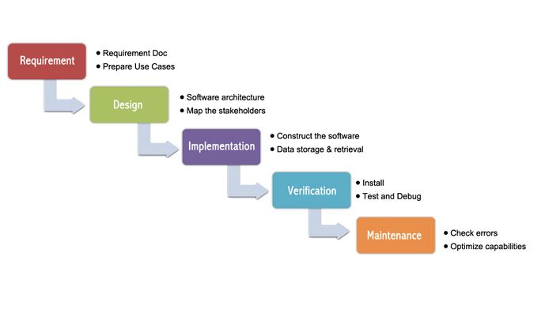

**3.1.1 How Myntra Would Be Developed Using Waterfall method:**

* **Requirement Gathering**: A complete definition process for new system requirements and update features proceeded according to business and technical specifications from Myntra's product and technology personnel.
* **System design**: The design process depends on the needs where technical architectures and system designs occur. The development process includes designing both the program interface and the database components for inventory administration.
* **Implementation**: During the implementation phase developers begin their work through code development using design plans. The team completed two key tasks such as adding payment gateway integration or upgrading the recommendation system.
* **Testing** :Following development the application completes extensive testing operations which check system functionality against established specifications. The testing phase covers user-driven evaluations and demands high-volume performance tests to verify system stability under peak usages.
* **Deployment**: After completing live testing the updated system or new configuration is deployed for Myntra to its operational environment
* **Maintenance:** The maintenance stage focuses on fixing bugs which occur after deployment while applying patches or improvements keeps the system operational.

**3.1.2 Pros Advantages of Utilizing the Waterfall Model for Myntra:**

1. **Unambiguous Requirements and Documentation**: The availability of elaborate specifications beforehand is the best way to meet the project requirements and this is crucial for all members to know accordingly, especially in the case of Myntra that requires large-scale developments.

2. **Predictable Timelines and Budget**: The phase lock mechanism would be advantageous for Myntra regarding resource & budget management and consequently, financial forecasting would be more precise.

3. **Designed Process**: The straight-line method can be utilized for both monitoring development and ensuring quality, which is especially beneficial for difficult tasks like backend optimization.

4. **Perfect for Small Projects**: Start-End flow would apply only for certain types of tasks like internal system upgrades where the requirements are simple and explicit.

**3.1.3 Cons of waterfall model for Myntra:**

1. **Resistance to Change**: Once requirements get frozen, changing them is difficult, which hampers Myntra's ability to adapt to changing market trends.
2. **Testing After Development**: Need for speed in Myntra's dynamic market makes testing after development a risky proposition that could potentially push out releases of features.
3. **Limited Scope for Revision**: Waterfall does not lend itself to iterative feedback, which makes it an unsuitable methodology for Myntra's ever-evolving e-commerce site.
4. **Inflexible Total Requirements vs Market Needs**: Total requirements will be fixed.

3.2 INCREMENTAL DEVELOPMENT MODEL

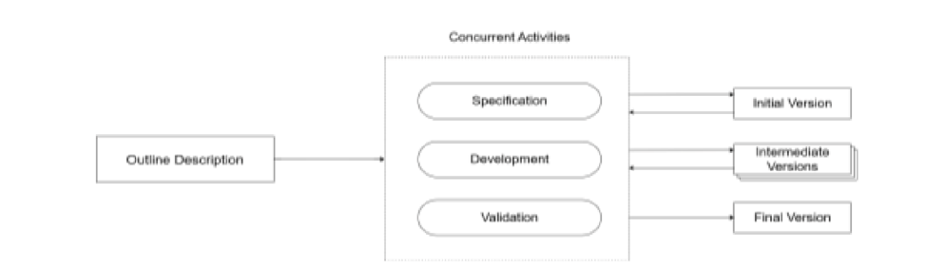

**3.2.1 Incremental Development Model at Myntra Involves:**

1. **Incremental Feature Additions**: Myntra's model includes a strategy to add features or updates incrementally. An example could be rolling out a product recommendation algorithm incrementally: first, through a small-sized dataset, observing real-time feedback from usersand then spreading the changes to the full-size deployment.
2. **User Interface and User Experience (UI/UX) Iterations**: On the website and mobile application, Myntra's The User Interface (UI) and User Experience (UX) are improved with each passing day to satisfy users' evolving needs. This keeps the ongoing experimentation with different layouts, designs, and navigation features running with a small group of users before rolling them out for the larger set, based on the feedback analysis.
3. **Backend System Optimizations**: Thanks to incremental development, backend systems (e.g., payment processing, logistics, or inventory management) can be incrementally optimized. For example, Myntra might start with optimizing a certain component of its backend such as the payment gateway, and after stabilization, proceed to the optimization of other systems.
4. **Incorporation of New Technology**: With incremental development, Myntra may explore AI shopping assistants or augmented reality (AR), and it may develop some distinct technology to pilot with some users before being expanded.
5. **Feature Flags**: With feature flags, Myntra may first roll out certain features or updates gradually across some groups of users. This allows them to switch features on or off conveniently for a small group of users, which becomes very useful for carrying out A/B tests and getting some real-time feedback about user preferences.

3.3 SPIRAL MODEL

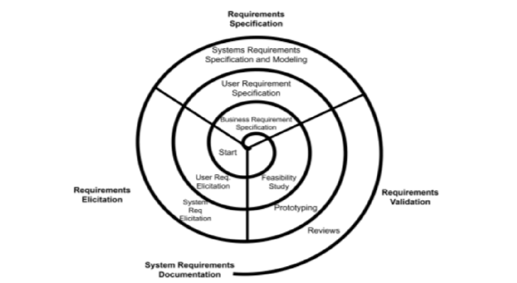

**3.3.1**  How Myntra Would Be Developed Using Spiral:

1. **Iterative Development**: Myntra may also be using the Spiral Model to jointly establish iteration-based development of features for continuous feedback and the refinement of new functionalities, such as version updates for its app.
2. **Risk Management**: By employing every phase in more effectively pinpointing and curtailing risks, Myntra can pre-empt potential problems, especially in complex areas like backend optimization.
3. **Prototyping**: Myntra can prototype new features, such as AI recommendations or AR experiences, testing on users before going wide scale.
4. **Continuous Refinement**: Features are iteratively refined, allowing Myntra to respond to macro trends in customer behavior and market switches.

**3.3.2 Pros of the Circular Model for Myntra:**

* **Reduction of Risk**: Regular assessment avoids later big problems by identifying and managing risk factors early.
* **Flexibility to Changes**: Features can be refined or changed based on continuous reviews from feedback, enabling Myntra to embrace change.
* **Focusing on the Customer**: Continuous prototyping ensures Myntra can put up features that can address customer needs seamlessly.
* **Improved Planning**: Frequent assessment brings about a good plan for resources and timelines and thus improves project management.

**3.3.3 Cons of the Circular Model for Myntra:**

* **Resource-Heavy**: Due to iterative nature, all teams need to participate all the time, which is very resource-consuming for Myntra.
* **Difficult to Handle**: Handling several prototypes and iterations can give serious problems in terms of project management; this may become difficult when working with large groups under this model.
* **Increased Time to Market**: Continuous iterations and re-evaluation may lead to increased time taken for the overall launch of the final product features.
* **Possible Overengineering**: While focus on prototyping and iterative design may create elaborate designs, in some cases it may lead to overengineering for the profit, therefore making a feature more complex than necessary.

3.4 Summary of Comparision

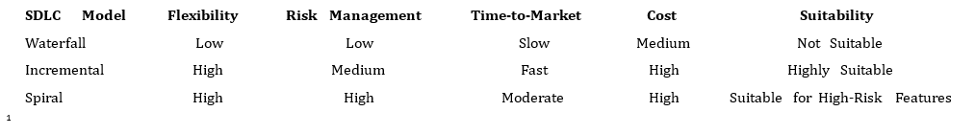

**4. Requirements Engineering Process**

**4.1 Requirements Gathering**

* **Stakeholder Meetings**: Were convened to elicit information through interviews, focus groups, and questionnaires.
* **User Stories and Use Cases**: Draft detailed documentation to capture user needs and expectations.

**4.2 Requirements Analysis and Verification**

* **Analysis**: Includes specification clarity, feasibility, and contradiction-free conditions.
* **Prototyping and User Feedback**: Validation of the requirements through the use of prototypes and early feedback collection.

**4.3 Requirements Specification**

* **Formal Documentations**: Each requirement is documented along with descriptions, acceptance criteria, and priorities.
* **Versioning**: Change tracking is there to effect the desires of stakeholders.

**4.4 Requirements Management**

**Change Management**: A structured approach is undertaken in managing any changes in requirements.

**5. Challenges and Solutions**

**5.1 Journey of Dynamics in Demand**

**Challenge**: Sudden spike in demand scenarios during sale events can pressurize the entire system.

**Solution**: AI-based prediction algorithms need to be put in place for optimizing the inventory and the delivery functions.

**5.2 Payment Failures**

* **Challenge**: Problems of the payment gateway can lead to the user experience, that would otherwise have been totally delightful, turn into agony.
* **Solution**: Smooth integration among multiple payment gateways facilitates fallback options.

**5.3 Logistics and Delivery**

* Challenge: Delivering across a vast geographical extent on time to all corners of India.
* Solution: With hybrid models in logistics, use a well-designed network of distribution CE... centers.

**6. Emerging Technologies and Innovations**

* 1. **Artificial Intelligence (AI), Machine Learning (ML)**

**-Personalized recommendations**, dynamic pricing; and fraud detection.

**6.2 IoT**

-Brainchild of smart inventory management and shipment tracking on the blink of an eye.

**6.3 Blockchain**

-Transaction security and transparency has taken an upside.

**7. Case Studies and Real-Life Example**

**7.1 Myntra's Growth Strategy**

Myntra's strategy for growth is about being ahead of the competitive e-commerce race by being centered around fashionable products, premium fashion, and private labels. By tapping into the latest fashion trends and offering exclusive products through private labels, Myntra has made a niche for itself in the Indian fashion industry. The company has partnered with global and domestic brands to offer a wide variety of products as well as utilized in-house brands targeting the price-conscious and fashion-conscious consumer. Additionally, Myntra's focus on high-quality, trendy, and unique products puts it ahead of the pack in the online fashion industry, building a huge customer base and encouraging brand loyalty.

**9.2 Myntra's UI Innovations**

Myntra has constantly innovated its user interface (UI) to offer a superior shopping experience, staying ahead of the curve in e-commerce technology. One of its cutting-edge features is the "Try Before You Buy" feature, which uses augmented reality (AR) to allow customers to virtually try on clothes before buying them. This technology allows customers to visualize how clothes will fit and look on their own bodies, reducing the likelihood of returns and building customer confidence. Myntra's use of AR enhances user engagement and sets the bar high in online shopping, making it more interactive, fun, and personalized.

**9.3 Profitability Achieved by Myntra**

Myntra's aggressive strategic actions have helped the company's profitability. In FY 2024, the company posted a profit of INR 31 crores, indicating its effective cost control and operational efficiency. By concentrating on premium fashion, private labels, and supply chain and logistics optimization, Myntra has been able to cut costs while improving product quality and variety. The brand's ability to strike a balance between quality products and cost-efficient strategies has helped the company, boosting profitability. Myntra has also concentrated on enhancing customer acquisition and retention through targeted suggestions and loyalty schemes, which have driven revenue and boosted margins.

**9.4 Market Position Achieved by Myntra**

Myntra has emerged as India's online fashion champion, constantly evolving to address the varied needs of its customer base. The platform has cemented its position by providing a vast array of products, from clothing to footwear and accessories, across price segments. Myntra's customer-centric approach is evident in its quick delivery, convenient return, and easy website and app experience. The company has emerged as the first choice brand for fashion and convenience, constantly innovating with the latest technologies, including AI-driven product recommendations and cutting-edge logistics. Myntra's market position is supplemented by its emphasis on enhancing the customer experience and staying in front of fashion, ensuring that it is the first choice among Indian online consumers.

**10. Conclusion**

The story of Myntra, from a small gifting website to an e-commerce giant, found its success in its innate qualities of innovation, agility, and user-centeredness. Adopting the Spiral Model and embracing the latest technologies was Myntra's key to overcoming challenges and setting new benchmarks . Myntra's commitment to quality will help it thrive as the e-commerce landscape continues to expand.

This report provides an overview of Myntra's Software Development Life Cycle (SDLC), Requirements Engineering Process, and Growth Opportunities, thus providing direction for businesses keen on mimicking its success.