**How to add crosshair**

1. Create a Widget Blueprint
2. Drop an image in the Widget Blueprint
3. Move the anchor (sun looked shape) in the right spot
4. Reset the image position and change the value of both alignment to 0.5
5. Make a Player Controller blueprint and go to the Event Graph
6. Follow this BP

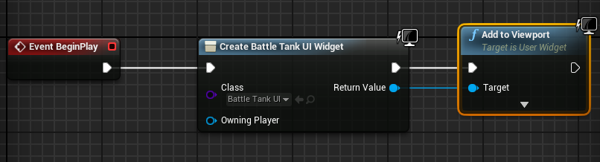

1. Go to your Gamemode blueprint and select the Player Controller blueprint you made.