If you want to see your mouse on the main menu screen, go to you level blueprint and add this:

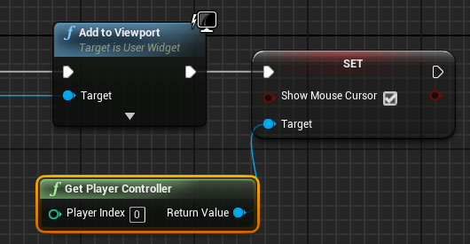

In the Widget blueprint add “Scale Box”. The Scale Box needs to be the child of the Canvas Panel and the Image needs to be the child of the Scale Box. Then, change the Anchors of “Scale Box” and reset the “Offset” value. Then, go to “Stretch” and change it to “Scale to Fill”. This will fix the scaling.

For text and other things, don’t put it in the Scale Box.

Don’t forget about the Anchor (sun shaped).