**How to make a button work**

1. On the button, check the “Is Variable” and click on “OnClicked”
2. Now you have an event graph where you can do anything

Example:

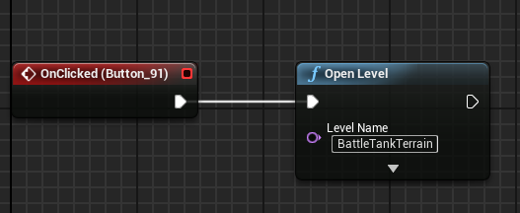

If you want that it selects the button if the game is started, you need to follow this:

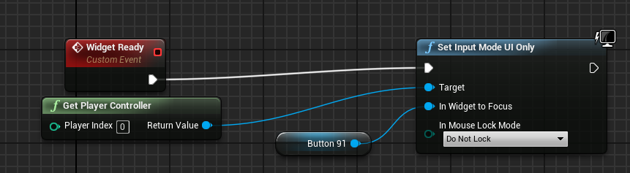

In the button blueprint

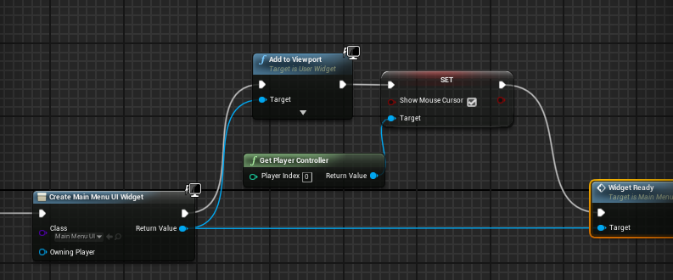

In level blueprint

Note: You can’t rotate the camera in game, will fixed soon