**How to get the controlled tank in C++**

1. Create a C++ player controller
2. Create a C++ pawn/actor/character
3. Go to your blueprint player controller
4. Click on “Class Settings”
5. Next to “Parent Class” select your C++ player controller
6. Go to your blueprint pawn/actor/character
7. Click on “Class Settings”
8. Next to “Parent Class” select your C++ actor/pawn/character
9. Open your C++ player controller and follow this code:

In .h

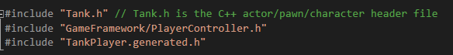

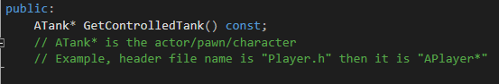

In .cpp

