A **virtual** method can be overridden by children

The **override** keyword is a sanity check

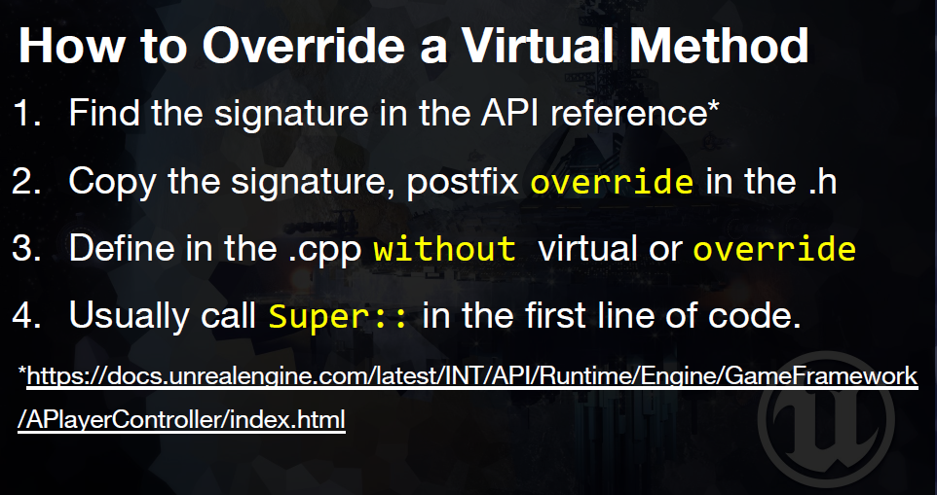

Example usage is BeginPlay()

In .h



In .cpp

