**Using OUT parameters**

Example:



In .h

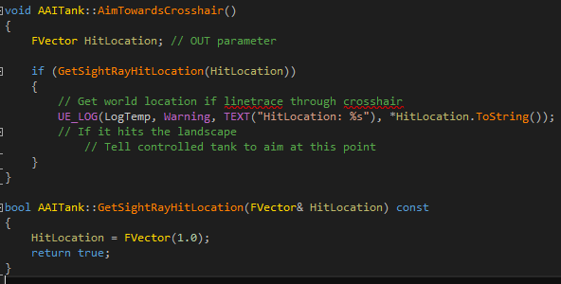

In .cpp