**How to get the location of crosshair on screen**

1. Where is the crosshair? If the crosshair is in the middle, the location is the half of the viewport. Example: Viewport x and y are 500. The location of crosshair is 500 * 0.5 = 250 x and 250 y.
2. Follow the code:



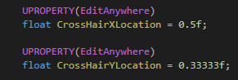

Crosshair is in x axis 50% from left and in y axis 33.3% from above