

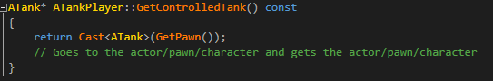

Calling a function from another .cpp file. In this example from ATank.