**Moving barrel**

1. Create a function that rotate the barrel and use AimDirection as parameter
2. Create FRotators for aim, barrel and delta

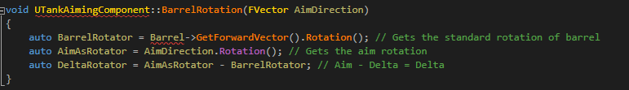

1. Understand complication process

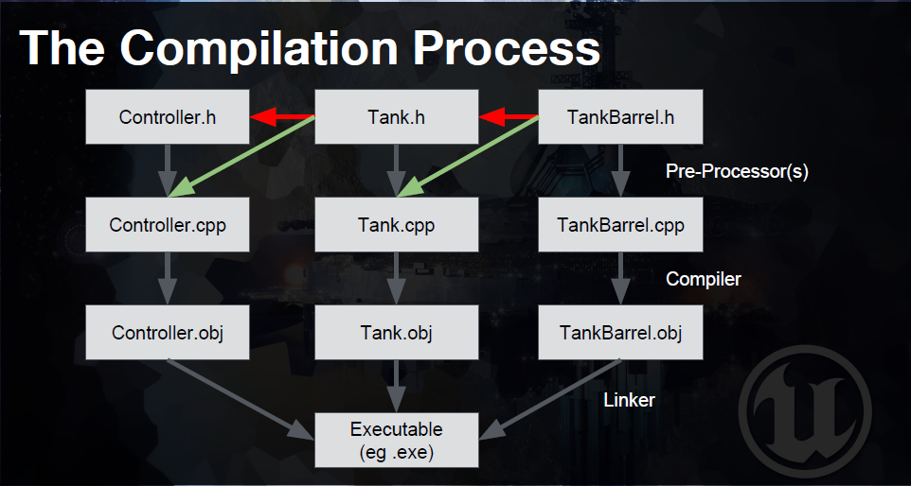

1. Make a new C++ class, make it StaticMeshComponent for the barrel

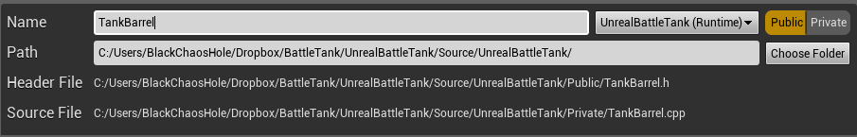

1. Make a function in TankBarrel that elevate the barrel with as parameter the degree per second

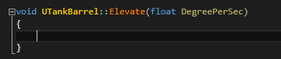

1. Make a forward declaration in TankAimingComponent



This will help you access TankBarrel



1. #include TankBarrel in TankAimingComponent.CPP



Because we change/use Barrel in .CPP



1. Make a forward declaration in Tank
2. In TankBarrel.H, we need to set so that the blueprint can call the component. To do this we are going to change UCLASS to this



10. In the blueprint, we are going to use the component

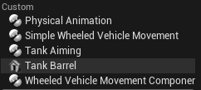

11. Use the following code

