Making a component in C++

1. Make a C++ Actor Component

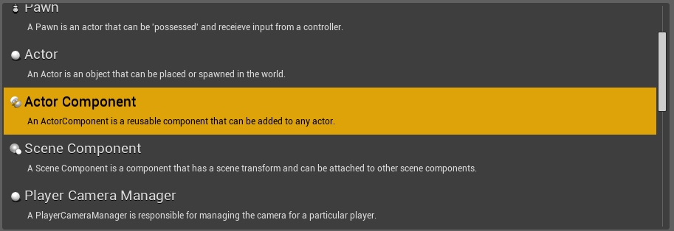

1. Include it in the actor.h or pawn.h



1. Creating the component in actor.h or pawn.h



(U stands for component)

1. Add the component. Use CreateDefaultSubobject



(Ignore the errors)

Calling codes from the C++ component

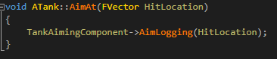

(Here, I am calling the function AimLogging)