Calling things from blueprint

1. Go to your C++ component
2. Create the object you want to call



(The barrel is a static mesh component)

1. Make a function that sets the object you want to call



(BarrelToSet = Barrel)

1. Create the function

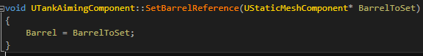5. Go to another C++ file that isn’t a component

6. Do step 3 with the exact same function name and parameter

7. Set above step 6 the following



(This will make you using the function in blueprint)

8. Make the following function

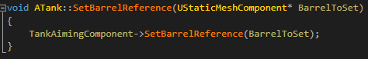

9. Go to your blueprint and now you can use this function and select your object

