**Projectiles**

Understand the physics of the projectile. There are 2 arcs.

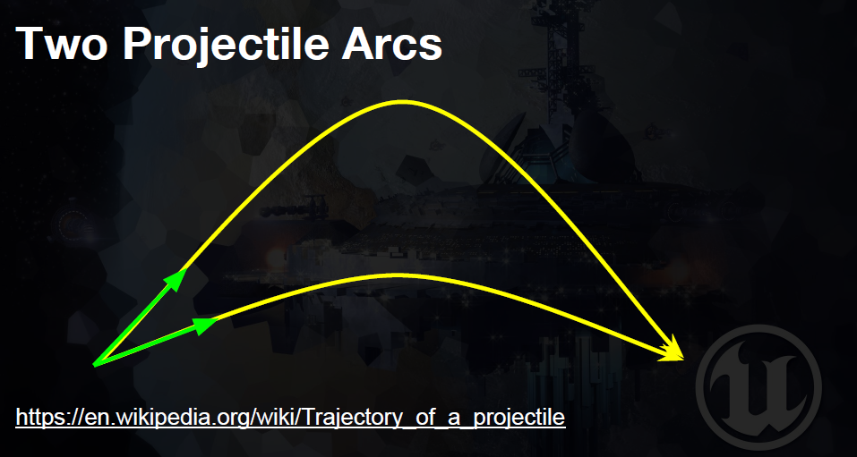

A low arc and a high arc. There begin and end in the same place, but the high arc is **slower** than the low arc. We are going to use the low arc.

More information: <https://en.wikipedia.org/wiki/Trajectory_of_a_projectile>

1. Make a float variable for LaunchSpeed



1. Add the float to the parameter of a component function:

In Tank.cpp

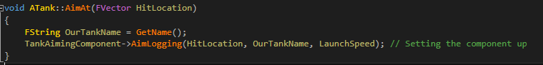

In TankComponent.cpp

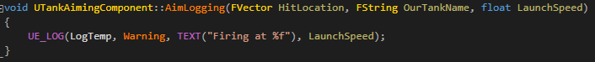

In TankComponent.h



You can now see that it will log the LaunchSpeed and you can edit it in the blueprint



