SuggestProjectileVelocity

Information: <https://docs.unrealengine.com/latest/INT/API/Runtime/Engine/Kismet/UGameplayStatics/SuggestProjectileVelocity/index.html>

1. Create a vector variable for the out parameter



1. Create a socket to the place where you fire the projectile

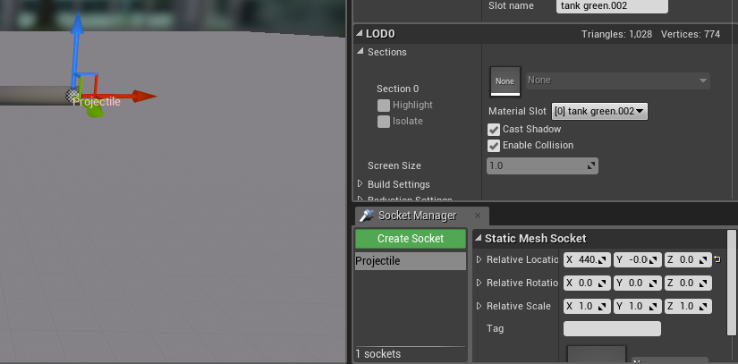

1. Create a vector variable for the StartLocation and make the value the location of the socket



1. Use SuggestProjectileVelocity()

