For firing, to the following things:

* Make a Fire() method in tank c++ file
* Make it BlueprintCallable
* Bind input

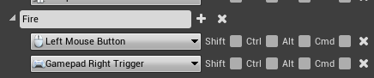

In .h



In .cpp

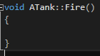

In BP

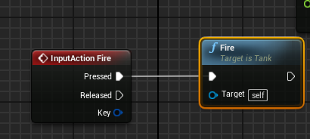

Making projectile

1. Create an actor c++ file
2. Make a blueprint based of c++ file