Spawning projectile

1. In the projectile blueprint, create a sphere mesh
2. In tank.h, follow this code

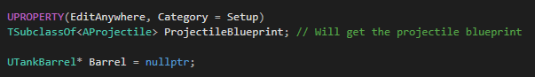

1. In blueprint, select the projectile blueprint
2. In tank.cpp follow this code



