Shooting projectile

1. We need to add the ProjectileMovement component to the projectile blueprint, we do this with CreateDefaultSubobject.
2. In projectile.h



In projectile.cpp

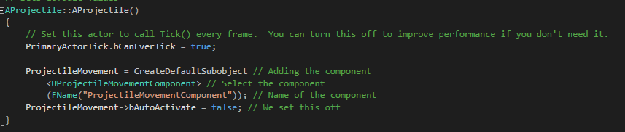

1. Compile the code and compile in the projectile blueprint
2. Create a function in projectile.cpp with as parameter float speed

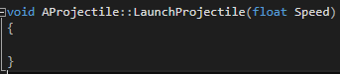

1. In tank.cpp we are going to call this function

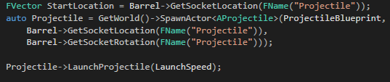

1. In projectile.cpp we are going to launch the projectile

