A.I Tank

1. In A.I Tank, change to this

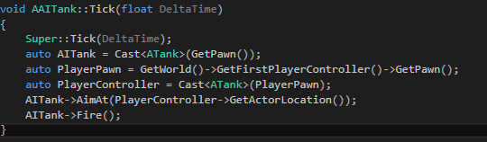

2. In tank.cpp we are going to make a reload time, here is how  
In tank.h



In tank.cpp

