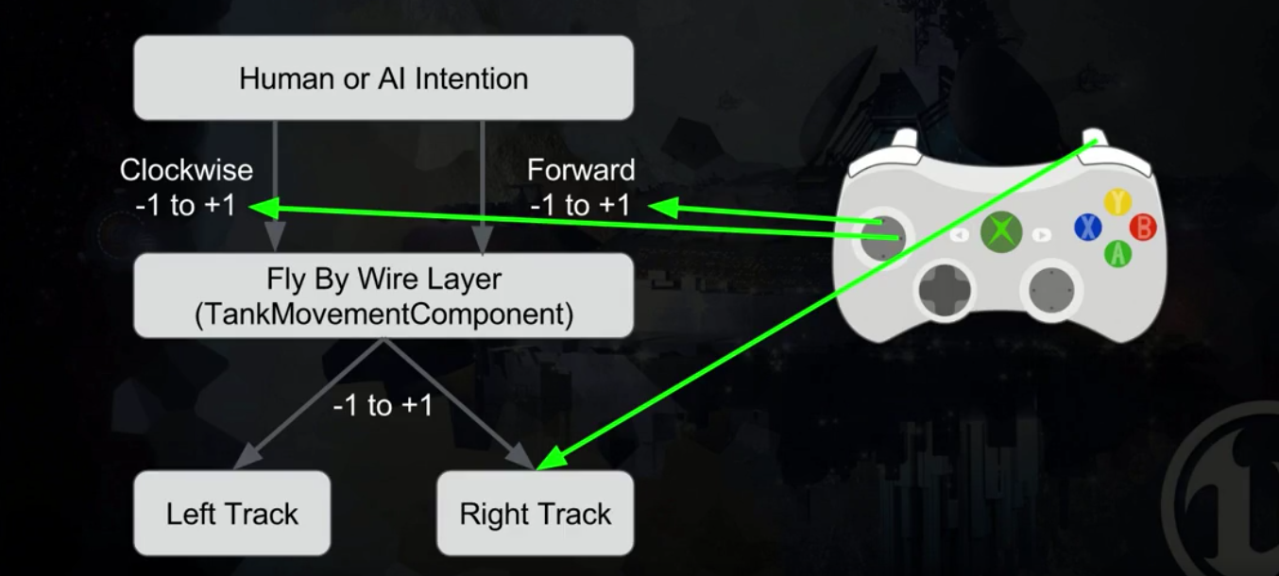

Fly by Wire controller

Create a C++ NavMovementComponent