1. Open your Tank Movement Component.

2. In .h, make a function called “IntendMoveForward” with as parameter a float called “Throw”.

3. Declare it and make a UE_LOG to log the value of Throw.

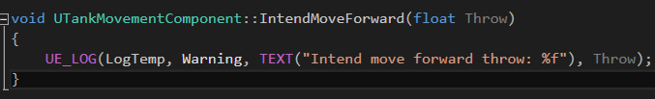

4. Go to your Tank.h and under protected make a component like this:

BlueprintReadOnly will allow you to make reference of the component. It is handy.

5. Forward declare the TankMovementComponent in tank.h.



6. In tank.cpp, #include the TankMovementComponent header file.

7. Under the set defaults, add this:



8. Go to your tankmovementcomponent.h and add this above the IntendMoveForward funtion:



9. Compile.

10. In the Tank blueprint, add this:

