1. Go to your TankMovementComponent.h and make a 2 references to the TankTrack (one for left and one for right).

DON’T FORGET “class UTankTrack”



2. In TankMovementComponent.cpp, make a function that can set references to the tanktracks. (Don’t forget to declare it and make it blueprintcallable in the header file.)

.cpp



.h



3. Protect LeftTrackToSet and RightTrackToSet inside the function.

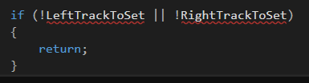

4. Make the value of the Tracks the same to the TracksToSet.



Include TankTrack



Add this in IntendForward()

5. In .h, add this



6. In tank.cpp, remove this



7. Compile.

8. In Tank blueprint, add this

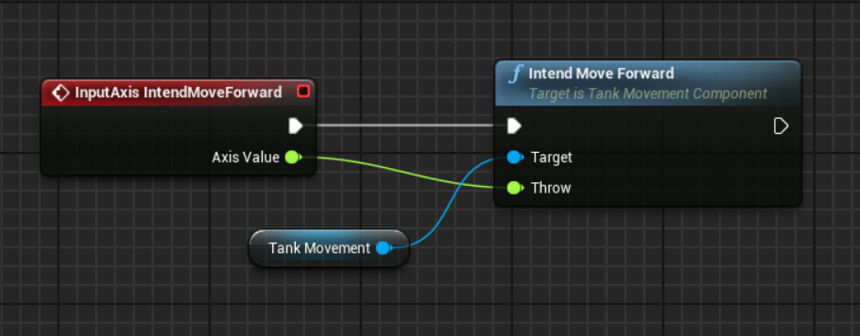

(Don’t forget to remove the old one)

9. Add this to Event Play:

