Moving the tank diagonal.

1. Go to TankMovementComponent and copy the function IntendMoveForward and name it IntendMoveRight. The only difference is that you change throw to -throw by the righttrack:

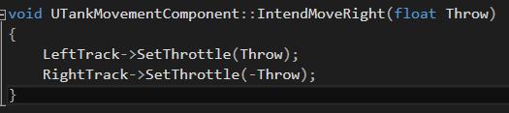

(Don’t forget to declare it and make it BlueprintCallable!)

2. In projectsettings, make an axis mapping gamepay joystick x. Call it TurnRight.

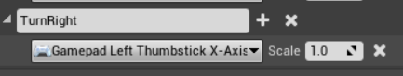

3. In tank blueprint, add this:

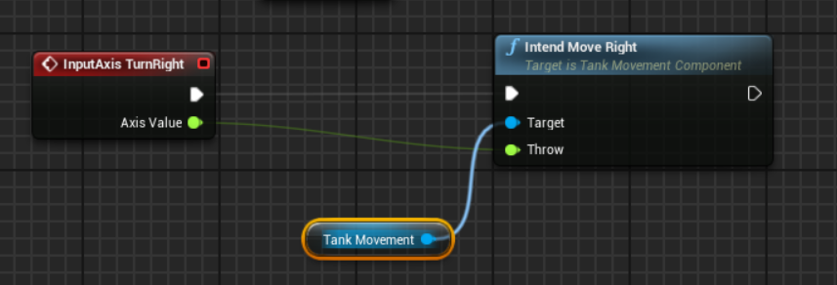

Navigation

1. In viewport, click on “Show” and then click on “Navigation”

2. In “Modes” tap, add “Nav Mesh Bounds Volume”

Green stuff is where the A.I. can go.

You can expand is via “Size”

Move to actor

1. Go to your TankAiController.cpp.

We’re going to add MoveToActor()

2. Under if(PlayerTank){}, add MoveToActor with the parameters:

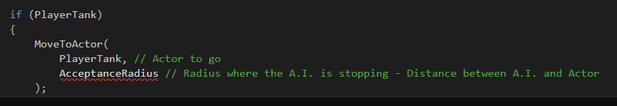

(Don’t forget to make an AcceptanceRadius float variable.)

3. Go to your TankMovementComponent.h and add the following line:



4. In TankMovementComponent.cpp, add the function:

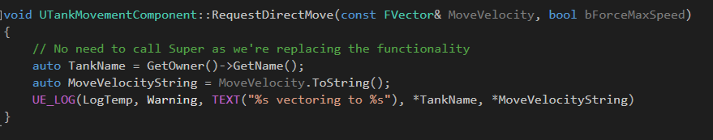

This is a debug to see where the A.I. wants to go.

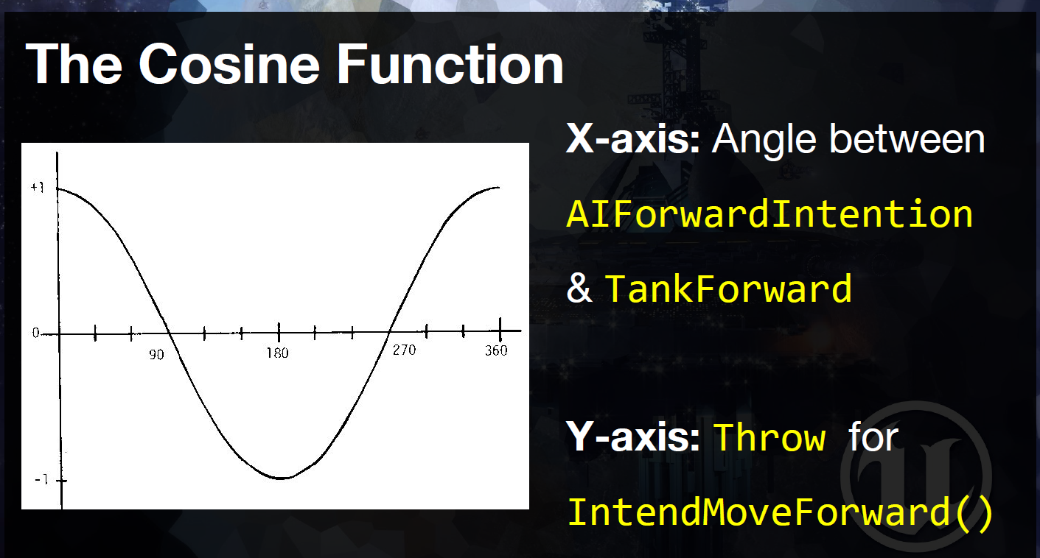

5. Make the function into this:

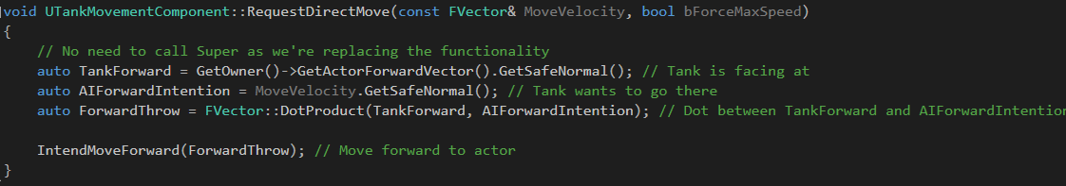

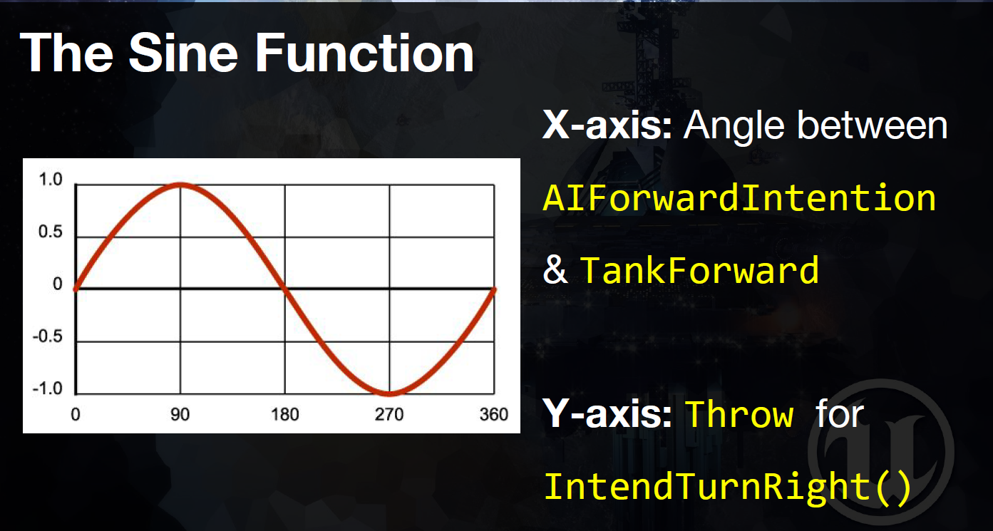

6. Now use this function to rotate:

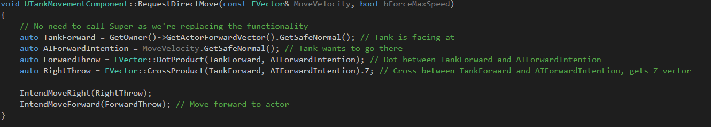

(We use Z so it rotate to you with Z)

Movement fix

1. Go to track.cpp and add a constructor and a tick:

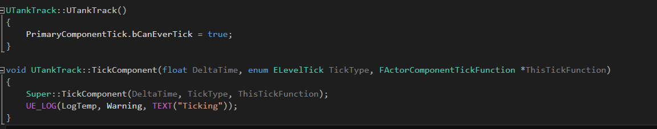



(NOTE: If ticking isn’t working, restart editor)

2. Change the function to this:

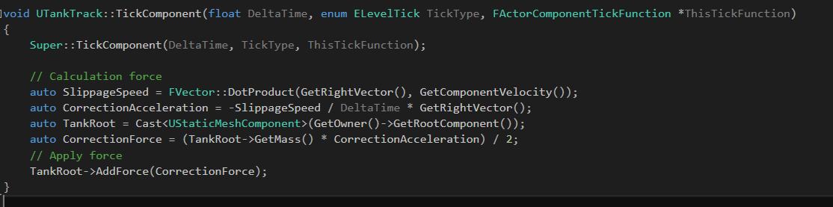

3. Go to your tank blueprint, select the tracks, check Simulate Generate….:

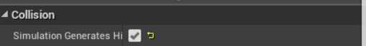

4. Go back to your TankTrack files and add a begin play function:

In .h



In .cpp

(With the following code)

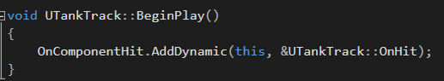

5. Add this function:

In .h

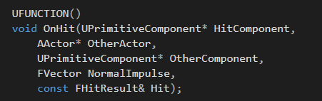

In .cpp

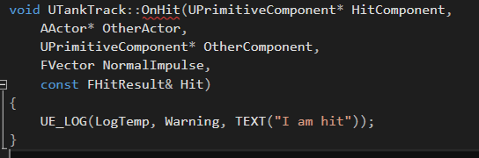

6. Go to your tank blueprint, select your Tank and check Simulate Generate….

7. Change Damping (How more Damping, how more the tank will slow down in acceleration):

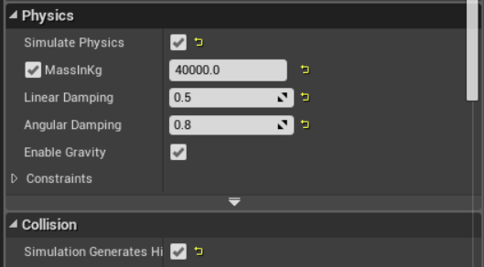

8. Go to your TankTrack file and select the code in the TickComponent and make that into a function and call it ApplySidewaysForce:

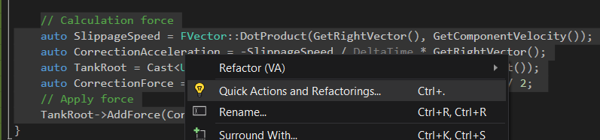

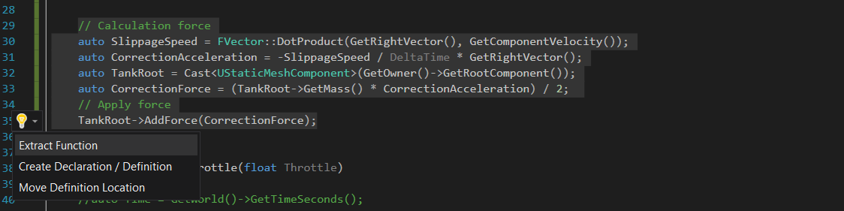

9. Remove the Delta Time parameter.

10. Add this to the ApplySidewaysForce:



11. Don’t call the function in the tick! Call it in the OnHit event:

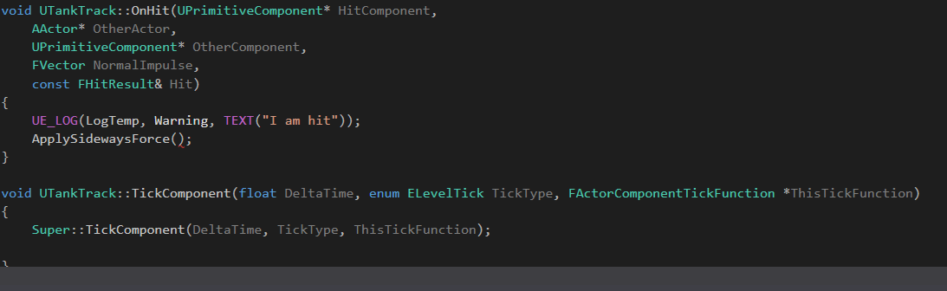

12. Select this, and make it into a function with right click. Called it DriveTrack. Remove the parameters:

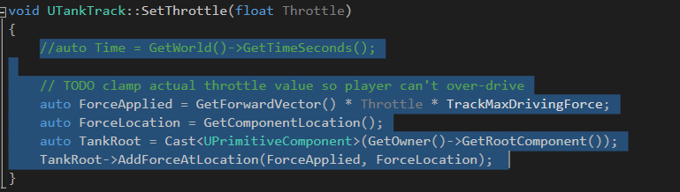

13. In the .h make this function:



14. Change Throttle inside the function to CurrentThrottle:

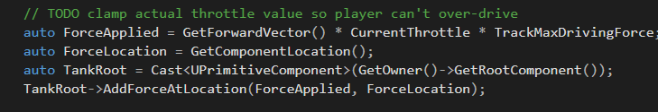

14. Change SetThrottle to this:

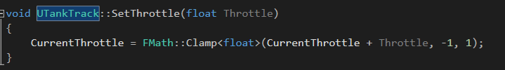

15. Change the function to this:

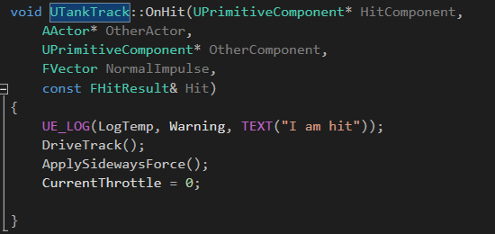

Aim fix

1. In TankAimingComponent.cpp, change to this:

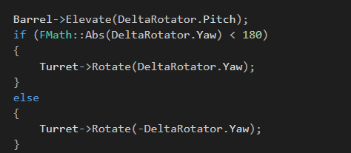

<https://www.udemy.com/unrealcourse/learn/v4/t/lecture/5477614?start=0>