Assignment 4 solutions
Name: Lino Joseph
Roll number: be24b028

Answers:

1. a. Write a program to construct a dot plot for the alignment of human and chicken
hemoglobin β chain. Identify the segments, which are same in both sequences.
b. Construct the dot plot manually for the residues 1-20 and verify with the plot
obtained using program

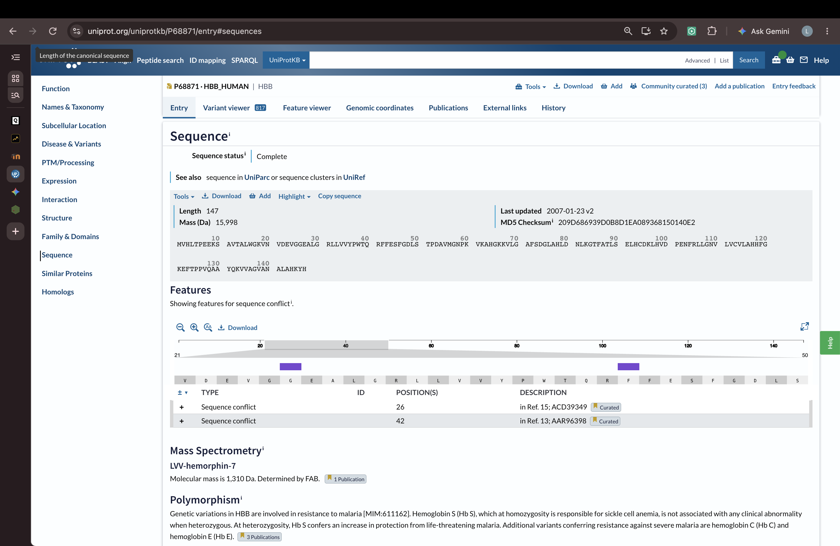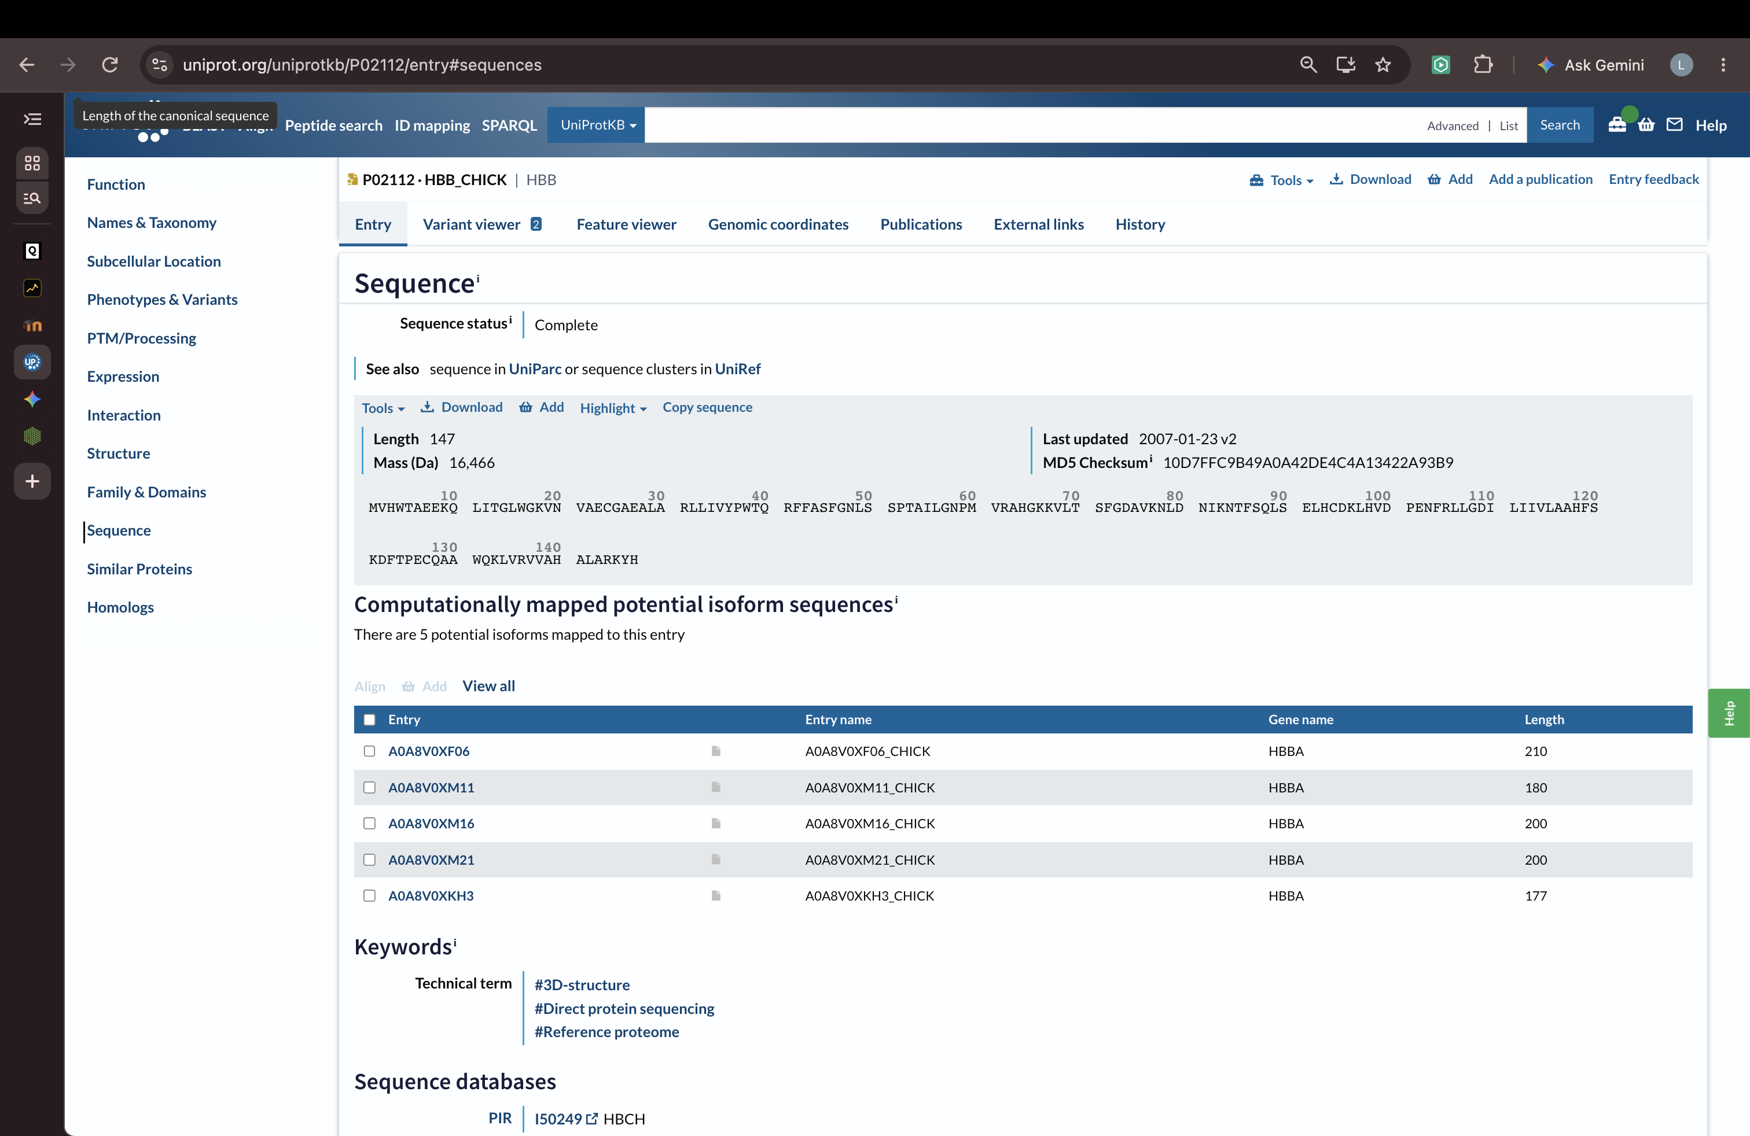
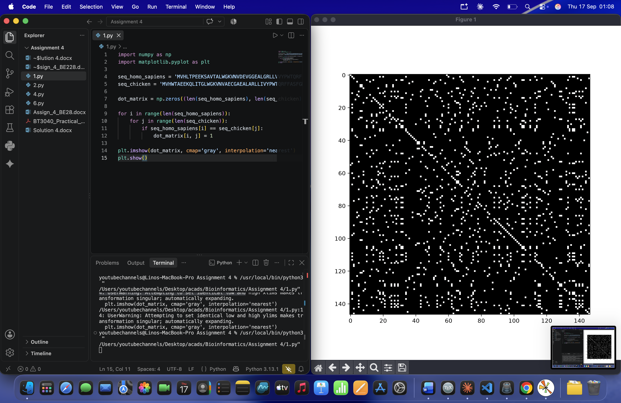

2. Calculate the score for the following alignments using code:
AATCTATA
AAG--ATA
Assume that the match score is 1, mismatch score is 0, origination penalty is -2, and
length penalty is -1.

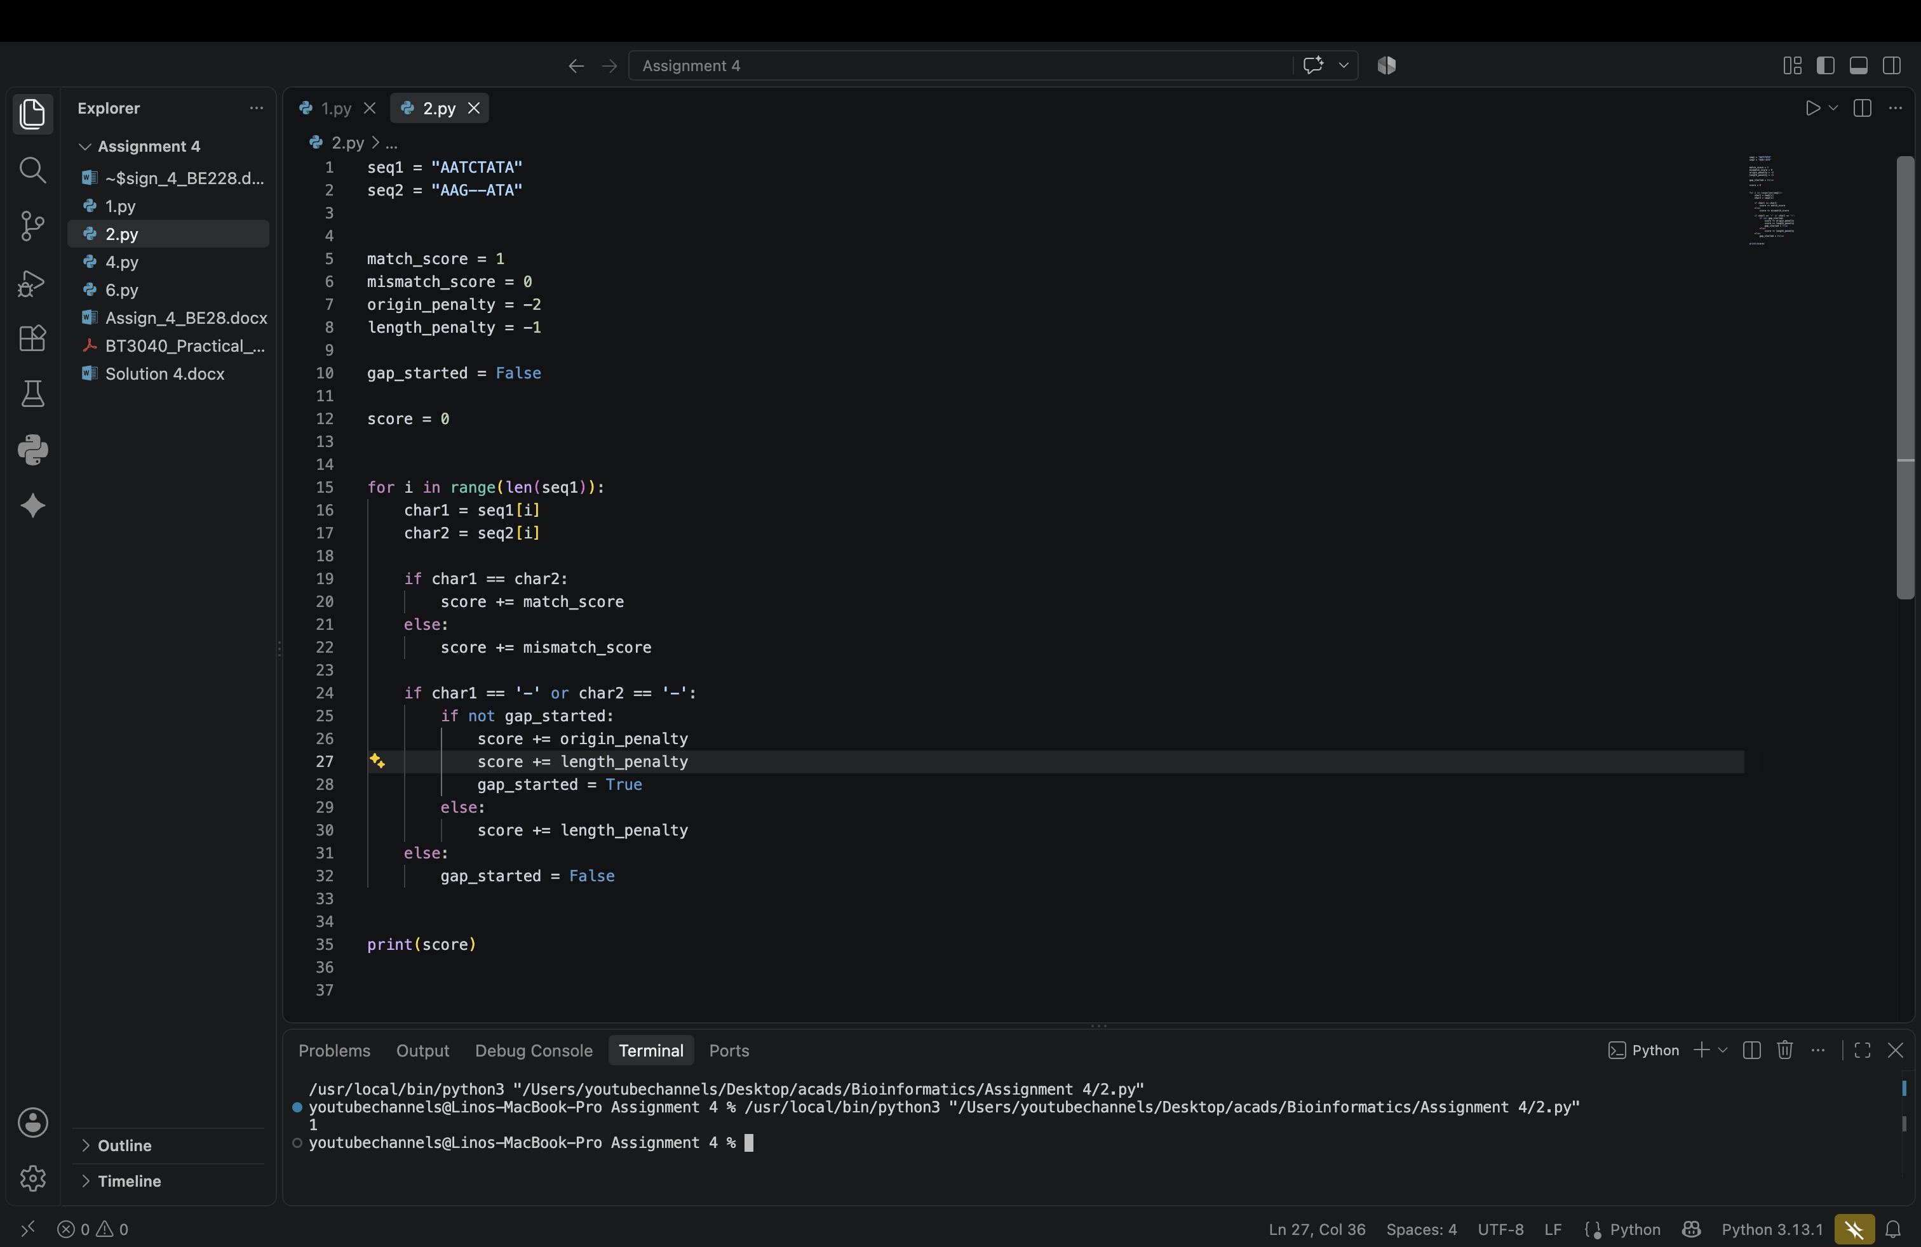

4. Using the Needleman and Wunsch dynamic programming method, construct the
partial alignment score table and align the following two sequences (using code):
ACAGTCGAACG and ACCGTCCG
use the scoring parameters: match score: +2; mismatch score: -1 and gap penalty: -2

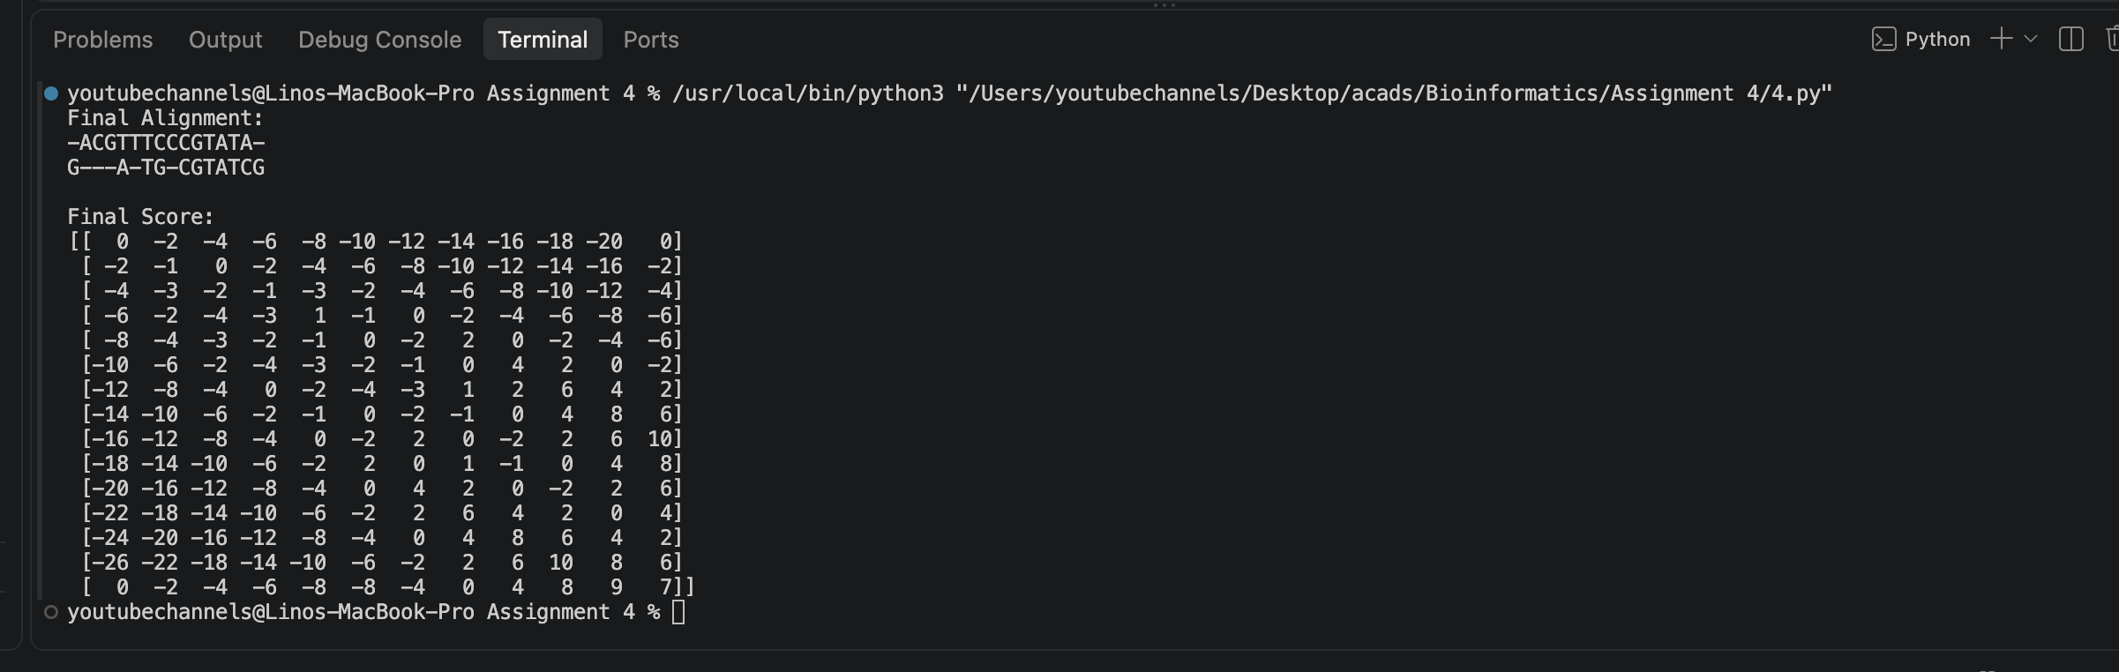
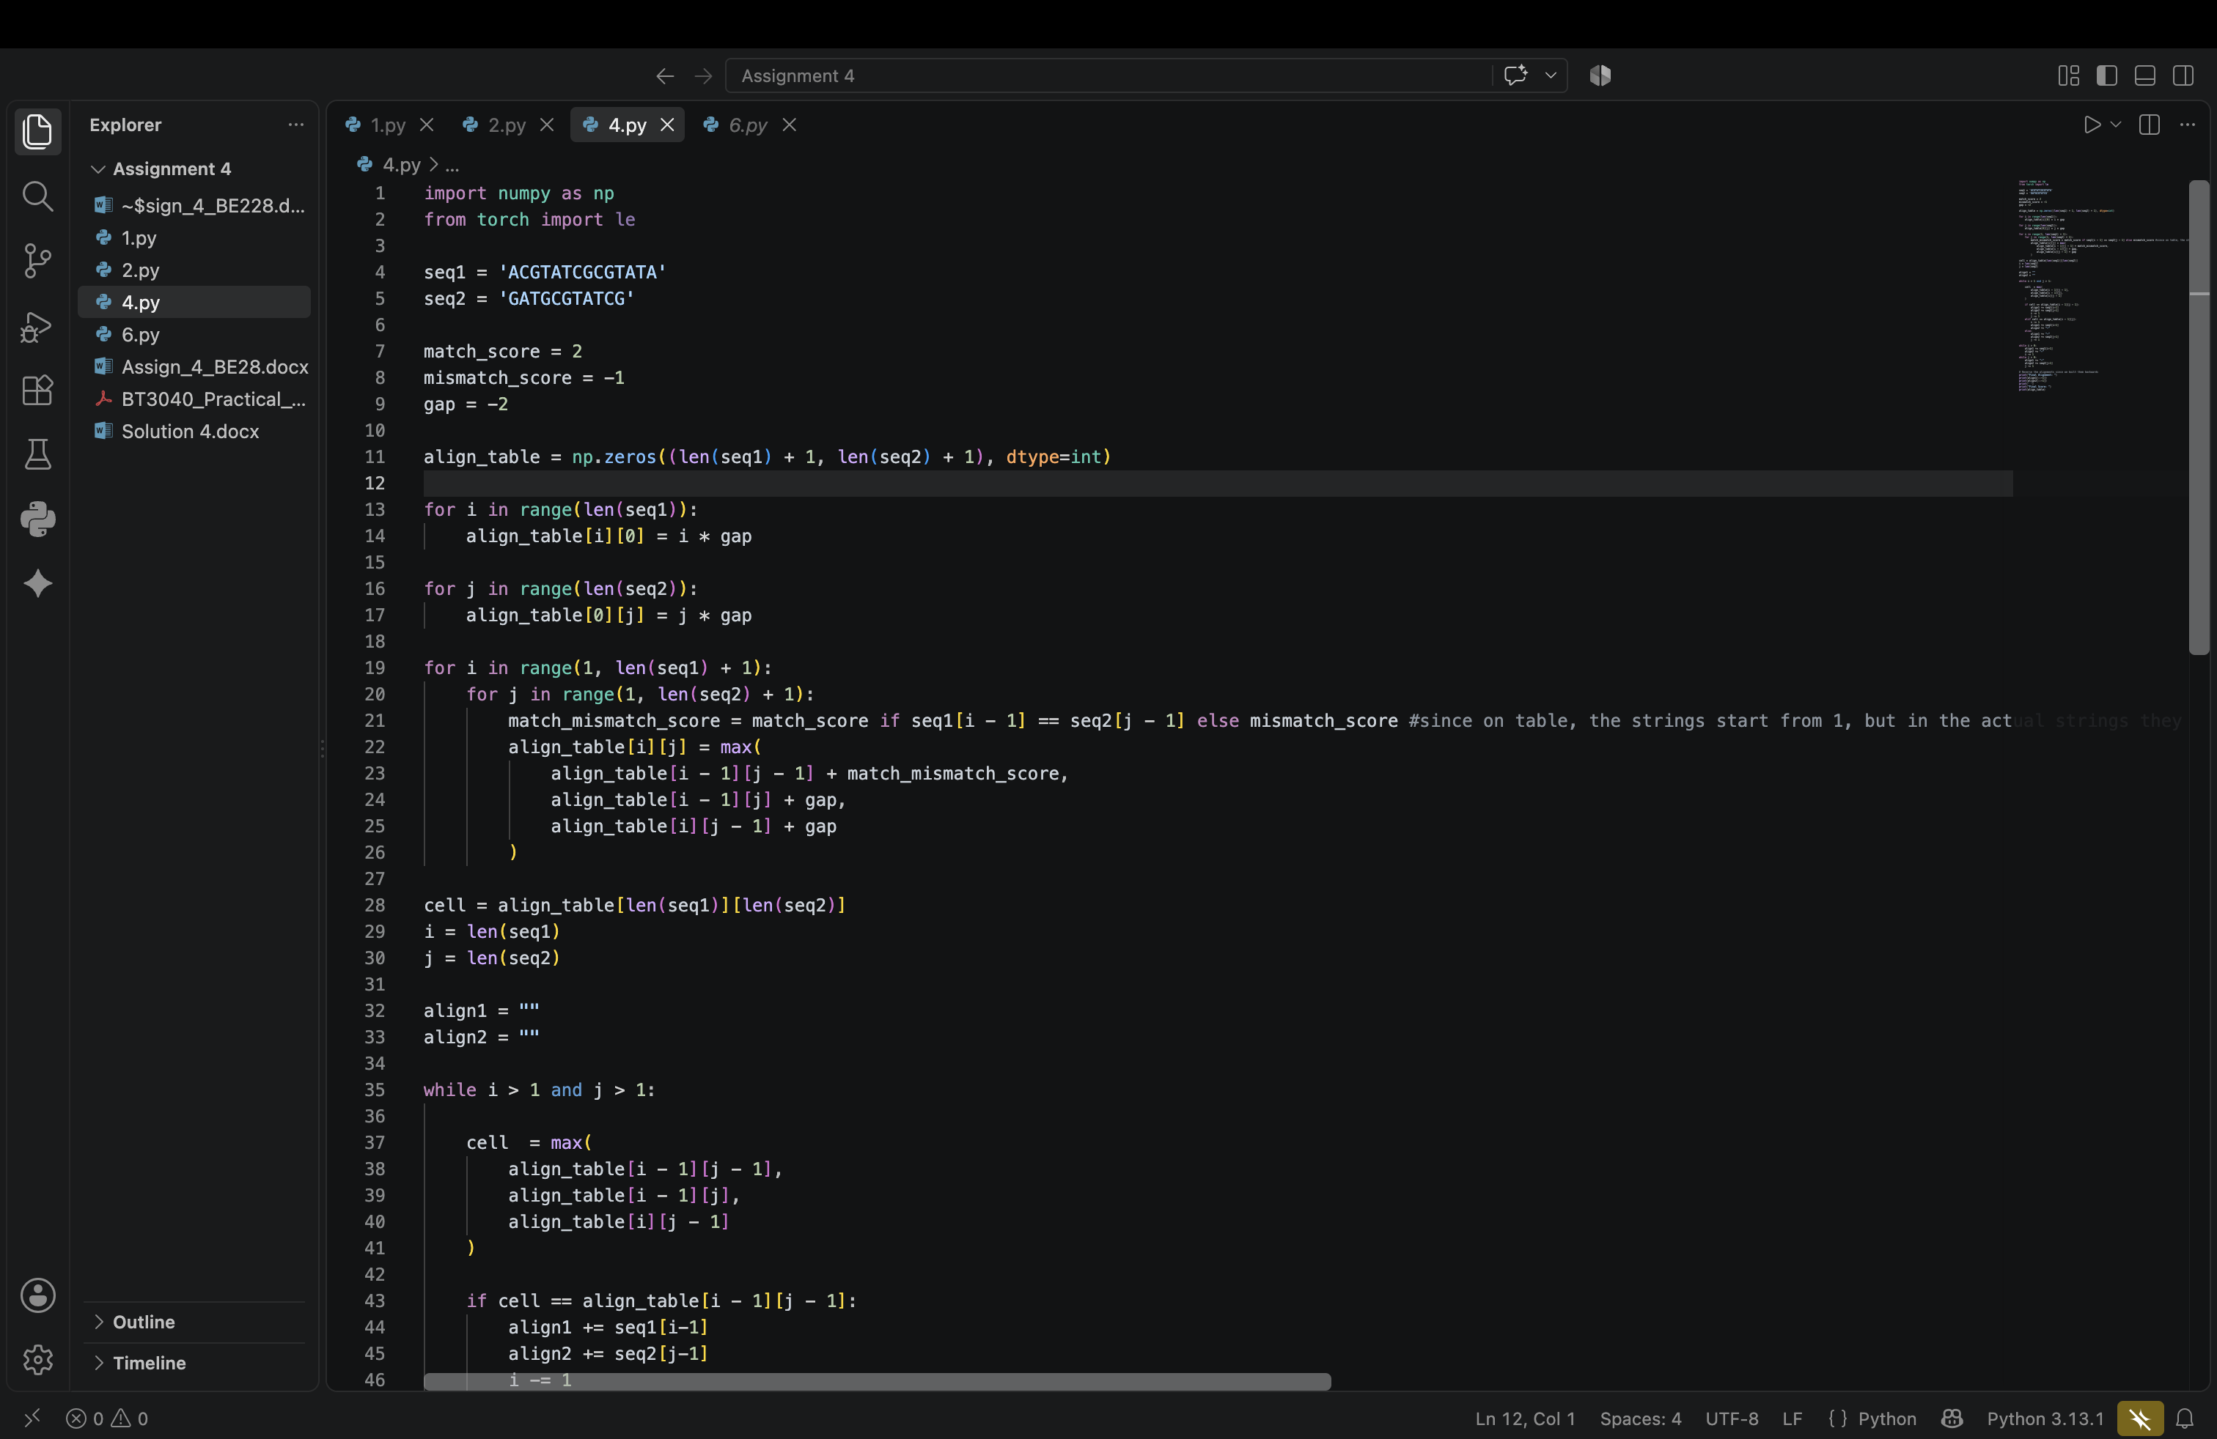
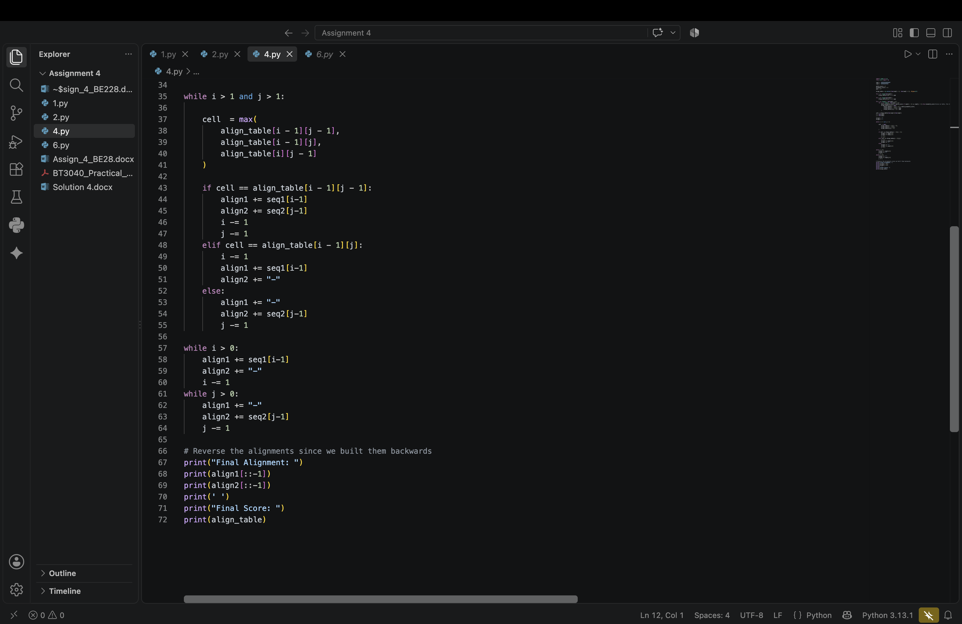
6. Using the Smith-Waterman method, construct the partial alignment scoring table and align
the following two sequences (using code):
ACGTATCGCGTATA and GATGCGTATCG
scoring parameters: match score: +2; mismatch score: -1 and gap penalty: -2

