Asclepius Clinical: An Offline Edge-Deployed Voice-to-Prescription Assistant Using Whisper ASR, Phonetic Medicine Normalization and Quantized Local Language Models
Ramees Muhammed K H  Reg. No. 24BCE5469  SCOPE.  Vellore Institute of Technology  Chennai  Chennai, India  ramees.muhammed2024@vitstudent.ac.in | Joe Jose Mammoottil  Reg. No. 24BCE5081  SCOPE  Vellore Institute of Technology Chennai  City, Country  joe.josemammoottil@vitstudent.ac.in | Dr. Suhasini S  Assistant Professor  SENSE.  Vellore Institute of Technology  Chennai  Chennai, India  suhasini.s@vit.ac.in

Abstract—Manually written and typed prescriptions take up a large chunk of the consultation time for outpatients, and are subject to transcription errors and poor legibility, while cloud speech services come with issues of internet connectivity and patient confidentiality. This work introduces Asclepius Clinical—a clinician-in-the-loop, offline-first system, which turns a doctor’s voice into a structured, editable prescription on a low-cost edge device, such as Raspberry Pi 5. The audio from the microphone, loopback, or a user-uploaded file is downmixed, resampled at 16 kHz, and preprocessed by DC-offset correction, a 5th order Butterworth band-pass filter, and RMS normalization. The voice is recognized by an int8 quantized faster-whisper model biased by a clinical vocabulary prompt. A deterministic pipeline processes recurring distortions of ASR, extracts complaints, diagnoses, medications, investigations, and advice, and performs normalization of medicine names against a 467 entries formulary through Soundex, medical phonetic, and fuzzy matching. An optional 4-bit GGUF language model (Qwen2.5 1.5B through llama.cpp) further refines the structured output, while a rule engine checks for missing data, duplicate ingredients, and drug-drug, disease-drug interactions prior to SQLite database storage and PDF creation. Using a 50-patient clinical note dataset, the hybrid system with LLM refinement provided medication recall of 87.69%, 96.0% diagnoses, and an average refinement delay of 9.55 s per patient, thereby proving prescription creation possible entirely on-device.
Keywords — speech recognition, Whisper, edge computing, Raspberry Pi, clinical NLP, e-prescription, phonetic matching, quantized LLM, offline healthcare
I. INTRODUCTION
Documenting clinical notes is one of the biggest factors that increase the physician’s workload. In the case of outpatient departments where there is a lot of activity, such as India, a physician will be seeing many patients during one session and will also need to write prescriptions for them. There is a wide understanding that handwritten prescriptions are prone to issues of readability and drug-related mistakes, whereas EHR documentation will make the doctor lose focus on the patient. It was seen recently that ambient and dictation-driven AI scribes help alleviate this documentation load [13]. LLMs have performed exceptionally well in clinical knowledge tasks and summarization [6], [7], [14].
However, most of the existing S2T and AI-scribe approaches rely on cloud inference, leading to three challenges: (i) practices where internet connection is unreliable cannot deploy them; (ii) sensitive patient audio data leaves the site, making it difficult to comply with privacy and data governance requirements; and (iii) subscription fees associated with cloud services are too high to be afforded by smaller practices. Moreover, generic ASR models often misinterpret Indian drug brands (like “Dolo 650”, “Pan-D”, “Augmentin 625”), dose abbreviations (“1-0-1”, “BD”, “SOS”), and lab terminology (“HbA1c”) and Whisper-type models have a history of hallucinating speech that was not actually uttered [15].
Modern achievements make a fully offline version possible. ASR models like Whisper [1] and its efficient versions [8], [9] can run on CPU, and with post-training quantization methods [4], [5], it becomes possible to run instruction-tuned LLMs [2], [3] on single-board computers. Leveraging these results, we propose Asclepius Clinical, an embedded voice-to-prescription assistant with the full inference path performed at edge devices.
The main contributions are:
• an end-to-end offline pipeline from multi-source audio capture to a reviewable PDF prescription, deployable on a Raspberry Pi 5 or a commodity PC;
• a lightweight DSP front-end and clinically prompted, int8-quantized Whisper ASR suited to CPU-only edge hardware;
• a hybrid extraction scheme combining deterministic rules, a 467-key medicine formulary and a weighted Soundex/medical-phonetic/fuzzy matcher, optionally refined by a 4-bit local LLM with graceful fallback;
• a clinical rule layer and mandatory clinician confirmation that keep the doctor in control of every prescription; and
• a 50-case benchmark quantifying medication recall, diagnosis detection and latency.
The rest of the paper is organized as follows. Section II reviews related work, Section III describes the methodology and system architecture, Section IV presents results and discussion, and Section V concludes the paper
II. RELATED WORK
Neural ASR technology has advanced from self-supervised encoders like wav2vec 2.0 [11] and convolution-enhanced Transformers like Conformer [10] to Whisper [1], trained on 680,000 hours of weakly labeled multilingual audio data and achieving good generalization performance without any fine-tuning. Distill-Whisper [8] achieves model downsizing through knowledge distillation while WhisperX [9] adds segmentation of voice-activity-based speech and word-level time-stamping for long audio input. Still, Koenecke et al. [15] showed that Whisper is prone to generating spurious phrases, which could be problematic in medical documentation and calls for downstream validation.
In clinical NLP research, domain-specific pretraining like PubMedBERT [16] enhanced biomedical entities recognition, while in 2018 the n2c2 shared task [17] set benchmarks for medication and adverse drug event extraction from EHRs text. Agrawal et al. [12] proved that LLMs are successful few-shot clinical information extractors, Singhal et al. [6] showed that LLMs encode much clinical knowledge, and Van Veen et al. [14] proved that adapted LLMs perform comparably or better than experts in clinical text summarization tasks.
In regard to edge computing, Chen et al. [18] did a survey of deep learning in edge devices with a focus on latency, bandwidth, and privacy gains. The quantization techniques of LLM.int8() [4] and GPTQ [5], which help in saving memory by 2–4× while sacrificing some accuracy, allow running 1–3 billion parameter models like Qwen2.5 [2] and Llama-based models [3] using CPUs. While all previous cloud-based scribes are separate, the suggested approach integrates them together into one deterministic safety workflow. Table VII, provided at the end of Section IV, is a comparative analysis of the suggested system against some representative methods.
III. METHODOLOGY
A. Design Requirements
This was based on five key criteria that were inspired by outpatient experience: (R1) offline mode, meaning that none of the audio recording and patient information will leave the clinic device; (R2) affordable CPU-based hardware with up to 8 GB RAM; (R3) resilience to Indian manufacturer names, abbreviated prescriptions, and cheap microphones; (R4) graceful degradation, meaning that a usable draft will be obtained even if any optional part fails; and (R5) physician confirmation for any generated prescription. Each of the components that follow satisfies one or more of these criteria.
B. System Architecture
The Block diagram of the suggested system is presented in Fig. 1. The software is programmed using Python programming language and is a Flask web server with HTML/JavaScript user interface which is accessible from any browser on the local network. Each stage is explained below.
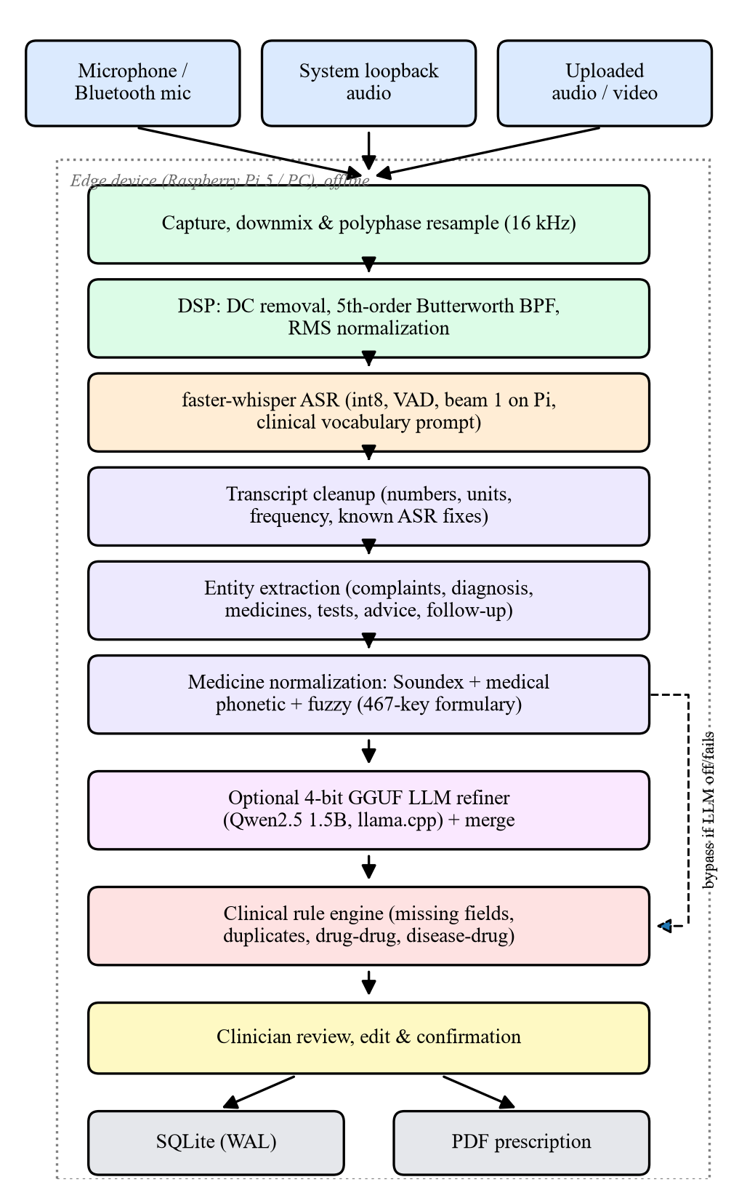
Fig. 1. Block diagram of the proposed Asclepius Clinical voice-to-prescription system.
C. Audio Acquisition and Resampling
Three sources are supported: a USB or Bluetooth microphone captured through PortAudio, system loopback audio, and uploaded audio/video files decoded by ffmpeg. The capture module tries a priority list of sample-rate and channel configurations (16 kHz mono first, then the device's native rate, 44.1 kHz and 48 kHz) so that it works with heterogeneous hardware. Multi-channel audio with C channels is downmixed by averaging,
x[n] = (1/C) Σc xc[n] (1)
and, when the capture rate fc differs from 16 kHz, polyphase resampling with up/down factors L = 16000/gcd(16000, fc) and M = fc/gcd(16000, fc) is applied. The signal is clipped to [−1, 1] and stored as 16-bit PCM.
D. Signal Pre-processing
The waveform x of length N is pre-processed using DC offset removal, band-pass filtering, and RMS normalization in order to enhance the robustness of ASR with low-budget microphones as follows:
x̃[n] = x[n] − (1/N) Σi x[i] (2)
y = SOSfilt(Butter5(100 Hz, fH), x̃) (3)
z[n] = clip( y[n] · 0.08 / rms(y), −1, 1 ) (4)
where fH = min(8000, fs/2 − 1). The low cut-off frequency of 100 Hz is used to avoid hum and handling noise, and the fifth-order Butterworth filter is realized through second-order sections in order to increase the numerical stability. If the signal processing step fails at any stage, the unprocessed signal is used directly.
E. Clinical Speech Recognition
In the process of transcription, faster-whisper (CTranslate2 implementation of Whisper [1]) with base, small, or medium checkpoints available locally is used. This means that it is not necessary to provide the connection with the network. The model works on CPU with int8 weights precision, with temperature equal to zero, for deterministic decoding, voice activity detection built-in, and beam size equal to one on Raspberry Pi (equals to 5 on PC). The bias towards clinical terms is done by the following prompt:
ŵ = argmax Σt log P(wt | w<t, p, a) (5)
where p is the clinical prompt and a is the audio. The original OpenAI Whisper implementation remains as a backup backend.
F. Transcript Cleanup and Entity Extraction
Deterministic clean up includes, respectively, spoken number normalization, unit normalization ("five hundred milligram" → "500 mg"), frequency normalization ("twice a day" → "BD"), an ASR corrections and punctuation lookup table. The extractor generates the complaint-diagnosis-medication-investigation-advice-follow-up-notes tuple E = (C, D, M, I, A, F, N). Longest matching symptom and disease lexicon search is followed by a formulary-based medication extraction based on precompiled regex and dose/frequency pattern lookup. The clause isolation step ensures that dose, frequency, duration, route and other instructions are associated with the right medication, while negation phrases like “stop taking” and "do not take" suppress candidate medications. Patterns like 1-0-1, 1-1-1 and "as needed" map to BD, TID and SOS.
G. Phonetic and Fuzzy Medicine Normalization
Since the ASR outputs are very likely to be near-homophones of drug names, then the token t is compared to all keys v in the formulary database (with 467 records consisting of the drug name, its brand, dose, administration mode and category information). Given the sequence similarity r and soundex similarity δs and δp of a custom medical phonetic key,
s(t,v) = min(1, r + 0.22δsδp + 0.12(δs ⊕ δp)) (6)
For |t| > 4, the score reaches at least 0.88. The matching drug name is selected if s ≥ 0.65 while the entry with s < 0.80 is flagged to be reconsidered. There is a list of the top terms which are not drugs, and there are known suffixes for creating new drug names with s = 0.70.
H. Optional Local LLM Refinement
If enabled, the execution of a 4-bit GGUF model (default Qwen2.5 1.5B Instruct; alternatives include Llama 3.2 1B Medical and Qwen2.5 3B Medical) takes place using llama.cpp via four threads of the CPU, with 2048 tokens context size and temperature of 0. The prompt consists of the deterministic draft and the last 1200 characters of the transcript. The JSON response is progressively repaired, keys are normalized, and the resulting values are combined with the deterministic draft; the LLM medicines not included in the formulary are flagged as needs_review. A re-entrant lock synchronizes the access to the model; any error leads to the return of the deterministic draft, and the LLM can only enhance but cannot obstruct the output.
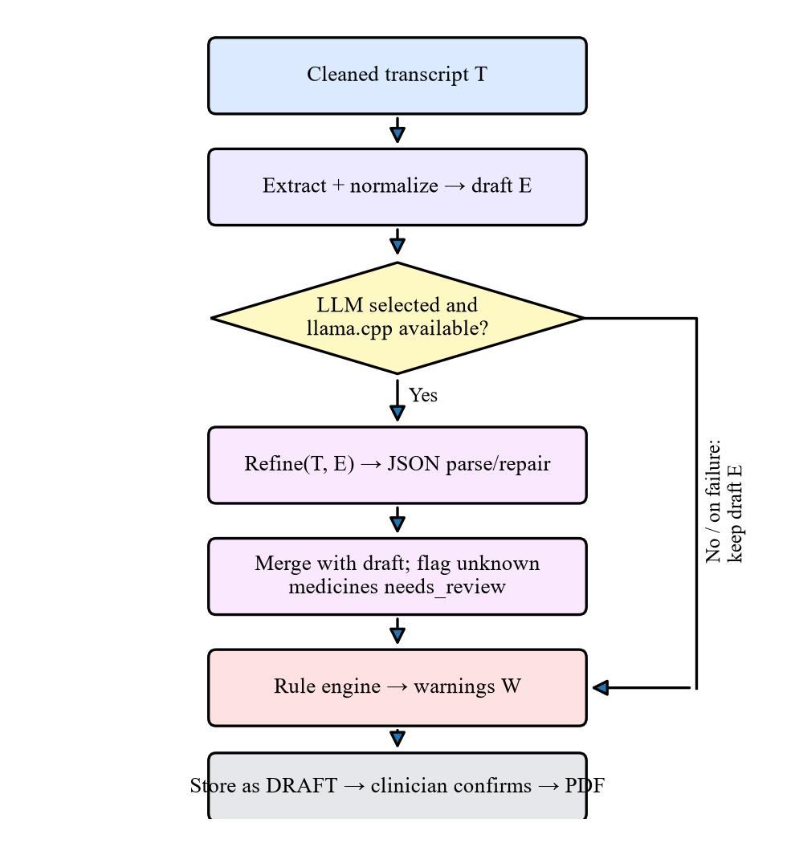
Fig. 2. Draft generation flow with optional LLM refinement and fallback.
TABLE I. SELECTABLE LOCAL LLM CONFIGURATIONS
Model (GGUF) | Params | Approx. RAM | Role
Qwen2.5 Instruct | 1.5 B | ~1.1 GB | Default refiner
Llama 3.2 Medical | 1 B | ~0.8 GB | Low-memory option
Qwen2.5 Medical | 3 B | ~2.2 GB | Higher-capacity option

I. Clinical Rule Engine, Storage and Output
The rule engine raises warnings for empty medication lists and non-existent dosage/frequency, as well as duplication of paracetamol drugs, use of several NSAIDs, NSAID combined with antiplatelet/anticoagulants, macrolides with statins, fluoroquinolones with steroids/antacids, and diseases-drugs interactions (beta-blockers with asthma/COPD, NSAIDs without PPI in case of gastritis, steroids with diabetes). All created prescriptions get recorded in a draft state into SQLite (WAL mode), whereas their status gets changed upon receiving clinician’s approval when a prescription is converted into a PDF with ReportLab. The performed checks are listed in Table II below.
TABLE II. CLINICAL RULE ENGINE CHECKS
Type | Condition detected | Level
Completeness | No medicines; missing dose/frequency | Info/Warning
Duplication | Multiple paracetamol products; multiple NSAIDs | Warning
Drug–drug | NSAID + antiplatelet/anticoagulant | Warning
Drug–drug | Macrolide + statin | Warning
Drug–drug | Fluoroquinolone + steroid / antacid | Warning
Disease–drug | Beta-blocker in asthma/COPD | Warning
Disease–drug | NSAID without PPI in GI complaints | Info
Disease–drug | Systemic steroid in diabetes | Warning

J. Edge Deployment
The identical codebase can be used for running on either a Windows/Linux PC or a 64-bit Raspberry Pi OS system. The presence of a Raspberry Pi is determined via /proc/device-tree/model (or overridden via an environment variable), and the edge profile subsequently reduces the Whisper beam size to 1 and turns off loopback capturing. The one-time setup script installs ffmpeg, PortAudio, OpenBLAS, creates a virtual environment, compiles llama-cpp-python with BLAS and ARM optimizations, and registers a systemd service so that the assistant launches at startup. Whisper checkpoints, GGUF models, and Python wheels are pre-loaded and hence installation and operation is possible without connecting to the internet. There is a script for pairing a Bluetooth microphone, and the interface is accessed via a phone or laptop browser at the clinic.
TABLE III. HARDWARE AND SOFTWARE STACK
Layer | Technology | Purpose
Hardware | Raspberry Pi 5 / x86 PC, USB/BT mic | Edge host
Web/UI | Flask, HTML, CSS, JS | Local UI and REST API
Capture | sounddevice, soundcard | Mic & loopback
DSP | NumPy, SciPy | Filter, resample, normalize
ASR | faster-whisper (int8) | Offline transcription
NLP | Regex, lexicons, Soundex | Extraction, normalization
LLM | llama-cpp-python, GGUF Q4 | Structured refinement
Storage/Out | SQLite, ReportLab | Records and PDF

IV. RESULTS AND DISCUSSION
A. Experimental Setup
The extraction and refinement processes were benchmarked using 50 synthetically generated outpatient consultations across 16 specialties, namely gastroenterology, cardiology, endocrinology, infectious diseases, orthopedics, dermatology, pediatrics, and neurology, and were annotated with expected medicines and diagnoses. In all cases, the consultations were extracted, normalized, and run through Qwen2.5 1.5B for refinement. The recall of medications in case i is calculated by:
Ri = |Gi ∩ Ġi| / |Gi| (7)
Where Gi and Ġi are the set of expected and predicted medicines respectively, and diagnosis recall is considered to be successful if at least one expected term from the diagnosis appears in the predicted list.
B. Overall Performance
TABLE IV. BENCHMARK SUMMARY (50 CASES)
Metric | Value
Medication recall | 87.69 %
Diagnosis hit rate | 96.0 %
Mean latency per case | 9.55 s
Median latency | 9.52 s
Min / Max latency | 5.74 / 17.64 s
Cases with 100 % med. recall | 40 / 50

Table IV demonstrates that the hybrid pipeline has succeeded in identifying 87.69 % of the predicted medicines, and the correct diagnosis has been provided in 48 out of 50 cases. The point here is that the deterministic draft does not substitute the LLM output but is used in combination with it; consequently, the medicines identified by the formulary and phonetic matcher remain included.
C. Category-wise Analysis
TABLE V. CATEGORY-WISE RESULTS
Category | Cases | Med. recall (%) | Diag. hit (%) | Latency (s)
Gastroenterology | 5 | 93.3 | 80 | 9.01
Cardiology | 5 | 83.3 | 100 | 9.22
Endocrinology | 5 | 93.3 | 100 | 8.97
Infectious Disease | 5 | 80.0 | 100 | 8.48
Orthopedics | 5 | 66.7 | 100 | 11.15
Dermatology | 5 | 100.0 | 100 | 9.33
Pediatrics | 5 | 93.3 | 100 | 8.56
Neurology | 3 | 77.8 | 100 | 9.59
Others (8 spec.) | 12 | 94.4 | 92 | 10.45

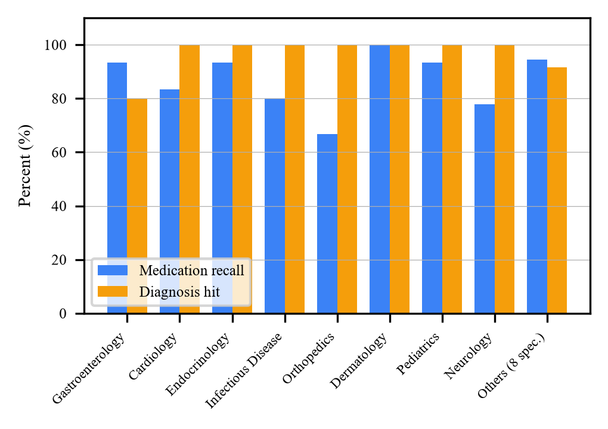
Fig. 3. Category-wise medication recall and diagnosis hit rate.
It can be seen from Table V and Figure 3 that dermatology, pediatrics, endocrinology, and gastroenterology have 93-100% medication recall. On the other hand, orthopedics has 66.7% medication recall and it is the weakest specialty because two cases (case_26 for orthopedics and case_24 for infectious disease) do not have any medication recall. Moreover, combinations are hard too and pulmonology asthma case (case_03) where combination inhalers are used such that one spoken brand has many generic drugs has 33.3% medication recall. Diagnosis can be missed only in one gastroenterology case (case_10) and one psychiatry case (case_39).
D. Latency Analysis
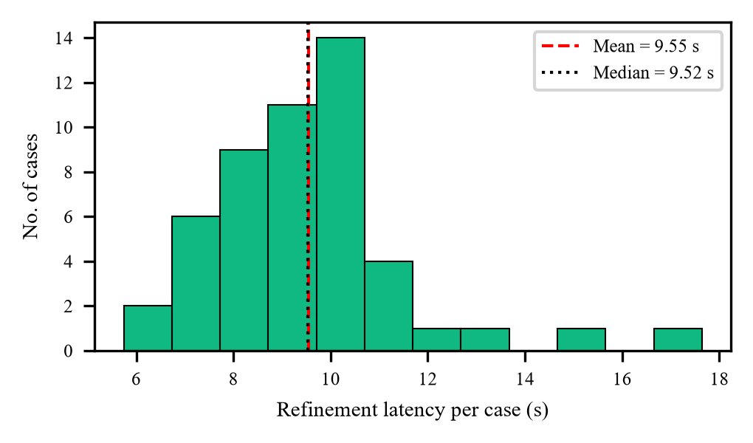
Fig. 4. Distribution of per-case extraction and LLM refinement latency.
As shown in Fig. 4, latency values are from 5.74 s to 17.64 s with a median of 9.52 s. Latency is mainly contributed by autoregressive LLM token generation and relies on the size of the generated output. Deterministic processing is comprised of regular expressions and dictionary lookup operations only, which is why switching off the LLM produces a very fast draft, whereas activating the LLM produces a richer draft in around ten seconds. Latency on the Raspberry Pi 5 will likely be higher.
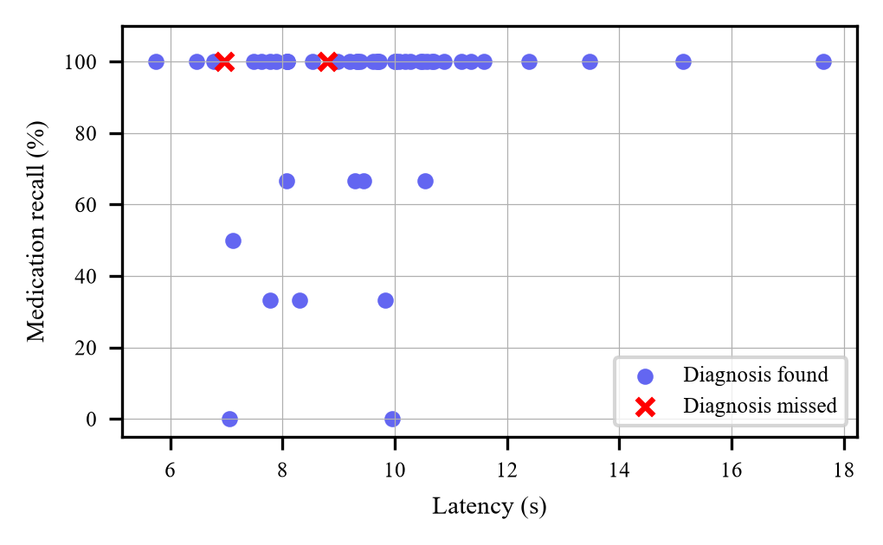
Fig. 5. Per-case medication recall versus latency (diagnosis misses marked ×).
Recall vs Latency per Case
Figure 5 shows recall plotted versus latency for all cases. Slow cases have low recall spread throughout the latency range, and not just among the slowest cases. This points to the errors resulting from lexicon coverage and name matching, not the exhaustion of output tokens from the LLM.
E. Worked Example
To show an example of the deterministic stage, the dictation text below was processed by the cleaner, extractor, normalizer and rule engine, sans the LLM: “Patient presents with fever and sore throat for the last three days. Patient is diagnosed with acute pharyngitis. Initiate Augmentin 625 1-0-1 for five days post prandial. Dolo 650 SOS for fever. Give Ibuprofen 400 mg twice daily. Advice for warm saline gargling. Follow up in five days.” The output is as follows in Table VI.
TABLE VI. DETERMINISTIC OUTPUT FOR THE SAMPLE DICTATION
Field | Extracted value
Complaints | Sore throat, fever
Diagnosis | Acute pharyngitis
Medicine 1 | Amoxicillin (from Augmentin), BD, 5 days, after food; conf. 0.67, needs review
Medicine 2 | Paracetamol (from Dolo), SOS; exact match
Medicine 3 | Ibuprofen 400 mg, BD; exact match
Medicine 4 | Epinephrine (false positive); conf. 0.75, needs review
Advice | Warm saline gargles
Follow-up | 5 days
Rule alerts | 3 missing-strength notes; missing frequency for Epinephrine

Augmentin and Dolo brands have been mapped to their correct generics, and the 1-0-1 regimen, “SOS,” duration, and follow up have been properly recorded. At the same time, the example demonstrates some present-day flaws, including the fact that the tablet strengths of 625 and 650 have not been transferred into the dose field, as well as the creation of a fictitious Epinephrine entry. Both drugs have been correctly identified and flagged for verification, and the rule engine has signaled the missing parts of information in order to direct the physician’s attention to the necessary fields for completion.
F. Discussion and Limitations
These findings suggest that the voice-to-prescription pipeline can be used entirely on the CPU without any cloud resources, thereby protecting patient data and running even in areas of poor connectivity. With its tiered structure, the architecture will gracefully degrade: the deterministic prescription draft will always be generated in the case of LLM unavailability, and all outputs have to be validated by the doctor. It should be noted, though, that the current assessment uses text-based transcripts as input, and thus does not consider factors like acoustic noise, accent, code-switching and ASR word error rate, does not take into account precision, dosage and frequency of the drugs prescribed, and has no validation by independent doctors.
G. Privacy, Safety and Comparison
Since inference is local, the system does not transmit audio data to third-party servers, which makes adherence to privacy requirements like India’s Digital Personal Data Protection Act, 2023 easier. However, local processing alone is insufficient for protecting confidentiality; the data in the SQLite database, audio files and PDF files can include confidential information and need to be secured through authentication, encryption and retention before use for clinical purposes. In terms of safety, three separate mechanisms mitigate potential issues resulting from errors made by the ASR system and LLM: formulary validation using a confidence score, deterministic rules alerting and the draft to confirmed workflow step. Table VII provides a comparison of the suggested architecture with literature examples.
TABLE VII. COMPARISON WITH REPRESENTATIVE APPROACHES
Approach | Offline | Edge HW | Drug norm. | Rx output
Whisper ASR only [1], [8] | Yes | Partly | No | No
WhisperX [9] | Yes | No (GPU) | No | No
LLM clinical extraction [12] | No | No | Partly | No
Ambient AI scribes [13] | No | No | Partly | Notes
Proposed Asclepius Clinical | Yes | Yes (Pi 5 target) | Yes | Yes (PDF)

In contrast to ASR alone systems, the new framework generates structured prescriptions; unlike online LLM-based extractors and commercial ambient scribes, it does not need any internet connectivity and works on a single-board computer. The drawback of such an approach is that the system has limited model capacity; nevertheless, it overcomes this by a number of means.
V. CONCLUSION
The Asclepius Clinical was one of the systems that were considered within this project to assist doctors to convert their dictations into structured prescriptions offline, edge-based and not requiring internet connectivity. With the help of the lightweight DSP front-end, int8 medically triggered Whisper ASR, deterministic prescription extraction, phonetic normalization for medicine names, optionally fine-tuned 4-bit LLM model, and the rules engine for the medical domain, we achieved the recall of 87.69% and 96% of accurate detection of the diagnosis on a 50-example benchmark dataset with 9.55 seconds of average fine-tuning latency. Future work will include the evaluation of the system end-to-end using the real clinical annotated audio data with WER and F1 precision/recall per entity, speaker diarization for filtering the doctor's voice, multi-lingual dictation with code switching, more extensive formulary and the database with validated drug interactions and security hardening in terms of authentication and encryption/an offline, edge-deployed assistant that converts doctor dictation into a structured, reviewable prescription. Through the incorporation of a light-weighted DSP front end, clinically motivated int8 Whisper ASR, deterministic extraction through phonetic medicine normalization, optionally with 4-bit local LLM fine-tuning, and a clinical rules engine, the approach attained a 87.69 % medication recall and 96 % diagnosis detection rate on a 50 sample benchmark, with an average time for fine-tuning of 9.55 seconds, without requiring any internet connection. The next steps will be conducting an end-to-end evaluation on actual clinician-labeled audio using word error rate and entity-level precision/F1 measures, diarization to extract the speech of the doctor, multi-lingual and code-switched dictation capability, formulating a larger formulary and validating a drug interaction database, along with securing it further through authentication, encryption and auditing mechanisms.
REFERENCES
[1] A. Radford, J. W. Kim, T. Xu, G. Brockman, C. McLeavey, and I. Sutskever, “Robust speech recognition via large-scale weak supervision,” in Proc. 40th Int. Conf. Machine Learning (ICML), PMLR, vol. 202, 2023, pp. 28492–28518.
[2] A. Yang et al., “Qwen2.5 technical report,” arXiv preprint arXiv:2412.15115, 2024.
[3] H. Touvron et al., “Llama 2: Open foundation and fine-tuned chat models,” arXiv preprint arXiv:2307.09288, 2023.
[4] T. Dettmers, M. Lewis, Y. Belkada, and L. Zettlemoyer, “LLM.int8(): 8-bit matrix multiplication for transformers at scale,” in Advances in Neural Information Processing Systems (NeurIPS), vol. 35, 2022.
[5] E. Frantar, S. Ashkboos, T. Hoefler, and D. Alistarh, “GPTQ: Accurate post-training quantization for generative pre-trained transformers,” in Proc. Int. Conf. Learning Representations (ICLR), 2023.
[6] K. Singhal et al., “Large language models encode clinical knowledge,” Nature, vol. 620, pp. 172–180, 2023.
[7] A. J. Thirunavukarasu, D. S. J. Ting, K. Elangovan, L. Gutierrez, T. F. Tan, and D. S. W. Ting, “Large language models in medicine,” Nature Medicine, vol. 29, pp. 1930–1940, 2023.
[8] S. Gandhi, P. von Platen, and A. M. Rush, “Distil-Whisper: Robust knowledge distillation via large-scale pseudo labelling,” arXiv preprint arXiv:2311.00430, 2023.
[9] M. Bain, J. Huh, T. Han, and A. Zisserman, “WhisperX: Time-accurate speech transcription of long-form audio,” in Proc. Interspeech, 2023.
[10] A. Gulati et al., “Conformer: Convolution-augmented transformer for speech recognition,” in Proc. Interspeech, 2020.
[11] A. Baevski, H. Zhou, A. Mohamed, and M. Auli, “wav2vec 2.0: A framework for self-supervised learning of speech representations,” in Advances in Neural Information Processing Systems (NeurIPS), vol. 33, 2020.
[12] M. Agrawal, S. Hegselmann, H. Lang, Y. Kim, and D. Sontag, “Large language models are few-shot clinical information extractors,” in Proc. Conf. Empirical Methods in Natural Language Processing (EMNLP), 2022.
[13] A. A. Tierney et al., “Ambient artificial intelligence scribes to alleviate the burden of clinical documentation,” NEJM Catalyst Innovations in Care Delivery, vol. 5, no. 3, 2024.
[14] D. Van Veen et al., “Adapted large language models can outperform medical experts in clinical text summarization,” Nature Medicine, vol. 30, pp. 1134–1142, 2024.
[15] A. Koenecke, A. S. G. Choi, K. X. Mei, H. Schellmann, and M. Sloane, “Careless Whisper: Speech-to-text hallucination harms,” in Proc. ACM Conf. Fairness, Accountability, and Transparency (FAccT), 2024.
[16] Y. Gu et al., “Domain-specific language model pretraining for biomedical natural language processing,” ACM Trans. Computing for Healthcare, vol. 3, no. 1, 2021.
[17] S. Henry, K. Buchan, M. Filannino, A. Stubbs, and O. Uzuner, “2018 n2c2 shared task on adverse drug events and medication extraction in electronic health records,” J. American Medical Informatics Association, vol. 27, no. 1, pp. 3–12, 2020.
[18] J. Chen and X. Ran, “Deep learning with edge computing: A review,” Proc. IEEE, vol. 107, no. 8, pp. 1655–1674, 2019.

