Harvest Valley - PixelLab Asset Brief
Every building and prop the new world still needs, with the image to give PixelLab as a style reference and the prompt to paste. Make them on any PixelLab account, name each file as shown, and send them back: I clean them (background, trimming), import them, place them and credit them.

How to make each one
- Tool: Create map object (the one that made the houses so far).
- Settings for all: view "low top-down", detail "medium detail", shading "basic shading", outline "single color outline".
- Canvas: the size given with each asset (the building should fill about 70-85% of it).
- Style reference: upload the image shown beside the prompt (they are in art/ai_houses and art/meshy_houses in the project), so the new one matches the houses we have.
- Paste the prompt as it is. If a result comes out at an angle (side walls showing), try once more; the words "no side walls visible" usually fix it.
- Save the PNG under the asset's name (for example home_saba.png) and send it to me. A flat background colour is fine.
About 39 assets in all. Sections 1 and 2 matter most (they make every home unique); 3 makes the farmhouse grow with its upgrades; 4 and 5 replace the placeholders.

1. Homes for the five new families
Each family has its workshop already (shown as the reference). The home should look like it belongs with it: same materials, same family.
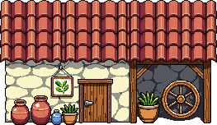  Style reference: olive_press.png | home_saba.png  For: Rami and Noor Saba, olive pressers in Olive Bay  Canvas: 256x224  Prompt (paste as it is):  pixel art family home for a top-down 2D farming RPG in the Liberated Pixel Cup (LPC) style. Straight-on front view: the front wall faces the camera, the roof seen from above, its ridge running left to right, no side walls visible, no isometric or perspective angle. A one-storey whitewashed stone house with a terracotta tile roof, green wooden shutters, a small olive tree in a clay pot and a bench by one centred wooden door, a string of drying herbs under the eaves. Crisp pixels, no anti-aliasing, 1px dark outline, light from the top left, soft muted palette. No ground, no scenery, no text, no letters, simple and readable.

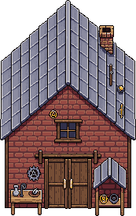  Style reference: tinker_workshop.png | home_brassbolt.png  For: Ottilie and Gus Brassbolt, dwarf tinkers at Hangar 12  Canvas: 256x256  Prompt (paste as it is):  pixel art family home for a top-down 2D farming RPG in the LPC style. Straight-on front view: the front wall faces the camera, the roof seen from above, its ridge running left to right, no side walls visible, no isometric or perspective angle. A sturdy two-storey red brick dwarf house with a grey tin-sheet roof, round porthole windows, a little brass weathervane, copper pipes on the wall and a small gear above one centred heavy wooden door. Crisp pixels, no anti-aliasing, 1px dark outline, light from the top left, soft muted palette. No ground, no scenery, no text, no letters, simple and readable.

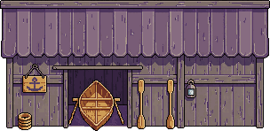  Style reference: boatyard.png | home_saltwhistle.png  For: Captain Hal and Marina Saltwhistle, boatwrights on South Beach  Canvas: 256x224  Prompt (paste as it is):  pixel art family home for a top-down 2D farming RPG in the LPC style. Straight-on front view: the front wall faces the camera, the roof seen from above, its ridge running left to right, no side walls visible, no isometric or perspective angle. A weathered blue-grey clapboard seaside cottage on a low stone base, a slate roof, a round ship's window, a life ring and a coil of rope by one centred wooden door, a lantern. Crisp pixels, no anti-aliasing, 1px dark outline, light from the top left, soft muted palette. No ground, no scenery, no text, no letters, simple and readable.

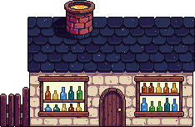  Style reference: glassworks.png | home_fairglass.png  For: Iris and Tomas Fairglass, glassblowers at Well's Head  Canvas: 256x224  Prompt (paste as it is):  pixel art family home for a top-down 2D farming RPG in the LPC style. Straight-on front view: the front wall faces the camera, the roof seen from above, its ridge running left to right, no side walls visible, no isometric or perspective angle. A pale stone cottage with a dark slate roof and tall windows of coloured glass panes (blue, green, amber), glass bottles on the window sill, one centred arched wooden door. Crisp pixels, no anti-aliasing, 1px dark outline, light from the top left, soft muted palette. No ground, no scenery, no text, no letters, simple and readable.

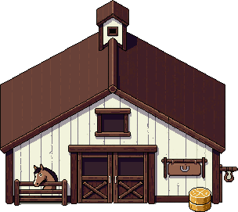  Style reference: stables.png | home_hayward.png  For: Bram and Della Hayward, stablemasters at Frere's Fray  Canvas: 256x224  Prompt (paste as it is):  pixel art family home for a top-down 2D farming RPG in the LPC style. Straight-on front view: the front wall faces the camera, the roof seen from above, its ridge running left to right, no side walls visible, no isometric or perspective angle. A dark timber and white plaster farmhouse with a wooden shingle roof, a horseshoe over one centred door, a hay bale and a saddle on a rail by the wall, flower boxes. Crisp pixels, no anti-aliasing, 1px dark outline, light from the top left, soft muted palette. No ground, no scenery, no text, no letters, simple and readable.

2. Homes that share a house today
These families live in a house the same as another family's. One new house each makes every home in the valley unique.
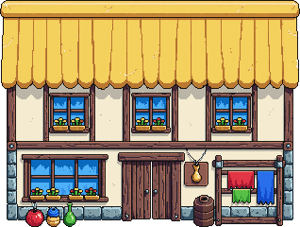  Style reference: weaver.png | home_larkspun.png  For: the Larkspun family, weavers and outfitters in Dahya  Canvas: 256x224  Prompt (paste as it is):  pixel art family home for a top-down 2D farming RPG in the LPC style. Straight-on front view: the front wall faces the camera, the roof seen from above, its ridge running left to right, no side walls visible, no isometric or perspective angle. A cosy half-timbered cottage with a golden thatched roof, bolts of coloured cloth airing on a line beside it, a spinning wheel by the window, one centred wooden door. Crisp pixels, no anti-aliasing, 1px dark outline, light from the top left, soft muted palette. No ground, no scenery, no text, no letters, simple and readable.

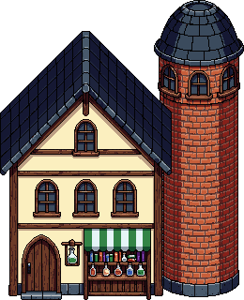  Style reference: alchemist.png | home_silverbough.png  For: the Silverbough elves at Resolve's Rise (Elda the potion-seller's family)  Canvas: 256x256  Prompt (paste as it is):  pixel art elven family home for a top-down 2D farming RPG in the LPC style. Straight-on front view: the front wall faces the camera, the roof seen from above, its ridge running left to right, no side walls visible, no isometric or perspective angle. A graceful pale wood house with a curved green-shingled roof shaped like leaves, vines climbing the walls, round windows, lanterns, one centred arched door with carved leaf patterns. Crisp pixels, no anti-aliasing, 1px dark outline, light from the top left, soft muted palette. No ground, no scenery, no text, no letters, simple and readable.

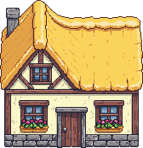  Style reference: small_house.png | home_frere.png  For: the Frere family at Frere's Fray  Canvas: 224x208  Prompt (paste as it is):  pixel art small family home for a top-down 2D farming RPG in the LPC style. Straight-on front view: the front wall faces the camera, the roof seen from above, its ridge running left to right, no side walls visible, no isometric or perspective angle. A small grey fieldstone cottage with a moss-covered slate roof, a vegetable patch fence, a beehive, one centred wooden door with a little porch roof. Crisp pixels, no anti-aliasing, 1px dark outline, light from the top left, soft muted palette. No ground, no scenery, no text, no letters, simple and readable.

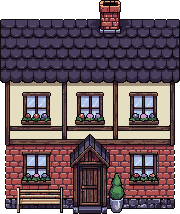  Style reference: family_house.png | home_quill.png  For: the Quill family at Oven's Window (Edwin the librarian, Wynn)  Canvas: 224x256  Prompt (paste as it is):  pixel art narrow family home for a top-down 2D farming RPG in the LPC style. Straight-on front view: the front wall faces the camera, the roof seen from above, its ridge running left to right, no side walls visible, no isometric or perspective angle. A tall narrow two-storey townhouse, cream plaster and dark beams, a blue slate roof, stacks of books visible in the windows, a quill-shaped weathervane, one centred door. Crisp pixels, no anti-aliasing, 1px dark outline, light from the top left, soft muted palette. No ground, no scenery, no text, no letters, simple and readable.

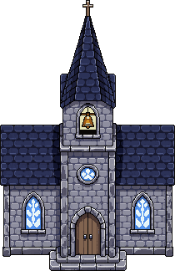  Style reference: church.png | home_ward.png  For: the Ward household at Abda's Ascent (Father Aldous, Sir Alaric)  Canvas: 224x208  Prompt (paste as it is):  pixel art small house for a top-down 2D farming RPG in the LPC style. Straight-on front view: the front wall faces the camera, the roof seen from above, its ridge running left to right, no side walls visible, no isometric or perspective angle. A modest grey stone house with a dark slate roof and a small stone cross on its gable, a pointed arched window, a rose bush, one centred arched wooden door. Crisp pixels, no anti-aliasing, 1px dark outline, light from the top left, soft muted palette. No ground, no scenery, no text, no letters, simple and readable.

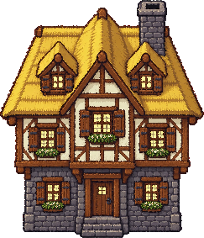  Style reference: house_4.png | home_tawil.png  For: the Tawil family in Dahya (Bryn, Dikhaj)  Canvas: 256x256  Prompt (paste as it is):  pixel art family home for a top-down 2D farming RPG in the LPC style. Straight-on front view: the front wall faces the camera, the roof seen from above, its ridge running left to right, no side walls visible, no isometric or perspective angle. A two-storey sandstone house with a flat roof terrace edged by a low parapet, potted plants and a striped awning on the terrace, arched windows with wooden shutters, one centred arched door. Crisp pixels, no anti-aliasing, 1px dark outline, light from the top left, soft muted palette. No ground, no scenery, no text, no letters, simple and readable.

Style reference: family_house.png | home_kassar.png  For: the Kassar family at Wing Hill (Zenya, Ayla)  Canvas: 256x256  Prompt (paste as it is):  pixel art family home for a top-down 2D farming RPG in the LPC style. Straight-on front view: the front wall faces the camera, the roof seen from above, its ridge running left to right, no side walls visible, no isometric or perspective angle. A two-storey house of yellow-ochre plaster with a red tile roof, a wooden balcony with flower pots on the upper floor, green shutters, one centred wooden door under the balcony. Crisp pixels, no anti-aliasing, 1px dark outline, light from the top left, soft muted palette. No ground, no scenery, no text, no letters, simple and readable.

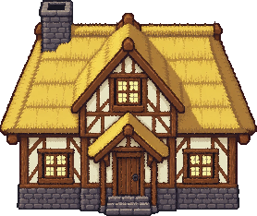  Style reference: house_6.png | home_night.png  For: the Night family's farmhouse at Saint Thereza (seeds and honey)  Canvas: 288x256  Prompt (paste as it is):  pixel art farmhouse for a top-down 2D farming RPG in the LPC style. Straight-on front view: the front wall faces the camera, the roof seen from above, its ridge running left to right, no side walls visible, no isometric or perspective angle. A long low farmhouse of honey-coloured stone with a thatched roof, beehives and a honey jar sign by the wall, sacks of seed, one centred wooden double door. Crisp pixels, no anti-aliasing, 1px dark outline, light from the top left, soft muted palette. No ground, no scenery, no text, no letters, simple and readable.

3. Your farmhouse, as it grows
One house in four stages, for the house upgrades. Make the first, then use it as the reference for the next three so they match.
Style reference: house_6.png | farmhouse_1.png  For: the farmhouse you start with  Canvas: 256x224  Prompt (paste as it is):  pixel art small farmhouse for a top-down 2D farming RPG in the LPC style. Straight-on front view: the front wall faces the camera, the roof seen from above, its ridge running left to right, no side walls visible, no isometric or perspective angle. A small one-storey timber farmhouse with a thatched roof, one window either side of one centred wooden door, a stone chimney, a little worn but loved. Crisp pixels, no anti-aliasing, 1px dark outline, light from the top left, soft muted palette. No ground, no scenery, no text, no letters, simple and readable.

use farmhouse_1 as the reference | farmhouse_2.png  For: after the first upgrade (kitchen and big bed)  Canvas: 288x240  Prompt (paste as it is):  the same farmhouse, a little bigger: a kitchen wing added on the right with its own small chimney and a window, fresh thatch, flower boxes. Straight-on front view: the front wall faces the camera, the roof seen from above, its ridge running left to right, no side walls visible, no isometric or perspective angle. Crisp pixels, no anti-aliasing, 1px dark outline, light from the top left, soft muted palette. No ground, no scenery, no text, no letters, simple and readable.

use farmhouse_2 as the reference | farmhouse_3.png  For: after the second upgrade (rooms and a nursery)  Canvas: 320x272  Prompt (paste as it is):  the same farmhouse with a second storey added: half-timbered upper floor with two windows, a covered porch over the door. Straight-on front view: the front wall faces the camera, the roof seen from above, its ridge running left to right, no side walls visible, no isometric or perspective angle. Crisp pixels, no anti-aliasing, 1px dark outline, light from the top left, soft muted palette. No ground, no scenery, no text, no letters, simple and readable.

use farmhouse_3 as the reference | farmhouse_4.png  For: after the third upgrade (a cellar)  Canvas: 320x288  Prompt (paste as it is):  the same farmhouse at its finest: a stone cellar door at the side, a bench and potted plants on the porch, a weathervane on the roof. Straight-on front view: the front wall faces the camera, the roof seen from above, its ridge running left to right, no side walls visible, no isometric or perspective angle. Crisp pixels, no anti-aliasing, 1px dark outline, light from the top left, soft muted palette. No ground, no scenery, no text, no letters, simple and readable.

4. Landmark buildings
These stand in the rooms as labelled placeholders today.
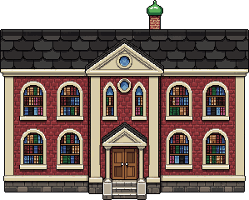  Style reference: library.png | museum.png  For: Uptown  Canvas: 320x256  Prompt (paste as it is):  pixel art town museum for a top-down 2D farming RPG in the LPC style. Straight-on front view: the front wall faces the camera, the roof seen from above, its ridge running left to right, no side walls visible, no isometric or perspective angle. A pale stone museum with four columns at the front, a triangular pediment, tall windows, a dinosaur skeleton visible through the glass of the central doors, banners. Crisp pixels, no anti-aliasing, 1px dark outline, light from the top left, soft muted palette. No ground, no scenery, no text, no letters, simple and readable.

Style reference: church.png | monastery.png  For: Frere's Fray  Canvas: 320x288  Prompt (paste as it is):  pixel art small monastery for a top-down 2D farming RPG in the LPC style. Straight-on front view: the front wall faces the camera, the roof seen from above, its ridge running left to right, no side walls visible, no isometric or perspective angle. A long grey stone monastery with a red tile roof, a small bell tower at one end, a row of arched windows, a herb garden and beehives along the wall, one centred arched wooden door. Crisp pixels, no anti-aliasing, 1px dark outline, light from the top left, soft muted palette. No ground, no scenery, no text, no letters, simple and readable.

Style reference: tinker_workshop.png | old_hangar.png  For: Hangar 12  Canvas: 352x256  Prompt (paste as it is):  pixel art old airship hangar for a top-down 2D farming RPG in the LPC style. Straight-on front view: the front wall faces the camera, the roof seen from above, its ridge running left to right, no side walls visible, no isometric or perspective angle. A big curved corrugated-metal hangar, rusty, one huge sliding door half open showing the ribs of a broken wooden airship inside, a faded painted number 12 shape (no letters), weeds. Crisp pixels, no anti-aliasing, 1px dark outline, light from the top left, soft muted palette. No ground, no scenery, no text, no letters, simple and readable.

Style reference: boatyard.png | beach_bar.png  For: White Sand Beach  Canvas: 256x192  Prompt (paste as it is):  pixel art beach bar shack for a top-down 2D farming RPG in the LPC style. Straight-on front view: the front wall faces the camera, the roof seen from above, its ridge running left to right, no side walls visible, no isometric or perspective angle. A small bamboo and driftwood beach bar with a palm-leaf thatched roof, a counter with stools, coconuts and colourful drinks, a hanging lantern, a surfboard leaning on it. Crisp pixels, no anti-aliasing, 1px dark outline, light from the top left, soft muted palette. No ground, no scenery, no text, no letters, simple and readable.

Style reference: boatyard.png | lifeguard_hut.png  For: White Sand Beach  Canvas: 128x192  Prompt (paste as it is):  pixel art lifeguard tower for a top-down 2D farming RPG in the LPC style. Straight-on front view. A small white and red wooden lifeguard hut on tall stilts with a ladder, a red flag, a life ring. Crisp pixels, no anti-aliasing, 1px dark outline, light from the top left, soft muted palette. No ground, no scenery, no text, no letters, simple and readable.

Style reference: small_house.png | rangers_cabin.png  For: Whispering Woods  Canvas: 224x208  Prompt (paste as it is):  pixel art forest ranger's log cabin for a top-down 2D farming RPG in the LPC style. Straight-on front view: the front wall faces the camera, the roof seen from above, its ridge running left to right, no side walls visible, no isometric or perspective angle. A small log cabin with a mossy shingle roof, a stone chimney, stacked firewood, an axe in a stump, a lantern by one centred door. Crisp pixels, no anti-aliasing, 1px dark outline, light from the top left, soft muted palette. No ground, no scenery, no text, no letters, simple and readable.

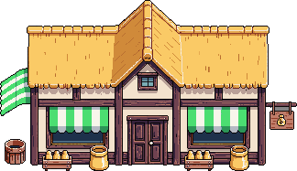  Style reference: market.png | fish_market.png  For: Starsand Pier  Canvas: 288x192  Prompt (paste as it is):  pixel art fish market stall for a top-down 2D farming RPG in the LPC style. Straight-on front view. A long wooden market stall with a blue and white striped awning, crates of fish on ice, hanging nets, a scale. Crisp pixels, no anti-aliasing, 1px dark outline, light from the top left, soft muted palette. No ground, no scenery, no text, no letters, simple and readable.

Style reference: boatyard.png | ferry_dock.png  For: Starsand Pier  Canvas: 256x192  Prompt (paste as it is):  pixel art ferry ticket booth and boathouse for a top-down 2D farming RPG in the LPC style. Straight-on front view: the front wall faces the camera, the roof seen from above, its ridge running left to right, no side walls visible, no isometric or perspective angle. A small wooden harbour booth with a slate roof, a ship's bell, a timetable board (no letters), ropes and a small moored rowing boat beside it. Crisp pixels, no anti-aliasing, 1px dark outline, light from the top left, soft muted palette. No ground, no scenery, no text, no letters, simple and readable.

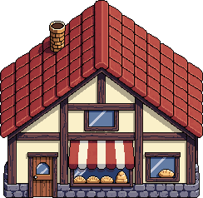  Style reference: bakery.png | cafe_terrace.png  For: Red Street  Canvas: 256x192  Prompt (paste as it is):  pixel art cafe for a top-down 2D farming RPG in the LPC style. Straight-on front view: the front wall faces the camera, the roof seen from above, its ridge running left to right, no side walls visible, no isometric or perspective angle. A small cafe with a red and white striped awning over a terrace of round tables and chairs, flower pots, a coffee cup sign (no letters), one centred glass door. Crisp pixels, no anti-aliasing, 1px dark outline, light from the top left, soft muted palette. No ground, no scenery, no text, no letters, simple and readable.

Style reference: church.png | roadside_shrine.png  For: Grace Tower  Canvas: 128x160  Prompt (paste as it is):  pixel art small roadside shrine for a top-down 2D farming RPG in the LPC style. Straight-on front view. A small stone shrine with a little peaked roof, candles and flowers at its base, a carved figure inside. Crisp pixels, no anti-aliasing, 1px dark outline, light from the top left, soft muted palette. No ground, no scenery, no text, no letters, simple and readable.

Style reference: market.png | merchant_cart.png  For: Wing Hill (the travelling merchant)  Canvas: 224x160  Prompt (paste as it is):  pixel art travelling merchant's wagon for a top-down 2D farming RPG in the LPC style. Straight-on side view. A colourful covered wooden wagon with a purple canvas top, open side showing goods, hanging lanterns and pots, a sleepy pony. Crisp pixels, no anti-aliasing, 1px dark outline, light from the top left, soft muted palette. No ground, no scenery, no text, no letters, simple and readable.

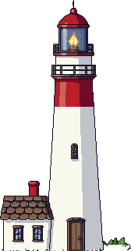  Style reference: lighthouse.png | cliff_lookout.png  For: Plummet's Point  Canvas: 160x288  Prompt (paste as it is):  pixel art old stone watchtower for a top-down 2D farming RPG in the LPC style. Straight-on front view. A narrow round ruined stone lookout tower, partly crumbled at the top, ivy, a wooden ladder, a spyglass on the ledge. Crisp pixels, no anti-aliasing, 1px dark outline, light from the top left, soft muted palette. No ground, no scenery, no text, no letters, simple and readable.

5. Props for the open places
Small things that fill the landmark areas (groves, gardens, beaches). Canvas sizes are small; make several of a kind if one comes out well.
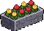  Style reference: prop_planter.png | prop_olive_tree.png  For: Olive Bay's grove  Canvas: 128x128  Prompt (paste as it is):  pixel art olive tree for a top-down 2D farming RPG in the LPC style. Front view. A gnarled olive tree with silvery-green leaves and small dark olives, a twisted trunk. Crisp pixels, no anti-aliasing, 1px dark outline, light from the top left, soft muted palette. No ground, no scenery, no text, no letters, simple and readable.

Style reference: prop_planter.png | prop_grapevine.png  For: Saint Thereza's vineyard  Canvas: 96x96  Prompt (paste as it is):  pixel art grapevine trellis for a top-down 2D farming RPG in the LPC style. Front view. A wooden trellis with leafy grapevines and bunches of purple grapes. Crisp pixels, no anti-aliasing, 1px dark outline, light from the top left, soft muted palette. No ground, no scenery, no text, no letters, simple and readable.

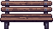  Style reference: prop_bench.png | prop_gravestones.png  For: Abda's graveyard  Canvas: 128x64  Prompt (paste as it is):  pixel art set of three old gravestones for a top-down 2D farming RPG in the LPC style. Front view. Weathered grey stones of different shapes, moss, a few flowers. No letters. Crisp pixels, no anti-aliasing, 1px dark outline, light from the top left, soft muted palette. No ground, no scenery, no text, no letters, simple and readable.

Style reference: boatyard.png | prop_shipwreck.png  For: South Beach  Canvas: 256x160  Prompt (paste as it is):  pixel art shipwreck on the sand for a top-down 2D farming RPG in the LPC style. Side view. The broken hull of an old wooden ship tilted on its side, ribs showing, a snapped mast, seaweed. Crisp pixels, no anti-aliasing, 1px dark outline, light from the top left, soft muted palette. No ground, no scenery, no text, no letters, simple and readable.

  Style reference: prop_fountain.png | prop_sea_arch.png  For: Pigeon Rocks  Canvas: 224x192  Prompt (paste as it is):  pixel art natural sea arch rock for a top-down 2D farming RPG in the LPC style. Front view. A tall pale limestone rock with an arch through it, pigeons on top, waves at its base. Crisp pixels, no anti-aliasing, 1px dark outline, light from the top left, soft muted palette. No ground, no scenery, no text, no letters, simple and readable.

Style reference: prop_fountain.png | prop_tide_pools.png  For: Pigeon Rocks  Canvas: 160x96  Prompt (paste as it is):  pixel art tide pool rocks for a top-down 2D farming RPG in the LPC style. Top-down view. Flat rocks with small pools of clear water, starfish, a crab, shells. Crisp pixels, no anti-aliasing, 1px dark outline, light from the top left, soft muted palette. No ground, no scenery, no text, no letters, simple and readable.

Style reference: prop_planter.png | prop_herb_bed.png  For: Resolve's Rise herb garden  Canvas: 128x64  Prompt (paste as it is):  pixel art raised herb garden bed for a top-down 2D farming RPG in the LPC style. Front view. A wooden raised bed with rows of herbs: lavender, basil, rosemary, little name stakes (no letters). Crisp pixels, no anti-aliasing, 1px dark outline, light from the top left, soft muted palette. No ground, no scenery, no text, no letters, simple and readable.

Style reference: prop_bench.png | prop_swing.png  For: Dahya playground  Canvas: 128x96  Prompt (paste as it is):  pixel art wooden swing set for a top-down 2D farming RPG in the LPC style. Front view. A wooden A-frame swing with two rope swings. Crisp pixels, no anti-aliasing, 1px dark outline, light from the top left, soft muted palette. No ground, no scenery, no text, no letters, simple and readable.

Style reference: prop_planter.png | prop_flower_bed.png  For: Verdun Street  Canvas: 128x64  Prompt (paste as it is):  pixel art round flower bed for a top-down 2D farming RPG in the LPC style. Front view. A stone-edged bed of red, yellow and white flowers. Crisp pixels, no anti-aliasing, 1px dark outline, light from the top left, soft muted palette. No ground, no scenery, no text, no letters, simple and readable.

Style reference: prop_bench.png | prop_beach_umbrella.png  For: the beaches  Canvas: 96x96  Prompt (paste as it is):  pixel art striped beach umbrella and towel for a top-down 2D farming RPG in the LPC style. Front view. A red and white striped umbrella over a towel on no ground. Crisp pixels, no anti-aliasing, 1px dark outline, light from the top left, soft muted palette. No ground, no scenery, no text, no letters, simple and readable.

