**Q13187  Felipe and the Sequence**

根據以下公式，給你一個正整數 S ，請你找出 n 為多少？  
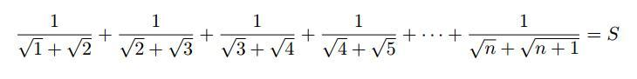

**Input**

輸入的第一列有一個正整數t代表以下有幾筆測資。（ 1 <= t <= 5*105 ）  
  
每筆測資一列，有一個正整數 S（ 1 <= S <= 109）

**Output**

對每筆測資輸出一列，輸出 n 是多少？

|  |  |
| --- | --- |
| **Sample Input** | **Sample Output** |
| 1 200 | 40400 |

**翻譯：luckycat**

Private Sub Form1_Load(ByVal sender As System.Object, ByVal e As System.EventArgs) Handles MyBase.Load

FileOpen(1, "in1.txt", 1)

FileOpen(2, "out1.txt", 2)

Dim a, b, c, d As String

c = 1

a = LineInput(1)

d = 0.0

For i = 1 To Val(a)

b = LineInput(1)

Do

d = Val(c + 1) ^ 0.5 - 1

If d = b Then

Exit Do

Else

c = Val(c) + 1

End If

Loop

If i = Val(a) Then

Print(2, c)

Else

PrintLine(2, c)

End If

c = 1

Next

End Sub