1. 程式執行環境
   * Python = 3.8.8
   * Numpy = 1.19.2
   * Opencv = 4.0.1
   * Matplotlib = 3.3.4
2. 使用的visual features
   * Pixel difference
   * Statistical difference
   * Histograms
   * Compression differences
   * Edge
3. shot change detection演算法
   * 實作了以下四種shot change detection，並去觀察其對於不同形式的shot change的效果
     1. Pair-wise comparison
        1. Default
        2. Windowed (3x3)
     2. Histogram comparison
        1. Gray level – x1
        2. Gray level – x2
        3. CHD
     3. Likelihood Ratio
     4. Edge Change Ratio
4. 偵測效能
   * Pair-wise comparison – Default
   * 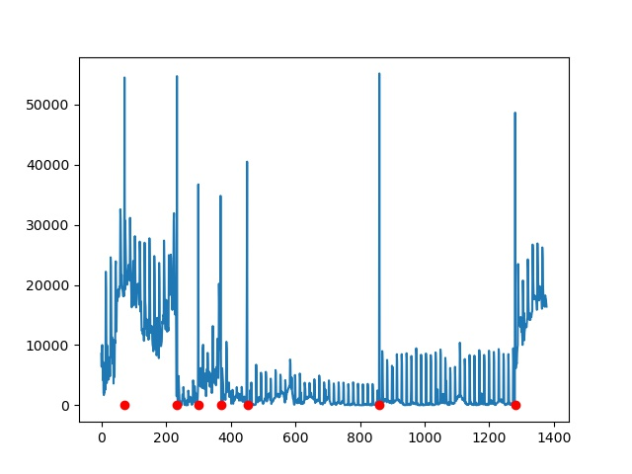News
     1. Precision: 100%
     2. Recall: 100%
   * Soccer 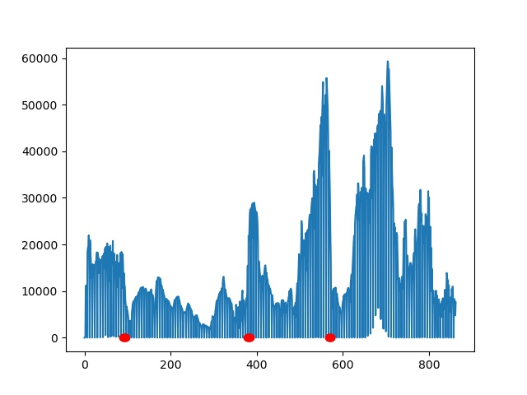
     1. Precision: 4.3%
     2. Recall: 13%
   * NGC 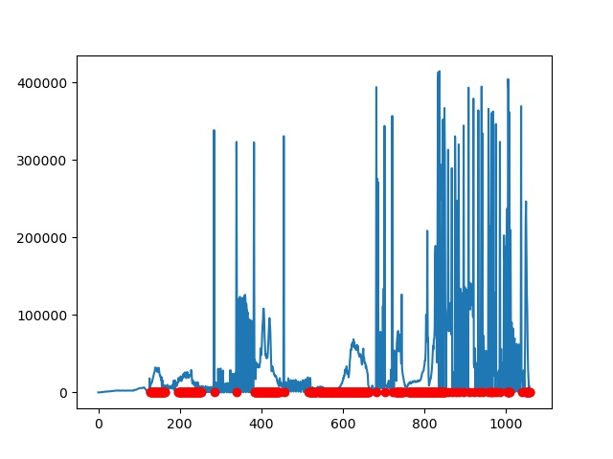
     1. Precision: 71.4%
     2. Recall: 9.8%
   * Pair-wise comparison – Windowed
   * News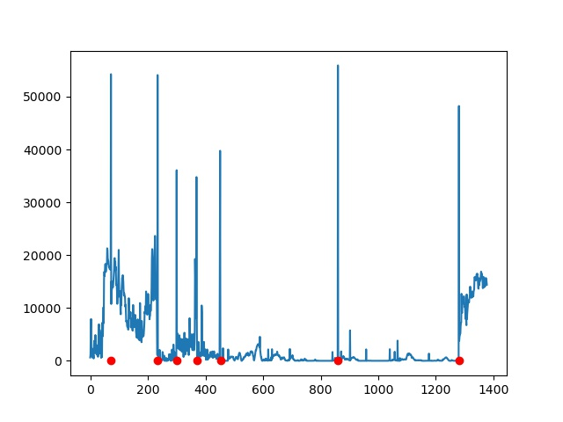
     1. Precision: 100%
     2. Recall: 100%
   * Soccer 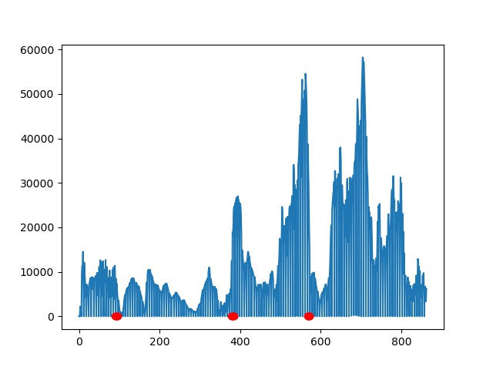
     1. Precision: 4.1%
     2. Recall: 8.6%
   * NGC 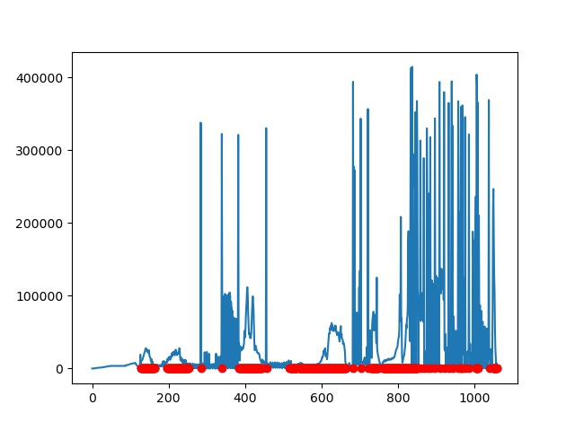
     1. Precision: 74.5%
     2. Recall: 9.5%
   * Histogram comparison – Gray level x1
   * News

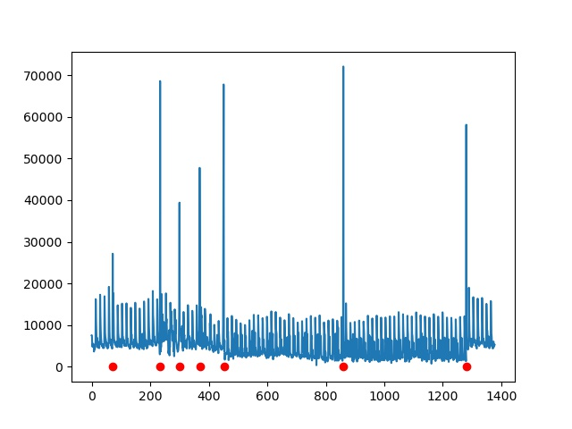

* + 1. Precision: 77.7%
    2. Recall: 100%
  + Soccer

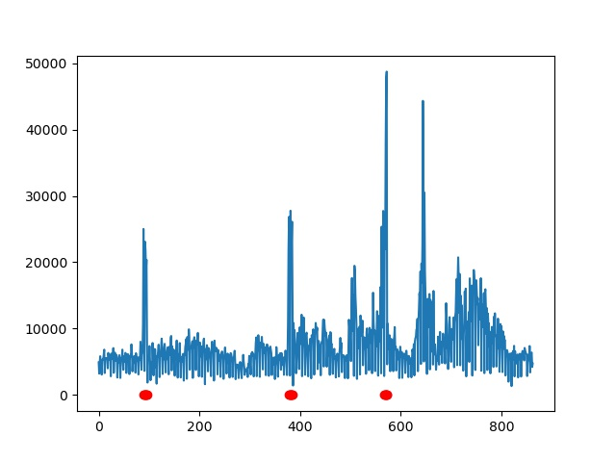

* + 1. Precision: 68.4%
    2. Recall: 56.5%
  + NGC 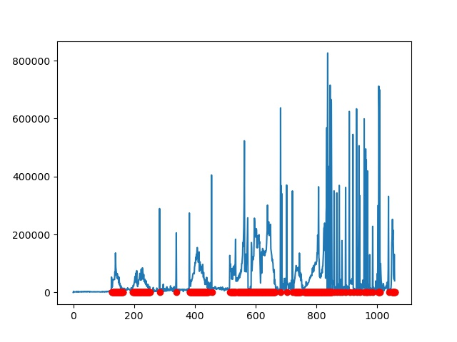
    1. Precision: 92.7%
    2. Recall: 70.1%
  + Histogram comparison – Gray level x2
  + News 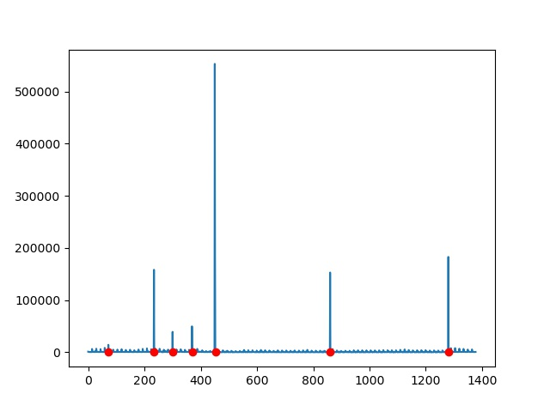
    1. Precision: 85.7%
    2. Recall: 85.7%
  + Soccer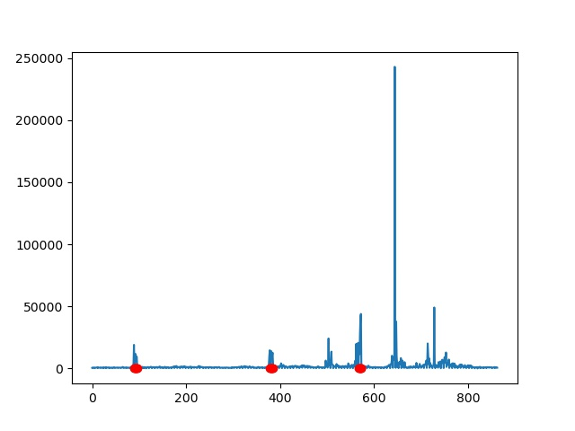
    1. Precision: 50%
    2. Recall: 30.4%
  + NGC 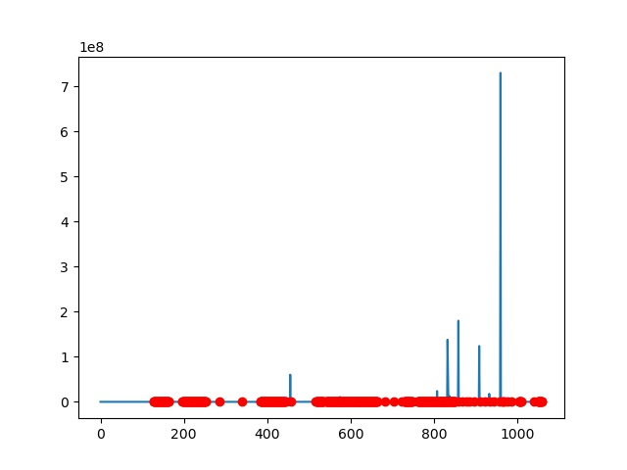
    1. Precision: 91.6%
    2. Recall: 55.3%
  + Histogram comparison – CHD
  + News 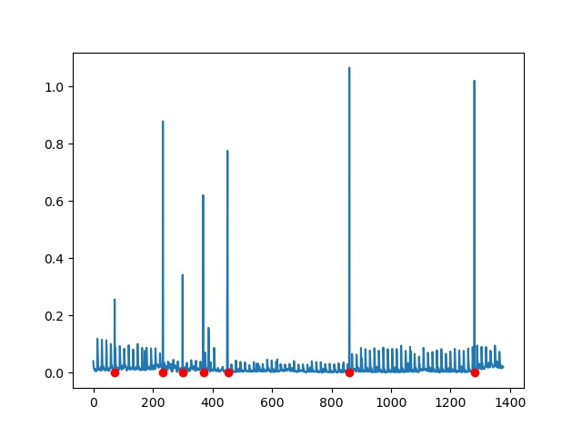
    1. Precision: 87.5%
    2. Recall: 100%
  + Soccer 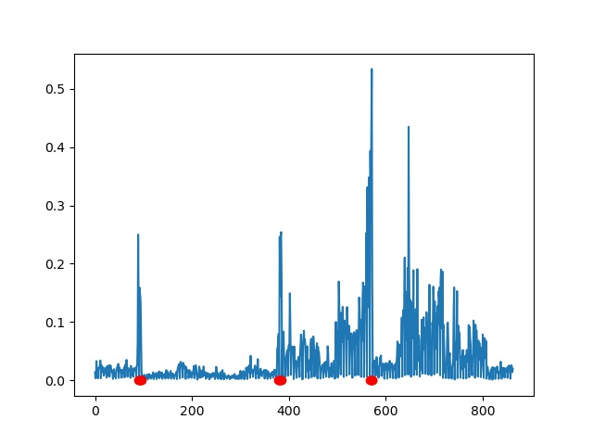
    1. Precision: 63.6%
    2. Recall: 30.4%
  + NGC 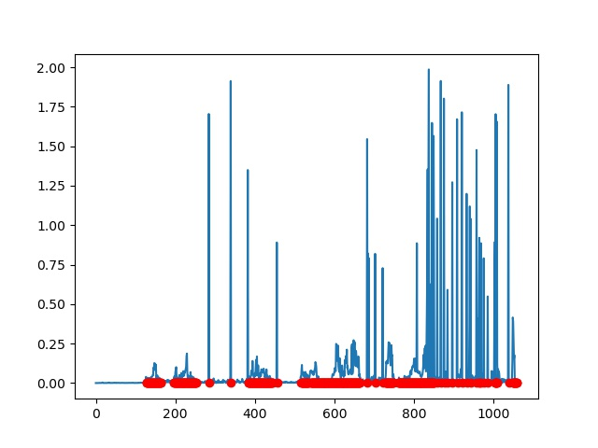
    1. Precision: 92.8%
    2. Recall: 28.1%
  + Likelihood Ratio
  + News 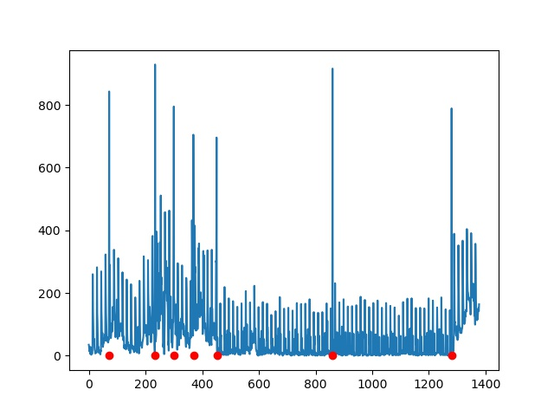
    1. Precision: 100%
    2. Recall: 100%
  + Soccer 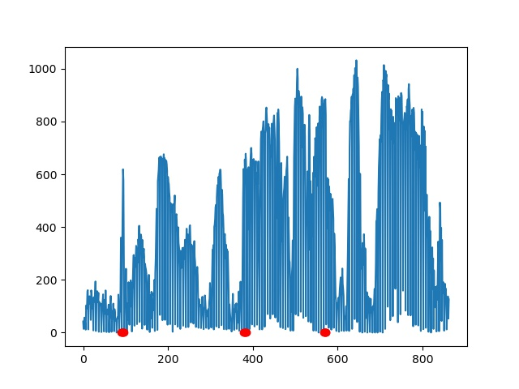
    1. Precision: 9.4%
    2. Recall: 21.7%
  + NGC 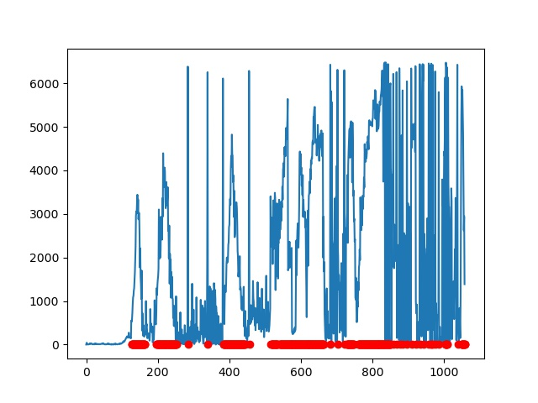
    1. Precision: 74.8%
    2. Recall: 73.4%
  + Edge Change Ratio
  + News

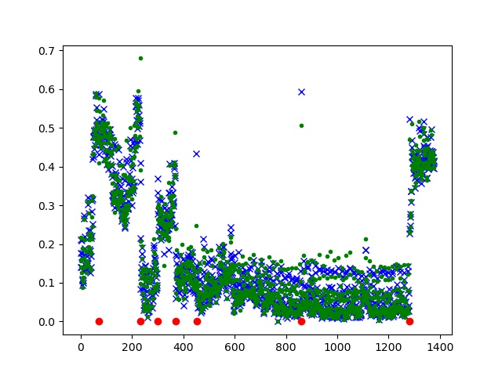 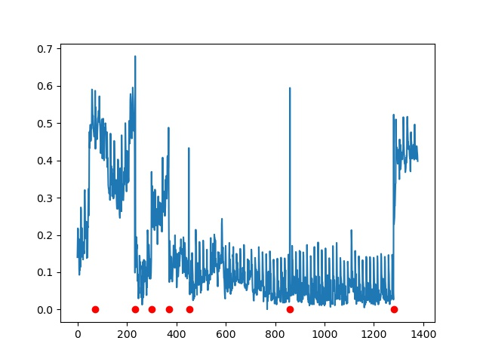

* + 1. Precision: 23%
    2. Recall: 42.8%
  + Soccer 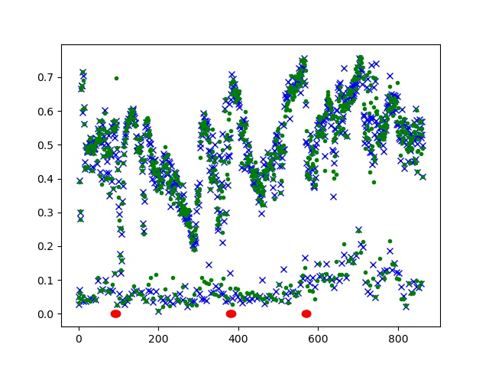 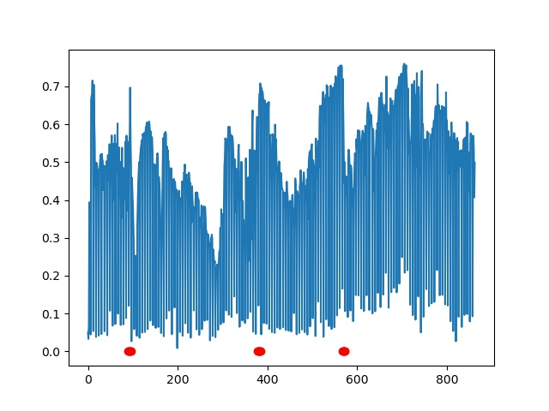
    1. Precision: 6.4%
    2. Recall: 17.3%
  + NGC 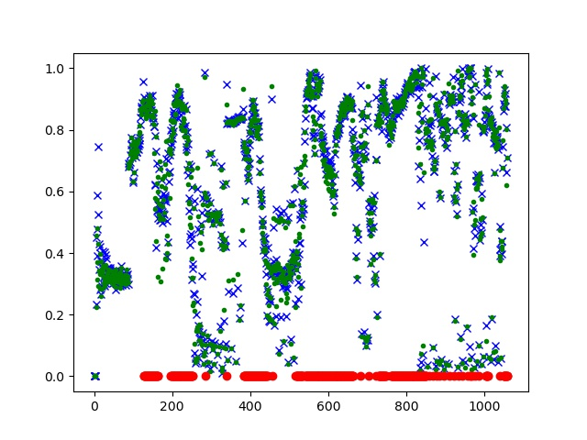 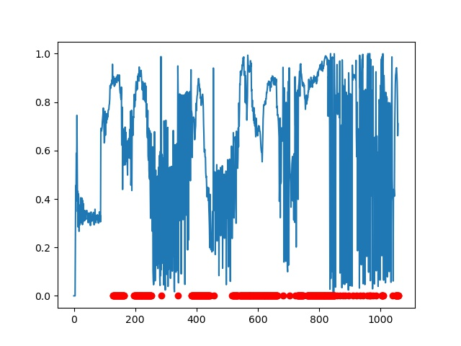
    1. Precision: 69.5%
    2. Recall: 64.7%

1. 結論
   * Pair-wise的結果雖然不盡理想，但是效率好，且在基本的hard cut上表現優異(news的結果)，且根據統計，多數影片普遍使用hard cut的手法，勢必能拿來加速運算。而windowed的pair-wise準確率有些微提升，但對於soccer這種移動快速的影片還是難以招架
   * 三種不同的Histogram，x1與x2的結果差異與Automatic partitioning of full-motion video此篇paper中提到的狀況雷同，雖然x2-test可以增強兩個圖片不同的程度，但是也會讓一些如鏡頭移動、物體移動的改變程度增強，反而造成準確率下降。另外CHD的結果是幾個測試中最好的，可能與重新量化色彩度，可以去除掉如物體移動、旋轉等顏色些微改變造成的histogram改變有關
   * Likelihood在news及NGC上有表現出對於小且緩速移動的物件有著不錯的容忍度，但是像soccer這種快速移動的場景就可能難以招架，嘗試過使用4x4, 8x8, 12x12, 24x24, 32x32, 60x60的sub-block效果都不好
   * Edge change ratio可能對於物體或鏡頭移動的場景表現不好，在news跟soccer中都可明顯地觀察到人物或者相機移動時，ratio明顯上升，造成誤判，這個部分我有想到可以利用幾個照片之間先比對是否雷同，再去採取edge change ratio的方法，但是來不及實作，有點可惜