|  |  |  |  |
| --- | --- | --- | --- |
|  |  | |  |
|  | |
|  | |
| 方圆ok1 | | |
|  | **WIN UAP Guide** | 附件1-16K |
| HUAWEI TECHNOLOGIES CO., LTD. |

|  |
| --- |
| **Copyright © Huawei Technologies Co., Ltd. 2011. All rights reserved.**  No part of this document may be reproduced or transmitted in any form or by any means without prior written consent of Huawei Technologies Co., Ltd.  **Trademarks and Permissions**  附件3-图 and other Huawei trademarks are trademarks of Huawei Technologies Co., Ltd.  All other trademarks and trade names mentioned in this document are the property of their respective holders.  **Notice**  The purchased products, services and features are stipulated by the contract made between Huawei and the customer. All or part of the products, services and features described in this document may not be within the purchase scope or the usage scope. Unless otherwise specified in the contract, all statements, information, and recommendations in this document are provided "AS IS" without warranties, guarantees or representations of any kind, either express or implied.  The information in this document is subject to change without notice. Every effort has been made in the preparation of this document to ensure accuracy of the contents, but all statements, information, and recommendations in this document do not constitute the warranty of any kind, express or implied. |

|  |  |
| --- | --- |
| Huawei Technologies Co., Ltd. | |
| Address: | Huawei Industrial Base  Bantian, Longgang  Shenzhen 518129  People's Republic of China |
| Website: | [http://www.huawei.com](http://www.huawei.com/) |
| Email: | [support@huawei.com](mailto:Support@huawei.com) |
|  |  |

Contents

1 Introduction 1-1

2 Supported Functions 2-1

3 Installing and Running Huawei WINUAP 3-1

4 Configuring Data 4-1

# Introduction

Huawei WINUAP is the edition of Huawei IPCC UAP3300 in the Windows operating system. The following sections describe the functions that Huawei WINUAP supports.

WINUAP is only for demo or can use as a development stub.

# Supported Functions

Huawei WINUAP supports the following functions:

* SIP agent registration and SIP trunk interconnection
* Interconnection with the CTI, MRA, and LogServer
* Voice playing and digit collecting functions of the simulated MRS (Signaling and media functions are supported such as the VP announcement and SPT announcement.)
* Interconnection with the VP, CP, and FP (The signaling function is supported. The media function is not supported.)

# Installing and Running Huawei WINUAP

Follow the below instructions for installation.

Huawei WINUAP supports the login through the telnet.

Click on “Next” button.

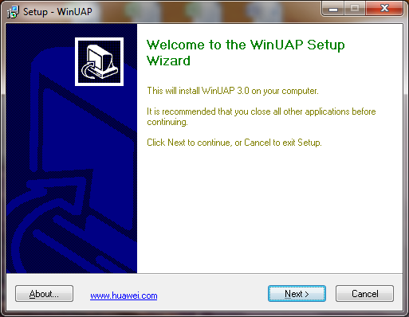

Give your name in the first text box and the name of your company in the second text box and click on “Next” button.

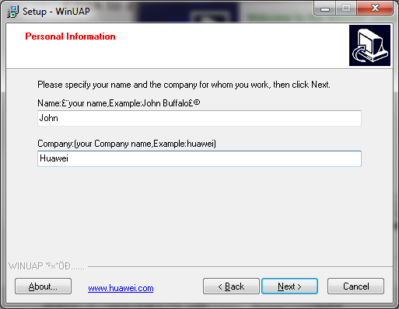

Give the MID as “1”. Enter the IP address of the WINUAP as the local machine IP where you are installing it and the CTI IP where it is running. Click on “Next” button. 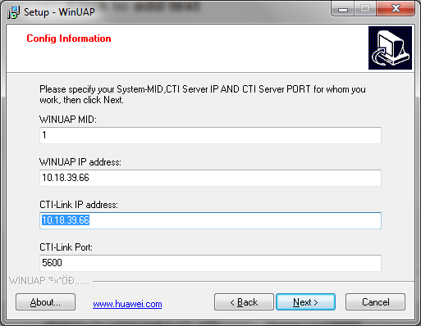

Give the CTI access code(Access code is the calling number). Enter the Start Phone no as any no, say 7100 and number of phone numbers to be created in the “User Number” field. (So, from 7100 to 7109 phone numbers will be created.).

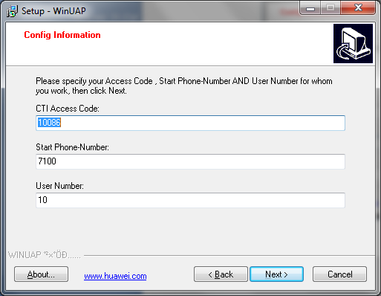

Select the destination location where you want to install.

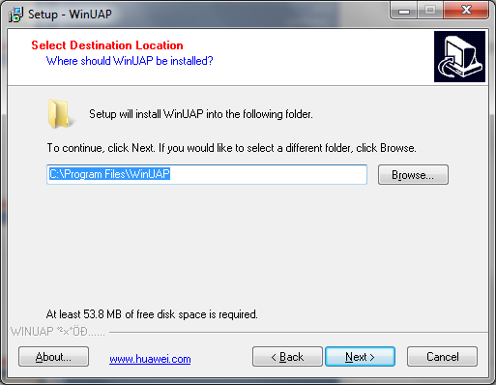

Enter a name to create a short cut in the Start menu.

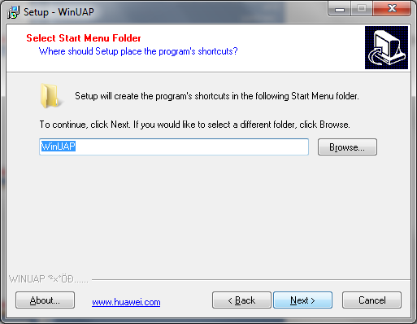

Check the appropriate icon and click on “Next”.

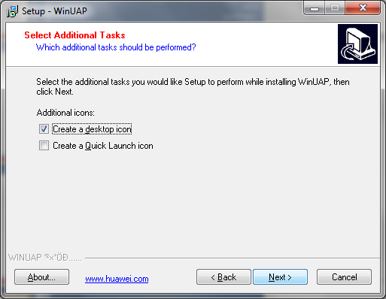

Click on Install.

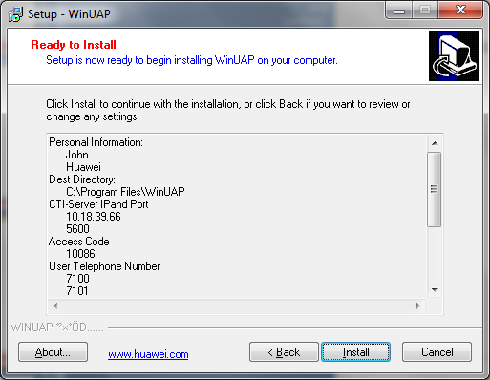

# Configuring Data

Configuration of WINUAP is same as configuration of UAP3300. Please find the path for UAP 3300 configuration in the below path.

<http://forum.huawei.com/jive4/thread.jspa?threadID=337757&tstart=0&orderStr=9>

WINUAP supports only voice; it does not support SPT, VP.