
Vologda State University
Department of Automatics
and Computer Facilities
e-mail: avt@vstu.edu.ru

Remote training on programming

http://atpp.vstu.edu.ru/acm
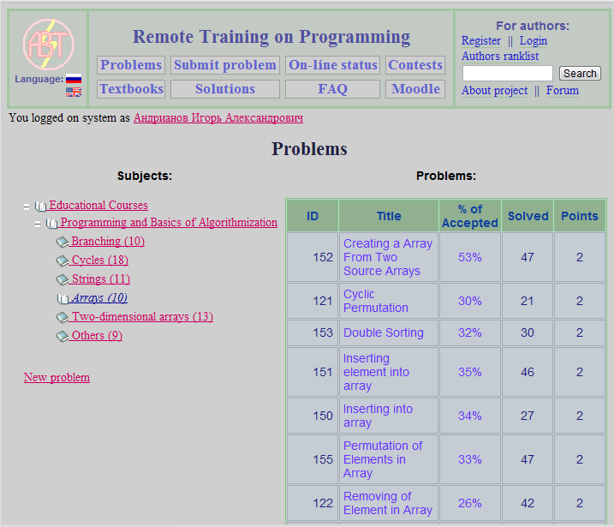

Сapabilities
- More than 1000 problems on different courses
- Problems are systematized in the hierarchical structure
- The system automatically checks solutions and gives out messages on errors and helps
- The system selects the best solutions on speed and memory
- Students can learn other students' solutions after the successful completion of problem
- The system supports automatic control of plagiarism in programming code
- The system can generate different reports on students and groups

The advantages as compared with the traditional form of education

- The teacher spared from routine work to verify the solutions and record keeping. The quality of both increases
- The resulting time can be used for individual work with students
- Students become accustomed to careful programming and testing
- The teacher can give students the task of developing their own problems. It also develops important skills for a programmer
- The element of competition increases the interest in the subject and contributes to the success of training
- The system can work at any time, including remotely via the Internet

Getting started guide
- Open web-site http://atpp.vstu.edu.ru/acm
- Click on the hyperlink «Register» and fill in the form (see the example below):
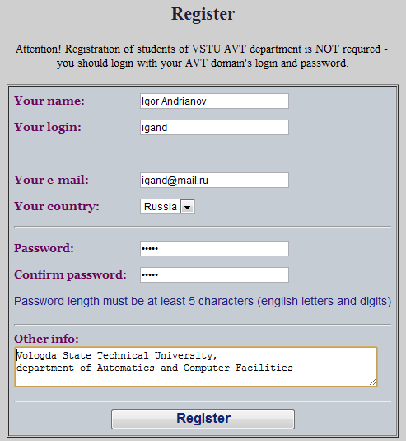
- Log in and click the «Problems».

- Let’s try to send a solution of the simple problem. Open the "Miscellaneous Problems" and click on the problem №1 "A + B". Read the condition of the problem.
Click on the «Submit». Select a compiler and write a code that reads two numbers and outs their sum (see the figure below). Press «Submit».
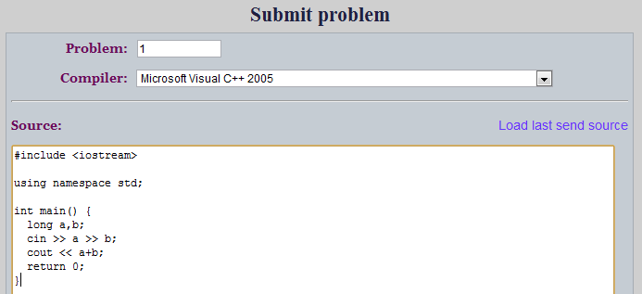
- Look for the checking result. If your solution has not yet checked, update web-page in the browser.
- Let’s try send a solution of the simple problem of the course «Databases. SQL Language». Click on the «Problems», expand the «Educational courses» - «Databases. SQL», select the problem №289 «Near Places».
Read the statement. You can click on the link «Database schema» to open it in a separate window.
Press «Submit». In the field "compiler" select «SQL (Oracle 9i)». In the field «Source» write SQL query (see the example below).
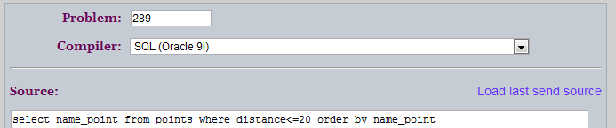
Click «Submit», refresh web-page and look for the result
7. You can try to send obviously incorrect solution. After that, click on the link in the form of yellow light bulb to see detailed information about the error.

