Testing results:

1)

INSERT INTO Booking (booking_number, event_number, paid, number_of_tickets, phone, booking_date)
VALUES (1, 2, 'N', 2, '+4365546546', '20161212')
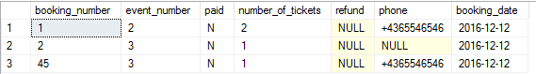

2)

DELETE FROM Booking
WHERE booking_number = 45
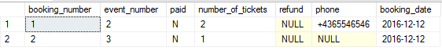

3)

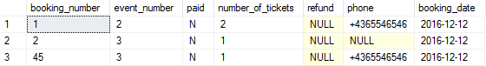
UPDATE Booking
SET number_of_tickets = 1
WHERE booking_number = 45

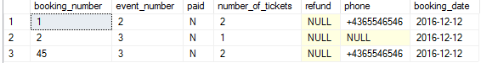

4)

UPDATE Booking
SET paid = 'Y'
WHERE booking_number = 45

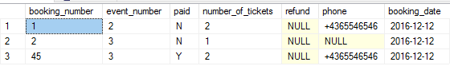

5)

DELETE FROM Booking
WHERE DATEDIFF(DAY, booking_date, GETDATE()) >= 3 AND paid = 'N'

6)

DELETE FROM Booking
WHERE Booking.event_number IN
(SELECT Event.event_number FROM Event WHERE DATEDIFF(DAY, event_date, GETDATE()) > 0) AND paid = 'N'

7)

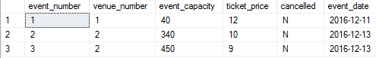
UPDATE Event
SET cancelled = 'Y'
WHERE event_number = 1

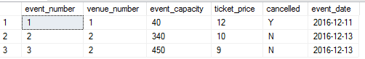

8)
UPDATE Booking
SET refund = 'Y'
WHERE Booking.event_number IN (SELECT Event.event_number FROM Event WHERE cancelled = 'Y')

9)
SELECT * FROM Event
WHERE MONTH(event_date) = 1

10)

SELECT * FROM Performance
JOIN Event ON (Event.event_number = Performance.event_number)
WHERE MONTH(event_date) = MONTH(GETDATE())

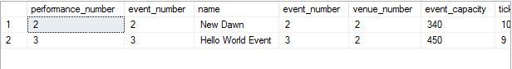

11)
SELECT first_name, surname, phone
FROM Artist
WHERE first_name = 'Snow' AND surname = 'John'


12)
SELECT first_name, surname, catering, event_date
FROM Artist
JOIN Performance ON (Artist.performance_number = Performance.performance_number)
JOIN Event ON (Event.event_number = Performance.event_number)
WHERE first_name = 'Snow' AND surname = 'John'



13)

SELECT SUM(number_of_tickets) AS 'Number of tickets', Performance.name, first_name, surname, Event.event_date
FROM Booking
JOIN Event ON (Event.event_number = Booking.event_number)
JOIN Performance ON (Event.event_number = Performance.event_number)
JOIN Artist ON (Performance.performance_number = Artist.performance_number)
WHERE Performance.name = 'Ego' AND Event.event_date = '20170104'
GROUP BY Performance.name, first_name, surname, Event.event_date



14)

SELECT (event_capacity - SUM(number_of_tickets)) AS 'Tickets', name
FROM Booking
JOIN Event ON (Event.event_number = Booking.event_number)
JOIN Performance ON (Performance.event_number = Event.event_number)
WHERE name = 'Ego' AND event_date = '20170104'

GROUP BY name, event_capacity



15)

SELECT SUM(ticket_price * number_of_tickets) AS 'Ticket price'
FROM Event
JOIN Booking ON (Booking.event_number = Event.event_number)
WHERE paid = 'Y' AND YEAR(event_date) = 2016


