Quick sort – It is a sorting algorithm in which we choose a pivot, such that the elements to the left of the pivot are less and elements to the right of pivot are greater than pivot

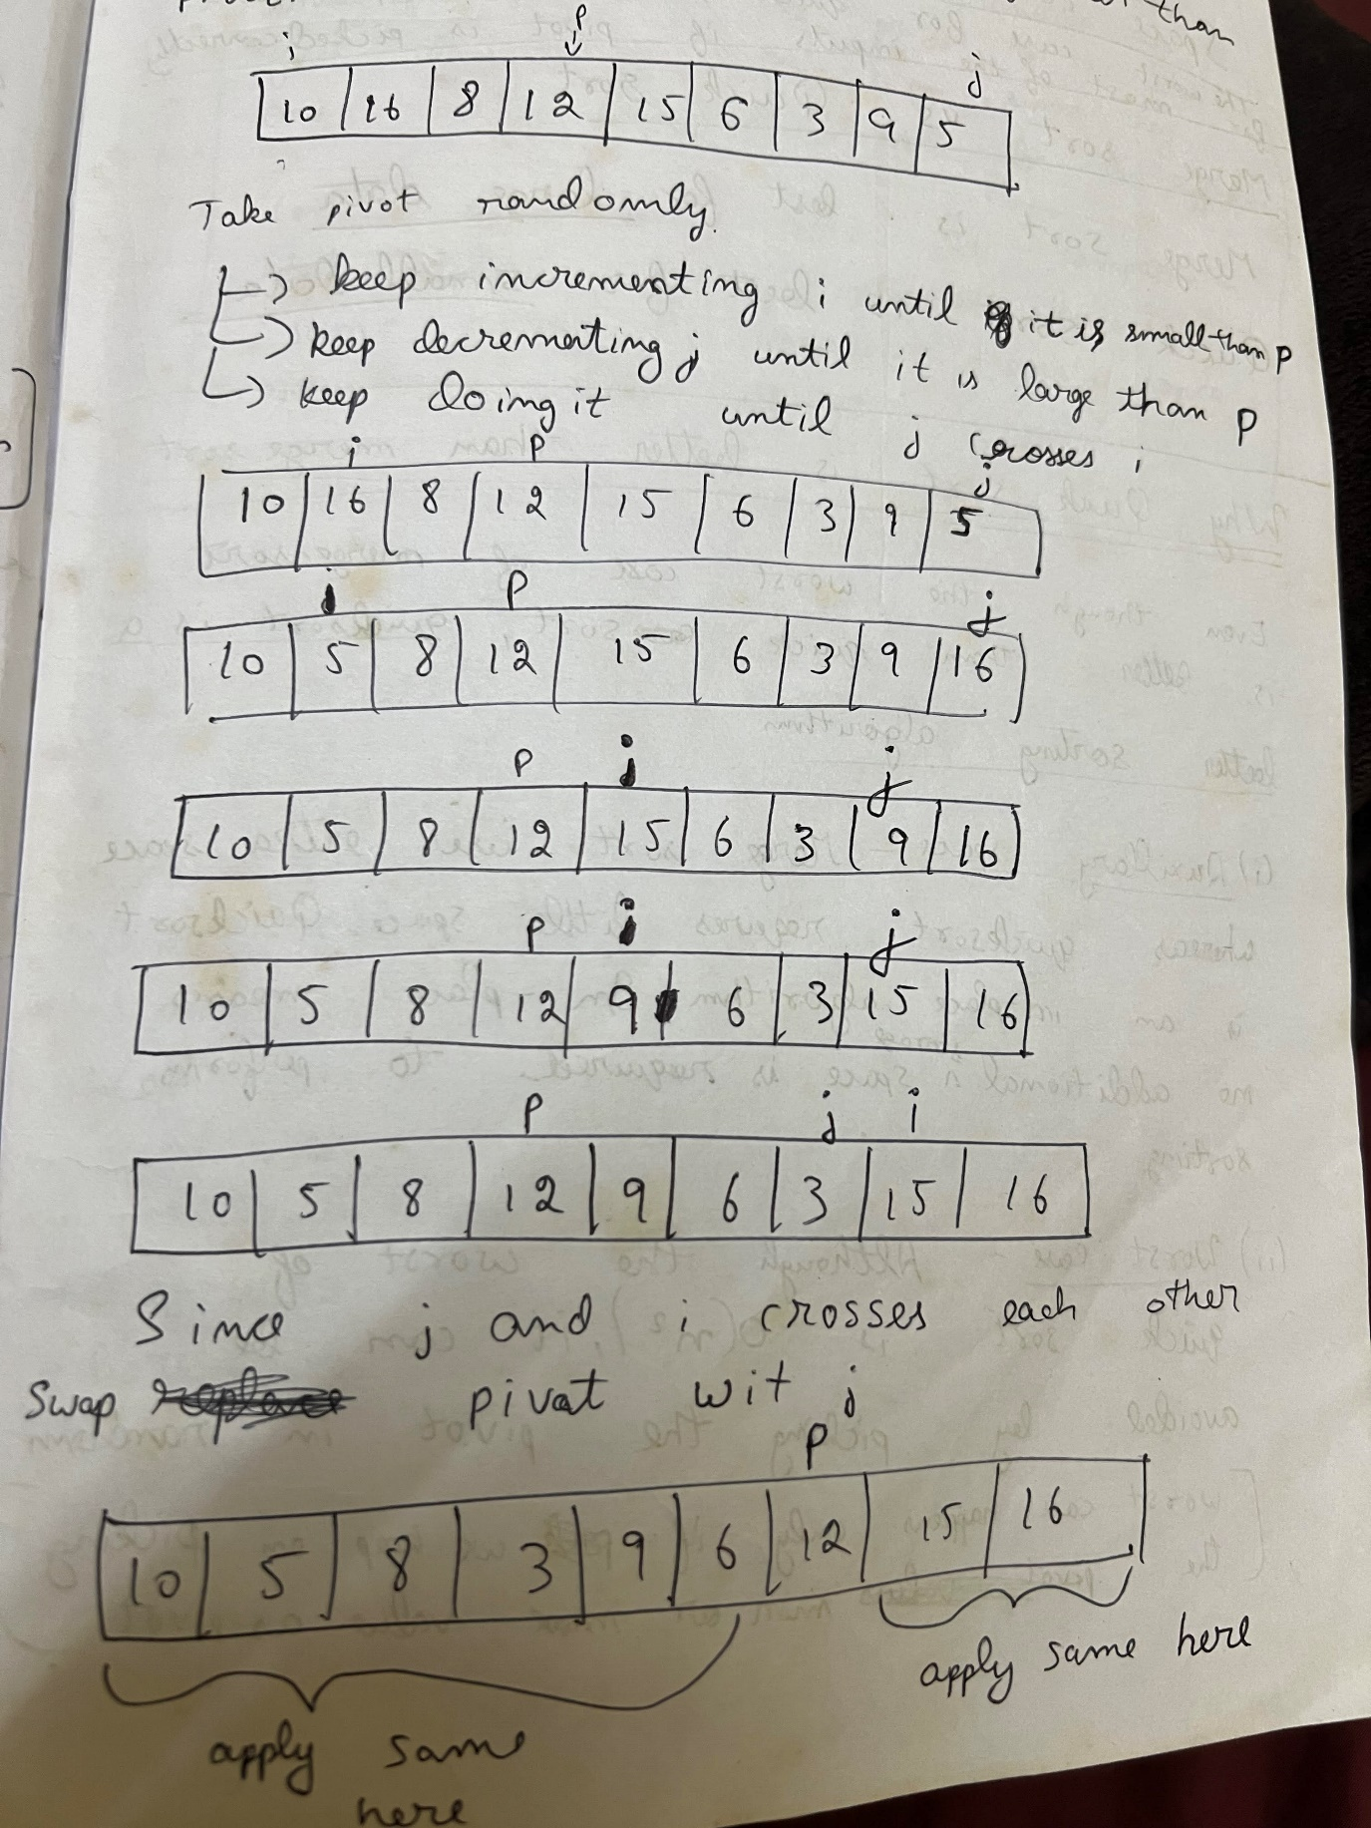

Approach used – Divide an dconquer

Time complexity – worst case - O(n2)

average case – O(nlogn)

Space complexity – worst case – O(n)

Average case – O(logn)