Dijkstra algorithm - I t is a single source shortest path algorithm, used to find shorted path from single source to all the other nodes

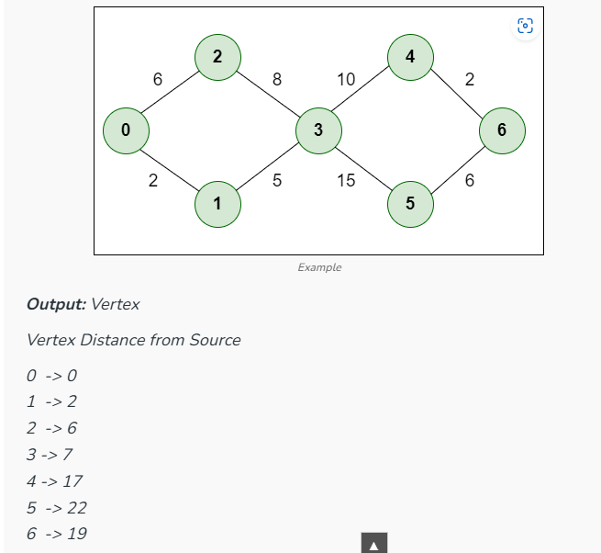

In the above image, initially we take 0 as our node of interest, then the path weight at node 1 is 2, at node 2 is 6, since path weight 2 is less than 6, we take node 1 as our next node of interest after 0

Bellmanford algorithm- It is a single source shortest path algorithm, used to find shorted path from single source to all the other nodes

It is slower than Dijkstra algorithm, but it can handle negative edges too

* There should be no negative sum in the cycle

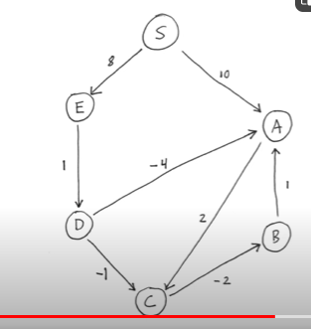

* We initially mention distance from source to each node as infinity, then keep on updating as and when we find shorter distance

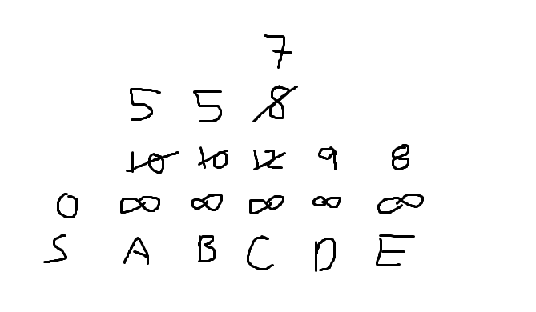

Floyd Warshal algorithm – It is all pair shortest path shortest path algorithm

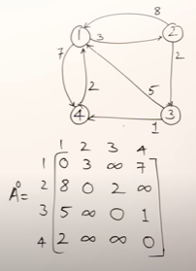

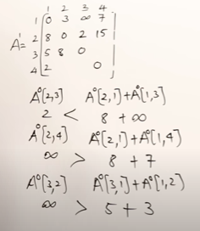

Similarly keep updating the tables with 2, 3, 4 as intermediate nodes

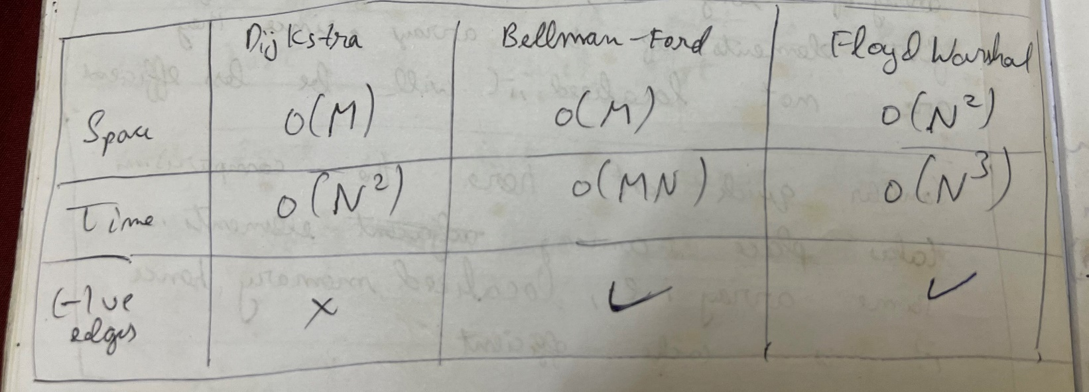

Prims algorithm – It is a minimum cost spanning tree

* It uses Greedy algorithm
* Initially we pick a node A, then find all the shorted weights from A which is 2 and add B to the visited node
* Then we find the shortest weight from visited nodes A or B to any not visited node and so on
* It uses a list to keep track of nodes visited

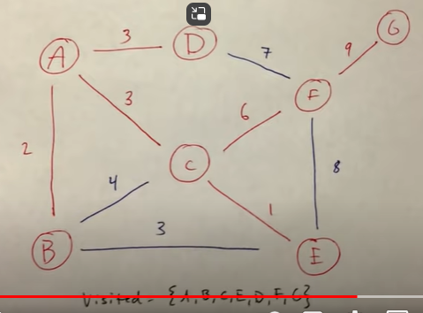

Kruskal algorithm – It is a minimum cost spanning tree

* Here we don’t start with any nodes, we directly keep picking edges with shortest path
* Also make sure that nodes which are already connected need not be connected again

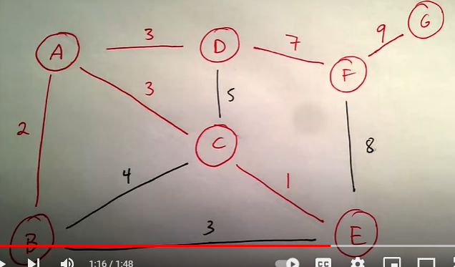

Time Complexity for Prims – O(n2)

Space complexity for Prims – O(n)

Time complexity for Kruskal – O(nlogn)

Space complexity for Kruskal – O(n)