Binary Tree – It is a tree data structure in which each node has a maximum of 2 children

Types of Binary trees-

1. Full Binary tree -  A Binary Tree is a full binary tree if every node has 0 or 2 children

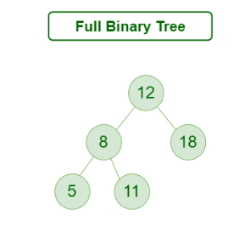

1. Degenerate (or pathological) tree - A Tree where every internal node has one child

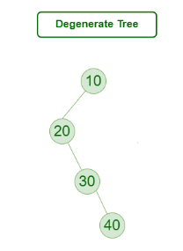

1. Skewed tree - A skewed binary tree is a pathological/degenerate tree in which the tree is either dominated by the left nodes or the right nodes. Thus, there are two types of skewed binary tree: left-skewed binary tree and right-skewed binary tree.

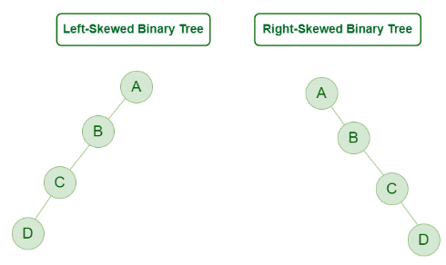

1. Complete Binary Tree-  A Binary Tree is a Complete Binary Tree if all the levels are completely filled except possibly the last level and the last level has all keys as left as possible

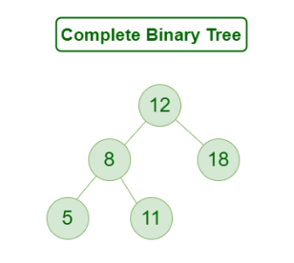

1. Perfect Binary Tree – A Binary tree is a Perfect Binary Tree in which all the internal nodes have two children and all leaf nodes are at the same level

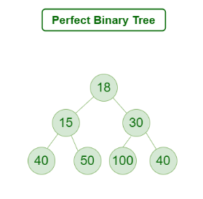

1. Binary Search Tree - Binary Search Tree  has the following properties:

* The left subtree of a node contains only nodes with keys lesser than the node’s key.
* The right subtree of a node contains only nodes with keys greater than the node’s key.

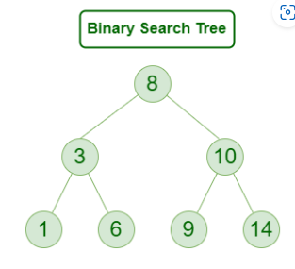

1. AVL Tree- AVL tree is a self-balancing Binary Search Tree (BST) where the difference between heights of left and right subtrees cannot be more than one for all nodes

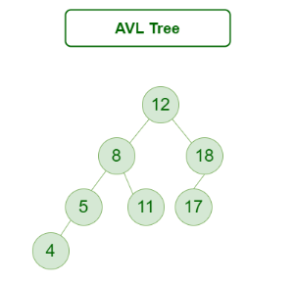

1. Red black trees - A red-black tree is a binary search tree  which has following properties

* It is a self-balancing BST
* Each node is either black or red
* Root node is always black
* If a node is red, then its children are black
* Every path from node to its leaf should have same number of black nodes

