Activity 9

3-tier:

**User interface:**

MainView

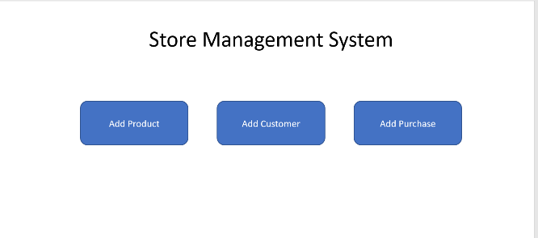

AddProductView class,

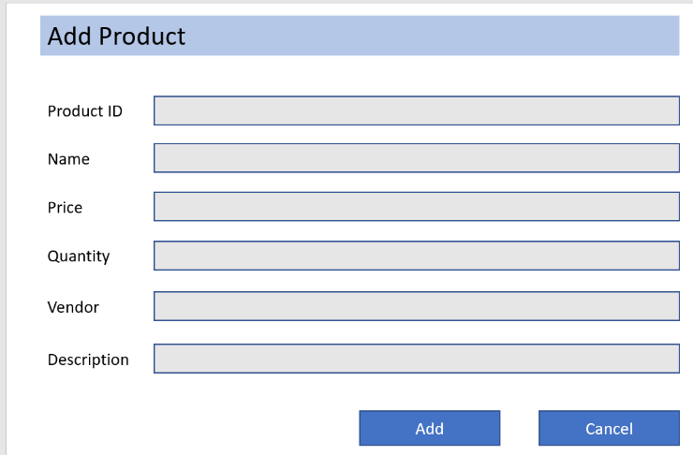

AddCustomerView class:

AddPurchaseView class:

AddSucessfully class:

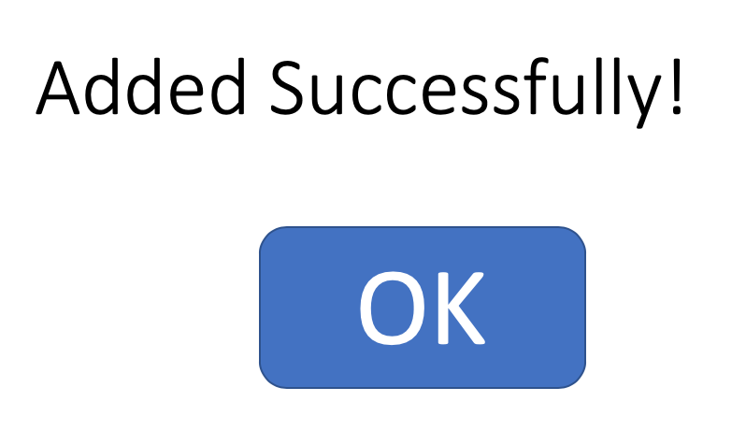

**Business Logic**

ProductModel class: store information of a product

AddProductController: process events of AddProductView

StoreManager: main application object

PurchseModel class: save information of purchase

AddCustomerController: add info from AddCustomerView class

**Data Access**

* SQLiteDataAdapter class: read/write data