PRL-HO: A Proactive Reinforcement Learning Framework for Handover Optimization in Ultra-Dense 5G Networks
Muhammad Umair Munir¹[0000-0001-5651-7795], Ismail Ahmedy^{1,2,*}[0000-0003-4324-8965], Saaidal Razalli Azzuhri¹[0000-0001-8603-8840], Rafidah Md Noor^{1,2}[0009-0004-2970-6290], Sharmin Sharmin¹[0000-0002-2540-455X], Md. Asri Ngadi^{3,*}[0000-0003-4907-6359], Syaril Nizam Omar⁴[0000-0002-7525-0579]
¹Faculty of Computer Science & Information Technology, Universiti Malaya, Kuala Lumpur, Malaysia.
²Center for Mobile Cloud Computing Research, Faculty of Computer Science & Information Technology, Universiti Malaya Kuala Lumpur, Malaysia
³Faculty of Computing, Universiti Teknologi Malaysia, Skudai, Johor, 81310, Malaysia.
⁴Fakulti Sains dan Teknologi, Universiti Sains Islam Malaysia, Bandar Baru Nilai 71800, Nilai, Negeri Sembilan, Malaysia
ismailahmedy@um.edu.my, dr.asri@utm.my
Abstract. Handover management in ultra-dense 5G networks presents critical challenges, as conventional rule-based approaches rely on fixed parameters that fail to adapt to dynamic user mobility and rapidly changing channel conditions, which result in Radio Link Failures (RLF) and ping-pong handovers. Existing machine learning and reinforcement learning methods either cannot adapt post-deployment or operate in a purely reactive manner without anticipation of future signal degradation. This paper proposes the Proactive Reinforcement Learning-based Handover Optimization (PRL-HO) framework, a unified architecture that integrates predictive intelligence with adaptive learning for handover optimization in ultra-dense 5G networks. The framework employs an Unscented Kalman Filter (UKF) with velocity-adaptive noise modeling to forecast signal quality up to two seconds ahead, which enables proactive handover decisions before signal degradation reaches critical levels. A Deep Q-Network (DQN) agent learns optimal handover policies through a KPI-Adaptive Reward Module that dynamically rebalances penalty weights based on current network performance. A Dynamic Handover Control Parameter mechanism jointly adjusts Time-to-Trigger and Handover Margin based on real-time velocity and signal conditions, while the Early Scheduled Handover Preparation (ESHOP) mechanism reduces handover latency from 100ms to 60ms. Simulation results over a 7-cell ultra-dense 5G network with heterogeneous user mobility demonstrate that PRL-HO achieved an RLF count of 0.21, a ping-pong count of 28.5, and a throughput of 421.8 Mbps. Compared with UKF-E2E-SARSA, PRL-HO reduced RLF by 8.7% and improved throughput by 23.7%. It also reduced ping-pong events by approximately 19.9% compared with DDPG-2024. Although Simple-DQN produced fewer ping-pong events, it experienced the highest RLF count, which indicates a trade-off between handover stability and connection reliability. These results indicate that proactive, prediction-based management can improve the balance between handover reliability, stability, and throughput under the evaluated simulation conditions.
Keywords: 5G networks, handover optimization, deep reinforcement learning, Unscented Kalman Filter, proactive handover, self-organizing networks.
- Introduction
The number of mobile users and their dependence on mobile networks has grown substantially in recent years. According to the Ericsson Mobility Report, global mobile network traffic reached 188 exabytes per month in Q3 2024 which represents a 20% year-on-year increase [1]. The share of traffic carried over 5G networks is projected to rise from 34% at the end of 2024 to 43% by the end of 2025, and is forecast to reach 83% by 2031 [1]. To meet the demand for high-speed connectivity with low latency, 5G networks rely on ultra-dense deployments where small cell base stations are placed at inter-site distances of 50 to 200 meters [2]. This results in cell densities of 1 to 5 cells per square kilometer in dense urban environments, which increases network capacity and improves coverage. However, this architecture introduces significant challenges for mobility management. Users in ultra-dense networks cross cell boundaries frequently and maintaining connectivity and quality of service under dynamic high-mobility conditions is a critical problem.
Current handover optimization approaches face fundamental limitations that prevent them from achieving optimal performance in ultra-dense 5G networks. The 3GPP standard handover mechanism [3] relies on fixed threshold-based rules with predefined Handover Control Parameters (Time-to-Trigger = 160 milliseconds, Handover Margin = 3 dB) that do not adapt to dynamic user mobility patterns or dynamic network conditions. This static approach results in Radio Link Failures when users experience rapid signal degradation in high-mobility scenarios and causes ping-pong handovers in overlapping coverage regions. Most studies confirmed that fixed handover parameters in ultra-dense networks lead to significant RLF, ping-pong and increased failures under high-velocity conditions [4–6] which degrade user experience and waste network signaling resources. To address these limitations, machine learning approaches have been explored. Multi-Layer Perceptron (MLP) based methods [7] predict handover parameters through data-driven learning but rely on static offline training that cannot adapt after deployment. Reinforcement learning techniques such as Deep Q-Networks (DQN) [8] and Deep Deterministic Policy Gradient (DDPG) [9] support continuous online adaptation but operate in a purely reactive manner, with no ability to anticipate future signal degradation. More recent prediction-based methods integrate Unscented Kalman Filter (UKF) to forecast signals [10], but they use predictions only to refine handover timing rather than to prevent failures proactively, and they lack adaptive multi-objective reward mechanisms that can rebalance competing performance goals as network conditions shift.
These limitations point to four concrete research gaps that PRL-HO addresses. First, among the reviewed studies, no method directly uses predicted signal quality to reward preventive action before a failure occurs. UKF-E2E-SARSA [10] does incorporate channel forecasts, but only to determine when to trigger a handover, not to reward the agent for early intervention. PRL-HO closes this gap through a graduated proactive reward mechanism that assigns bonuses based on predicted SINR risk, the more severe the forecast degradation, the higher the bonus awarded to the agent for a timely handover, before the signal reaches a critical threshold. Second, existing RL methods apply fixed penalty weights across all network conditions. Approaches such as DQN [8] and DDPG [9] use a static reward function where the importance assigned to each objective, such as reducing RLF, minimizing ping-pong, or maximizing throughput, remains constant regardless of how the network conditions change. PRL-HO addresses this through a KPI-Adaptive Reward Module that adjusts penalty weights every ten training episodes based on deviation from target performance metrics. Third, parameter adaptation remains partial across all prior methods. MLP-based approaches [7] adjust either HOM or TTT in isolation, without joint consideration of velocity, signal quality, and prediction confidence. PRL-HO resolves this through a Dynamic HCP mechanism that scales both TTT and HOM simultaneously based on real-time velocity and SINR. Fourth, no prior work integrates all these capabilities into a single framework. PRL-HO addresses this by unifying seven components, UKF-based multi-step channel prediction, confidence-weighted forecast filtering, graduated proactive reward shaping, KPI-Adaptive weight adjustment, joint HCP scaling, ESHOP-based handover latency reduction from 100 to 60ms, and DQN-based policy learning, into one coherent architecture, which constitutes the primary contribution of this work. To the best of our knowledge, PRL-HO represents the first framework to unify velocity-adaptive channel prediction, confidence-gated proactive rewards, adaptive multi-objective optimization in a single integrated architecture for ultra-dense 5G handover management.
The remainder of this paper is organized as follows. Section 2 reviews existing literature on types of handover optimization in mobile networks which include traditional rule-based methods, ML based approaches, RL-based techniques, and prediction-based methods, followed by identification of the research gaps that motivate the proposed framework. Section 3 presents the system model, network architecture, channel model, mobility model, and the Markov Decision Process formulation with state space, action space, and reward function. Section 4 describes the PRL-HO framework in detail, with coverage of UKF-based channel prediction with velocity-adaptive noise modeling, DQN-based policy learning, Dynamic Handover Control Parameter adjustment, the ESHOP mechanism, and the KPI-Adaptive Reward Module. Section 5 presents the experimental evaluation which includes simulation setup, baseline comparisons across five methods, and performance analysis over five key metrics: Radio Link Failure count, ping-pong handover count, total handover count, average SINR, and system throughput. Section 6 concludes the paper and outlines directions for future research.
- Literature Review
This section provides a comprehensive review of existing handover optimization approaches in 5G ultra-dense networks. As illustrated in Fig. 1, the literature is organized into six primary methodological categories: rule-based, weighted-based, velocity-based, fuzzy logic-based, AI/ML-based (further subdivided into supervised learning, reinforcement learning, and prediction-based methods), and hybrid approaches [6, 11]. Each category is analyzed in terms of its contributions, technical mechanisms, and inherent limitations.
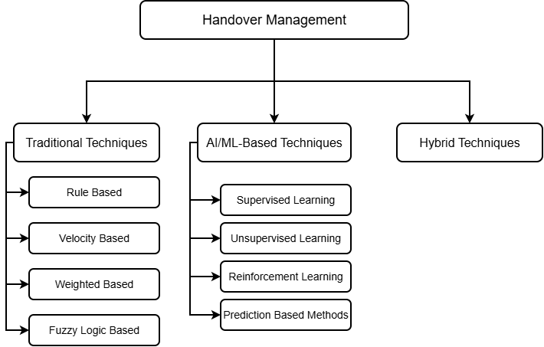
Fig. 1. Taxonomy of Handover Optimization Approaches in 5G Ultra-Dense Networks
  - Traditional Techniques
Traditional handover optimization techniques rely on predefined rules and mathematical formulations without incorporating learning-based adaptation. These approaches form the baseline against which intelligent methods are evaluated. These approaches are categorized into several methods like rule based, velocity based, weighted based and fuzzy logic-based methods. Rule-based methods implement the 3GPP A3 event mechanism where handover triggers when the target cell's RSRP exceeds the serving cell by a fixed HOM (typically 3 dB) for a fixed TTT duration (typically 160 ms) [3]. Alraih et al. [4] demonstrated that fixed parameter configurations fail to perform optimally across diverse mobility scenarios, as high-velocity users experience significantly elevated RLF and ping-pong rates under static TTT and HOM settings. Riaz et al. [5] further analyzed handover behavior under high-velocity conditions in 5G HetNets, and demonstrated that fixed-threshold approaches lead to significant RLF events and excessive unnecessary handovers when users move at vehicular speeds due to rapid signal degradation that exceeds the fixed TTT window. These methods lack adaptation to dynamic network conditions and user mobility patterns.
Velocity-based methods adapt handover parameters based on user speed. These methods recognize fast-moving and slow-moving users and adjust handover behaviors accordingly. Fast-moving users benefit from shorter TTT and reduced HOM to avoid late handovers and RLF as they rapidly cross cell boundaries, while slow-moving users require longer TTT and larger HOM to resist unnecessary handovers triggered by temporary signal fluctuations. Nie et al. [12] proposed an Enhanced Mobility State Estimation algorithm for LTE-Advanced SON that classifies users into four discrete mobility states (stationary, pedestrian, medium-speed vehicular, high-speed vehicular) based on handover frequency and cell dwell time, then adjusts TTT values accordingly. Simulation results demonstrated reductions in both handover failure and ping-pong rates across pedestrian and vehicular speed scenarios compared to fixed-parameter baselines. Huang et al. [13] extended this model to SDN-enabled ultra-dense networks by developing a self-adapting framework that uses GPS-derived or cell-tower triangulation velocity estimates to dynamically select TTT values from discrete candidate configurations and achieved improved effective handover ratio and reduced ping-pong percentage in mixed-mobility scenarios. Despite these contributions, velocity-based approaches exhibit two critical limitations. First, velocity is treated as the sole adaptation signal while ignoring current signal quality trends, predicted future channel conditions, and network load. Second, only TTT is adjusted while HOM remains fixed which restrict the ability to simultaneously optimize both handover timing and signal strength margin. This prevents coordinated adjustment necessary to balance RLF prevention and ping-pong minimization. As shown in Table 1, velocity-based methods achieve velocity adaptation and partial dynamic HCP but lack channel prediction and proactive intervention mechanisms.
Weighted-based methods extend rule-based frameworks by combining multiple network metrics into a handover trigger score using weighted functions. These methods do not rely on signal strength alone. These approaches compute multi-dimensional scores that combine SINR, cell load, and user speed for context-aware handover decisions. For example, Shayea et al. [14] proposed an Individualistic Dynamic Handover Parameter Self-Optimization Algorithm that employ automatic weight functions to optimize HOM and TTT based on current SINR and cell load for each user and demonstrated improvements in handover rate and ping-pong reduction across heterogeneous network scenarios. Alhabo and Zhang [15] introduced a load-dependent HOM approach that dynamically adjust handover thresholds based on weighted cell load functions to achieve load balancing while maintaining acceptable handover failure rates. Saad et al. [16] proposed a mobility robustness optimization algorithm that uses weighted linear regression to predict optimal HCP configurations from real-time KPI measurements, with regression weights calibrated offline on historical data to minimize weighted combinations of RLF, ping-pong, and handover failure rates. Despite greater flexibility through multiple weights, these approaches depend on manual calibration of weight coefficients. These coefficients are typically optimized offline under specific deployment assumptions and traffic patterns, and cannot self-adjust when network conditions evolve dynamically. This limits responsiveness in environments with unpredictable user mobility distributions or time-varying interference patterns.
Fuzzy logic methods encode expert knowledge as linguistic rules for parameter adaptation across varying conditions. Hwang et al. [17] proposed FLDHDT for 5G ultra-dense networks, which uses SINR and UE horizontal speed as dual inputs to a fuzzy controller that simultaneously adjusts both HOM and TTT. The fuzzy rule base contains linguistic rules such as "if SINR is low and speed is high then TTT is very short and HOM is small." FLDHDT demonstrated reduced ping-pong ratio and improved throughput compared to 3GPP A3. Alraih et al. [18] developed RHOT-FLC for 5G and beyond networks with RSRP, RSRQ, and user velocity as three inputs. [18] used fuzzy membership functions to partition RSRP and RSRQ into five categories (very low, low, medium, high, very high), and velocity into three categories (low, medium, high) to produce rule base that covers diverse mobility and signal quality scenarios. Their evaluation results showed improvements in handover probability, failure rate, ping-pong effect, latency, and interruption time over conventional rule-based and competing fuzzy approaches. Riaz et al. [5] extended fuzzy logic to 5G ultra-dense HetNets by incorporation of cell load alongside RSRP and user speed as fuzzy inputs, which demonstrated reduced RLF and improved handover stability under high-velocity conditions. Despite parameter adaptation through human-interpretable rules without labeled training data requirements, fuzzy logic methods have fixed rule bases and membership functions after design that cannot automatically update when network behavior changes or new patterns emerge. This limitation restricts performance in previously unseen conditions and requires significant manual expertise to design and periodically recalibrate membership functions and rule sets as network characteristics evolve. Table 1 indicates that fuzzy logic methods achieve velocity adaptation and partial dynamic HCP but lack channel prediction, proactive intervention, and adaptive reward mechanisms.
  - AI/ML Based Techniques
AI and Machine Learning-based techniques overcome the limitations of traditional methods by proving adaptive learning from network conditions and operational experience. Unlike traditional techniques that rely on fixed rules or manual set parameters, AI/ML-based approaches can learn optimal policies either from historical datasets or through direct interaction with live network environments. This section categorizes AI/ML-based techniques into four primary approaches: supervised learning, unsupervised learning, reinforcement learning, and prediction-based methods.
Supervised learning methods learn handover parameter mappings from labeled historical datasets. These approaches train models offline to predict optimal HCP configurations from input features such as RSRP, SINR, user speed, and cell load. For example Riaz et al. [7] proposed an MLP-based handover decision optimization method that trains a feedforward neural network to predict optimal TTT and HOM values from network measurements and demonstrated improvements over 3GPP A3 baseline: 90.9% reduction in handover rate, 76.6% reduction in handover failure, 79.8% reduction in ping-pong rate, and 75% reduction in RLF. Saad et al. [16] applied linear regression for mobility robustness optimization that maps real-time KPI observations to predicted optimal HCP settings. The regression weights are learned offline from historical network performance data to minimize prediction error. Simulation results showed reduced handover failure and ping-pong rates across dynamic traffic scenarios compared to fixed-parameter baselines. Despite strong offline performance, supervised learning methods share a fundamental limitation: once deployed, models cannot update their parameters in response to new network conditions that differ from training distributions. This static nature causes performance degradation when signal characteristics, user mobility patterns, or traffic loads shift from training conditions.
Unsupervised learning approaches apply clustering and pattern recognition without labeled data. unsupervised methods alone do not provide direct handover decision policies and must be combined with other learning paradigms. For example, Wang et al. [19] utilized LSTM-based digital twins to model network state evolution and guide exploration in reinforcement learning frameworks. The LSTM component learns temporal patterns from historical network observations and predicts future network states to assist the DQN agent in action selection, which achieved 2.7% improvement in effective handover ratio over standard DQN while reducing training time through predictive guidance.
Reinforcement learning methods enable online policy adaptation through environment interaction without requiring pre-labeled training data. The RL models use Markov Decision Process where agents observe network states, select actions, receive rewards, and update policies to maximize long-term cumulative reward. For example, Wu et al. [8] proposed a DQN-based handover management framework for SDN-enabled ultra-dense networks which maps network state observations to discrete handover actions through deep neural networks. The DQN agent learns Q-value functions that predict expected long-term rewards for each action in each state, and selects actions greedily during deployment. Simulation results demonstrated improvements in handover success rate and network throughput over rule-based baselines through learned policies that adapt to local network conditions. Kwong et al. [9] developed an autonomous handover optimization method using DDPG with Actor-Critic architecture for 5G cellular networks. The DDPG-based method was trained to minimize composite objectives of handover probability, outage probability, and ping-pong probability, and achieved superior multi-objective performance compared to fixed-parameter and rule-based baselines. Despite online learning capability, RL methods share a critical limitation: they operate reactively based on current observations without predictive capability to anticipate future signal quality degradation. This reactive nature means handover decisions trigger only after SINR has begun to deteriorate, which leaves insufficient time to execute preventive actions and avoid RLF in high-velocity scenarios.
Prediction-based methods augment handover decision-making with channel quality forecasting to enable forward-looking decisions. These approaches estimate future signal conditions several timesteps ahead to shift handover initiation before signal quality reaches critical failure thresholds. For example Junejo et al. [10] proposed an adaptive handover management framework that integrates UKF channel prediction with Expected SARSA reinforcement learning for high-mobility scenarios in smart city environments. The UKF component forecast future RSRP values for serving and neighboring cells based on recent measurement history and user velocity. The predicted RSRP values enable the E-SARSA agent to identify target cells with highest predicted Q-values and dynamically select RSRP and SINR offset values through epsilon-greedy exploration. While UKF-E2E-SARSA advances beyond reactive approaches through channel forecasting, predicted signal information is used primarily to refine timing and target selection rather than to directly reward agents for executing preventive handovers before predicted failure conditions materialize. The framework lacks graduated, prediction-confidence-gated proactive risk intervention that assigns differential reward bonuses based on predicted signal degradation severity. Furthermore, UKF-E2E-SARSA does not incorporate adaptive multi-objective reward balancing mechanisms that dynamically adjust penalty weights based on recent performance trends, which limits ability to re-prioritize between RLF prevention and ping-pong reduction as network conditions evolve.
  - Hybrid Techniques
Hybrid handover optimization techniques combine different AI/ML approaches, e.g., fuzzy logic with reinforcement learning, supervised learning with metaheuristics, or deep learning with traditional ML, to achieve robust performance across multi-objective scenarios. For example, Alhammadi et al. [20] integrated fuzzy logic with SON optimization principles. The researchers combined local fuzzy controllers for parameter adaptation with centralized load balancing coordination. Phatcharasathianwong and Kunarak [21] developed neural network prediction with fuzzy decision rules for vertical handover across LTE, 5G, and WiFi-6. Hassan et al. [22] developed a deep hybrid learning approach for 5G mmWave networks that combines LSTM, GRU, and CNN architectures to predict optimal HOM and TTT parameters. The hybrid model processes historical measurement data through multiple neural network stages to increase handover efficiency while reducing unnecessary and delayed handovers, which achieved reduced ping-pong effects and avoided RLF in high-mobility scenarios. Lima et al. [23] proposed a deep learning-based handover prediction framework that uses LSTM to forecast future RSRP samples with mean absolute error around 0.6 dB and binary classification to identify handover trigger moments with over 97% accuracy. Their two-stage approach enables 100ms advance prediction for proactive handover preparation. While achieving partial capabilities across multiple dimensions, hybrid approaches introduce system complexity without unified integration of prediction, proactive intervention, adaptive reward balancing, and joint parameter optimization. Table 1 provides systematic comparison across seven capability dimensions: Channel Prediction, Proactive Intervention, Adaptive Reward, Dynamic HCP, Early Scheduling, Multi-Step Prediction, and Velocity Adaptive. Analysis reveals no existing method achieves full capability across all dimensions. Rule-based [3, 4] methods exhibit no advanced capabilities. Velocity-based [12, 13], weighted-based [14–16] and fuzzy logic [5, 17, 18] approaches achieve partial dynamic HCP and velocity adaptation but lack prediction. Supervised learning achieves strong offline performance but cannot adapt post-deployment. Reinforcement learning [8, 9] provides online adaptation but operates reactively without prediction. UKF-E2E-SARSA [10] incorporates prediction but lacks proactive reward shaping. Hybrid methods [20–23] demonstrate partial capabilities without complete integration.
Table 1. Comparative Analysis of Handover Optimization Methods
Method | Channel Prediction | Proactive Intervention | Adaptive Reward | Dynamic HCP | Early Scheduling | Multi-Step Prediction | Velocity Adaptive
Rule-Based [3, 4] | ✗ | ✗ | ✗ | ✗ | ✗ | ✗ | ✗
Velocity-Based [12, 13] | ✗ | ✗ | ✗ | Partial | ✗ | ✗ | ✓
Weighted-Based [14–16] | ✗ | ✗ | ✗ | Partial | ✗ | ✗ | ✗
Fuzzy Logic [5, 17, 18] | ✗ | ✗ | ✗ | Partial | ✗ | ✗ | ✓
Supervised Learning [7, 16] | ✗ | ✗ | ✗ | Partial | ✗ | ✗ | ✓
Unsupervised Learning [19] | ✗ | ✗ | ✗ | ✗ | ✗ | ✗ | ✗
Reinforcement Learning [8, 9] | ✗ | ✗ | ✗ | Partial | ✗ | ✗ | ✗
Prediction-Based [10] | ✓ | ✗ | ✗ | Partial | ✗ | ✗ | ✗
Hybrid [20–23] | Partial | ✗ | ✗ | Partial | ✗ | ✗ | ✓
Proposed PRL-HO | ✓ | ✓ | ✓ | ✓ | ✓ | ✓ | ✓

From table 1, several research gaps have been identified. Like, no existing method implements proactive, prediction-confidence-gated risk intervention that assigns graduated reward bonuses based on predicted signal degradation severity to incentivize early preventive handovers before failure conditions materialize. While prediction-based methods [10] incorporate channel forecasting, but predictions are used to refine timing and target selection rather than to shape reward functions with proactive bonuses. Similarly, all RL methods like [8, 9] employ static reward functions with fixed penalty weights that cannot dynamically re-prioritize objectives as network performance trends evolve during training and deployment. This prevents adaptive balancing between RLF prevention and ping-pong reduction when network conditions shift. Moreover, parameter adaptation remains partial across all categories, with methods adjusting either TTT or HOM individually without joint scaling based on simultaneous consideration of velocity, signal quality, and prediction confidence. This individual parameter optimization restricts ability to achieve optimal tradeoffs between handover timing and signal strength margins. While hybrid methods [18], [19], [20], [21] combine multiple techniques, they lack complete integration of all these capabilities. To address these gaps, this paper proposes the Proactive Reinforcement Learning-Based Handover Optimization (PRL-HO) framework, whose architecture and mechanisms are detailed in Section 4. The following sections detail the proposed framework architecture, mechanisms, and evaluation results.
- System Model and Problem Formulation
The proposed handover optimization problem is formulated as a Markov Decision Process (MDP) which is a mathematical framework for sequential decision-making in which agents learn to select actions that maximize cumulative rewards. The MDP is defined by the tuple (S, A, R, P, γ), where S is the state space that represent the network conditions, A is the action space of handover strategies, R is the reward function encoding optimization objectives, P is the state transition probability, and γ is the discount factor for long-term planning.
  - Network Architecture
The network architecture defines the physical deployment scenario that consists of ultra-dense 5G network with seven hexagonal cells (Nc = 7), each with radius R = 500 meters which represents dense urban deployment scenario. This hexagonal topology is standardized in 3GPP specifications [3] and it ensures uniform coverage and it also minimizes the interference overlap between cells. The network serves M = 20 mobile users with heterogeneous mobility patterns, velocities ranging from v = 1 to 30 m/s which represent pedestrians (slow-moving UE whose velocity range is 1-5m/s) to vehicular users (diverse mobility whose range from 15-30m/s). This range also allow the algorithm to learn adaptive handover strategies for different mobility classes [24]. The main network simulation parameters are summarized in Table 2.
Table 2. Simulation Environment Parameters
Parameter | Value/Description
Network Configuration
Number of cells (Nc) | 7 (hexagonal topology)
Cell radius (R) | 500 meters
Number of users (M) | 20
Coverage area | ~6.5 km²
Carrier frequency: | fc = 3.5 GHz (5G mid-band)
Bandwidth | B = 100 MHz
gNodeB transmit power | Ptx = 46 dBm
UE receiver sensitivity | -110 dBm
Antenna configuration | 8×8 MIMO at gNodeB, 2×2 at UE
Mobility Parameters
Mobility model | Random Waypoint Mobility Model (RWMM)
Velocity distribution | [1, 30] m/s
Pause time | Uniform [0, 5] seconds
Simulation Timing
Timestep (Δt) | 100 milliseconds
Episode duration | 2000 timesteps (200 seconds)
Training episodes | 250 episodes (~500K timesteps)
Evaluation episodes | 100 episodes
Handover Configuration
Handover mechanism | 3GPP A3 event trigger
Handover latency | 100 ms
Performance Metrics
RLF threshold | SINR < -6.5 dB for 200 ms
Ping-pong window | Handover A→B→A within 1 second
Tracked KPIs | RLF count, ping-pong rate, handover count, average SINR, throughput
Implementation
Programming language | Python 3.9
Key libraries | NumPy (vectorized operations), PyTorch 2.0.1 (DQN)
Simulation speed | ~10,000 timesteps/second
  - Channel Model
The channel model describes how signal strength varies with distance, obstacles, and multipath propagation. Handover decisions rely on signal quality measurements (RSRP and SINR). The wireless channel follows the 3GPP Urban Macro (UMa) model [3], which consist of three components: path loss, shadowing and fast fading. The received signal power (RSRP) at user $m$ from base station $n$ at time $t$ is expressed as:
$${RSRP}_{\left\{m,n\right\}\left(t\right)}= P_{\left\{tx\right\}}- PL\left(d_{\left\{m,n\right\}}\right)+ {SF}_{\left\{m,n\right\}\left(t\right)}- {FF}_{\left\{m,n\right\}\left(t\right)}$$ | (1)
where $P_{”tx}”$ is the transmit power of the base station (dBm), $PL\left(d_{m,n}\right)$ is the path loss at distance $d_{m,n}$, $SF_(m,n) (t)∼N(0,σ_”SF” ^2 )$ represents log-normal shadow fading with standard deviation $σ_{”SF}” =8$ dB, and $FF_{m,n}\left(t\right)$ denotes small-scale Rayleigh fast fading. The path loss model for the UMa scenario is given by:
$$PL\left(d\right)= 28.0 + 22\log_{\left\{10\right\}}\left(d\right)+ 20 \log_{\left\{10\right\}}\left(f_{c}\right)$$ | (2)
where $d$ is the distance between user and base station (in meters), $f_{c}$ is the carrier frequency (in GHz). The Signal-to-Interference-plus-Noise Ratio (SINR) at user $m$ is calculated as:

$${SINR}_{m}\left(t\right)=\frac{P_{\left\{r,s\right\}}\left(t\right)}{\sum_{\left\{I ≠s\right\}P_{\left\{r,i\right\}}}{\left(t\right)}+ N_{0}B}$$ | (3)
where $P_{r,s}\left(t\right)$ is the received power from the serving cell, $P_{r,i}\left(t\right)$ represents received interference power from neighboring cells, $N_{0}=-174$dBm/Hz is the thermal noise power spectral density, $B$ is the system bandwidth.
  - Mobility Model
In this research, User mobility is modeled using the Random Waypoint Mobility Model (RWMM) [25] in which each user moves toward randomly selected waypoints at velocities sampled from a truncated Gaussian distribution. RWMM is widely used in wireless network simulation studies [25] because it generates realistic mobility patterns without requiring any detailed geographical data. The Gaussian velocity distribution with mean 15 m/s represents mixed traffic (pedestrians + vehicles), while the [1, 30]m/s range ensures diversity in mobility classes.
  - State Space Formulation
The state space defines the information available to the DQN agent for decision-making. A well-designed state space must contain sufficient information to make optimal decisions (that satisfy the Markov property) while remaining compact to enable efficient learning. The state vector includes four categories of information: first, instantaneous measurements ( that include RSRP, SINR, velocity), second, handover context (that include count, time since last HO), third, current parameters ( that include TTT, HOM, A3_offset), and fourth predictive features ( that include predicted SINR, RSRP trends). This combination enables both reactive and proactive decision-making. The 16-dimensional state vector at time t is shown in equation 4.
s_{t} = [RSRP_{serving}, RSRP_{nb1}, RSRP_{nb2}, RSRP_{nb3}, SINR, v, N_{HO}, t_{HO}, TTT, HOM, A3_{offset}, SINR_{trend}, Predict_{SINR}, RSRP_{degradation}, pred_{serving}, pred_{neighbour}]ᵀ | (4)
Each dimension serves a specific purpose as shown in table 3.
Table 3. State space dimensions and their purposes in handover decision-making.
Dimension | Purpose
RSRP_{serving} | Current serving cell signal strength - primary handover decision factor
RSRP_{nb1,nb2,nb3} | Three strongest neighbors - candidate target cells for handover
SINR | Link quality indicator - determines throughput and RLF risk
V (Velocity) | User speed - determines optimal handover aggressiveness
N_{HO} | Handover count - tracks handover frequency to avoid excessive switching
t_{HO} | Time since last handover - identifies ping-pong risk scenarios
TTT,HOM, A3_offset | Current handover control parameters - enables parameter-aware decisions
SINR_{trend} | Signal quality trend - detects rapid degradation
Predict_{SINR} | UKF prediction 1-2 seconds ahead - enables proactive handovers
RSRP_{degradation} | Rate of signal decline - identifies emergency scenarios
Pred_{serving} / pred_{neighbor} | Future signal strengths - supports ESHOP early preparation
  - Action Space
The action space defines the available handover strategies that the agent can execute based on network conditions. In the proposed PRL-HO framework agent learn six discrete actions as denoted by a₀ to a₅ as illustrated in Table 4. Each action defines specific configuration of HCP. These HCP are of three types such as TTT, HOM, A3_offset. TTT is the duration of handover condition that must persist before execution. Higher values (480 ms) prevent unnecessary handovers from temporary fluctuations and the lower values (40 ms) lead to response to signal degradation. HOM is the additional signal strength threshold that the neighbor cell must exceed. Higher values (6 dB) reduce handover frequency whereas lower values (0.5 dB) enable quicker handovers. A3_offset is the adjustment factor added to neighbor signal strength. Higher values promote earlier handovers whereas, lower values delay handovers until clearer signal advantage exists.
Table 4. Action Space Configuration and Trigger Conditions for PRL-HO Framework
Action | TTT (ms) | HOM (dB) | A3_{offset} (dB) | Trigger Conditions | Purpose
a₀:  Very Conservative | 480 | 6 | 6 | Low velocity (v<5 m/s), stable high SINR (>5 dB), no signal degradation | Minimize handovers for stable scenarios
a₁:  Conservative | 320 | 4 | 4 | Moderate velocity (5≤v<10 m/s), acceptable SINR (0-5 dB), stable signal trend | Low mobility with good signal
a₂:  Balanced (3GPP default) | 160 | 3 | 3 | Average network conditions, no extreme mobility or signal issues | Standard configuration for typical scenarios (3GPP default)
a₃:  Moderate | 100 | 2 | 2 | Moderately high velocity (10≤v<20 m/s), slight SINR degradation, neighbor RSRP increasing | Moderate mobility scenarios
a₄:  Aggressive | 80 | 1 | 1 | High velocity (20≤v<30 m/s), SINR near threshold (-6.5 to -3 dB), UKF predicts degradation | High mobility or degrading signal
a₅:  Very Aggressive | 40 | 0.5 | 0.5 | SINR<-5 dB, rapid signal degradation (ΔSINR/Δt<-2 dB/s), very high velocity (v>25 m/s) | Emergency RLF prevention

During training, the agent uses an ε-greedy policy to balance exploration and exploitation. The exploration rate ε starts at 1.0 (100% random exploration) and gradually decreases to 0.01 (1% exploration, 99% exploitation) over 100,000 training steps. This decay strategy is essential because of the following reasons:
- Initially, the agent has no knowledge and must explore different actions to discover their consequences
- As training progresses and the agent learns which actions work well in different situations, it should increasingly rely on this learned knowledge rather than random choices.
- By maintaining a small amount of exploration (1%) even after training prevents the agent from becoming trapped in suboptimal strategies.
At each decision point during training, the agent select a random action with probability ε (exploration) or chooses the action with the highest predicted Q-value with probability 1-ε (exploitation), where the Q-value represents the expected cumulative reward for taking a specific action in the current state. During deployment, the agent operates in fully greedy mode in which it always selects the action with the highest predicted Q-value based on the learned policy. Once an action is selected, the corresponding TTT, HOM, and A3_offset parameters are applied to configure the 3GPP A3 handover event trigger as shown in equation 5
$$A3_{\left\{event\right\}}= {RSRP}_{\left\{neighbor\right\}}+ A3_{\left\{offset\right\}}> {RSRP}_{\left\{serving\right\}}+ HOM$$ | (5)
When this condition satisfies for duration TTT, handover executes to the strongest neighbor.
  - Reward Function
The reward function is the main function that guides the agent to learn handover strategies that minimize Radio Link Failures (RLF) and ping-pong handovers and also maintain the quality of service. In this research, multi-objective reward function has been used that uses five objectives: RLF prevention, ping-pong reduction, handover frequency control, quality of service maintenance, and proactive intervention rewards. The reward structure assigns penalties based on relative importance: RLF receives the highest penalty (10.0) due to complete connection loss, ping-pong receives medium penalty (5.0) for wasting signal resources, and handovers receive small penalty (0.5) as they are necessary but should be controlled. Quality of service rewards are based on SINR and throughput levels, and proactive rewards encourage early interventions when RLF risk is detected. The penalty weights are adaptive and dynamically adjusted based on current network performance (detailed in Section 4) which help the agent to prioritize different objectives depending on network conditions. This multi-objective formulation follows standard reinforcement learning practices and is inspired by similar approaches in mobile network optimization [8–10].
- Proposed PRL-HO Framework
This section presents the proposed PRL-HO framework that addresses the critical challenges of handover management in ultra-dense 5G networks through the integration of predictive intelligence and adaptive learning. Traditional handover schemes operate reactively and trigger the handover decisions only after signal quality has degraded below acceptable thresholds which results in more RLF, enhanced ping pong and service interruptions. The proposed PRL-HO framework resolves this challenge by introducing a proactive approach that can predict channel conditions 1-2 seconds ahead and learn optimal handover strategy through deep reinforcement learning to achieve superior performance across multiple key performance indicators simultaneously.

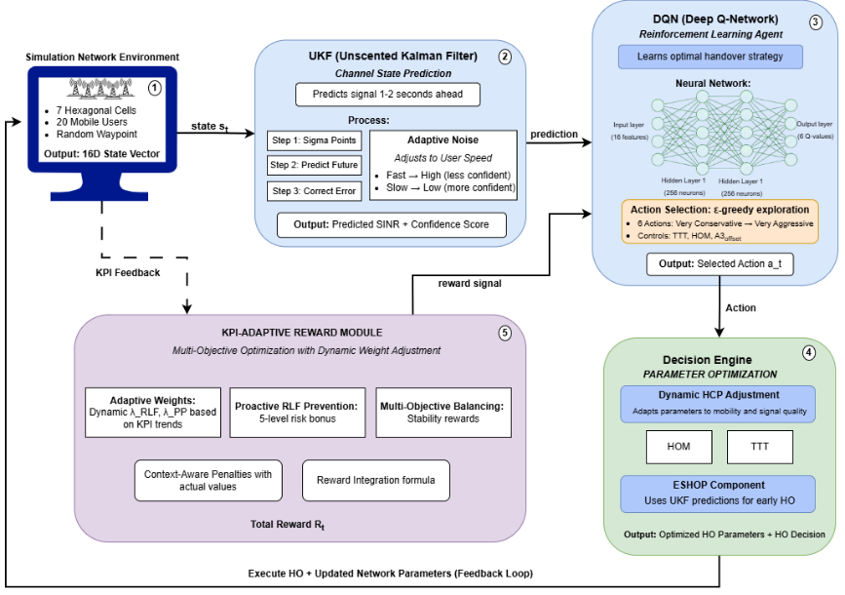
Fig. 2. Architecture of the proposed PRL-HO Framework

Fig. 2 presents the PRL-HO framework, which consists of five interconnected components. The Simulation Network Environment generates state vectors from the current network conditions and feeds them into the UKF module, which forecasts channel quality up to two seconds ahead and attaches a confidence score to each prediction. The DQN module receives both the current state and the UKF predictions, then selects one of six discrete handover actions through its learned policy. The Decision Engine translates the selected action into concrete parameter adjustments, either through the Dynamic HCP mechanism, which scales TTT and HOM based on velocity and signal quality, or through ESHOP, which initiates handover preparation before the standard A3 event triggers. The KPI-Adaptive Reward Module evaluates the outcome of each decision and returns a reward signal that reflects how well the agent balanced RLF prevention, ping-pong reduction, and throughput. This reward feeds back into DQN to guide further learning. The following subsections detail the design and operation of each component.
  - UKF-Based Channel Prediction
Proactive handover decisions require accurate prediction of future channel conditions before signal quality reaches critical levels. Traditional Kalman filters are designed for linear systems and perform poorly in wireless environments. The Extended Kalman Filter (EKF) extends Kalman filtering to nonlinear systems through first-order linear approximations, but these approximations introduce prediction errors in highly nonlinear wireless channels [10]. The Unscented Kalman Filter (UKF) addresses this limitation through deterministic sampling that captures nonlinear dynamics more accurately without requiring linearization. This makes UKF particularly suitable for wireless channels where signal quality exhibits nonlinear behavior due to multipath fading, shadowing, and user mobility.
Within the proposed PRL-HO framework, the UKF module processes RSRP and SINR measurements obtained from the simulation environment to forecast signal quality 1-2 seconds ahead (10-20 timesteps at 100ms intervals). The filter maintains a 5-dimensional state vector which is defined as
x̂_{t} = [RSRP_{serving}, RSRP_{nb1}, RSRP_{nb2}, RSRP_{nb3}, SINR]ᵀ
which represents current channel conditions for the serving cell and three strongest neighbor cells. At each timestep, the UKF performs two operations: (i) Time Update (Prediction) and (ii) Measurement Update (Correction). During the Time Update, the filter predicts the next state using a nonlinear transition model that captures how wireless signals change over time. During the measurement update, the predicted state is refined using newly observed measurements from the environment. This correction step compares the prediction with actual measurements and adjusts the estimate to improve accuracy. Our contribution to UKF is the introduction of velocity-adaptive noise modeling which adjusts the prediction uncertainty based on user mobility. In wireless networks, slow-moving users experience stable signal conditions that make future signal predictions more reliable. In contrast, fast-moving users encounter rapid signal fluctuations which reduce prediction accuracy. Following state correction, the UKF performs recursive multi-step prediction by repeatedly applying the time-update step to generate forecasts at t+1s and t+2s horizons. To capture this behavior, the process noise covariance is dynamically scaled according to user speed as
$$Qk​=Q_base​×(1+ \frac{v}{v_max}​α_noise​),$$
where $v$ is the current user velocity, $v_{max}=30$m/s which represent the maximum considered speed, and $α_{\text{noise}}=2.0$ that is used to control the strength of noise scaling. When the user velocity is low, the noise process remains small which allows the UKF to place higher confidence in its predictions. However, when the user velocity increases, the process noise also increases that indicates higher uncertainty in future channel estimation. By incorporating velocity-adaptive uncertainty, the proposed framework prevents over-reliance on unreliable predictions for high-speed users and exploits accurate predictions for low-speed users. As a result, the reinforcement learning agent learns when predictive information can be trusted which leads to more stable handover decisions. Prediction reliability is quantified using a confidence metric which is defined as
$$conf_{t}=\exp\left( -\frac{|error_{t}|}{σ_{\text{thresh}}}\right)$$ | (6)

where ${\text{error}}_{t}$ represents recent prediction error and $σ_{\text{thresh}}=3.0$dB is a normalization threshold. This exponential function maps prediction errors to confidence scores between 0 and 1, where values closer to 1 indicate highly reliable predictions and values closer to 0 signal greater uncertainty. The predicted future states and their corresponding confidence scores are appended to the 16-dimensional state vector that is forwarded to the DQN agent. This enables the agent to make proactive handover decisions based on expected future channel conditions rather than purely reactive responses to signal degradation. Unlike conventional UKF implementations that use fixed process noise parameters, this velocity-adaptive approach ensures prediction reliability matches actual channel dynamics across heterogeneous mobility scenarios.
  - DQN Architecture and Learning
After UKF channel state prediction, the predicted states are forwarded to DQN module that learns optimal handover decision policies through interaction with the network environment. In traditional Q-learning, a lookup table is used to store Q-values for each state–action pair which become infeasible for complex systems such as ultra-dense 5G networks with continuous mobility and 16-dimensional state representation. DQN solves this problem by using a neural network which approximates the Q-value function. In the proposed PRL-HO framework, the DQN agent receives 16-dimensional state vector $s_{t}$ from UKF module at each timestep. This state vector combines:
- channel measurements (RSRP, SINR, and user velocity),
- handover context information (recent handover count and time since last handover),
- current HCP (TTT, HOM, and A3 offset),
- and predictive features generated by the UKF module which include future SINR estimations and their confidence scores.
DQN processes this state vector information through a feedforward neural network that consists of an input layer with 16 neurons, two hidden layers with 256 neurons each, and an output layer with six neurons. Moreover, Rectified Linear Unit (ReLU) activation functions are used in the hidden layers to enable efficient gradient-based learning. The output layer produces Q-values:
$Q(s_{t},a_{0}),Q(s_{t},a_{1}),…,Q(s_{t},a_{5})$,
where each Q-value represents the expected cumulative reward for selecting a particular handover action in the current network state.
During training, action selection follows ε-greedy policy which helps to balance exploration and exploitation. With probability ε, the agent selects a random action to explore the environment, while with probability $1-ε$, it selects the action with the highest predicted Q-value. The exploration rate ε is initially set to 1.0 to encourage broad exploration and is gradually decayed to 0.01 over the first 100,000 timesteps. This schedule allows the agent to transition smoothly from exploratory behavior to refined exploitation as learning progresses. During deployment, the agent operates in a fully greedy mode where it selects the action that maximizes learned Q-function.
The learning process of DQN is dependent on rewards which are generated by the KPI-Adaptive Reward Module (Section 4.4). After executing an action $a_{t}$ in state $s_{t}$, the environment transitions to a new state $s_{t+1}$, and the agent receives a scalar reward $r_{t}$ that reflects the quality of the handover decision. The reward is composed of five components: a radio link failure penalty, a ping-pong handover penalty, a handover count penalty, a quality-of-service reward, and a proactive intervention bonus. The total reward is expressed as:
$r_{t}=R_{\text{RLF}}+R_{\text{PP}}+R_{\text{HO}}+R_{\text{QoS}}+R_{\text{proactive}}$,
where the penalty weights are dynamically adjusted based on current network performance. Algorithm 1 shows the complete DQN training procedure used in the PRL-HO framework.

Algorithm 1. Enhanced DQN Training algorithm for Handover Optimization
Input: State space S, action space A, replay buffer capacity N = 100,000
Output: Learned policy π(s) = arg max_{a} Q(s, a; θ)
1: Initialize Q-network parameters θ randomly
2: Initialize target network parameters θ⁻ ← θ
3: Initialize replay buffer D with capacity N
4: Set exploration rate ε ← 1.0 and decay rate ε_{decay} ← 0.99999
5: for episode = 1 to 250 do // Training episodes
6: Reset environment and observe initial state s0
7: for t = 0 to 1999 do // 2000 timesteps per episode
8: // Action selection using ε-greedy policy
9: With probability ε:
10: a_{t} ← random action from A
11: Otherwise:
12: a_{t} ← arg max_{a} Q(s_{t}, a; θ)
13: // Execute selected handover action
14: Apply handover parameters (TTT, HOM, A3_{offset}) from Table 4
15: Execute action a_{t} in the environment
16: // Observe environment feedback
17: Observe reward r_{t} from KPI-Adaptive Reward Module
18: Observe next state s_{t+1}
19: // Store experience in replay buffer
20: Store transition (s_{t}, a_{t}, r_{t}, s_{t+1}) in D
21: // Network update using experience replay
22: if t mod 4 = 0 then // Update every 4 timesteps
23: Sample random minibatch of 32 transitions from D
24: for each transition (s_{i}, a_{i}, r_{i}, s_{i+1}) do
25: y_{i} ← r_{i} + γ max_{a'} Q(s_{i+1}, a'; θ⁻)
26: end for
27: Update θ by minimizing (y_{i} − Q(s_{i}, a_{i}; θ))²
28: end if
29: // Target network synchronization
30: if t mod 1000 = 0 then
31: θ⁻ ← θ
32: end if
33: // Decay exploration rate
34: ε ← max(0.01, ε × ε_decay)
35: s_{t} ← s_{t+1} // Move to next state
36: end for
37: end for
38: return Learned Q-network parameters θ

Algorithm 1 presents the complete DQN training procedure used in the PRL-HO framework. The algorithm starts with the initialization of the Q-network, target network, and replay buffer, along with the exploration parameters. Training runs over 250 episodes, each with 2000 timesteps, which produces approximately 500,000 learning interactions with the environment. At each timestep, the agent selects a handover action through the ε-greedy policy applied on HCPs, then receives a reward and observes the next state. The experience tuple is stored in the replay buffer for later use. Every four timesteps, the agent samples a random minibatch of past experiences and updates the Q-network through gradient descent on the temporal difference error. The target network synchronizes with the main network every 1000 timesteps to keep training stable. The exploration rate decays gradually and remains at a minimum value to prevent premature convergence to suboptimal policies. Through this iterative process, the agent learns to map complex network states to optimal handover actions across diverse mobility and channel conditions. The proposed Algorithm 1 extends the standard DQN formulation through four specific enhancements that adapt the framework to the demands of ultra-dense 5G handover management. First, the state vector includes UKF-predicted SINR values and their confidence scores alongside current network measurements, so that the agent makes decisions based on anticipated future conditions rather than only the present state. Second, the reward at each timestep comes from the KPI-Adaptive Reward Module rather than a fixed function, which means the penalty weights that shape learning adjust automatically as network performance evolves during training. Third, the reward structure includes a graduated proactive bonus that reinforces early handover decisions when predicted SINR indicates an approaching failure, a component absent from standard DQN. Fourth, each discrete action maps to a complete HCP configuration that sets TTT, HOM, and A3 offset together, rather than adjusting one parameter at a time. These four modifications turn a standard DQN into a prediction-aware, adaptive policy learner suited to the demands of ultra-dense 5G handover management.
  - Decision Engine
The Decision Engine is the execution layer of the proposed PRL-HO framework which translates the DQN agent's selected actions into actual handover control operations. Once the DQN module selects an optimal action from one of the six predefined handover strategies (as shown in Table 4), the Decision Engine implements this decision using two enhanced mechanisms: (i) Dynamic Handover Control Parameter (HCP) Adjustment and (ii) Early Scheduled Handover Preparation (ESHOP).
Dynamic HCP adapts the handover trigger conditions in real-time based on current network conditions whereas, ESHOP helps in taking proactive handover initiation when UKF predictions have high-confidence score. These mechanisms work together to allow the framework to react to current signal variations and help the framework to maintain connectivity during high-speed mobility while avoiding unnecessary handovers in stable scenarios. This joint optimization of learned policies with real-time parameter adjustments addresses the limitation of existing approaches that perform either learning-based adaptation or rule-based adjustment, but not both simultaneously.
4.3.1 Dynamic Handover Control Parameter (HCP) Adjustment
The Dynamic HCP mechanism refines the handover parameters selected by the DQN agent by applying lightweight, rule-based scaling factors based on user velocity and signal quality. When the DQN agent select an action (for example, a₃ - Moderate), the Decision Engine further adjusts TTT based on current user speed. For high-speed users (v > 20 m/s), TTT is reduced to enable faster handover response, whereas for low-speed users (v < 5 m/s), TTT is increased which prevents unnecessary handovers caused by short-term signal fluctuations. The adjusted TTT is computed as:
$$TTT_{adjusted}= TTT_{base}× \left(1 - 0.3 ×\frac{v - 20}{10}\right), for v > 20\frac{m}{s}$$
$$TTT_{adjusted}= TTT_{base}× \left(1 + 0.2 ×\frac{5 - v}{5}\right), for v < 5\frac{m}{s}$$
where TTT_{base} is the base parameter from the selected action in Table 4 and $v$ is the current user velocity in m/s. Similarly, the HOM is dynamically adjusted based on SINR conditions. When SINR approaches critical levels (SINR < −3 dB), HOM is reduced to trigger handover earlier and prevent radio link failure or when the SINR is strong (SINR > 5 dB), HOM is increased to preserve a stable connection and avoid unnecessary handovers. The adjusted HOM is given by:
$$HOM_{adjusted}= HOM_{base}× \left(1 - 0.4 ×\max\left(0,\frac{-3 - SINR}{3.5}\right)\right), for SINR < -3 dB$$
$$HOM_{adjusted}= HOM_{base}× \left(1 + 0.25 ×\min\left(1,\frac{SINR - 5}{5}\right)\right), for SINR > 5 dB$$
where HOM_{base} is the base parameter from the selected action in Table 4, and SINR is the current signal quality in dB. The A3_{offset} parameter remains unchanged, as it primarily controls the handover trigger threshold rather than timing or margin adaptation. This two-layer decision structure allows the framework to combine learned decisions from the DQN agent with reactive adjustments that result in stable handover behavior in dynamic environments.
4.3.2 Early Scheduled Handover Preparation (ESHOP)
The ESHOP mechanism introduces proactive handover execution using high-confidence channel predictions that are generated by the UKF module. In conventional handover procedures, preparation begins only after the A3 event is triggered, which can lead to increased latency and increased RLF for fast-moving users experiencing rapid signal degradation. ESHOP addresses this limitation by initiating handover preparation before the A3 condition is met. At each timestep, ESHOP evaluates the following activation condition:
$$ESHOP_{trigger}=\left(SINR_{pred\left(t+1s\right)}< -4 dB AND conf\left(t+1s\right)> 0.7\right) || \left(SINR_{pred\left(t+2s\right)}< -5 dB AND conf\left(t+2s\right)> 0.75\right)$$
In above equation SINR_{pred(t+Δ)} denotes the UKF-predicted SINR at future time horizon Δ, and conf(t+Δ) is the prediction confidence computed using the exponential metric defined in Equation (6) of Section 4.1, where higher confidence values indicate more reliable forecasts. The confidence thresholds ensure that early preparation is triggered only when predictions are reliable, which avoids unnecessary handovers caused by uncertain forecasts. Once the ESHOP condition is satisfied, the Decision Engine immediately sends preparation messages to the target cell before the A3 event formally triggers. This proactive schedule reduces overall handover latency from approximately 100ms in standard procedures (50ms preparation + 50ms execution) to approximately 60ms, as preparation overlaps with the period just before the A3 trigger. For high-speed users (v > 25 m/s), this 40ms reduction is sufficient to prevent SINR from falling below the RLF threshold of -6.5 dB, which significantly improves connection reliability during rapid mobility. Compared to standard reactive procedures that cannot initiate preparation until signal degradation is already underway, ESHOP is an enhanced scheduling mechanism that exploits predictive channel information to reduce handover latency and protect connectivity under high-speed conditions.
  - KPI-Adaptive Reward Module
4.4.1 Reward Function Formulation
The proposed KPI-Adaptive Reward Module generates the reward signal that guides the learning behavior of the DQN agent. Unlike fixed-weight reward functions used in existing RL approaches, it dynamically adjusts the penalty weights based on current network conditions, which allows the agent to focus on the most critical issues at each stage of training. This module uses five components to compute the reward: RLF penalty, ping-pong penalty, handover count penalty, quality of service reward, and proactive intervention bonus. The total reward provided to the DQN agent at each timestep is:
$$r_{t}= R_{RLF}+ R_{PP}+ R_{HO}+ R_{QoS}+ R_{proactive}$$
In above equation, $R_{RLF}$ is applied when SINR drops below -6.5 dB for a continuous duration of 200ms (two consecutive timesteps), which indicates a complete loss of connectivity. This is the most severe failure mode in handover management and receives the highest penalty:
$$R_{RLF}= - λ_{RLF}× 10.0 if RLF occurs$$
$$R_{RLF}= 0 otherwise$$
where λ_{RLF} is an adaptive weight. The base penalty magnitude of 10.0 reflects the critical importance of maintaining continuous connectivity. The ping-pong component ($R_{PP}$) is applied when a ping pong is detected, where a user executes a handover from cell A to cell B and then returns to cell A within 1 second (10 timesteps). This pattern indicates oscillating decisions that causes ping pong and degrade user experience.
$$R_{PP}= - λ_{PP}× 5.0 if ping-pong detected$$
$$R_{PP}= 0 otherwise$$
The base penalty of 5.0 reflects that ping-pong is serious but less critical than complete connection loss as in RLF. The handover count component ($R_{HO}$) is applied when any handover occurs. This component discourages unnecessary handovers.
$$R_{HO}= - λ_{HO}× 0.5 if handover executed$$
$$R_{HO}= 0 otherwise$$
A small penalty of 0.5 is applied when a handover occurs, acknowledging that handovers are necessary for mobility management but should not be performed excessively. Moreover, the quality-of-service component ($R_{QoS}$) provides positive feedback for maintaining good signal quality and throughput.
$$R_{QoS} = 0.1 × (SINR(t) + 6.5) / 16.5$$

This formulation normalizes the typical SINR range [−6.5, 10] dB to a small positive reward range which ensures that QoS incentives do not overpower failure-related penalties. Finally, R_{proactive} is the proactive intervention bonus, awarded when the agent takes preventive action based on UKF predictions before signal quality reaches a critical level. The bonus is assigned across five risk bands derived from predicted SINR:
- Level 1 (CRITICAL): SINR_{pred} < -5 dB, bonus = +2.0
- Level 2 (HIGH): SINR_{pred} ∈ [-5, -3) dB, bonus = +1.5
- Level 3 (MODERATE): SINR_{pred} ∈ [-3, -1) dB, bonus = +1.0
- Level 4 (LOW): SINR_{pred} ∈ [-1, 1) dB, bonus = +0.5
- Level 5 (NONE): SINR_{pred} ≥ 1 dB, bonus = 0
where SINR_{pred} is the UKF-predicted SINR at t+1s horizon and the bonus is awarded only if the agent executes a handover and the prediction confidence exceeds 0.7. This graduated structure encourages early intervention when predictions indicate signal degradation, which enables the agent to learn proactive handover strategies.

4.4.2 Adaptive Weight Adjustment
The adaptive weight adjustment mechanism dynamically updates the penalty weights (λ_{RLF}, λ_{PP}, λ_{HO}) after every 10 training episodes based on recent network performance metrics. The objective is to ensure that the learning process focuses on the most critical performance issue at each stage of training, rather than treating all objectives with equal fixed importance. For example, when RLF exceeds its target, λ_{RLF} is increased; when ping-pong exceeds its target, λ_{PP} is increased; and when handover count is excessive, λHO is increased. This allows the reward function to shift focus toward the most problematic objective at each training stage. The penalty weights are adjusted according to the following equation:
λ_{new} = λ_{current} × (1 + α × (KPI_{current} - KPI_{target}) / KPI_{target})
where α = 0.3 is the adaptation rate, KPI_{current} is the average metric value over the last 10 episodes, and KPI_{target} is the desired performance threshold. The target values are RLF_{target} = 0.5% (maximum acceptable RLF rate), PP_{target} = 1.5% of handovers (maximum acceptable ping-pong rate), and HO_{target} = 3.5 handovers per user per episode. When a KPI exceeds its target, the corresponding penalty weight increases that causes the agent to prioritize that objective. When a KPI is below its target, the weight decreases, which allows the agent to allocate learning capacity to other objectives. To ensure stable training and prevent extreme parameter scaling, all weights are constrained within the range [0.5, 5.0].
4.4.3 Multi-Objective Balancing
To prevent the agent from optimizing only one objective at the expense of others, the reward module implements two additional balancing mechanisms. Firstly, consecutive failure penalties and secondly stability bonuses. Consecutive failure penalties apply escalating negative rewards when the same failure type occurs multiple times
$$Rconsecutive = -2.0 × nfailures if same failure type repeats$$
where $nfailures$is the number of consecutive occurrences (capped at 5). This discourages the agent from repeatedly making the same mistake. Second, stability bonuses provide small positive rewards for maintaining consistent connection quality over extended periods
$$R_{stability}= +0.2 ×\frac{t_{stable}}{20}$$
where $t_{stable}$ is the number of consecutive timesteps with SINR > 0 dB and no handovers (capped at 20 timesteps = 2 seconds). This encourages the agent to maintain stable connections when signal quality is good, rather than performing unnecessary handovers. By dynamically adjusting penalties based on current performance, the KPI-Adaptive Reward Module enables the agent to progressively improve across all objectives rather than prematurely converging to solutions that optimize only one metric. This adaptive approach is particularly important during the later stages of training when fine-tuning trade-offs between conflicting objectives such as minimizing handovers while preventing RLF requires careful balance that static reward functions cannot achieve.
  - PRL-HO framework Algorithm
Fig. 3 presents the complete training and deployment procedure of the PRL-HO framework. The procedure integrates all five components, UKF prediction, state construction, DQN-based action selection, Decision Engine, and KPI-Adaptive Reward Module, into a single unified learning loop that operates across two nested iterations: an outer episode loop and an inner timestep loop. The outer loop runs for 250 episodes. At the start of each episode, the simulation environment resets with randomized user positions, velocities, and channel states, which ensures that the agent encounters diverse network conditions and does not overfit to a fixed scenario. Within each episode, the inner timestep loop executes 2000 iterations at 100ms intervals, representing 200 seconds of simulated network operation per episode and approximately 500,000 learning interactions in total.
At each timestep, the UKF module processes the latest RSRP and SINR measurements and forecasts signal quality 1–2 seconds ahead, with each forecast accompanied by a confidence score that reflects prediction reliability. These outputs combine with current network measurements to form the 16-dimensional state vector, which captures signal strength, user mobility, current handover control parameters, and predictive channel information. The DQN agent receives this state vector and selects one of six discrete handover actions through an ε-greedy policy, where the exploration rate decays from 1.0 to 0.01 over the first 100,000 timesteps to transition gradually from broad exploration to refined exploitation. The selected action then passes through the Decision Engine, which applies Dynamic HCP scaling to adjust TTT based on user velocity and HOM based on current SINR. Simultaneously, the ESHOP condition is evaluated: when the predicted SINR falls below −4 dB and the prediction confidence exceed 0.7, the Decision Engine initiates early handover preparation before the A3 event formally triggers, which reduces handover latency from 100ms to 60ms. After handover execution, the KPI-Adaptive Reward Module computes the reward from five components which are RLF penalty, ping-pong penalty, handover count penalty, QoS reward, and a proactive bonus of up to +2.0 based on predicted SINR risk level, awarded only when prediction confidence exceeds 0.7. The resulting transition is stored in the replay buffer, and the Q-network updates every four timesteps through minibatch sampling of 32 transitions. The target network synchronizes with the main network every 1000 timesteps to maintain stable gradient targets and prevent oscillation during training.
After every 10 episodes, the adaptive weight mechanism adjusts the penalty coefficients λ_{RLF}, λ_{PP}, and λ_{HO} according to λ_{new} = λ_{current} × (1 + 0.3 × (KPI_{current} − KPI_{target}) / KPI_{target}), with all weights clamped to [0.5, 5.0]. This ensures the reward function shifts focus toward the most critical performance objective at each stage of training rather than treating all objectives with equal fixed importance throughout.
After training converges, the learned policy deploys in greedy mode with ε = 0, where the agent selects the action with the highest Q-value at every 100ms interval. The deployment phase executes the same UKF prediction, state construction, and Decision Engine flow as training but without experience storage, Q-network updates, or target network synchronization, which reduces computational overhead and achieves a processing latency of under 10ms per decision.

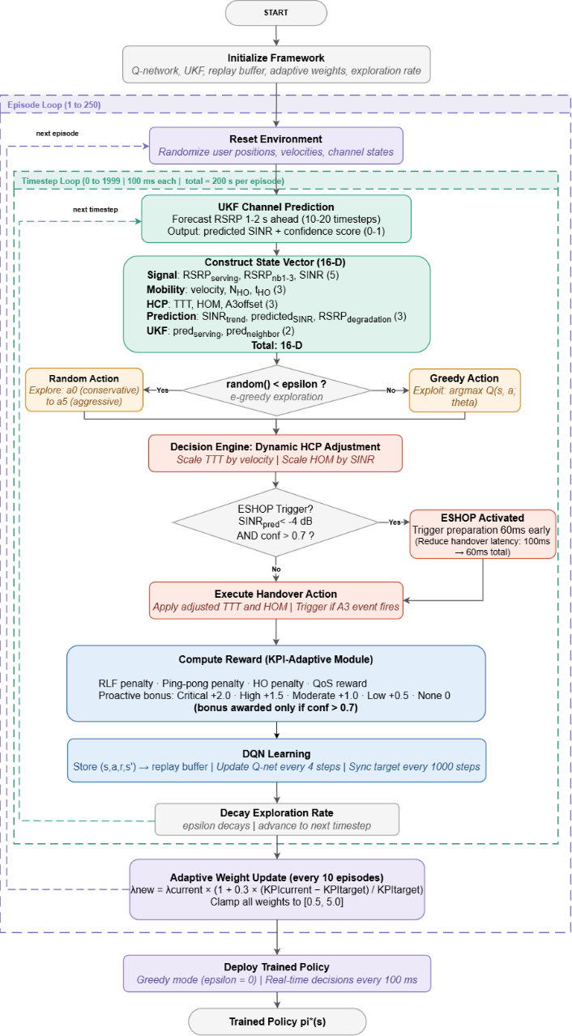
Fig. 3. Complete training and deployment procedure of the PRL-HO framework
- Results and Discussion
This section presents the experimental evaluation of the proposed PRL-HO framework and compare its performance against state-of-the-art baseline methods. The proposed PRL-HO framework and all baseline methods are evaluated using the same simulation environment as described in Section 3.1. The selected baseline methods are as follows. First, the Rule based method (3GPP Standard) [3, 26]. This baseline implements the standard 3GPP A3 event trigger with fixed handover control parameters (TTT = 160 ms, HOM = 3 dB, A3_offset = 3 dB). It represents the industry-standard approach that does not adapt to network conditions and serves as the baseline for comparison. Secondly, supervised learning approach named as MLP-based Method (multi-layer perceptron) has been selected. This approach predicts optimal TTT and HOM values based on current network conditions (RSRP, SINR, velocity, cell load). The MLP is trained offline on a dataset of historical network measurements and handover outcomes [7]. Third, a standard Deep Q-Network implementation that learn handover policies through reinforcement learning without any predictive or proactive components. It uses the same state space and action space as the proposed PRL-HO but lacks UKF prediction, ESHOP mechanism, and adaptive reward weighting. Fourthly we selected UKF-E2E-SARSA proposed by [10]. This method combines Unscented Kalman Filter for channel prediction with Expected SARSA for handover decision-making. It includes prediction capability similar to our approach, it uses a simpler SARSA learning algorithm and lacks the proactive RLF prevention, ESHOP scheduling, and KPI-adaptive reward mechanisms of the proposed framework. Fifth, the DDPG method proposed by [9]. This is a recent deep deterministic policy gradient method for continuous handover parameter optimization. It represents a recent actor–critic approach for continuous handover parameter optimization. However, it does not include channel prediction, proactive failure prevention, or adaptive multi-objective balancing.
The performance of all methods is evaluated using five performance indicators which capture different aspects of handover quality and network performance. These metrics include Radio Link Failure (RLF) Count, Ping-Pong Handover Count, Total Handover Count, Average SINR, and Throughput. RLF Count is the average number of RLF events per user per episode. An RLF occurs when SINR drops below -6.5 dB for a continuous duration of 200 milliseconds which indicate complete loss of connectivity. This is the most critical failure metric, and lower values indicate better performance. Ping-Pong Handover Count is the number of ping-pong handover events which are detected during evaluation. A ping-pong handover occurs when a user executes a handover from cell A to cell B and then immediately returns to cell A within 1 second which indicate oscillating handover decisions. Lower values indicate more stable handover behavior. Total Handover Count is the total number of handovers executed per user per episode. This metric should be balanced because too few handovers can lead to RLF in high-mobility scenarios while too many handovers waste signaling resources and cause service interruptions. The handover count is interpreted jointly with RLF and ping-pong performance because an excessively low count may delay necessary handovers, whereas an excessively high count may increase signaling overhead and service interruptions. Moreover, average SINR is the time-averaged signal-to-interference-plus-noise ratio which is experienced by users during the evaluation period which is measured in decibels (dB). Higher SINR values indicate better signal quality and improved data transmission reliability. And in the last throughput, which is the average data throughput achieved by users which is measured in megabits per second (Mbps). Throughput is computed based on the Shannon capacity formula using the measured SINR and allocated bandwidth. Higher throughput indicates better quality of service and network capacity utilization.
  - Evaluation Procedure:
All methods are implemented in Python 3.9 using PyTorch 2.0.1 for neural network components and NumPy for numerical computations. All methods were evaluated using the same network configuration, episode duration, test seeds, and computational platform. Algorithm-specific training hyperparameters were retained according to the requirements of each method. Training is conducted over 250 episodes where each episode consists of 2000 timesteps which result in approximately 500,000 learning interactions with the environment. The exploration rate for DQN-based methods starts at ε = 1.0 and decays exponentially to ε_min = 0.01 over 100,000 timesteps using decay rate ε_{decay} = 0.99999. Experience replay is implemented with buffer capacity 100,000 transitions and minibatch size 32. The Q-network is updated every 4 timesteps using Adam optimizer with learning rate α = 0.0001 and the target network is synchronized every 1000 timesteps. After training convergence, all methods are evaluated on 100 independent test episodes with different random seeds to ensure statistical reliability. During evaluation, learning is disabled and all DQN-based methods operate in fully greedy mode (ε = 0). Performance metrics are computed for each episode and then averaged across all test episodes with standard deviations reported to quantify variability. Performance is reported as the mean ± standard deviation across 100 independent evaluation episodes.
  - Performance Comparison
5.2.1 Radio Link Failure Performance
Radio Link Failure (RLF) represents the complete loss of connectivity between the user equipment and the serving cell. In the proposed evaluation framework, RLF event is detected when the measured SINR drops below the threshold of -6.5 dB and remains below this threshold for a continuous duration of 200 milliseconds which correspond to two consecutive timesteps in the simulation. The RLF count metric is computed as the average number of RLF events experienced by each user during a 200-second evaluation episode. For example, if 20 users collectively experience 4 RLF events during one episode, the RLF count for that episode is 4/20 = 0.20 events per user. This metric is then averaged across all 100 test episodes, and the standard deviation is computed to quantify the variability of RLF occurrence across different network conditions and user mobility patterns.
Fig. 4 presents the RLF count comparison across all six methods, where lower values indicate better performance. The proposed PRL-HO achieved the lowest RLF count of 0.21 ± 0.45, which means each user experiences on average 0.21 RLF events per 200-second episode, approximately one RLF event per 1000 seconds of operation. The second-best method is UKF-E2E-SARSA (0.23 ± 0.22), followed by Rule-Based (0.29 ± 0.26), MLP (0.34 ± 0.26), DDPG-2024 (0.36 ± 0.44), and Simple-DQN (0.53 ± 0.38).
PRL-HO achieves fewer RLF events than all baselines through three mechanisms. First, the UKF module generates multi-step SINR predictions at 1–2 seconds ahead, which allow the framework to predict signal degradation before RLF conditions occur, when predicted SINR falls below −5 dB, proactive handover preparation begins immediately. Second, the graduated proactive reward mechanism assigns higher bonuses for earlier interventions, which trains the DQN agent to act before failures occur rather than after that. Third, ESHOP reduces handover execution latency from 100ms to 60ms, which is particularly critical for high-velocity users (v > 25 m/s) where signal quality can degrade by 3–4 dB per second and the saved 40ms can prevent SINR from reaching the RLF threshold.
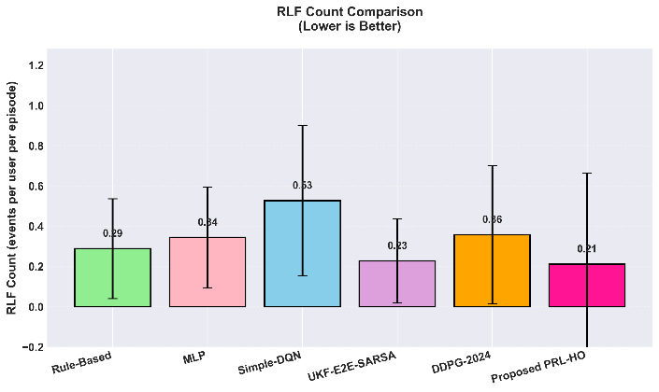
Fig. 4. RLF Count Comparison Across All Methods

5.2.2 Ping-Pong Handover Performance
In the evaluation framework, a ping-pong event is detected when a user executes a handover from cell A to cell B and then returns to cell A within 1 second (10 timesteps). The ping-pong count was calculated by dividing the total number of detected ping-pong events by the number of evaluation episodes and the number of users. Therefore, the reported value represents the average number of ping-pong events per user per episode. Lower values indicate more stable and consistent handover decisions. Figure 5 presents the ping-pong handover count comparison across all methods. The proposed PRL-HO framework achieved a ping-pong count of 28.5 ± 11.2 which represents a 19.9% improvement over DDPG-2024 (35.6 ± 12.0), 38.3% improvement over UKF-E2E-SARSA (46.2 ± 19.3), 39.6% improvement over MLP (47.2 ± 14.8), and 43.0% improvement over Rule-Based (50.0 ± 21.1). Simple-DQN achieves the lowest ping-pong count (23.9 ± 7.7) but also records the highest RLF count (0.53), which indicates an unfavorable trade-off under the evaluated simulation conditions. PRL-HO achieves the best balance between ping-pong minimization and RLF prevention, which is a key challenge in multi-objective handover optimization. PRL-HO controls ping-pong through two complementary mechanisms. The KPI-Adaptive Reward Module includes an explicit ping-pong penalty (R_{PP} = −λ_{PP} × 5.0), where λ_{PP} increases automatically when the ping-pong rate exceeds 1.5% of total handovers. This prevents the agent from over-optimizing RLF prevention at the expense of handover stability. The Dynamic HCP mechanism scales TTT based on user velocity, which prevents rapid back-and-forth handovers in cell-edge regions. Low-velocity users (v < 5 m/s) receive increased TTT values of up to 1.5× baseline, which requires the neighbor cell signal to remain stronger for longer before a handover triggers and suppresses oscillatory decisions caused by short-term signal fluctuations. UKF-E2E-SARSA shows a high ping-pong count (46.2) because its reward function prioritizes RLF minimization without explicit ping-pong control, which results in frequent handovers in cell-edge regions where serving and neighbor SINR values are comparable. Rule-Based achieves the highest ping-pong count (50.0) as its fixed parameters (TTT = 160 ms, HOM = 3 dB) trigger repeated A3 events in overlapping coverage areas. DDPG-2024 achieves moderate performance (35.6) through continuous HOM adjustment but lacks velocity-adaptive TTT scaling and adaptive multi-objective weight balancing.

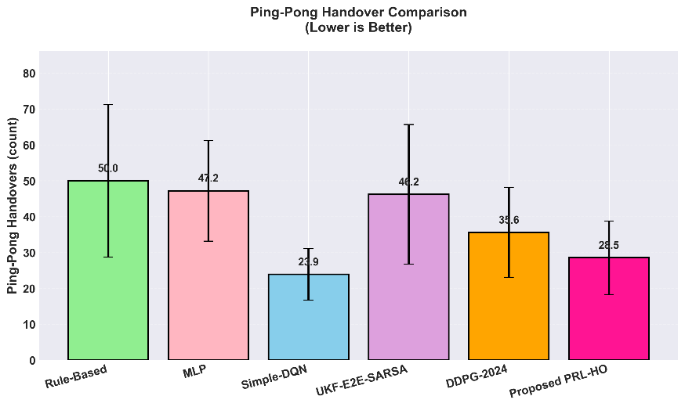
Fig. 5. Ping-Pong Handover Count Comparison
.
5.2.3 Total Handover Count Performance
Total handover count represents the number of cell reselection events executed per user during network operation. This metric requires balance, too few handovers lead to prolonged connection to weak cells and elevated RLF risk, while too many waste signaling resources increase network load, and cause frequent service interruptions. The total handover count is computed as the average number of handovers per user per episode across all 100 test episodes. Based on the observed results for the simulated network configuration, a handover count of approximately 65–75 handovers per user per episode was used as a reference range for balanced handover behavior. Values within this range provided sufficient mobility management without producing excessive handover activity in the evaluated scenario.
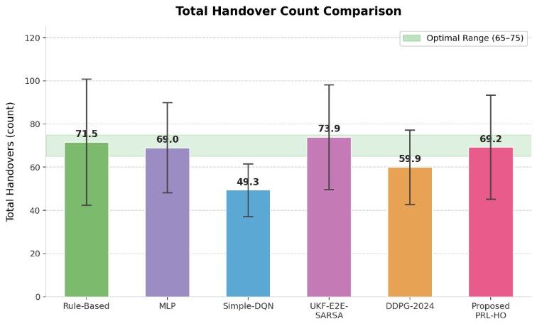
Fig 6. Total Handover Count Comparison Across All Methods
Fig. 6 presents the total handover count across all methods. PRL-HO records 69.2 ± 24.1 handovers per user per episode, which falls within the reference range used for the evaluated scenario. Rule-Based and MLP record similar values of 71.5 ± 29.2 and 69.0 ± 20.9, respectively, while UKF-E2E-SARSA records a slightly higher value of 73.9 ± 24.2. Simple-DQN and DDPG-2024 record lower values of 49.3 ± 12.2 and 59.9 ± 17.2, respectively. These values should be interpreted together with RLF and ping-pong performance because a lower or higher handover count alone does not necessarily indicate better performance.
PRL-HO achieved a balanced handover count through two adaptive mechanisms. The Dynamic HCP mechanism scales TTT and HOM based on user velocity and SINR, which ensures handover frequency adapts to each user's mobility pattern, high-velocity users (v > 20 m/s) receive TTT reductions of 30–40% to enable rapid cell reselection, while low-velocity users (v < 5 m/s) receive TTT increases of 20% to suppress unnecessary handovers from temporary signal fluctuations. The KPI-Adaptive Reward Module includes a small handover count penalty (R_{HO} = −λ_{HO} × 0.5), which discourages excessive switching while the larger RLF and ping-pong penalties ensure connectivity and stability remain the primary objectives.
Simple-DQN’s lower handover count of 49.3 is accompanied by the highest RLF count of 0.53, as users remain connected to serving cells longer than optimal, which results in severe signal degradation before handovers execute. UKF-E2E-SARSA's comparatively higher handover count of 73.9 contributes to its high ping-pong rate (46.2) as its RLF-focused policy triggers frequent reselections in regions where multiple cells offer comparable signal quality. DDPG-2024's lower optimal count 59.9 likely contributes to its moderate RLF performance, as some users do not receive timely handovers under degrading signal conditions.

5.2.4 Average SINR Performance
Average SINR (Signal-to-Interference-plus-Noise Ratio) measures signal quality and directly impacts data transmission reliability and throughput capacity. SINR is computed at each timestep based on received signal power from the serving cell, interference from neighboring cells, and thermal noise. The average SINR metric represents the time-averaged SINR across all users and all timesteps in the 100 test episodes. Higher SINR values indicate better signal quality and enable higher-order modulation schemes and increased data rates. Fig. 7 presents the average SINR comparison across all methods. PRL-HO achieves a competitive average SINR of 8.12 ± 1.94 dB. Simple-DQN achieves the highest SINR (8.77 ± 2.53 dB), followed by MLP (8.47 ± 2.28 dB), DDPG-2024 (8.32 ± 1.98 dB), PRL-HO (8.12 ± 1.94 dB), UKF-E2E-SARSA (7.99 ± 2.20 dB), and Rule-Based (7.88 ± 1.77 dB). The narrow range across all methods (7.88–8.77 dB) indicates that the primary performance differences lie not in average signal quality but in how effectively each method prevents RLF events, handles signal quality transitions, and manages handover timing.
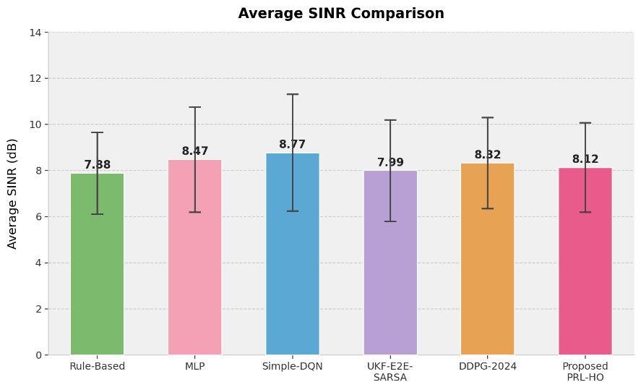
Fig. 7. Average SINR Comparison
5.2.5 Throughput Performance
Throughput is a quality-of-service metric that directly measures the data transmission rate (in Mbps) experienced by users. Throughput is computed using the Shannon capacity formula based on the current SINR and allocated bandwidth (100 MHz). The average throughput metric represents the mean data rate across all users and all timesteps during the evaluation period. Higher throughput values indicate better network capacity utilization and improved user experience. Fig. 8 presents the throughput comparison across all methods. PRL-HO achieved 421.8 ± 21.7 Mbps that represent a 23.7% improvement over the best baseline UKF-E2E-SARSA (341.0 ± 33.1 Mbps). The throughput gain is primarily driven by increased active transmission time rather than higher average SINR, since SINR values differ by less than 1 dB across all methods, SINR alone accounts for less than 4 Mbps difference under Shannon capacity. The remaining gain stems from three factors. First, PRL-HO's lower RLF rate (0.21 vs 0.23–0.53 for baselines) means users spend more time in active connected states, during RLF events, data transmission halts entirely and connection re-establishment takes several seconds, so proactive failure prevention directly translates to more transmission time. Second, UKF-based proactive handover timing reduces the duration users spend in poor signal quality regions (SINR < 0 dB) where data rates are severely constrained, as PRL-HO initiates handovers before signal quality deteriorates rather than after. Third, ESHOP reduces per-handover interruption from 100ms to 60ms, across approximately 69 handovers per episode, this 40ms reduction accumulates into a significant active transmission time advantage. All baseline methods achieve similar throughput (331.9–341.0 Mbps) because their reactive strategies produce comparable performance under normal conditions but cannot prevent the transmission losses caused by RLF events and handover interruptions.
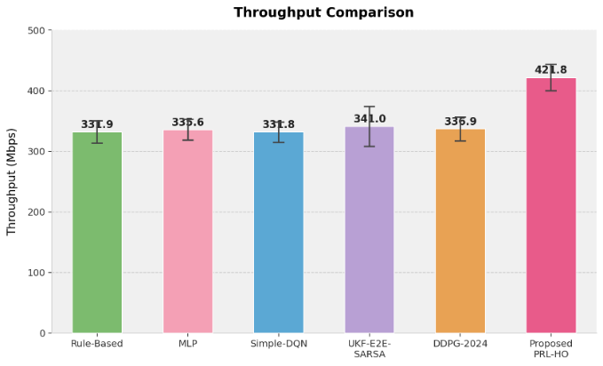
Fig. 8. Throughput Comparison
- Conclusion
This paper presented the Proactive Reinforcement Learning-based Handover Optimization (PRL-HO) framework for handover management in ultra-dense 5G networks. The framework addresses four limitations identified in the existing literature: the lack of proactive failure prevention, the use of fixed reward weights, the separate adjustment of individual handover control parameters, and the absence of an integrated framework that combines prediction, learning, and adaptive handover control. PRL-HO combines seven components within a unified framework. The UKF module forecasts signal quality up to two seconds ahead to identify potential signal degradation before an RLF occurs. The DQN agent selects a handover action from six predefined strategies, and the Dynamic HCP mechanism further adjusts Time-to-Trigger and Handover Margin according to user speed and current signal conditions. The ESHOP mechanism initiates early handover preparation and reduces the modeled handover latency from 100ms to 60ms, while the KPI-Adaptive Reward Module periodically adjusts the penalty weights according to recent network performance. The simulation results indicate that PRL-HO improved handover performance under the evaluated Urban Dense Small Cell conditions. It achieved an RLF count of 0.21, a ping-pong count of 28.5, and a throughput of 421.8 Mbps. Compared with UKF-E2E-SARSA, PRL-HO reduced RLF by 8.7% and improved throughput by 23.7%, while it reduced ping-pong handovers by 19.9% compared with DDPG-2024. Simple-DQN achieved a lower ping-pong count, but it also recorded the highest RLF count, which indicates that PRL-HO provided a more balanced trade-off between connection reliability, handover stability, and throughput under the evaluated conditions. This study has certain limitations. The evaluation was simulation-based and limited to a single Urban Dense Small Cell scenario consisting of seven hexagonal cells and twenty users. Therefore, performance in larger networks, different cell densities, and other mobility environments, such as Indoor and Highway scenarios, was not examined and may differ from the reported results. Future work will extend the evaluation using real-world 5G network traces and additional deployment environments, investigate alternative learning techniques such as Proximal Policy Optimization, actor–critic methods, and multi-agent reinforcement learning, and explore lightweight architectures suitable for deployment on resource-constrained edge hardware.
Acknowledgments: This research is supported by the Universiti Malaya Research Excellence Grant (Project No. UMREG011-2024) and the Universiti Malaya Center of Research Grant (Project No. CORG008-2024).
Author Contributions: M.U.M. conceptualized the study, led the development of the simulation framework and codebase, conducted the main experiments, performed the formal analysis, and prepared the original draft. I.A. and M.A.N. supervised the research, contributed to the methodology design and refinement, validated the results, provided resources, and reviewed and edited the manuscript. R.M.N. contributed to the framework design, validated the results, and reviewed and edited the manuscript for structure and clarity. S.R.A. contributed to the supervision of the work, simulation development, result validation, and framework optimization. S.S. contributed to conducting experiments and drafting the manuscript. S.N.O. contributed to result validation and manuscript drafting. All authors reviewed and approved the final version of the manuscript.
Availability of Data and Materials: The source code, trained models, and simulation outputs supporting the findings of this study are available from the corresponding author upon reasonable request.
Conflicts of Interest: The authors declare no conflict of interest.

References
1. Explore the Ericsson Mobility Report, November 2025, https://www.ericsson.com/en/reports-and-papers/mobility-report/reports/november-2025, last accessed 2025/12/06.
2. Alam, M.J., Hossain, M.R., Azad, S., Chugh, R.: An overview of LTE/LTE‐A heterogeneous networks for 5G and beyond. Trans. Emerg. Telecommun. Technol. 34, (2023). https://doi.org/10.1002/ett.4806.
3. Technical Specification Group Radio Access Network. In: 3rd Generation Partnership Program (3GPP) (2020).
4. Alraih, S., Nordin, R., Shayea, I., Abdullah, N.F., Abu-Samah, A., Alhammadi, A.: Effectiveness of handover control parameters on handover performance in 5G and beyond mobile networks. Wirel. Commun. Mob. Comput. 2022, 1–18 (2022).
5. Riaz, H., Öztürk, S., Çalhan, A.: A robust handover optimization based on velocity-aware fuzzy logic in 5G ultra-dense small cell HetNets. Electronics (Basel). 13, 3349 (2024).
6. Sharmin, S., Ahmedy, I., Jabaraj, B.R.P., Munir, M.U., Noor, R.M., Ahmad, M.: A comprehensive review of machine learning-driven self-organizing networks for 5G coverage and capacity. Telecommun. Syst. 89, 44 (2026).
7. Riaz, H., Öztürk, S., Aldirmaz-Colak, S., Çalhan, A.: A Handover decision optimization method based on data-driven MLP in 5G ultra-dense small cell HetNets. J. Netw. Syst. Manag. 33, (2025). https://doi.org/10.1007/s10922-025-09903-6.
8. Wu, M., Huang, W., Sun, K., Zhang, H.: A DQN-based handover management for SDN-enabled ultra-dense networks. In: 2020 IEEE 92nd Vehicular Technology Conference (VTC2020-Fall). IEEE (2020). https://doi.org/10.1109/vtc2020-fall49728.2020.9348779.
9. Kwong, C.F., Shi, C., Liu, Q., Yang, S., Chieng, D., Kar, P.: Autonomous handover parameter optimisation for 5G cellular networks using deep deterministic policy gradient. Expert Syst. Appl. 246, 122871 (2024).
10. Junejo, Y.S., Shaikh, F.K., Chowdhry, B.S., Ejaz, W.: Adaptive handover management in high-mobility networks for smart cities. Computers. 14, 23 (2025).
11. Munir, M.U., Ahmedy, I., Azzuhri, S.R., Raj, B., Noor, R.M., Ali, I.: A systematic review of handover optimization techniques in 5G self-organizing networks. ICT Express. (2026). https://doi.org/10.1016/j.icte.2026.03.020.
12. Nie, S., Wu, D., Zhao, M., Gu, X., Zhang, L., Lu, L.: An enhanced mobility state estimation based handover optimization algorithm in LTE-A self-organizing network. Procedia Comput. Sci. 52, 270–277 (2015).
13. Huang, W., Wu, M., Yang, Z., Sun, K., Zhang, H., Nallanathan, A.: Self-adapting handover parameters optimization for SDN-enabled UDN. IEEE Trans. Wirel. Commun. 21, 6434–6447 (2022).
14. Shayea, I., Ergen, M., Azizan, A., Ismail, M., Daradkeh, Y.I.: Individualistic dynamic handover parameter self-optimization algorithm for 5G networks based on automatic weight function. IEEE Access. 8, 214392–214412 (2020).
15. Alhabo, M., Zhang, L.: Load-dependent handover margin for throughput enhancement and load balancing in HetNets. IEEE Access. 6, 67718–67731 (2018).
16. Saad, S.A., Shayea, I., Sid Ahmed, N.M.O.: Artificial intelligence linear regression model for mobility robustness optimization algorithm in 5G cellular networks. Alex. Eng. J. 89, 125–148 (2024).
17. Hwang, W.-S., Cheng, T.-Y., Wu, Y.-J., Cheng, M.-H.: Adaptive handover decision using fuzzy logic for 5G ultra-dense networks. Electronics (Basel). 11, 3278 (2022).
18. Alraih, S., Nordin, R., Abu-Samah, A., Shayea, I., Abdullah, N.F., Alhammadi, A.: Robust Handover Optimization Technique with Fuzzy Logic Controller for beyond 5G mobile networks. Sensors (Basel). 22, 6199 (2022).
19. He, J., Xiang, T., Wang, Y., Ruan, H., Zhang, X.: A reinforcement learning handover parameter adaptation method based on LSTM-aided digital twin for UDN. Sensors (Basel). 23, 2191 (2023).
20. Alhammadi, A., Hassan, W.H., El-Saleh, A.A., Shayea, I., Mohamad, H., Saad, W.K.: Intelligent coordinated self-optimizing handover scheme for 4G/5G heterogeneous networks. ICT Express. (2022). https://doi.org/10.1016/j.icte.2022.04.013.
21. Phatcharasathianwong, S., Kunarak, S.: Hybrid artificial intelligence scheme for vertical handover in heterogeneous networks. In: Proceedings of the 2024 8th International Conference on Graphics and Signal Processing. pp. 47–53. ACM, New York, NY, USA (2024).
22. Hassan, K.M.A.: An approach to make handover efficient in 5G and beyond using deep hybrid learning. Wirel. Netw. 31, 4397–4411 (2025).
23. Lima, J.P.S.H., de Medeiros, Á.A.M., de Aguiar, E.P., Silva, E.F., de Sousa, V.A., Nunes, M.L., Reis, A.L.: Deep learning-based handover prediction for 5G and beyond networks. In: ICC 2023 - IEEE International Conference on Communications. IEEE (2023). https://doi.org/10.1109/icc45041.2023.10279195.
24. Study on channel model for frequencies from 0.5 to 100 GHz. 3rd Generation Partnership Program (3GPP). 16, (2019).
25. Camp, T., Boleng, J., Davies, V.: A survey of mobility models for ad hoc network research. Wirel. Commun. Mob. Comput. 2, 483–502 (2002).
26. Specification # 36.331, https://portal.3gpp.org/desktopmodules/Specifications/SpecificationDetails.aspx?specificationId=2440, last accessed 2025/12/21.

